INTRODUCTION TO THE NARRATIVE OF THE EARLY LIFE OF MY FATHER
LAMBETH SHELTON ALLEN, JUNIOR

I lean heavily, and with immeasurable gratitude, on the memoirs of Shelton’s older sister Nancy for much of the information in this and the sections about the preceding two generations on the Allen/Smith sides. I am so grateful that at 79 years old she began typing her memories. We would have very little information or photographs from his childhood nor tales of their parents and grandparents otherwise.

From Nancy’s memoirs (although obviously from her own perspective, but undoubtedly similar to Shelton’s experience) we hear of an “almost fairy-tale childhood … given by the two parents I always deeply loved and respected, by an aunt who guided and shaped my character and my future, by an adored ‘Poppy’ who died too young and a beloved ‘Mommy’ who I still talk about with great affection.” The close connection Nancy, Shelton and Evelyn had with their mother’s brother Edward Smith and his family in East Troy, Wisconsin is also evident in the stories which are interwoven throughout this narrative.

Also, thankfully, we have the sporadic entries of Shelton’s own journal in 1946 and 1947 and a letter written by him to his mother in 1950, which my sister Sharon transcribed for us and are included in the appropriate years below, in which we hear in his own words his inner journey from a young developing-alcoholic Navy man to the humble Christian missionary I knew him to be.

An interesting phenomenon occurs when I read these memoirs and narratives or have time to set aside a few hours for research. While diving deeply into the stories or making online discoveries of historic documents and family connections, the world around fades and I find I have virtually stepped back in time and am walking in these relatives’ footsteps.

It is my hope that these stories are passed down through many generations of our family who can then also walk in their ancestors’ footsteps and learn to know them as more than just a name with dates attached, but as the living, breathing people they were, and perhaps even catch a glimpse of a physical trait or characteristic that may have been inherited from them.

THE EARLY LIFE OF MY FATHER, LAMBETH SHELTON ALLEN, JUNIOR
Covering the years 1925 to 1951

(All text that is indented and in italics is directly quoted from Nancy’s memoirs, unless otherwise noted.)

1925

On a cold and windy day in mid-November 1925 a young mother labored in childbirth in her home at 349 North Ashland Avenue in River Forest, Illinois, a suburb of Chicago. Two years before, when pregnant with her oldest, Alice had read in the newspaper about two babies born in a local hospital who had been sent home with the wrong families. She did not want such a mix-up with any of her babies and therefore had resolutely decided to give birth at home. In those days doctors still regularly made house calls.

There was frost on the ground outside and frost on the windowpanes of the downstairs unit of the duplex she and her husband Lam had rented after they were married in 1922. The temperature outside would not rise above 30 degrees Fahrenheit, but inside the rooms were warm and cozy. Perhaps Alice thought of the new home they were building in the nearby suburb of Glen Ellyn and imagined living there with her growing family.

As the contractions intensified and the time for delivery drew nearer, Alice may have worried about the noises she couldn’t help but make, wondering if it would bother the neighbors upstairs. And she most certainly worried about the new baby and the delivery. Would it go well as it had two years before, would baby be healthy, would baby be a boy or another girl? In those days there was no way to tell until the child was born. Would the doctor arrive on time?

She may have worried about those things, but she did not have to worry about her little daughter Nancy Ellen who had turned two years old in August three months before. Alice’s mother and grandmother also lived in the Chicago area and would take care of Nancy while she gave birth to her second child. She also did not have to worry about money. Her husband ran a very successful mail order printing business and she and her children were well-provided for. Although she could not have known it at the time, the Great Depression, which left so many families destitute, would start less than four years later, but she would still be well-cared for through the darkest hours of those years. Already there was a nurse, Miss Hough, lined up to care for the baby after she gave birth. Huffy, as she was affectionately called by the family, had cared for Nancy after her birth and eighteen months later would care for Alice’s youngest daughter Evelyn as well.

But, on that Monday, November 16, 1925, ten days before Thanksgiving, twenty-five year old Alice gave birth at home to a son. His father, as was the practice of the day, would not have been in the room when the baby was born, but Lam, who had turned forty-nine just three days before, most likely did not take the 45-minute train ride into Chicago to work that day and would have been waiting anxiously nearby to come into the room shortly after the baby’s birth to marvel at his little boy who they would call Shelton - Lambeth Shelton Allen, Junior. And thus Lam, proud of his name and the heritage he bore, passed on to his infant son the two old surnames, steeped in family history, that his own parents had given their only son – Lambeth from his mother Ellen Nancy Pitts side and Shelton from his father Robert Alexander Allen’s side.

1926

THE HOUSE IN GLEN ELLYN WHERE SHELTON GREW UP

When the house at 638 Lenox Road right across from Lake Ellyn itself “on the best street in Glen Ellyn” (as Nancy would later declare) was complete, the Allen family of four moved in. Here Shelton lived until he left for college in 1943 and so included below are the descriptions Nancy gave of their home and their hometown.

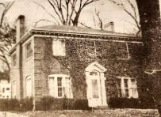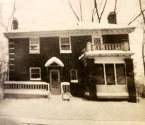

The picture on the left was taken in the 1960s by a realtor when the widowed Alice Allen put the house up for sale to move to an apartment in Wheaton, Illinois. It shows the house “covered with ivy as it had been for years.” The picture on the right is of the back of the house which originally had a “garage under the house which turned out to be a disaster and later closed off,” according to Nancy. The top corner of this original garage can be seen in a later picture from Nancy’s 5th birthday in 1928 with all the family on the back porch. The porch was extended to the end of the house after the remodeling as can be seen in the picture on the right above and a two-car garage was added to the back of the lot. (This “new” garage can be seen in later pictures in the year 1931 with the children playing in the backyard.)

The reason the underground garage was a disaster is that the Hilton and our houses were the culmination of the land that lowered to the lake. There was a hill to the right on Lenox Road coming down to our house and a hill up Linden Avenue coming down to the Hilton House. Whenever a gully-washer rainstorm overflowed the drains at the intersection of the two streets, the basements of both houses flooded, within two steps of the first floor! Dad’s car was in the garage underneath the house and covered with dirty flood water, as was the furnace and everything else in the basement. The first time it happened they got the car running again and cleaned up, but it always smelled musty. The second time they decided to build a ground-level garage and seal off the entry to the basement. Then the two families decided to put in a cement trench between the two houses to direct the rainwater to the street as it came down the hills; it was about 2 ½ feet deep. Dad then had a pump put in the basement to direct any flooding out into the trench. Part of the basement was our play area, so there was a platform built which was about a foot off the floor to attempt to keep our toys dry. Of course, the pump only worked if the electricity didn’t go off!!

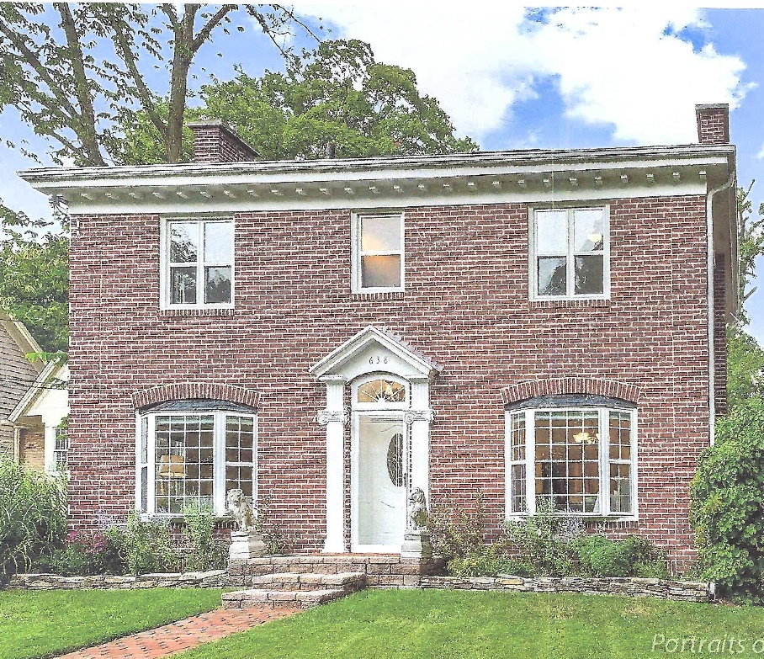

The above picture of the house on Lenox Road, copied from Zillow, was taken before the new façade was added around 2018. The two downstairs windows were made into bay windows many years after the Allens no longer lived there. In 2018 the façade of the whole house was redone to cover up the brick and a porch was added to the front. The picture below was taken by our father’s cousin Muriel Smith Skinkle when she drove by in May of 2020. I believe the owners were in the process of relandscaping.



The following floor plan of the house is based on the detailed description given by Nancy, which follows, and pictures from the internet on Zillow (although Nancy wrote that “after Mother was living in the house alone, she had the kitchen remodeled, tearing out the wall between the kitchen and breakfast room, putting in a dishwasher and new sink. And, of course, had the most up-to-date refrigerator and stove.” Further interior remodeling had also been done by the time the pictures on Zillow were taken). The positioning of the interior doors is purely speculation on my part, as on which side are the stairs in the entry way to the second floor.

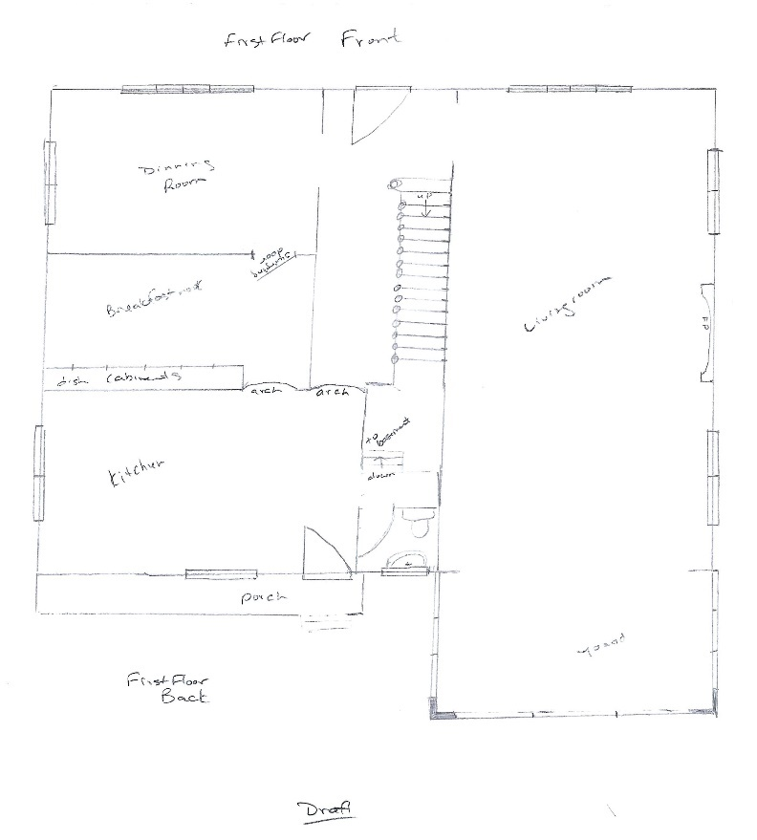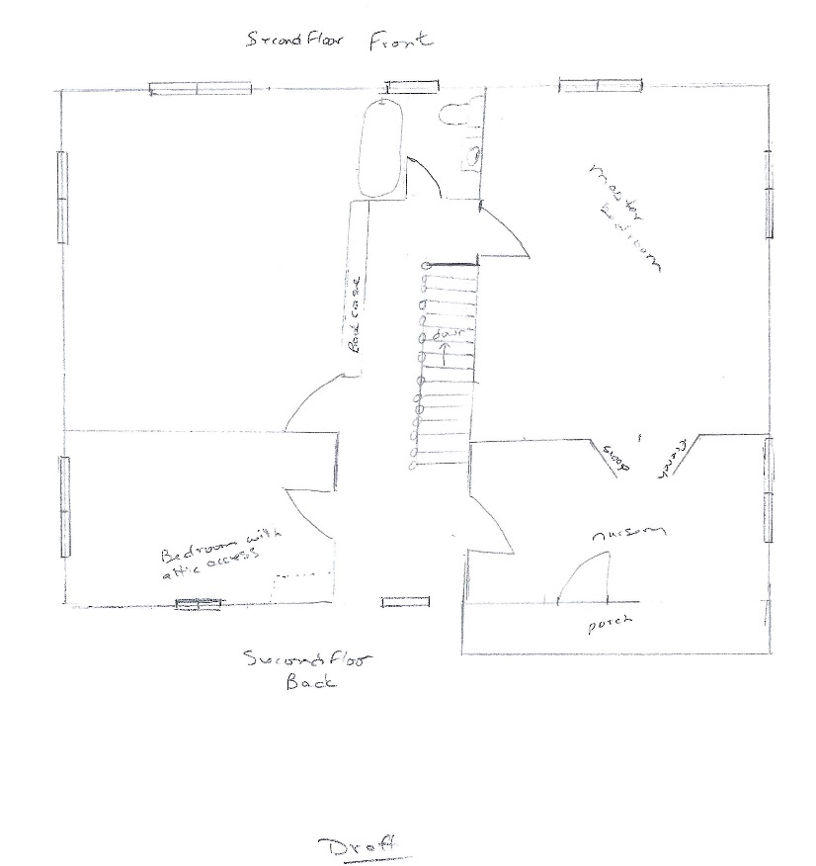

Looking at the back of the house, the door [off the small porch] went into the kitchen. To the right was an archway into the hall that went to the front foyer and front door, and a short hall with the door to the basement stairway on the left and a small lavatory on the right. That is the little oblong window to the right of the kitchen door. The [big] porch was an extension of the living room, screened in with inside awnings which were rolled up when the weather was nice and down and tightly hooked when it was raining. I’m pretty sure there were storm windows put up on the porch, as they were on the rest of the house, during the winter. There was a glass-topped rattan table, three rattan chairs with back and seat cushions, a swing, and a colorful, straw-like rug on the floor. The roof was metal and made a lovely racket when it rained. It had a railing and could have been used as a sun porch, I suppose, but I don’t recall that anyone ever did. The door [on the second floor above the screened-in porch] enters a bedroom which is connected by French doors to the master bedroom. It was used as a nursery when there was a baby in the house. After that it was musical bedrooms; I recall my room was any one of the bedrooms, except Mother and Dad’s, at one time or another.

The back middle window was at the top of the stairs coming up from the front foyer and the other back window was in the bedroom which had access to the attic, a square cut in one corner of the ceiling. You had to get a stepladder and then push up the opening lid and slide it sideways onto the rafters and hoist yourself up off the top of the ladder.

The stairway was enclosed by a railing which matched the handrail coming up the stairs, and along the hall from the top of the stairs to the front of the house was a long built-in bookcase. There was one more large bedroom in the front of the house and a full bathroom between that and the master bedroom.

Looking at the picture of the front of the house, the living room is on the left which extends into the porch; a full dining room is across the front foyer to the right. There was a swinging door from the dining room into a breakfast nook which had dish cupboards along the back wall and just inside the swinging door to the left an archway into the kitchen. With the exception of the bathroom, washroom, kitchen, and basement, all the windows in the house were of the type known as French which meant they were long, opened into the house, with the screen outside, and were locked with bolt-like locks at both the top and bottom of the open edge. For the three panel windows in the front of the living and dining rooms, the center panels did not open. The two-panel windows opened in the middle. And here I must digress, because the locking of those windows when we were all going to be away for the day, like a visit to East Troy, became a ritual for Mother. Why she did not trust the simple putting of the bolt into the metal socket which held it, I will never understand; she must have had her reasons. Anyway, as soon as we were all out of the house, sitting in the car waiting for her, she would take a hammer and go through the whole house pounding on the bolts to make sure they were secure. At any rate, she kept the house safe. As far as I know, no one ever broke in!

The breakfast nook was furnished with a long maplewood table and benches and the kitchen had a gas stove, sink and cupboards. Mother said when they first moved in they had an ice box … which was later adapted to electricity by a unit which attached to the ice box. When the first refrigerators were available in the 1930s … we had one like this one.

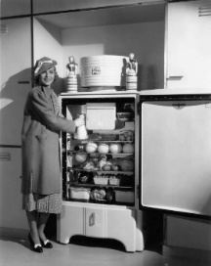
Stock photo of a refrigerator with coils on top

Directly below the coils, inside the box, was a small freezing unit which held two trays for freezing ice. It was not powerful enough to keep ice cream frozen, or to freeze anything other than water, however. Later there was a more modern refrigerator with a freezer compartment.

When we had the refrigerator with the coils on top there was no place to keep ice cream frozen, so if we wanted ice cream for dessert for Sunday dinner, just before we sat down Mother would call Heintz’s [Drug Store] and order a quart and a pint of hand packed vanilla ice cream. By the time we finished eating the doorbell would ring and the [delivery boy] would be at the door delivering the ice cream.

All milk products came in glass bottles and were delivered fresh to the house every day. Each customer had a card which was left in a box outside the kitchen door showing what you needed that day and the milk was put into the box, early in the morning, and then into the ice box or refrigerator as soon as you got up. Before there were electric refrigerators, meat and groceries, as well as dairy products, were delivered to the house every day, because they would easily spoil in boxes cooled with just ice. The “milkman” also delivered cottage cheese, buttermilk, butter, and other products like eggs … Coffee cream came in separate pint bottles, and if Mother had a recipe which called for whipping cream, that was also sold separately.

HISTORICAL NOTE: In 1926 the Pop-Up Toaster was marketed for home use. Nancy would later write in the historical portion of her memoirs, “The Water Genter Company (later called Toastmaster) introduced the first pop-up toaster … Although it cost $12.40, the Toastmaster quickly displaced the manual electric toaster that cost only $1.00." A few years later Shelton would be given the outdated hand-cranked toasters to “tinker with”.

THE CITY OF GLEN ELLYN, ILLINOIS

Glen Ellyn, Illinois, a suburb about 25 miles west of Chicago between two main four-lane highways that went into the city, Roosevelt Road (named after Teddy, not Franklin Delano) south of the town and North Avenue at the opposite end. At the time the population was about 10,000. Main Street went through Glen Ellyn from one highway to the other; the main business section was half-way between the two highways with both railroad lines running through it - the Chicago, Aurora and Elgin electric rail train and the Chicago, Northwestern steam trains - both of which were commuter trains for all the western suburbs. The Chicago, Northwestern lines also ran trains all the way to San Francisco, and on which, by the time I was in high school, ran the first “streamliners” with names like “City of Denver” and “City of San Francisco”. When they were first introduced they would advise the Glen Ellyn station when they would go through our town and people would line up along the roadway which ran beside the rail lines, to watch them whiz by.

Going north on Main Street across North Avenue, Medinah Country Club was about a 20 minute drive away. Going south on Main Street to Roosevelt Road there was what we considered a pretty unique restaurant, shaped like a lighthouse, although it wasn’t anywhere near Lake Michigan, and which served barbeque beef sandwiches, which were a real treat at the time. A little farther south was an Arboretum with bicycle and hiking trails.

We lived on the north side of the railroad tracks and from Lenox Road it was three blocks up the Linden Street hill to Main Street. Hawthorne Grade School was about two blocks on the other side of Main Street. Then left down Main Street past the Presbyterian Church, where Evie was married, about five blocks to the business section of town. To the right, past the telephone company, where Evie worked when she was in high school, there was a two-lane road which went along the tracks about five miles to Wheaton, right past Wheaton College. To the left there was the red brick post office which matched the telephone company building. Both of them were trimmed in white. Then a block of businesses, Heintz’s Drug Store, McChesney and Miller grocery store and meat market, hardware store, bank, then left to the movie theater, a dry goods store, the Chicago, Northwestern railroad station, the Lutheran Church, the Women’s Exchange, the library, and two more blocks to Glenbard High School. Our family doctor’s office, Dr. Hyatt, (later Dr. Pugh) was one flight up over one of the businesses on Main Street. On the south side of the tracks were the Chicago, Aurora and Elgin railroad station, Benjamin Franklin Junior High School, the Methodist Episcopal Church, another drug store and several small shops, hairdressing salons, etc. There was also another elementary school and a Catholic Church with a parochial school through eighth grade. Everything was within walking distance from our house.

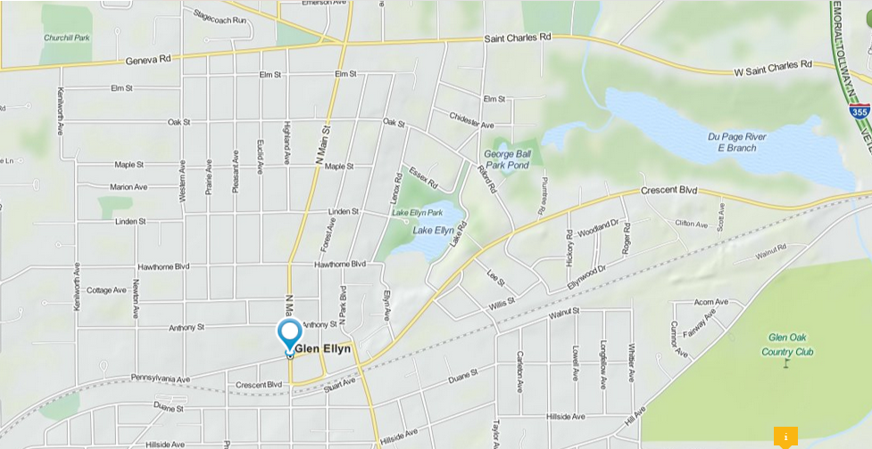
Zoomed-in map of Glen Ellyn showing Lenox Road by Lake Ellyn and the railroad tracks represented by a dotted line towards the bottom of the picture. Chicago is to the right.

Back at Lenox Road - at the immediate south end of Lake Ellyn Park was the Glenbard High School football and track field. Behind the bleachers was one strip of parking spaces for faculty cars - no parking spots for students - in fact, most high school students had no cars of their own. If you ever get a chance, see any of the Mickey Rooney and Judy Garland movies made back in the 1940s in which they played high school kids. His father was a judge named Hardy, and there were scenes about having to get permission to drive the family car if he wanted to go on a date. I forget the name of the series [the Andy Harding series]; Mickey was Andy Hardy, but it was one we all related to when we were that age. Immediately behind the faculty parking lot up a hill was the high school, just 2 ½ blocks from our house. So, even though we were very close to a big city and had advantages such a city could provide, this town was my world and I have always felt very privileged to have lived there.

On the fringes of the town, before getting to North Avenue there were several gravel roads which intersected at Main Street called “Five Corners”. There was a small grocery store, a feed and grain store, a small country lunchroom, I don’t remember what else. These five roads ran past small farms. The years between 1929 and 1940 while I was growing up and attending school were depression years, and farmers were having a rough time because of fallen prices. In the summer months they were able to supply the grocery stores in the area with fresh produce, but the grocers had to be competitive in their pricing in order to make a profit and therefore didn’t offer the farmers adequate money for their produce. The farmers found they could do better by selling directly to their own customers. Some of them would fill a basket with various items and sell them door-to-door. Mother was told about one farmer’s wife, Mrs. Johnson, who had a vegetable stand in front of her house and was accommodating about calling and letting you know just what was in season. Mother became one of her regular customers. She could call Mrs. Johnson at 4:30 o’clock and ask for a dozen ears of corn, for instance, who would go out and pick them fresh for that evening’s dinner. If you have never eaten freshly picked sweet corn, you’ve really missed something!

Although Glen Ellyn was near a big city it was still very much a small town where the fire department tested its whistle every night at 6:00 o’clock. There was a big Fourth of July celebration with a parade which came down Linden Avenue and marched right into Lake Ellyn Park where there was an all day celebration with speeches by the Mayor and other dignitaries from a temporary bandstand decorated with red, white and blue bunting, a picnic, a band concert, games and races, clowns, and fireworks over the lake after dark. We could watch the parade from the top of our driveway on Linden and sit on our front lawn to watch the fireworks. Mother wouldn’t let us participate in the public celebration, but we always had a lot of friends and neighbors, including Mommy and Poppy and Aunt Lil and Uncle Carl [long-time friends of Mommy and Poppy], for a big picnic in our yard.

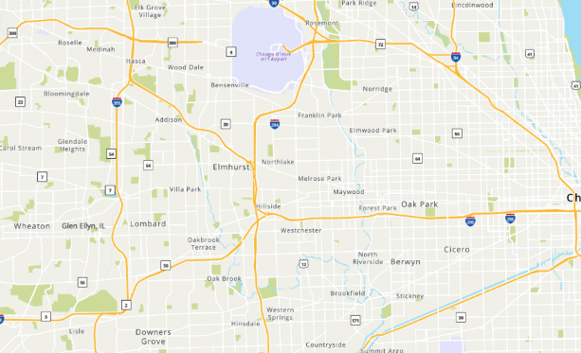
Zoomed-out map showing the “Ch” of Chicago to the right. The road highlighted above Glen Ellyn is North Avenue (Highway 64), the one below is Roosevelt Road (Highway 38). The yellow highlighted area above North Avenue is the location of the Medina Country Club to which both Edward “Poppy” Smith and Lam Allen belonged.

LAKE ELLYN

Directly across the street from the house on Lenox Road was Lake Ellyn. A recreation house was built in 1936 (when Shelton was 11) with a refreshment stand, a jukebox, restrooms, and a place to rent ice skates in the winter when the lake froze over.

In a letter to Shelton in the year 2000 his younger sister Evelyn wrote, “Remember how we tried to ice skate? We had all the opportunities to be pretty good, but we were terrible!”

Nancy recalled that the lake “was a very popular place, but far enough away from the houses near the lake to not be a noise nuisance … directly in front of the recreation house was a fountain commemorating all those in Glen Ellyn who had served or died in World War I. That memorial had been there when Mom and Dad had the house built.”

NOVEMBER 16 – Shelton turned one.
1927

JANUARY 7 - "The first transatlantic telephone call is made, from New York City to London, via radio waves." http://www.fsmitha.com/time/1927.htm

MAY 20 - 18-month old Shelton became a big brother when his mother gave birth, at home of course, to his sister Evelyn Mae. Big sister Nancy, who would turn four that year, later recalled that Evelyn was born “on the very night that Charles Lindbergh was making the first solo flight from the East coast to Paris in a single-engine airplane.”

OCTOBER 6 – With the release of the movie The Jazz Singer, the era of silent film came to an end. https://en.wikipedia.org/wiki/The_Jazz_Singer

NOVEMBER 16 – Shelton turned two.

FALL - The pictures below were taken in the front yard of their house. Nancy later wrote:

And here is little brother, Shelton [2], being babied by sister, Nancy [4].
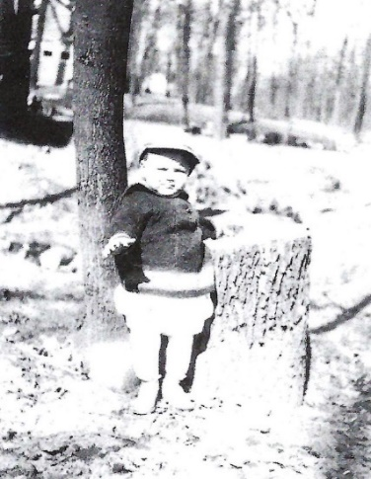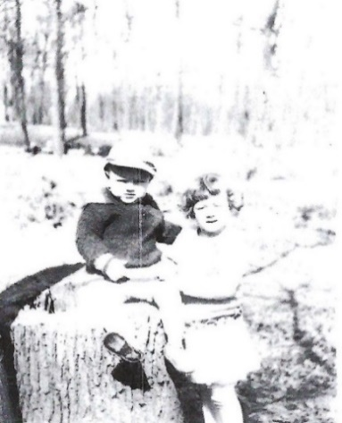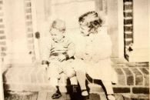

[Although those old pictures aren’t very clear, I would like to point out how remarkably similar baby pictures of Shelton’s son Nathan and Nathan’s son Peter look like baby pictures of their father and grandfather!

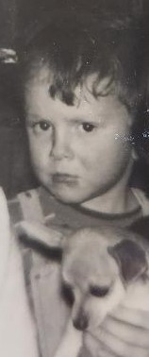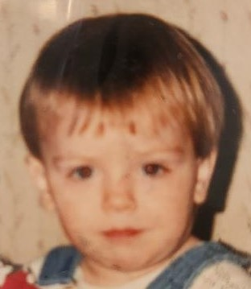
Nathan Allen (Shelton’s son Peter Allen (Shelton’s grandson
January 1967, 2 years and 3 months) December 1990, 2 years and 2 months]

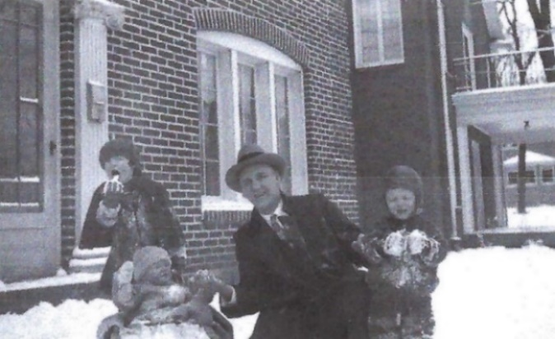
Nancy (4), Evelyn (6 months), Lam (51), Shelton (2)

DECEMBER 30 – In Tokyo Japan the first of the commuter metro lines and the beginning of “their great rail system” was opened with the construction of the Ginza Line. http://www.fsmitha.com/time/1927.htm

1928

JULY - The L.S. Allen family took a trip by car to Florida to visit Lam’s mother Ellen Nancy Pitts Allen who was living in a house he had purchased for her at 2318 23rd Court in Miami. She was 89 years old at the time. Two of the following pictures are from their visit to the Atlantic Ocean during that trip.
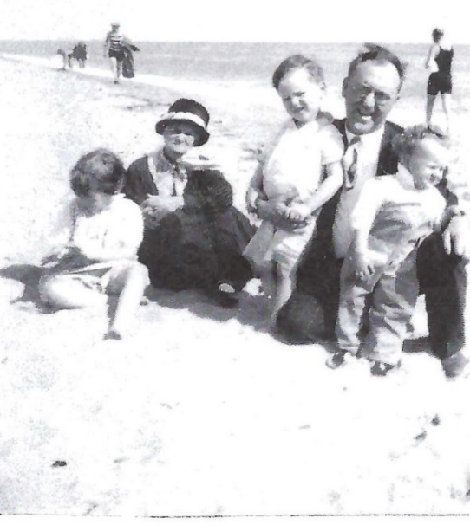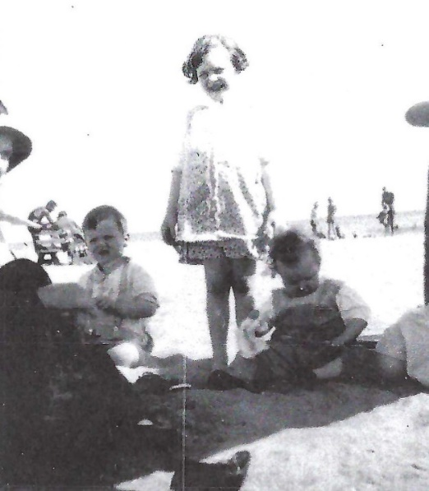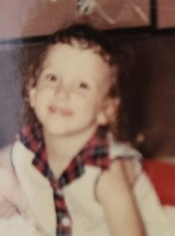

The picture on the left shows Nancy (almost 5), Shelton’s Grandma Allen (89), Shelton (2 years, 8 months) [looking remarkably like Nathan], Lam (51), and Evelyn (14 months). The picture in the middle has just a hint of Shelton’s Grandma Allen, Shelton, Nancy [looking remarkably like Keren], and Evelyn. The picture on the right is of Keren, Shelton’s daughter, at four years and about two months old in 1962.

Of the two beach pictures Nancy wrote:

Please note the bathing suit on the man behind Daddy. Obviously we didn’t go swimming, and Daddy had on a suit and tie!

My only memory of that trip was being in the car driving back from the beach. We were each given a tangerine, which we had never had before, and I can still see baby Evelyn sitting on Grandma Allen’s lap with her nose stuck in that tangerine. [Infant car seats weren’t required let alone heard of until many years later.]

AUGUST 12 - The picture below, taken on the back porch of the family home on Nancy’s fifth birthday, includes some of the family closest to Shelton as he was growing up.

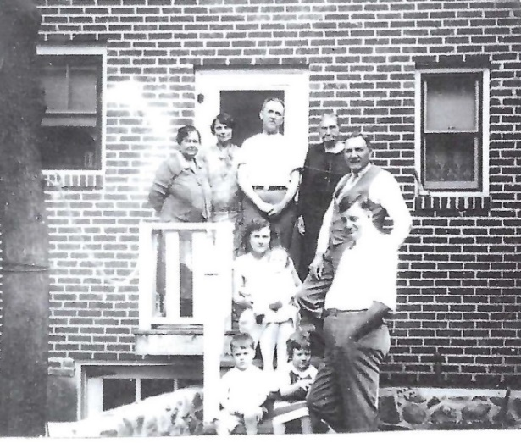
In this picture to the bottom left can be seen the top corner of the original underground garage which Nancy wrote “turned out to be a disaster”.

Nancy labeled the people in the above picture, back row from left to right, as Shelton’s Grandmother Smith (56) who they called “Mommy”, a friend of Mommy and Poppy Smith from when their daughter Alice (Shelton’s mother) was a young girl “Aunt” Lil Duncan, Shelton’s father Lam (51), his Great-Grandmother Winckler (82), his Grandfather Smith (56) who they called “Poppy”, and “Uncle” Carl Duncan. Shelton’s mother Alice (28) is sitting with (barely visible) baby Evelyn (15 months) on her lap. Shelton (2 years, 9 months) and Nancy (5) are on the bottom step.

Mommy and Poppy were an integral part of our lives, literally on a weekly basis, spending most Sundays together and all holidays, Thanksgiving, Christmas, Easter, even the fourth of July!

NOVEMBER 16 – Shelton turned three.

1929

MARCH 4 - Herbert Hoover was sworn in as the 31st President of the United States.

SOME TIME THIS YEAR - Shelton’s aunt, a sister of his father, Esther Virginia Allen Carter (Aunt Genna) moved in with the family as their nanny. Nancy recalled the circumstances that led to this happy event.

One of my earliest recollections happened when Evelyn was not quite two years old. Mother and Daddy were out of town and “Huffy”, the nurse who had attended Mother when each of us was born, had been hired to care for us. We were eating our lunch; I was sitting at the breakfast room table and a small table with two small chairs had been put in the doorway leading into the dining room where Shelton and Evelyn were sitting. I could see over their heads and saw Mommy and Poppy drive up in front of the house. I jumped up to go greet them, with the two younger ones getting ready to follow me when Huffy stopped us and made us go back to the tables to finish our lunch. Huffy let Grandma and Grandpa in the front door to three crying children, told them they could sit in the dining room and talk with us but we couldn’t leave our chairs until we finished eating. In recalling this incident with Mother years later, she told me that Grandpa was furious at the time, but held his cool until Mother and Daddy got home when he voiced his anger saying, “No one was going to tell him when he could hug his grandchildren!” And Huffy, when questioned, said she resented having the grandparents coming by to check up on her (which was not what they were doing) when she was in charge of us. And so that was the last we ever saw of Huffy! Shortly after that Aunt Genna came to live with us as our Nanny, our dear Aunt Genna.

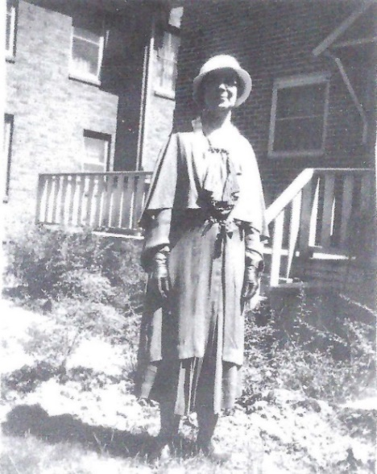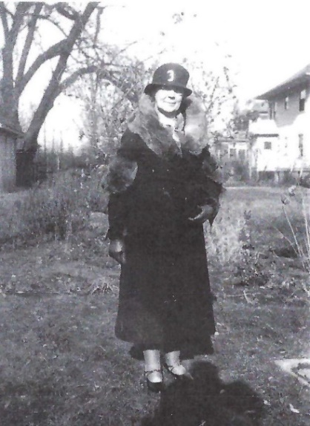
Aunt Genna in summer. Aunt Genna in winter.

Esther Virginia Allen Carter was the fifth daughter of Robert A. and Ellen Nancy Pitts Allen, the next oldest to my Father, their only son. She was living with her Mother and the youngest sister, Mabel, in Miami, Florida, when our family went to visit them [in 1928]. Shortly after that, when Evelyn was between two and three years old, she came to live with us as our Nanny, our dear Aunt Genna. Mother and Dad liked to travel, and even when they were home, Mother was very involved with church activities, the Glen Ellyn Women’s Club, a bridge club or two, and various functions at both Medinah Country and Athletic clubs. Besides being a member of the family, Aunt Genna was paid a salary and had one day a week off which she used to write letters to her sons, her Mother and Aunt Mabel, to wash her long hair which she wore in a rolled-up braid at the nape of her neck, and in the evening to go to the movies. I remember her favorite actor was Robert Montgomery [The father of Elizabeth Montgomery who played Samantha on the original Bewitched series.]. I think her day off every week was Thursday, which meant that was the day that Mother was home when we got home from school, usually sewing and fixing dinner. Aunt Genna didn’t drive, so either Mother or Dad took her to the theater; sometimes I went with her.

Until I was 13 years old I suffered with terrible headaches which, more likely than not, developed into a sick stomach or what the doctor called bilious attacks. I would get so sick I would have to be put to bed. This would happen every month or so and when one hit Aunt Genna would put everything aside and sit beside the bed, putting cold cloths on my head, running back and forth to the bathroom with me, and when my stomach finally calmed down bringing me some beef cubes dissolved in hot water (called beef tea) and feeding me a few teaspoons at a time until I fell asleep. Meanwhile, Mother would take care of dinner and the dishes and putting Shelton and Evelyn to bed, and to calm herself because of concern about me, would sit down at the piano and play the two pieces she had memorized from her piano lessons, "Whispering Hope” and “The Old Rugged Cross”.

[Esther Virginia “Genna” Allen Carter was born on 29 August 1873, so when she came to live with her brother and his family in 1929 or 1930 when Evelyn was two or three she would have been about 56. She is listed twice in the 1930 U.S. Census, in Glen Ellyn with her brother and his family and also in Homestead, Florida with her husband and her thirty-six-year-old son Allen. Her husband Will Carter was a preacher, but, according to Nancy, did not have a church and “wasn’t earning much and wanted to turn his house into a boarding house … Aunt Genna became disgruntled with her role as boarding housekeeper and Will’s inability to earn a living and divorced him, which was practically unheard of in the early 1900s.” Whether they were actually divorced or simply separated for the remainder of their lives, in the 1930 Census they both claimed to be married. Will died in 1939 but Genna still claimed to be married in the 1940 Census. By the 1950 Census she claimed widowhood.]

THE EXCHANGE OF COUSINS

A picture below which shows only Cousin Charles Smith and none of his sisters in Glen Ellyn for Nancy’s sixth birthday party leads me to believe that it was most likely this summer, when Shelton and Charles were three years and nine months old, that they became a part of the “exchange of cousins” that had been started when Nancy began school. Shelton and Charles (who was only 5 days younger than Shelton) began to spend one week every summer at each other’s houses, Charles one week in Glen Ellyn with Shelton and Shelton one week in East Troy with Charles. Nancy’s “corresponding cousin” was Alice Smith, who was five months younger. Later Evelyn (named after her Aunt Evelyn Gifford Smith) and Uncle Ed and Aunt Evelyn’s third child Dolores (14 months younger than Evelyn) also participated in the “exchange of cousins”. Nancy recalled, “In later years when we were together, reminiscing about our young years, invariably we would say that the favorite part of our summers were the weeks we spent in East Troy, and they always said, ‘No, the best part of the summers were the weeks they spent with us and “Aunty Alice” in Glen Ellyn.’”

NANCY’S MEMORIES OF EAST TROY, WISCONSIN

Uncle Ed was the only veterinarian in the East Troy area and was always on call so most family gatherings were up there except for some holidays. He and his family also spent some holidays with the Giffords [Aunt Evelyn’s family], so our family was not always part of those, and the Giffords were rarely, if ever, part of our family celebrations if the Smiths were going to share them at our house.

East Troy was typical of most midwestern small towns with the possible exception of the fact that they blew the fire station whistle twice a day at noon as well as at 6 o’clock in the evening. Although the primary blowing of the whistle was to test that equipment was in top shape, the town seemed to have adapted their daily living to them. There was a small grist mill [for grinding grain into flour] in town so the noon whistle meant it was time to stop work and open the lunch pails, school kids all went home to lunch when the whistle blew. At the 6 o’clock whistle, stores closed and families all sat down to dinner together. Those daily whistles only blew once - any more meant a fire, and suddenly the streets would be awake with cars carrying volunteer firemen answering the call, and curious townspeople following the engines for some unexpected excitement!

The center of the town was a big square with a park in the middle. In the center of the park was a bandstand. In the summer months there was a concert in the bandstand every Wednesday evening by the high school band and any former band members who happened to be in town. Around the park were marked angle parking spaces where farming families who had come into town to shop could listen to the concert, honking their horns to show their appreciation.

One corner of the square had a gas station and car repair garage next to the two-lane highway heading up the 30 miles to Milwaukee. Around the square were the grocery store, a feed store, a small dress shop, a hardware store, several others including a drug store with a soda fountain and a small building which had been converted into a movie theater furnished with folding metal chairs instead of upholstered seats. The town schools were just a couple of blocks from the center of town. There were churches of many Protestant denominations and a little way outside of town a good sized Catholic church with a parochial school through eight grades.

There was a lake within bicycle-riding distance - Booth Lake - with bath houses where you could change into your suit and lifeguards to watch over the swimmers. I seem to remember a refreshment stand, but we would either take our sandwich with us or, more usually, just bicycle back home for lunch.

There was a stream running near the grist mill where we would sometimes go for picnics, but in order to get to it we had to cross a cow pasture so had to look out for “cow pads” and the master of the herd - the bull! Charles and Shelton would occasionally fish in the stream.

If we were in East Troy on the 4th of July we got to participate in Uncle Ed’s fireworks display. He would send away for a huge variety of Roman candles, sparklers, rockets and other noise makers which would be shipped to him in a big wooden box. Although the town of East Troy put on a modest evening fireworks display down at Booth Lake every year, most of the neighborhood kids around Uncle Ed’s house had more fun participating in shooting off his collection. There were no legal restrictions against personal fireworks at that time, but Uncle Ed was very strict about who got to shoot off what, and surprisingly there weren’t any injuries, at least at the times when I was there to be a part of it.

Part of the East Troy memories include the Gifford farm in Genoa City, just three miles over the border between Illinois and Wisconsin.

Charles and Della Gifford were Uncle Edward Smith’s father-in-law and mother-in-law. They had five girls and no boys: Edna, born in 1900; Evelyn, who married Uncle Ed, born in 1903; the twins Mariette and Nellie, born in 1905; and Della, born in 1910.

Here are the only pictures I could find of Grandpa and Grandma Gifford:

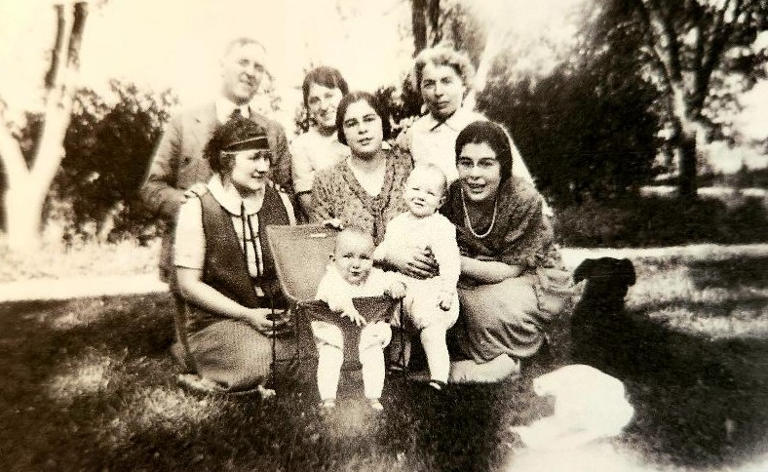

Back row left to right: Lam Allen, 47; Evelyn Gifford Smith, 21; “Grandma” Della Gifford, 47. Middle row left to right: Alice Allen, 24; the twins Mariette and Nellie, 19, holding Nancy Allen, about one. The baby in the seat is Edward and Evelyn Smith’s daughter Alice, about 7 months old (although she was our father’s cousin, we would come to know her as “Auntie Alley”).

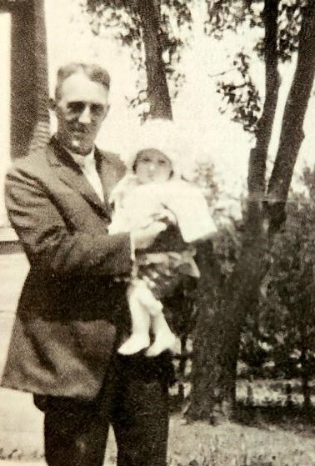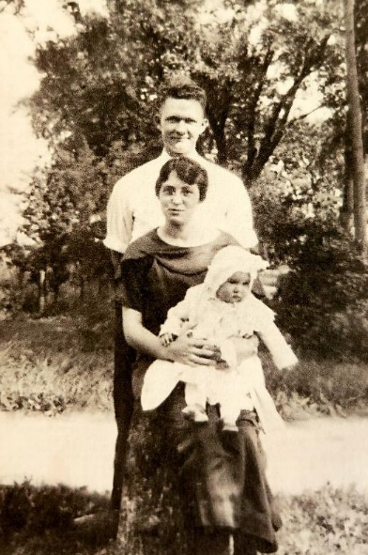
“Grandpa” Charles Gifford, 49, with Alice Edward Smith, 26, Evelyn Gifford Smith, 21, Alice, about 7 months

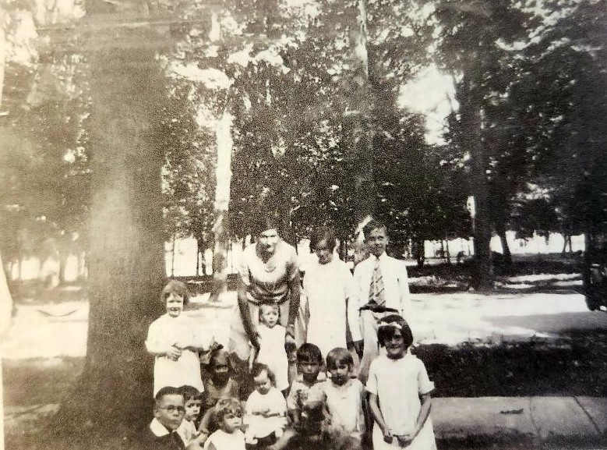

AUGUST 12 - This picture was taken in Glen Ellyn at Nancy’s 6th birthday party. She is standing in front of the big tree; Shelton (3 years, 9 months) is sitting in front of her with Cousin Charles Smith (3 years, 9 months) in front of him. Evelyn (2 years, 3 months) is the little girl in the white dress sitting looking at her hands. The others are neighborhood kids and older ones who came to help keep the young ones under control.

OCTOBER 29 – The New York Stock Market crashed - later known as Black Thursday and the beginning of the Great Depression which would last for ten years.

NOVEMBER 16 – Shelton turned four.

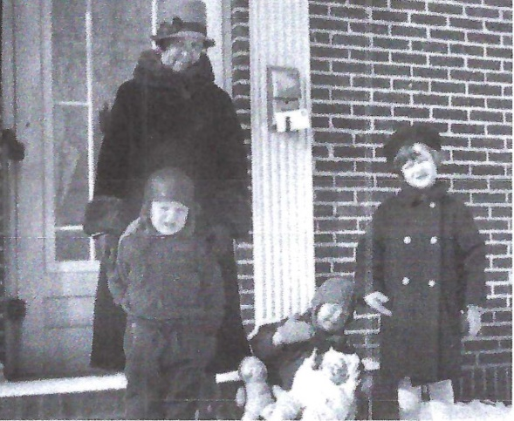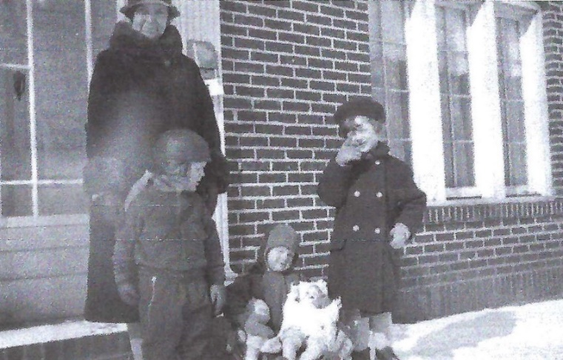
Aunt Genna (56), Shelton (4), Evelyn (2 ½), Nancy (6)

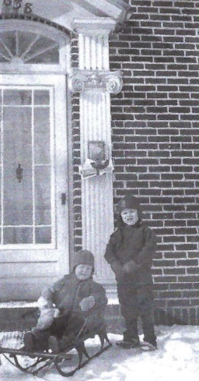
Evelyn and Shelton

1930

SHELTON’S SCHOOL YEARS

APRIL 21 – The U.S. Census recorded Lambeth S. Allen (head, 53, owner of mail advertising company), Alice J. Allen (30, wife), Nancy E. Allen (6, daughter), Lambeth S. Allen (4, son), Evelyn M. Allen (2, daughter), and Virginia Carter (55, sister) living at 638 Lenox Road in the village of Glen Ellyn, DuPage, Illinois (24 miles west of the city of Chicago). Their house was valued at $18,000. That same house sold for $680,000 in 2018.

SEPTEMBER 8 - Scotch Tape was first introduced: "3M sent its first roll of cellophane tape to a prospective client, who enthusiastically endorsed it." https://www.acs.org/content/acs/en/education/whatischemistry/landmarks/scotchtape Scotch tape, not just any old cellophane tape, was something Shelton always would have on hand later in his life, even when it was difficult to come by when he was a missionary in Okinawa.

FALL - Shelton started kindergarten.

That was before the time when kindergarten was part of the public school system in Glen Ellyn. It was a private school and also offered a first grade. Shelton and I went to only the kindergarten in that school, then started first grade at Hawthorne Elementary School.

Shelton was left handed, and quite proud of this fact. If he or his parents had not realized his left handedness before he started school, they certainly would have when he began to learn to write.

NOVEMBER 16 – Shelton turned five.

Before either Shelton or Evelyn could read we would get up early on Sunday morning and I would read the Chicago Tribune funny papers to them before Mother and Daddy got up. One of their favorites was a cartoon about a fireman named “Smokey Stover” who used the word “Phooey” when things did not go his way. One time Mother and Daddy were just about to leave for the evening and Shelton was in the living room concentrating so hard on one of his Erector Set inventions, he didn’t hear Aunt Genna call us to dinner. When she called him the second time, Daddy was putting on his overcoat in the front foyer and heard Shelton say “Phooey” when he had to turn off the motor and leave his toy. Daddy, who never spanked us, grabbed him by the arm and started paddling him all the way up the stairs through his corduroy knickers, saying, “I don’t want to ever hear you say that word in this house again!” We were all shocked to hear Daddy shouting at Shelton, and Shelton was so surprised that Daddy would spank him, even though it didn’t hurt, that he never forgot that reprimand or said the word “Phooey” again, at least where Daddy might hear him!

SOME OF NANCY’S MEMORIES ABOUT MEDINAH COUNTRY CLUB (a members-only club to which both Lam Allen and Edward Smith belonged)

Christmas for young children at Medinah Country Club was held on a Saturday afternoon in the ballroom. Most of the children sat on the floor in front of the stage, the parents in the back of the room … The entertainment was a puppet show, then Santa came in and gave each kid a bag of hard candy then we went home.

After I started school there wasn’t much to interest me at Medinah Country Club. Up until Poppy died in 1934 we did continue to go there on occasion for dinner … in order to get on the grounds you had to stop at the gate and give your member number to the guard; Daddy’s was A-100. And just inside the gate there was a fenced in pen where they kept a brown bear. Why it was there I have no idea, but when I was little we always had to stop and look at the bear, after being warned not to get too close. Some years later I heard that a little boy had put his hand through the fence and the bear caught and mangled his arm. After that they got rid of the bear.

1931

This year, Shirley Temple began her acting career. "She was just 3 years old when she was discovered at her dance school by producers from Educational Films." https://www.biography.com/news/shirley-temple-biography-facts

MARCH 3 - The Star-Spangled Banner became the national anthem. https://www.infoplease.com/history/us/us-history-progressive-era-and-world-wars-1900-1949

SUMMER - That summer after Shelton finished kindergarten was the first of many years of summer vacations from school. Children have always been creative and imaginative and in those days, before even television was available to entertain, much of their time was spent playing games indoors and out. The Allen’s backyard had swings, a slide, a sandbox, and a swimming pool and so was an attraction for other children in the neighborhood too.

One of the games Nancy recalled playing, which was still a popular game for elementary students at least into the 1960s and early 1970s, was Jacks.

[Jacks] could be played while sitting on the sidewalk or while standing next to a table … It was played by throwing a handful of the metal Jacks on the table, I think there 12, then bouncing a small rubber ball while picking up one Jack with each bounce, then two each time, then three on up until the last bounce you had to pick up all 12. Then there were variations like each time you tossed the ball you had to pick up the Jack(s) and circle the ball with your hand before catching it.

There were other forms of entertainment which seemed to have been more specific to Shelton and not his sisters.

His favorite toys were Tinker Toys and later Erector Sets which were metal pieces which could be put together to be all kinds of toys like ferris wheels and were connected to motors which made them operable. He would get so engrossed watching them work, he would hold his hands in front of his face and wriggle his fingers together while moving his lips. Mother and Daddy watched him repeatedly doing this with some concern, wondering if he had some mental disorder. When they finally asked him what was going through his head while he was doing this, he told them he was making up stories about what the people were saying or doing when they were riding or driving whatever he had made and our parents realized he just had an extremely active imagination.
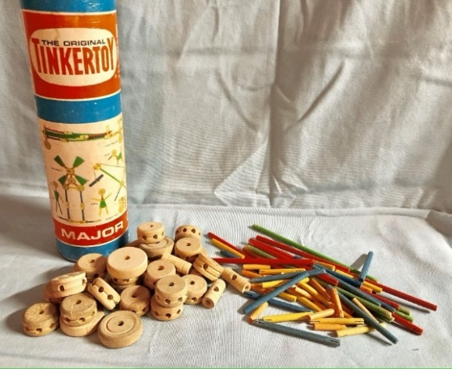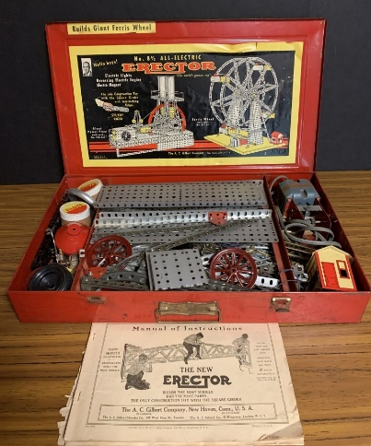

Although televisions weren’t in homes in those days, there were movies in theaters, as Nancy recalled:

We also liked to go to the Saturday afternoon children’s matinees at the local movie theater. (It cost only 10 cents). There were usually two feature films, (Cowboys and Indians, Charlie Chan mysteries and the like), a short comedy like Laurel and Hardy, Our Gang or the Three Stooges (I never liked that one much) and a cartoon. Sometimes there would be an episode of a serial movie where they would leave the hero or heroine in some terrible danger and you had to go back the next week to see how they got out of it during the next episode. Those movies and stories became part of our play time with all the neighborhood kids. Our favorite one to act out was called Rocky Mountain Mystery … We also played hide-and-seek, kick-the-can, Simon says, among other backyard games, but acting out the movies was the most fun and creative.

We went to the Saturday matinees for kids when we were in grade school, and selected other movies like those made by Shirley Temple … One or two features ran Sunday through Tuesday, Wednesday through Saturday evening, and cost about 25 or 30 cents.

[There were] Wednesday night giveaways of dishes or glassware and Saturday night “Bank Nights”. Half of your admission ticket was put into a rotating metal basket. Between the two features there would be a drawing for a piece or two of glassware or five or ten dollars in cash.

We would sometimes go to the movies at the theater in Wheaton which was a little larger and more fancy than the one in Glen Ellyn, and they also had similar giveaway nights. Evie says she remembers she always hoped that she would win a bicycle at one of the drawings in Wheaton and was reprimanded by Shelton who told her Daddy could get her one of the Manton and Smith “Bike-Lock" bicycles which he told her were better than the ones being given away, but she still longed to win one at the theater. (She never did!)

[Manton and Smith was co-founded by their grandfather Edward “Poppy” Smith. Originally the company did decorative wrought-iron work including the original work on Buckingham Fountain in Chicago’s Grant Park, on the famous Chicago Theater on the Loop, and on the facades of many of the buildings along Michigan Ave.]

There was also swimming to entertain and cool off during the hot summer months.

The nearest public swimming pool was in Naperville, 25 or so miles away, and Mother took us there several times during the summer. It was built in an old stone quarry with sand at one end with the water getting gradually deeper to the diving end. There was a rope across which separated the shallow from the deep water … The picnic part was fun … Mother usually made our favorite ham salad sandwiches which I still occasionally whip up in the food processor - much easier than the hand-cranked grinder, clamped on the kitchen counter, which Mother used to mix together the ham, sweet pickles and hard-boiled eggs.


A Hand-cranked Countertop Meat Grinder

Since that pool was so far away, and plastic backyard pools were not yet a reality, Mother had a wooden wading pool, maybe two feet deep, built for us behind the garage. Because the water wasn’t chlorinated, it had a plug in the bottom and the pool was drained every time it was used, rinsed out with a hose and covered with a tarp, then refilled the next time we wanted to use it. Kind of a nuisance, but really helped to keep us cool, for a while anyway, on those hot, muggy summer days [before air conditioning].

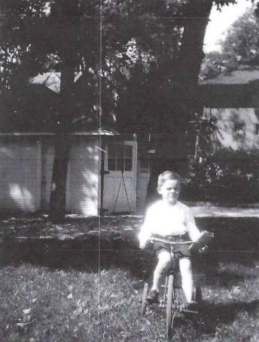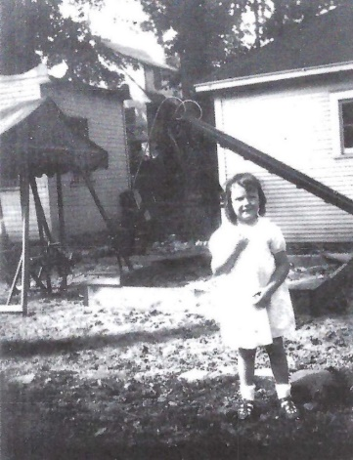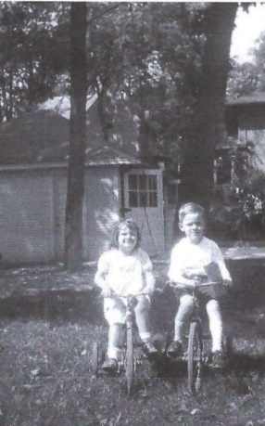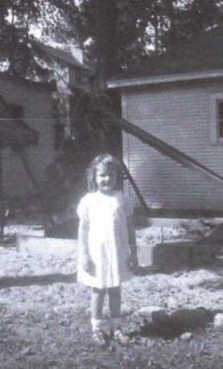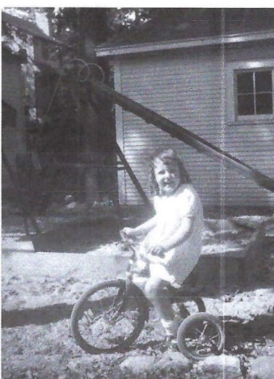
Shelton and Evelyn in the backyard playground on Lenox Road. The “new” two-car garage can be seen in the background. Nancy wrote, “During the summer months our yard was the gathering place for all the neighborhood children because we had such a nice playground.”

There was a rope swing in the backyard where I could soar high in the air while making up stories. There was also a two-seated glider that was great for reading, and there was always a swing or glider on the back porch where I could swing and read, or swing and daydream or make up stories while listening to the rain on the metal roof.

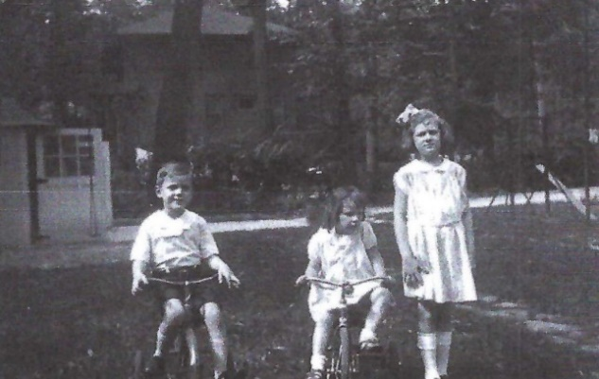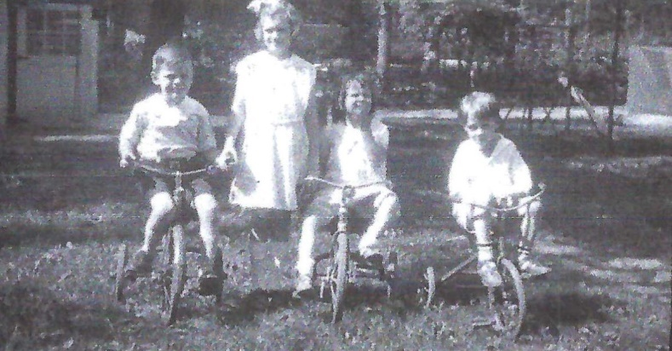
Shelton (5 ½), Evelyn (4), Nancy (8), and Howard Hinton (5, the neighbor boy)

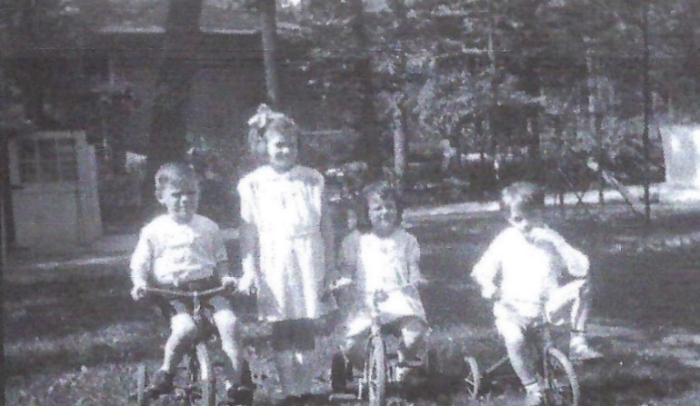

Seeing the pictures above brought up the following memories for Nancy about Aunt Genna:

She had four sons and no daughters, so Evelyn and I became like daughters to her, although she was about the same age as Mommy and Poppy. She took special pride in washing and curling Evelyn’s hair.

On a day like the picture [above] Evelyn was in the back yard, recently bathed and newly curled when Howard, the little boy next door, came over to play, and in a pique over something threw sand in her hair. She ran screaming to Aunt Genna, who came out, and showing the only example of anger we ever saw in her, virtually threw him into his own yard. At all other times we remember her as being the gentlest and most patient of souls, who was always there for us, had a treat waiting for us when we got home from school, helped with our music and school lessons, played the piano and sang some of the old songs she remembered from her childhood like “Way Down on the Swanee River”, “My Old Kentucky Home”, and my favorites, “Darling Clementine!” and “Oh! Suzannahl”

“Oh! Suzannah!”
Oh, I come from Alabama with a banjo on my knee.
I’m gwin’ to Louisiana, my true love for to see.
Oh, Suzannah! Don’t you cry for me.
For I come from Alabama with a banjo on my knee!

“Darlin’ Clementine!”
In a cavern, in a canyon, excavating for a mine
Lived a miner, forty-niner, and his daughter, Clementine.
Hit her foot against a splinter; fell into the foamy brine!
Oh, my darlin’, Oh, my darlin’, Oh, my darlin’ Clementine!
You are lost and gone forever. Dreadful sorry, Clementine!

[According to the website BalladofAmerica.org "’Oh! Susanna’ was the first huge hit song in American popular music. Stephen Foster … was only 21 years old when he composed it in 1848 … As "Oh! Susanna" was beloved by ‘49ers during the California gold rush and others heading west during the mid-nineteenth century, the song became emblematic of Westward Expansion.”

According to the website songfacts.com "‘Oh My Darling, Clementine’ is a popular American Western folk ballad [the origins of which] lie in an 1863 tune by H.S. Thompson called ‘Down By the River Liv'd a Maiden.’ Like ‘Clementine,’ the song is a mock-serious ode to the narrator's deceased lover, who drowned after she stubbed her toe and fell in the river.”]

There were also summer visits to Fox Lake, Illinois where Uncle Carl and Aunt Lil had a fishing cabin.

This was directly north of Glen Ellyn and about 30 miles from the Wisconsin border. Aunt Lil’s sister (Cora) and brother-in-law owned the one next door. You drove down a narrow paved street with tiny cottages on both sides, their fronts almost right up to the street. You can see from the picture of Aunt Lil, Mommy and Cora [below] how close together the houses were. Inside there was a small living room, one bedroom with a tiny bathroom and shower, small kitchen and a little, screened back porch just big enough to hold a table where they ate. The lake was almost right at their back door with a small dock to which Uncle Carl’s fishing boat was tied. The boat had a motor and he would take us for rides which I liked. What I didn’t like was that he would try to show us how to fish which meant we were supposed to put wiggly worms on the hooks, and if we happened to be what he called “lucky” we would catch a catfish which I thought were ugly. Once I remember Uncle Carl had caught a bunch of them before we came up there and they fried some of them for our lunch. I wasn’t impressed! Of course we were all terribly spoiled. The butcher in town (Mr. Miller of McChesney (the grocer) and Miller in Glen Ellyn) always got a fresh supply of what Mother called “white fish” on Fridays. (This was back when it was the rule for Catholics that they could eat no meat, only fish, on Fridays.) So we frequently had fish on Friday. It wasn’t my favorite meal, but sprinkled with parsley and served with lemon wedges, it was a far cry from catfish! If I recall correctly, Daddy wasn’t much interested in fishing; I certainly wasn’t, and neither was Shelton.

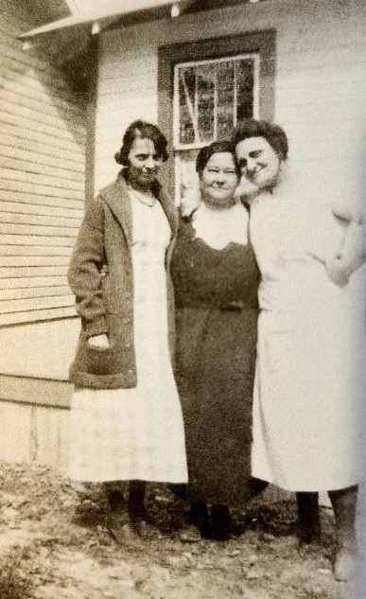
Aunt Lil, Mommy and Cora Yeldham at their cottages on Fox Lake, Illinois

FALL - Shelton started first grade at Hawthorne Elementary School.

The first eight grades were divided into three buildings. Hawthorne Elementary School had two buildings, one of only one floor for the first and second grades and the other for third and fourth grades on the first floor and fifth and sixth grades on the upper floor. It was within walking distance, but I’m pretty sure Mother drove [us] there and back for at least the first year. [We] usually went home for lunch.

Shelton was a born teacher, and he loved teaching things to his little sister, Evelyn. By the time she was old enough for kindergarten he had already taught her everything he learned, and they put her in the private first grade when she was only 5; so she started public school in the second grade.

We didn’t have homework through sixth grade, and [our] evenings were spent listening to the radio with Mother and Dad … Some of our favorite radio shows were Amos and Andy, a serial “soap opera”, One Man’s Family, The Shadow, Fred Allen, Jack Benny, Edgar Bergen and his dummy, Charlie McCarthy, Burns and Allen, Fibber Magee and Molly.

Beginning with first grade a representative from the Dupage County Bank in Glen Ellyn visited our school once a month for "Bank Day”. We each had a little book in which our deposits were entered and added to the total. It was all part of our arithmetic lessons; you could bring whatever amount you wanted to deposit, but it seems to me no one ever brought more than 10 cents. As the depression deepened, however, that little bank fell victim to the bad times and closed. The man who usually came every month to collect the money and enter the amounts, along with any interest, in our books came to tell us that there wouldn’t be any more bank days and that we wouldn’t be able to get back the money we had put into our accounts! I had probably only two or three dollars in my account by the time this happened, and Daddy did his best, but try to explain that to an eight year old!

[The FDIC (Federal Deposit Insurance Corporation) wasn’t founded until 1933 to protect deposits in banking institutions.]

MORE OF NANCY’S MEMORIES ABOUT THE GREAT DEPRESSION

One of the many tragedies of the depression was that thousands of men were thrown out of work and many were forced to leave their homes and families in a desperate effort to find any kind of work. They had no travel money so “riding the rails” became a way of getting around the country … These freight train “hobos”, as they were called, would jump off the moving trains in the suburbs outside the city and beg for odd jobs and food. Mother and Aunt Genna never turned anyone away and frequently there would be some stranger sitting on the steps of our back porch eating a sandwich and a bowl of soup, drinking a glass of milk or cup of coffee, and leaving the house with an apple or an orange or maybe a fresh-baked cookie. We weren’t allowed to go out to talk to them, but sometimes we would stand by the kitchen door and they would tell us about their children they had left back home, often with tears in their eyes …

There was a continuing rumor during the depression that the hobos who rode the trains had a secret code which they passed to one another to indicate which of the Chicago suburbs were the best places to find odd jobs or food handouts. Some of these indications were also said to be carvings on trees or fences leading lo particularly generous neighborhoods or individual houses, but Shelton and I tried from time to time, usually after one had been seen eating on our back porch, but never could locate anything we thought was suspicious. I have read this rumor repeated in many articles written about the depression over the years, however.

NOVEMBER 16 – Shelton turned six.

1932

NANCY’S MEMORIES OF A NEIGHBOR’S DOG ATTACKING LITTLE SISTER EVELYN.

At the time Shelton had Kermit [Kelly] as a playmate, Evelyn played with the two little girls who lived in the house to the south of us … About the time she started school she was a contemporary of the young Shirley Temple. She had a Shirley Temple doll and wore Shirley Temple dresses patterned after the ones Shirley wore in her movies. But in spite of her long finger curls and Shirley Temple dresses, Evelyn was a bit of a tomboy, and very often liked to follow Shelton and play with the boys. One afternoon I was practicing on the piano, Aunt Genna was in the kitchen and we heard screams from the backyard. At first we thought it was just the usual noise from the backyard until it became so loud Aunt Genna called me and we went out to see Evelyn running, screaming toward the house, her dress ripped and one arm bleeding. Shelton came running after her yelling that she had been bitten by the chow dog from across Linden Avenue.

Aunt Genna called Mother who was at a bridge party only a few blocks away who told her to call the doctor. She was then so busy trying to calm down Evelyn that I called the doctor and he told me to cover her arm with gauze and he would be right there. I knew Mother always kept cotton and gauze in a bureau drawer, and by the time I had gotten some cut to cover the wounds both Mother and the doctor had arrived. Evelyn was screaming not only in pain, but when the doctor arrived he cut off her Shirley Temple dress to get to the shoulder wounds!

The dog belonged to the Reinhardts who lived across the street. The children were noisily riding their bicycles and tricycles on the sidewalk up and down our side of the street. Somehow the chow dog had gotten out of the fenced yard and came charging after the children. They were frightened and started to run. Evelyn was the smallest and the dog knocked her down and was biting her on one arm and a shoulder close to her throat.

By this time Mr. Rheinhardt had caught and penned the dog and came to our back door. He came in to explain to the doctor and all of us that he just happened to be doing some work at home that day, (he was a lawyer whose office was in Chicago). He heard the children screaming, looked out the window to see what was happening, ran out and grabbed his dog by the tail and threw him out into the street so that Evelyn could get up and run home.

She had to take rabies shots. I don’t really remember, but I think the Rheinhardts got rid of the dog. The wounds healed, of course, and Evelyn was pacified when Mother was able to find the same Shirley Temple dress which had been cut up, but she still has the scars, and is frightened of big dogs to this day. A terrifying experience!

Another event involving Shelton, although not potentially life-threatening to Evelyn, but which did affect her:

One “Shelton” story was about Evelyn’s “Teddy” bear … Mother had bought a tanning machine which she kept in her bedroom to help her get a tan during the winter months. One day when she was out Shelton had convinced Evelyn that if she would cut off some of the teddy bear’s hair they could put it under the tanning machine and the hair would grow back in. When Mother came home, there they were, sitting beside the tanner, patiently watching the bear lying under the lights. When Mother turned off the machine and explained to them both how completely impossible that was, Evelyn realized for the first time that Shelton was not infallible; she had always believed every word he told her!

FALL - Shelton started second grade at Hawthorne Elementary School.

NOVEMBER 16 – Shelton turned seven.

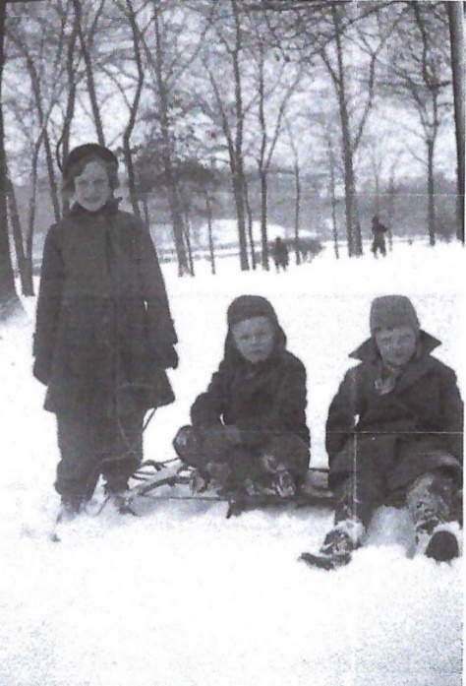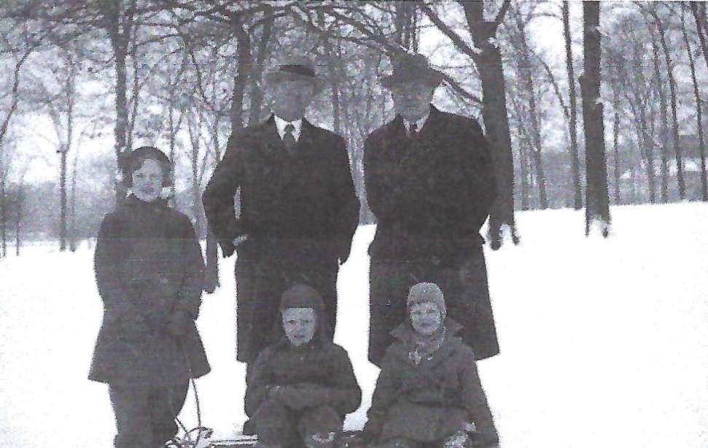
Nancy (9), Shelton (7), Evelyn (5 ½), Lam (56), Poppy (60)

1933

MARCH 4 - Franklin Roosevelt was sworn in as the 32nd President of the United. In 2000 a panel of nine presidential historians for Time magazine ranked Franklin D. Roosevelt 1st of 17 U.S. Presidents in the 20th century and in the 2010 Siena Research Institute's Expert U.S. Presidents Study, "more than 200 professors of history and political science around the United States" ranked him 1st of 43 presidents to that date. https://scri.siena.edu/wp-content/uploads/2018/08/Presidents-2010-Rank-by-Category.pdf

FALL - Shelton started third grade at Hawthorne Elementary School.

NOVEMBER 16 – Shelton turned eight.

NANCY’S MEMORIES ABOUT THEIR CHILDHOOD THANKSGIVINGS

As I am typing this page, it is a few days before Thanksgiving, 2002, and I’m remembering Thanksgivings which were always at Mommy’s and Poppy’s house. And having written that I have suddenly realized that I am actually remembering only five, possibly six, of the Thanksgivings and Christmases with both Mommy and Poppy, when I was from age 4 to 10. I was too young to remember the ones before that.

[Shelton would have remembered even fewer still as he was not yet nine when Poppy died.]

The things which I remember most about Thanksgiving at Mommy’s were that she always stuffed the turkey the evening before and then left it in the roasting pan sitting on the landing outside the kitchen door next to the ice box. The pan was too big to fit in the ice box, but, the landing was probably colder than the inside of the ice box, anyway. Stuffing the turkey hours before putting it in the oven would be a definite no-no today, but I don’t remember any of us getting sick after eating Mommy’s Thanksgiving dinner. She also made her own cranberry sauce, straining the whole big pot full so that it was thick and smooth. Each place setting at the table had a little dish which matched the whole set of her best dishes, filled with this cranberry sauce, and each adult place setting also had a miniature set of crystal holders with a tiny spoon to sprinkle salt and pepper on the food on their plate. I felt so grown up when I was allowed to have my own salt and pepper at my place. And if you happened to get a tummy ache from overeating, Mommy always had a supply of Pepto Bismol on hand.

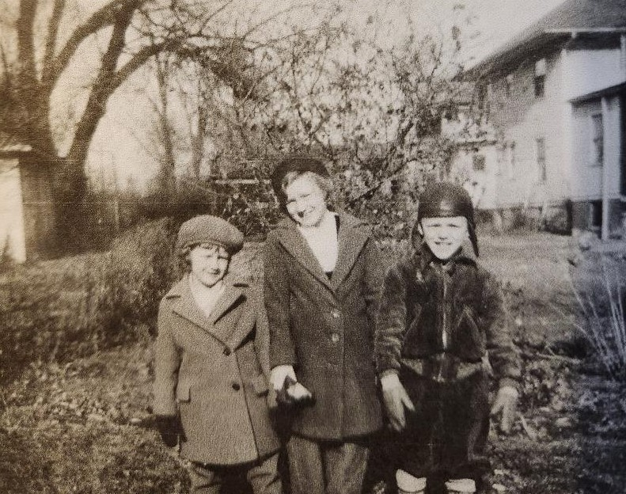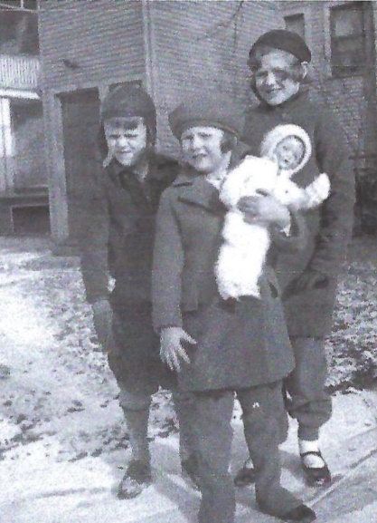
Evelyn (6), Nancy (10), and Shelton (8) in Poppy’s back yard Shelton, Evelyn, and Nancy

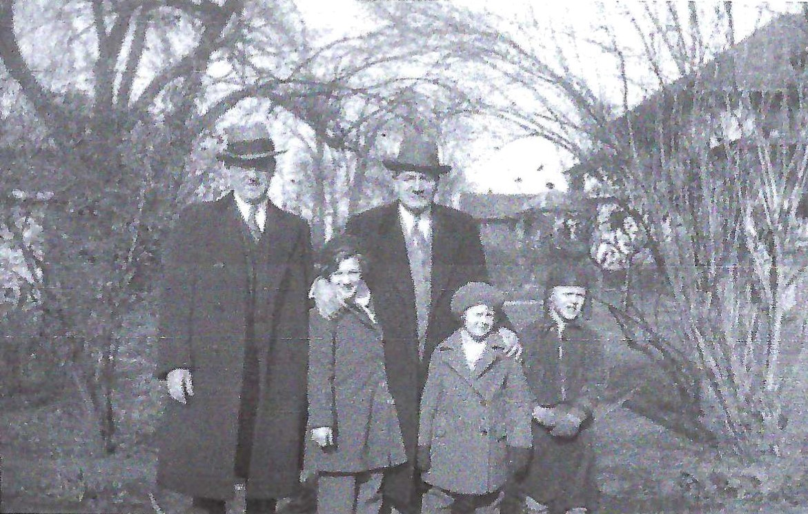
Lam Allen (57), Nancy (10), Poppy (61), Evelyn (6), Shelton (8)

DECEMBER 5 - The 21st amendment to the US Constitution (repealing the 18th amendment, Prohibition) was ratified with the support of President Roosevelt who had "campaigned for it, stating that legalizing beer alone could raise 'the federal revenue by several hundred million dollars a year.'" https://prohibition.themobmuseum.org/the-history/the-end-of-prohibition/repeal-of-prohibition/

NANCY’S MEMORIES OF CHRISTMASTIME

For as long as I can remember, Mommy and Poppy’s best friends were Carl and Lillian Duncan. We were taught to call them Uncle Carl and Aunt Lil. In those early days while Poppy was still alive, they were always invited to Thanksgiving dinner at their house, as well as to our house for Christmas Eve …

After dinner Daddy, Uncle Carl, Poppy and Mother played a game, each winning hand of which brought forth a cry of “High, Low, Jack and the Game!” I believe the name of the game was [Auction Pitch]. It has recently caused me to wonder, however, who ended up washing the dishes after that big dinner - the other women, I suppose - Aunt Genna, Mommy and maybe Aunt Lil?

Mommy never seemed to mind cleaning up after a meal. Even when Evelyn and I were old enough to do the dishes (during which we used to sing duets at the top of our voices) when she was staying with us, she always volunteered to do the pots and pans. Just recently, while mentioning this to Evie, she said it was because she liked to nibble on the leftovers while she was in the kitchen alone. Mommy was short and plump, but I loved her that way so never gave a thought as to how she got that way!

[On Christmas Eve] we children were put to bed rather early. I don’t remember exactly what year, but at some point the poem, “The Night Before Christmas” was printed, and I do remember Aunt Genna reading that to us before we went to sleep. Then the work began for the adults. For us, of course, Santa Claus was the one who put up the tree, leaving it decorated and surrounded with presents. So for several hours the tree was retrieved from wherever it had been hidden, decorated, and magically adorned with candy canes and surrounded with gifts from parents, grandparents, aunts and an uncle, all of whom were family and loved by us. We had to wait for an awfully long time for Mother and Daddy to wake up the next morning, then, after Daddy had gone down first, lit the fire and turned on the Christmas tree lights, we were allowed to come down to the wonderland waiting for us. One year there was a train running around the tree for Shelton, and a dollhouse for me which was hooked up to the same transformer which ran the train so that lights came on in the house. Another time there was a little village set up on the cotton around the base of the tree. Evie said it later was set up in the fireplace and she and Shelton used to lie on the floor in front of it and make up stories about what went on in the village.

In the year 2000 Evelyn wrote of the following memory to Shelton: “We certainly remember Grandma and Grandpa (Mommy and Poppy) coming to our house at Christmas and you and me pretending and making up stories while [lying] under the Christmas tree. You made the Christmas village in the fireplace.”

As Nancy’s memories of Christmas showed, the children when they were young were taught to believe in Santa Claus. But then one Christmas came when Nancy was old enough to help with the ruse. Shelton and Evelyn were sent to bed and Nancy and their parents waited for them to fall asleep. However, the two youngsters snuck out of their beds and were secretly waiting at the top of the stairs when they heard Nancy ask, “Do you think they’re asleep now and we can set up the tree?” Shelton was devastated, Santa was make-believe!! [For his own children, he did not pass on the myth of Santa Claus, although Christmas was still magical with the presents not being put out under the tree until after we young ones were fast asleep so we could wake up to the glorious surprise.]

After breakfast, weather permitting, we packed up to drive up to East Troy for dinner, or we started getting ready for Uncle Ed’s family to come to our house. It was at one Christmas day dinner at our house that Mother introduced the white pie for dessert - a pre-baked crust with a vanilla and almond flavored filling into which had been folded whipped cream then topped with chopped pecans. It became a family favorite Christmas dessert for years.

[It wasn’t until a Christmas when we were on furlough from Japan that our family was introduced to the “white pie”. I believe it was the Christmas of 1979 during my senior year of high school. Keren and Sharon were in college at Bethel in Minnesota, so I don’t remember if they were there. But the rest of us drove from Ann Arbor, Michigan to Littleton, Colorado where Grandma Allen was living with Aunt Evie and Uncle Bill. Aunt Nancy lived in the area as well and was there, but I do not remember if any of our cousins were.

After this Christmas with the pie introduction, our mother Dorothy made it for Christmas thereafter, knowing it was special to our father, even though he had probably never mentioned it in their previous thirteen Christmases together. She was so good at keeping Allen and Friesen family traditions alive when she found out about them, as she did with this “white pie” which we called almond pie and also with pluma moos and particularly pfeffernusse from the Friesen side. From my recollection the recipe for the almond pie was just a ready-made graham cracker crust with instant vanilla pudding flavored with almond extract and whipped cream mixed together and toasted slivered almonds on top. I have not been able to find this recipe among the many loose hand-written recipes of Mom’s that I inherited but I will continue to look and try to include it here. Or, perhaps our cousin Joy, Nancy’s daughter, may have it.]

One year (I was somewhere around 10 or 11) Daddy had a new car (the first car we had where the gear shift was moved from the floor to the steering wheel shaft). It was cold but not snowing, but he came upon a small patch of ice, lost control of the car and we were suddenly sliding backwards down the grassy side of the hill. Daddy was surrounded with three scared and crying children, a wife who was trying to reassure us and a car which couldn’t make it back up the hill. I just asked Evelyn if she remembered this and she said she did, so she was about 6 or 7. Other drivers up on the road stopped and helped us all climb up the hill, then drove us into the nearest town where we eventually got a garage with a tow truck which pulled the car up and brought it to us. I asked Evie (we have been calling her that for so long it is hard to keep going back to calling her Evelyn) if we had to stay overnight somewhere, but she said no, the car wasn’t damaged, none of us were hurt, and neither of us remembered that we ever called the police or highway patrol. She said when they got the car back into the town we got in and drove home.

At one Christmas season, Marshall Fields [in Chicago] had a special presentation of a fabulous dollhouse owned by screen star, Colleen Moore. I remember standing in line what seemed like a very long time waiting for my chance to see this extraordinarily large miniature house, lavishly furnished, ablaze with lights, and peopled with tiny figures - the daddy, mother, children, a cook, maids, a butler, cars at the front door with a chauffeur, and landscaped with trees, bushes, flower beds and a swimming pool. What a profusion of dreams that started running through my head! After seeing that house, when Mommy, Poppy, Mother and Daddy went together on a trip to Canada I knew that it was a very special and magical place. Poppy, who was born in Birmingham, England, had told me that Canada was ruled by an English King and Queen, with princes and princesses and they were waited on by lots of servants. Whenever Mother and Daddy went on a trip they brought back presents for all of us, including Uncle Ed, Aunt Evelyn and all my cousins in East Troy, Aunt Genna, Aunt Olga, Uncle Otto, and Junior.** I was absolutely positive they would bring me back a real miniature palace, not only beautifully furnished with mirrors and thrones but with live miniature people inside - a royal family and many servants to wait on them! I don’t remember what they actually brought me, maybe a picture book, and I never told them how disappointed I was. Talk about a childhood daydream popping like a huge balloon! It didn’t stop me from daydreaming about other things, however, many of which did come true!

** “Aunt” Olga was their mother Alice’s best friend, Otto was Olga’s husband and “Junior” her son, Otto Junior.

1934

APRIL 1 – Easter Sunday

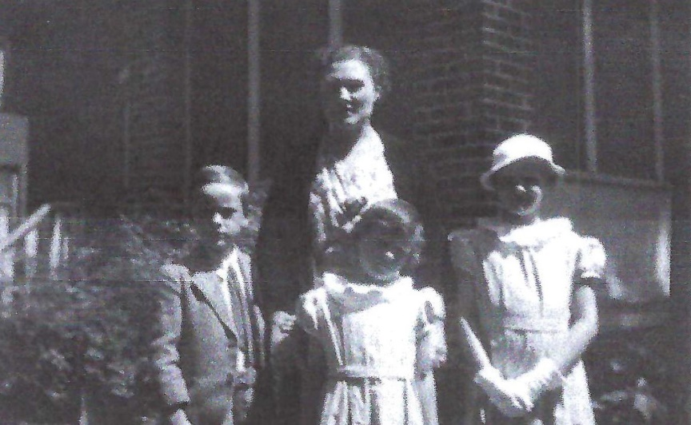

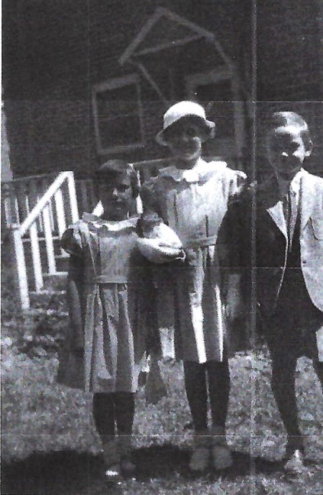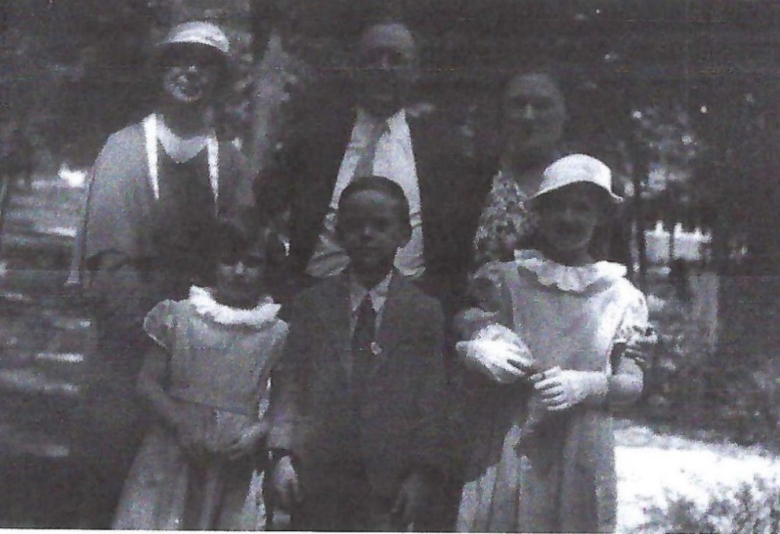
Evelyn (almost 7), Nancy (10 ½), Shelton (8), Aunt Genna (61), Lam (57), Alice (34)

MAY 19 – Julia Weiss Winckler, the mother of Shelton’s Grandmother “Mommy” Smith, died at 87 years, eleven months, and 10 days old.

THE SMITH COUSINS – Not just for Thanksgiving and Christmas dinners, but many Summer weekends as well were spent in East Troy, Wisconsin. Nancy recalled in her memoirs that along with Mommy and Poppy “we would all, including Aunt Genna, drive, in two cars, the 80 miles up to Uncle Ed’s … arriving about one o’clock for one of Aunt Evelyn’s sumptuous country dinners and perfect home-baked pies, playing all afternoon with our cousins, and arriving home after dark after some of the most special days of our young lives!”

We didn’t catch on to the fact that Shelton and Charles, when we paired off after dinner, started going to a nearby field where open-air, two seated airplanes offered 10 minute rides for only 25 cents. When Alice and I heard about it we joined them one Sunday afternoon and traded a promise not to tell our folks that they were taking these rides if they would pay for each of us to take one. That was a truly daring and exciting experience!

And also while out at the “airfield” I had my first ride (maybe it was my only ride) in a rumble seat in a two door, one seat coupe, with a handle in back which opened onto an open-air seat for two, with two school friends of Alice’s. I don’t think I told my folks about that either!

[These memories of Nancy’s are such an amazing gift! I don’t remember our father speaking much about his childhood and nothing really about Aunt Evelyn or even Aunt Genna that I can recall (even though Aunt Genna lived with them from when he was about five until about 13). Yet these people were very important in his life, as demonstrated in the picture below which shows him affectionately leaning against his Aunt Evelyn. And from his own journal right after he got out of the Navy - the story of his conversion, his decision to abandon his scholarship at Northwestern University and go to Bob Jones University, his ordination at East Troy Bible Church, all were very much were influenced by his Uncle Ed and family.]

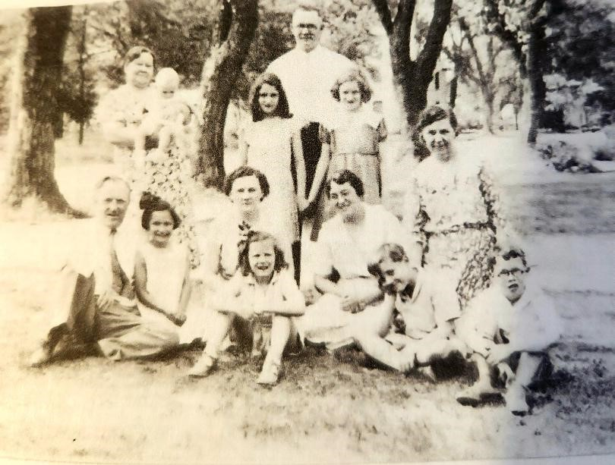

Judging by the age of Muriel, the baby, and by the warm-weather outfits, the above picture was taken in the summer of 1934, possibly at a celebration for the summer birthdays of Aunt Evelyn (June 29), Delores (July 5), Nancy (August 12), Uncle Ed (August 22), and Aunt Genna (August 29). Nancy said that Poppy took this picture. He died just a few months later in October of 1934 of colon cancer. She identified the people in it as follows: “in the back Mommy [62] holding Muriel [about nine months] and Uncle Ed [36] between Alice [10] and me [11]. Front – Daddy [57], Dolores [6], Mother [34], Evelyn [7], Aunt Evelyn [31], Aunt Genna [61] with Shelton [8] and Charles [8].”

[I am writing this in 2023 and just recently heard from our father’s cousin Carol Smith Rowntree. She is 83 this year and was not even born when the above picture was taken. She kept repeating herself but had called to tell me that the husband of her only other sibling who is still alive, Muriel “Murt” Smith Skinkle (the baby in the picture above) who is 90 this year, had been placed in hospice care. I had spent perhaps a month with these cousins in the summer of 1972 when I was ten years old. First with “Auntie” Allie (ten year old Alice in the picture above) and her veterinarian husband “Uncle” John in East Troy, Wisconsin. Then we went to a family cabin by a lake somewhere (perhaps Fox Lake mentioned above?) and later I went to stay with Russ and Muriel Skinkle on their farm in Michigan. While I knew they were related to me, I wish I had been more aware at the time of exactly who they were and the significance they had had in our father’s life.]

There’s only one memory that my father shared of his Mommy (Grandma Smith) that I remember. He was very sick with a high fever, and she was sitting by his bed. As you can see in the picture above, she was quite a plump woman and he said he must have been hallucinating because he looked over at her and asked, “Mommy, why are you in a circus tent?”

A memory, or impression, he shared of his mother’s brother, Uncle Ed, was that he was a big man, with a large, round stomach, but as a veterinarian he was quite strong and could take a kick in the gut from a horse or cow. Uncle Ed had four daughters and only one son. I don’t specifically remember anything my father shared about his cousins, despite him being quite close to them, other than that Delories, who they called “Dorie”, the second daughter and third oldest, was his favorite, even though she was three years younger and his cousin Charles, born on the 21st of November 1925, was just five days younger.

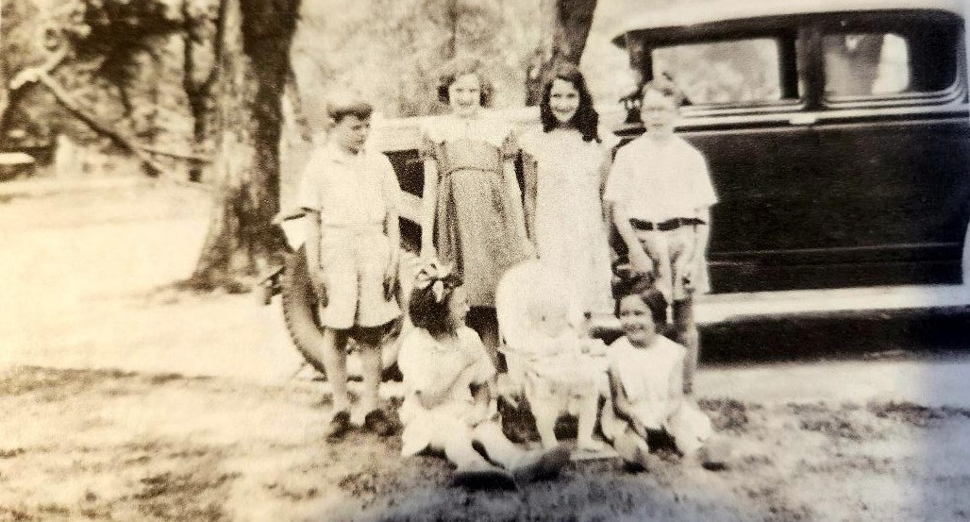
Poppy took this picture of his seven grandchildren in front of his new two-door Buick coupe.
Back row: Shelton (8), Nancy (11), Alice (10), Charles (8)
Front row: Evelyn (7), Muriel (about 9 months), Delores (6)

FALL - Shelton started fourth grade at Hawthorne Elementary School.

OCTOBER 10 – Edward Smith, “Poppy”, Shelton’s Grandfather, died in Oak Park, Illinois of colon cancer at 62 years, eight months, and 26 days old.

Poppy died in October, 1934, two months after my 11th birthday, before either Thanksgiving or Christmas that year. Shortly after that Mommy sold the Oak Park house and moved to East Troy. She bought the little house next door to Uncle Ed’s, and although we had many Thanksgivings together after that, either at Uncle Ed’s or at our house, they weren’t at Mommy and Poppy’s house in Oak Park.

[Cousin Alice and her husband John Rogers would later own that little house and were still living there when I spent time with them the summer of 1972.]

When we were little we all liked to rock, but Shelton was the only one with a rocking chair. Evelyn and I had straight chairs which we rocked back and forth on their legs. When we were left in the house alone with Aunt Genna we would line the chairs up in the kitchen while she was fixing dinner and all three rock. How she could stand the racket I don’t know - the straight chairs seldom hit the floor at the same time - but she never told us to stop or sent us out of the room. On that sad night [when Poppy Smith died] we were all crying as well as rocking and I told Aunt Genna about a dream I had at the time great grandmother Winckler died [about five months before Poppy died]. She was on a large ship, waving to Poppy and me standing on the pier watching the ship sail away. She could stand up, which she hadn’t been able to do for many years, and I heard her say, “I’ll come back for you, Edward.” I remember saying to Aunt Genna, “l guess Grandma Winckler came back for Poppy!”

NOVEMBER 16 – Shelton turned nine.

THE METHODIST EPISCOPAL CHURCH

We were allowed to join the church when we became nine years old, in third grade. Beginning with first grade Sunday School we were given Bible verses to memorize every week which our teachers marked in a book when we recited them correctly, and then on “graduation Sunday” we were presented to the congregation, given a copy of the New Testament and then were given the grape juice communion for the first time.

A CHRISTMAS CARD - An artist came to the house to create the silhouettes of the family.

Evie says she remembers being fascinated with watching the process. For each portrait he tacked a large piece of white paper on a wall, had one of us sit in a straight chair and turned on a floodlight which cast our shadow on the paper. He then traced the shadow. Later he cut the silhouette, using the traced shadow as a guide. Daddy was in the printing business which included direct mail advertising, so he evidently had equipment which could reduce the size of the original silhouettes to get the end result of this card.

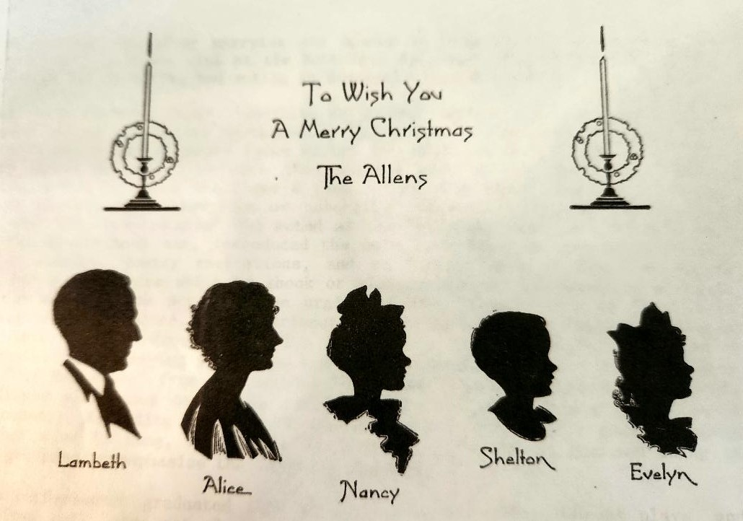
1935

THIS YEAR - Parker Brothers began selling Monopoly. 278,000 copies were purchased in the first year alone. https://www.monopolyland.com/when-was-monopoly-invented/

FALL - Shelton started fifth grade at Hawthorne Elementary School.

Shelton … liked to take things apart and then put them back together again. Mother kept him supplied with old alarm clocks and other replaced appliances like the hand-turned toasters before the “pop-up” kind were on the market. I suppose this interest was what made them get him the advanced erector sets which he enjoyed so much.

Evelyn later recalled: “You were always ‘fixing something’ and mother was never sure if you fixed it or not!

NOVEMBER 16 – Shelton turned ten.

One of Mother’s friends was Gladys Grazer who bred Boston Bull dogs. One time when she had a new litter of puppies she invited Mother to bring Shelton to see them. Mother had told Gladys that she wanted to buy one of the puppies for Shelton’s birthday, but didn’t want him to know it. He fell in love with one of the males which seemed to be kind of a loner - kept himself apart from the rest - and also was not perfectly marked - had more white hair than was considered perfect for the breed. Shelton thought the dog had been sold to another little boy. The day before Shelton’s birthday, Gladys called Shelton and told him the little boy was going to get the dog the next day and asked him if he would like to keep him overnight before she had to deliver him. Shelton was so excited about having him that he slept beside him all night on the floor in the kitchen. The next morning he asked Mother when Gladys was going to deliver the dog to the other little boy. All of us were standing in the kitchen when Mother said, “She already has, Shelton. Happy Birthday! You are that little boy!" He was so happy he had a hard time believing it was his! He named him “Teddy” (in memory of Evelyn’s hairless Teddy Bear?) and we all loved it and had it until Uncle Ed had to put him to sleep, he was so arthritic. Evelyn was away to college at the time [between July 4, 1946 when Lam tried to take Teddy for a walk in the park and June 1948 when Evelyn graduated from college. Teddy would have been between 11 and 13 years old].

CHRISTMAS -

The Thanksgiving and Christmas right after Poppy died were not our happiest ones, of course, but the very worst Christmas was when I was 12 years old. [Shelton was 10 and Evelyn was 8. Their Grandma Allen in Florida was 96 and still living with her daughter Mabel in the home Lam Allen had purchased for them.] There had been a hurricane which had hit Miami sometime in November and it had blown the roof off the apartment over Aunt Mabel’s garage and done a considerable amount of damage to the rest of the building. Aunt Mabel apparently had no experience in dealing with insurance appraisers and builders and Daddy was in the middle of his busiest business season, so Mother had to go down to handle the paperwork. She went by train and expected to be back before Christmas. Well, she didn’t get home until after the first of the new year, and of course Christmas was not the same without her.

1936

SUMMER - The following story about Nancy having appendicitis (as well as the one about Evelyn in 1945) is significant for later in our father’s life when he would be very concerned when we had bad stomach aches and would test for appendicitis by having us lie flat on our backs and bending our right leg up to our stomach and quickly releasing it to see if it increased the pain. My siblings Keren and Nathan later would have their appendixes removed do to inflammation and my son Keelan did as well.

The summer of 1936 when I turned 13 before entering 8th grade, Mother sent me to a YMCA camp located at a lake in Wisconsin not too far from East Troy. I think it was for two weeks. We lived in tents with girls our own age, with an older girl in each tent as a kind of counselor. The usual activities were the order of the day, swimming, horseback riding, hikes, crafts, skits, campfires and singing, There was a refreshment section in the dining room where you could get candy and ice cream bars, cracker jacks and other snacks. Camp became a place I enjoyed much more than I expected. But at about the second week I began to have a dull ache in my right side but I didn’t want to go home. When I skipped a couple of swimming sessions, the camp nurse called my Mother and somehow determined if I didn’t do anything too strenuous for the few days of camp left I could stay.

When I got home Mother took me to the doctor who determined that I had an enlarged, and probably inflamed, appendix and said that it should be removed. Daddy was very much against the idea of cutting me open and removing part of my insides, but Mother took the bull by the horns, having been told by the doctor that if the appendix ruptured it could be life threatening, as it was in those days [without antibiotics]. So without telling Daddy, she arranged for operation, hired two private nurses, one for day and one for night, so that I would have someone with me constantly for the 10 days I was expected to stay in the hospital. Yes, 10 days, in bed - not allowed up even to walk to the bathroom or get any exercise of any kind. (Today I think they do it as an outpatient procedure!) By the time I was released, I was so weak I had to learn to walk all over again, hanging on to things like a one year old! And was thereafter, through both 8th grade and senior high school, excused from participating in physical education classes because of this serious operation.

After my Junior High years, when I had my appendix removed, I stopped having those sick headaches which I had so frequently in my younger years. In fact, I have been almost headache free during the rest of my life. I still get motion sickness, though, in a car, airplane, bus or train. Not on a boat, however. Strange!

FALL - Shelton started sixth grade at Hawthorne Elementary School.

Shelton was intelligent and shy but also got into his fair share of mischief as young children will. Big sister Nancy recalled the following stories.

Shelton, in his younger years, joined other geniuses like Einstein and Edison, in not being particularly outstanding academically in the public school system [although he would get a full scholarship to Northwestern University based on a science fair project he did in high school] or particularly popular. He was not athletic and was terribly shy around girls. He had one close friend in his grade school years, Kermit Kelly, who lived a few doors from us.

One Halloween when tricks were the order of the day, windows and screens were marked with soap; in the country, outhouses were overturned, billboards got defaced and trees were toilet-papered, Shelton and Kermit, neither of whom had participated in such acts before, decided to do some mild neighborhood pranks. A neighbor at the top of the hill from us had outside folding doors which opened from the center on stairs to the basement. In rural areas these doors were called “root cellar” or “tornado cellar” doors. Anyway, the boys had hardly started their Halloween tour when they decided to toss stones on the neighbor’s basement doors. Before they could toss very many and then run away into the dark, the owner came out and grabbed Shelton by the back of the neck. Kermit managed to run away home, but Shelton got dragged to our house where he was presented to Mother and Daddy as the neighborhood bad boy. He was so scared he wet his corduroy nickers and so humiliated that was his last Halloween as a prankster. It wasn’t long after that before “Tricks or Treats” was established. Evie says she remembers Shelton taking her out Trick or Treating.

And the day he and Evelyn were fooling around in the living room and shoved a chair into the wall, creating a sizable hole. Shelton had beautiful brown eyes, the only one in the family to inherit them from Mommy Smith. He knew Mother would be very upset about this episode when she got home, and met her at the back door to confess it was his fault before she went into the living room to see the damage herself. This time, looking into his sincere, tearful, brown eyes, she melted, and even though she was certainly annoyed, didn’t reprimand either him or Evelyn too severely.

Mother did a lot of entertaining which meant the house had to be immaculately cleaned and special food prepared. Also children had to be kept out of the way as much as possible. If she was entertaining the “Oak Park Club” it was held on Saturday night and we could go to the movies in the afternoon, but sometimes we had to play in our rooms or in the basement. One of the treats Mother used to fix were salted almonds which had to be prepared from scratch - that is from the shell. Step 1. Shell the almonds. Step 2. Put nuts in 9” x 13” pan and cover with boiling water to soften the skins then pop the nuts out of the skins. Step 3. Heat olive oil in large frying pan then brown the skinned nuts. Step 4. Remove nuts with slotted spoon and drain on absorbent paper. Step 5. Salt the nuts while still warm, then cool on the paper before serving or storing. (A rather lengthy and tedious process, especially removing the skins, one by one.) Mother had spent one Saturday morning preparing the food for the bridge club, including a good-sized mixing bowl full of these delicious (and high-cholesterol) almonds. She had gone upstairs to rest and dress for the party. Shelton and Kermit had been playing in the basement. When she came down to start putting the dinner together she found more than half of the nuts gone! Shelton and Kermit had been helping themselves to them all afternoon! This was another time Mother lost her cool. I don’t know where Evelyn and I were while this was going on, but we sure heard about it. In later years, this was another story which made all of us, including Mother, laugh.

As was the one about the chemistry set Shelton was given one Christmas - not one that had the potential to blow up the house, but managed to get Mother’s dander up when one day she was expecting guests he filled the house with sulfuric acid fumes!

The lasting memories of these stories were not lost on little sister Evelyn who commented on them in her letter to Shelton in 2000.

Remember the terrible stink coming from the basement when mother was trying to entertain – and the time you and Kermit ate most of the toasted almonds mother had made for her company?

I remember my father telling us the story of the “terrible stink”. It was cold outside, but his mother had to open all the windows to fumigate the house before the guests arrived. Dad would also chuckle when he would say that his mother, if the house was too quiet, would shout, “Shelton! What are you doing?” He would reply, “Nothing, Mother!” to which she would respond, “Well, stop it!”

NOVEMBER 16 – Shelton turned eleven.

1937

JANUARY 20 - Franklin Roosevelt was sworn in for his second term as President of the United States.

FALL - Shelton started seventh grade at Benjamin Franklin Junior High School.

All of us were encouraged to take piano lessons; I was the only one who continued, however. Evelyn wanted to play the violin, and Shelton took up the saxophone in junior high school and played in the marching band in high school. At one time we used to play together, for what purpose I’m not sure, with me accompanying them on their instruments. That is the only thing I remember we all did together.

Seventh and Eighth grades were farther away at Benjamin Franklin Junior High School. We took our lunch to school for those two years.

It combined the students from the two grade schools in town. If I remember correctly the Catholic school went through the eight grades so they didn’t become our classmates until high school.

[We walked to school], but it was too far to go home for lunch in the scheduled time so most days we took a bag lunch. However, there was an alternative right across the street called “Prince Castle”, the first little fast-food place in town, which served 10 cent (or was it 15 cent) hamburgers and assorted flavors of take-out ice cream cones, sundaes and milk shakes. Parental restriction, fearing it might become habit forming, limited us to that lunch diet only a couple of times a month, but it was considered a real treat, and since we all had allowances, we sometimes treated ourselves to a cone (5 cents) to lick on our way home!

This is written in March of 2004 when currently there is a Supreme Cout decision pending on whether the two words, “Under God’ which were added to the Pledge Allegiance to the Flag during the Presidency of Dwight Eisenhower in the 1950, should be called unconstitutional. This made me remember my grade school days when we recited the pledge, without those two words, every school day morning. At that time there were only 48 United States of America since 1912 when New Mexico and Arizona became the 47th and 48th states to enter the Union. Alaska and Hawaii made it 50 states in 1959.

Along with their allowances there were stores like Heintz’s Drug Store, which was also the local soda shop, where the family had open credit. Shelton could order something and say, “Charge it to Allen on Lenox.” Once a month Alice would go around town and pay the bills. Even during the depression years money was no problem for the Allens on Lenox Road. As Shelton would later recall, sometimes in making sandwiches they’d skip the bread and put sliced roast beef between two slices of Swiss cheese. And once when he saw an advertisement for Oleo margarine he asked his mother what it was. She said, “That’s what poor people have instead of butter.”

NOVEMBER 16 – Shelton turned twelve.

One of Aunt Genna’s sons came to visit:

Ernest [42] lived in Valdosta, Georgia, and brought with him his daughter, Mary Esther, who was 13 or 14 at the time. They had heavy southern accents which I parroted for weeks after they left.

DECEMBER 21 - Walt Disney's Snow White and the Seven Dwarfs, the first feature-length animated cartoon, premiered in Los Angeles. https://en.wikipedia.org/wiki/Snow_White_and_the_Seven_Dwarfs_(1937_film)

MORE CHRISTMAS MEMORIES

Instead of around Halloween, back then the Christmas season didn’t start until the day after Thanksgiving. There was no television, so no televised Macy’s Thanksgiving Day Parade as far as we in Chicago knew, if it was going on in New York at the time. [According to History.com the first Macy’s Thanksgiving Day Parade was in 1924.] One of our pre-Christmas treats was a trip to Chicago to see the decorated windows in the Marshall Field’s department store - which were animated and different every year. They became very famous and were one of the featured Christmas attractions of the city. The many floors of the store were also lavishly decorated. Marshall Field’s was the department store in Chicago, but particularly spectacular during the month of December! And, naturally, that was where Mother did most of her shopping!

[My husband Chris and I visited Chicago in 2023. The original Marshall Fields’ store is now a Macy’s, but bronze plaques on the corners of the large stone building which takes up a whole city block still say “Marshall Field and Company”.]

There were also special entertainment events during the holiday season. Sonja Henie [three-time Olympic champion from Norway] went professional by 1937 and we attended one of her ice shows one year; the Chicago Theater would have dancing and singing stage shows in between the running of the movie.

1938

Sometime this year Aunt Genna (65) moved back to Florida to help her sister Mabel (58) care for their mother Ellen Nancy Pitts Allen, Shelton’s Grandmother Allen who would be 99 years old in July. Nancy was 15, Shelton 13, and Evelyn 11 and they were no longer in need of a nanny.

FALL - Shelton started eighth grade at Benjamin Franklin Junior High School.

OCTOBER 30 - War of the Worlds was first broadcast over radio by Orson Wells. “For much of its duration, the program was presented as a faux newscast. Consequently, Welles, who was then all of twenty-three, had somehow persuaded a portion of the public that Martians were annihilating Earthlings. The New York Times headline painted the picture: 'Radio Listeners in Panic, Taking War Drama as Fact.'' The next day, apologetic, Wells states, “I know that almost everybody in radio would do almost anything to avert the kind of thing that has happened, myself included ... Radio is new, and we are learning about the effect it has on people. We learned a terrible lesson.” https://www.neh.gov/article/fake-news-orson-welles-war-worlds-80

NOVEMBER 16 – Shelton turned thirteen.

1939

APRIL 30 - The World's Fair opened in New York. "When President Franklin Roosevelt opened the fair, RCA broadcast his speech on the new invention called television and NBC (owned by RCA) used the occasion to launch the first regularly scheduled TV broadcasts in the United States." https://antiqueradio.org/RCA_40X-56_1939_Worlds_Fair_Radio

JULY 25 – Ellen Nancy Pitts Allen, Shelton’s Grandmother, died in Florida one week after her 100th birthday.

A TRIP TO THE WORLD’S FAIR

Before he was 14 years old … Mother and Daddy took [Shelton] and Evelyn to the New York World’s Fair which had a “Futurama” exhibition about super highways and airports, he had been telling stories to the family at the dinner table about vehicles which would be able to fly from one end of the country to the other in only a few hours, automobiles which could fly and other fantastic imaginings like radios which would bring pictures as well as sound into our homes. From this Mother and Daddy were convinced that he would be an inventor or an engineer of some kind.
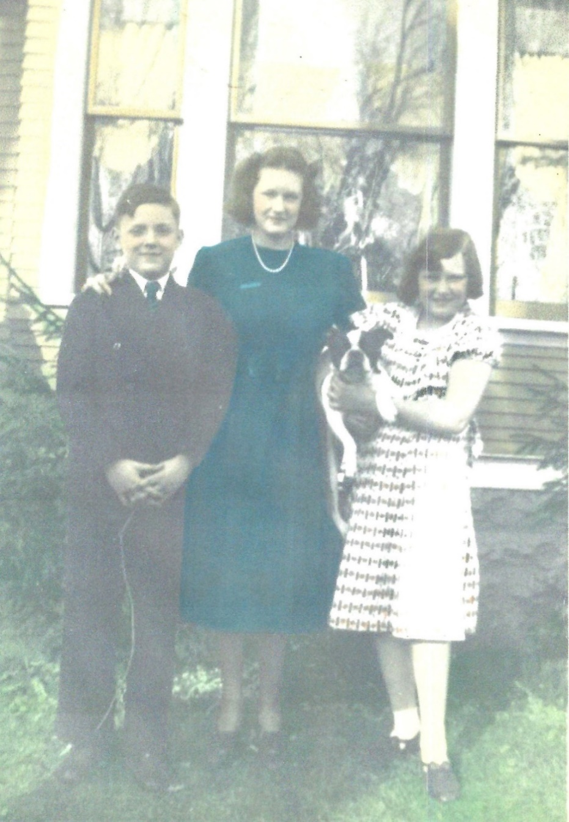
Shelton (13 ½), Nancy (16), Teddy (4), and Evelyn (12)

AUUST 12 - The Wizard of Oz premiered in Oconomowoc, Wisconsin. https://www.history.com/this-day-in-history/the-wizard-of-oz-movie-musical-premieres-in-oconomowoc-wisconsin

[I remember our father talking about this being the first live-action colorized film he and most of his piers had seen. He recalled that when Dorothy stepped out of her house into the land of Oz and everything went from black and white to color the whole auditorium gasped.]

SEPTEMBER 3 – WORLD WAR II – Britain and France declared war on Germany after Hitler’s troops had invaded Poland two days prior thus beginning the conflicts of World War II nearly twenty-one years after the first World War ended. The U.S. would not enter this war until over two years later. https://www.history.com/topics/world-war-ii/world-war-ii-history

FALL - Shelton started nineth grade at Glenbard High School. Nancy’s memories of high school in the paragraphs below were most likely similar to Shelton’s.

Entering high school was like becoming part of a whole new world. “Glenbard” represented two of the three suburbs, Glen Ellyn and Lombard, located close together west of the city of Chicago (Lombard, Glen Ellyn and Wheaton) … Glenbard’s student body was made up of Glen Ellyn’s and Lombard’s public and Catholic four year high school students. So from relatively small junior high schools made up of classmates, at least half of whom we had known since first grade, we were integrated into a school of around 1000 students. There were 238 in my graduating class. Wheaton had its own school system and was also the home of Wheaton College, a Christian institution, the under-graduate alma mater of the world-wide known evangelist, Billy Graham.

Lombard’s population was predominately working middle class while Glen Ellyn’s was more upper middle class white collar as was Wheaton’s with a higher percentage of academics because of the college. Both Glenbard and Wheaton high schools offered two courses of study - college preparatory or business like shop, auto repair, wood working, shorthand, typing and the like, for those not planning to continue their education after high school. The Lombard and Glen Ellyn students who lived some distance from the school were bussed … [we] lived only a couple of blocks away and walked, approaching up the hill to the back entry into the lower floor where most of the padlocked student lockers were located. There was a big cafeteria on this lower floor, but those of us who lived close had the option of going home for lunch. Because of the large number of students who ate in the cafeteria, there were two lunch periods - 11 to 12 and 12 to 1 - which were assigned along with your class schedule. (There was usually a frenzy of lunch room re-scheduling at the beginning of each year in case you and your friends happened to be assigned to different lunch hours!)

The school day started at 8:25 and ended at 3:00, and except for those who did go home for lunch, all were expected to be in school the entire day. There was a library and two good sized study halls where, if you did not have a class, you were expected to be. Each student had a home room where he/she reported the first short period of the day and role was taken. At the beginning of each semester the home room teacher was given a complete schedule for each of her students, including room numbers of each class, and the hours each would be in either a class or study hall. Passes to the library were given, upon request, on a daily basis by the study hall monitor. The Principal’s Office had an alphabetical list of the students and their home room numbers, so at any hour of the day any student could be located unless they had been reported absent by their home room teacher. Sound complicated? Once you knew where you were expected to be, you just followed the routine! It was certainly more restrictive than the routine today where, similar to a college campus, students can leave the grounds any hour they don’t have a scheduled class, but we were all used to the way it was and just accepted that we went to school from 8:25 to 3:00 every day.

In most ways I suppose the activities at my high school were not, overall, much different than they are today. There were football games, basketball games (the teams were called the Hilltoppers), the local hangout was Heintz’s Drug Store which had a soda fountain and a row of booths where we kept the high school “soda jerk” on his toes by ordering vanilla, chocolate or marshmallow cokes.

Football was not the exciting game it has developed into today. The same team played both offensive and defensive. Oh, there were substitutions made during play, of course, but if the offense didn’t make the 10 yards in the four downs, the same team would turn around and play defense. Also this was before the forward pass had been introduced as a legitimate football play, so every play was a running play. It could be quite uninteresting to watch. In my junior year [Shelton’s freshman year] our team was the West Suburban League Champion and that made the game a little more interesting because they kept making first downs as they marched down the field for touchdowns.

NOVEMBER 16 – Shelton turned fourteen.

1940

Around our house there were certain things which never changed. First of all we had the same mailman, at least for all the years that I remember … His name was Art Weinbauer and he became like a member of the family. If the weather was bad he was invited in for a cup of coffee or hot chocolate, he always knew when one of us had the measles or chicken pox, you could count on him to arrive at about the same time every day … When I was in my teens and expecting a letter from someone special, he would see me watching for him from the living room windows and signal as he came down the sidewalk that he was bringing what I was looking for. Mother said when Shelton was overseas during the war that he would do the same for her or would even make a special trip after his regular round to bring her a letter from him. They just don’t make mailmen like that anymore!

A regular Fall and Spring ritual was putting up and taking down the storm windows. Evie remembers the downstairs and porch screens were replaced with glass panes. Upstairs was a different story. There were eight double windows, two in each bedroom, the storm windows were wide and heavy and had to be hung, rather than just being pushed into place. The hanging was required because the windows were designed to be pushed out about a foot away from the window frame when the weather was mild enough to let fresh air into the bedrooms. When it was really freezing cold the storm window was pulled flush with the frame and secured. There was a little flap in the bottom of each storm window which would let in a limited amount of cold air. I guess Daddy and Mother managed to put them up when I was a wee tot, but by the time I remember being old enough to understand what they were doing, it was a two man job and Daddy wasn’t one of them. To take them down, because they were so heavy, was almost as bad, and then the screens had to be replaced. What a blessing are double and triple pane windows!

APRIL 19 – The U.S. Census recorded Lambeth S. Allen (61, head, had completed though four years of high school, owner of advertising firm), Alice Allen (40, wife, had completed through four years of high school), Nancy Allen (14, daughter, had completed two years of high school), Shelton Allen (13, son, had completed eighth grade), and Evelyn Allen (12, daughter, had completed seventh grade) living at 638 Lenox Road in the village of Glen Ellyn, DuPage, Illinois.

REGARDING AUNT MABEL ALLEN:

Around this time Daddy was notified that Aunt Mabel [his youngest sister who would have been about 60 at the time and had been responsible for the care of their mother in Florida until the previous year when she had passed] was ill and in the hospital. Granny [Mommy, about 69] came down from East Troy to stay with us while Mother and Daddy went to Florida to see her. When they came home they brought her with them to live with us. She was in what today would be called a state of deep depression, with some mental delusions about God’s love for her. As the youngest daughter in the family, it had been determined that she was the one to be responsible for the care of her aging father and mother, a “duty” which had prevented her from marrying although she was said to have been the most attractive of all the sisters. I was aware of her condition but as an active high school junior paid little attention to her presence in the house. Evie tells me that she and Shelton were deeply affected by her mood swings, were somewhat afraid of her and tried to stay out of her way as much as possible. About a year later she told Mother and Daddy that she felt she might do some harm to the younger children and Daddy admitted her to a private mental hospital in Elgin, Illinois. This removed the pall from the house, but submitted Mother and Daddy to visits to check on her condition; she was given periodic electric shock treatments which a few years later were banned, but are now beginning to reappear on the psychiatric care scene. None of us children were ever taken into see her and after a while Mother didn’t go in either. We would sit in the car and after Daddy’s visit we would go to Medinah or some other nice place for dinner. After a year she called Daddy one day and said she was better and was leaving the hospital; it was private so her hospitalization was voluntary and she could have left anytime she wanted. She did not keep in touch with us; someone reported to Daddy that they had seen her working as a clerk in the glove department of Marshall Fields but when Mother checked on that she was told that she had quit. We never heard from her after that.

[In the 1935 Florida Census Mabel was living with her mother Ellen Nancy in the house Lam bought for them at 2318 NW 23rd Court in Miami, Florida. Grandma Ellen died on 25 July 1939. The 1940 U.S. Census lists Mabel and Genna living together in the house on 23rd Court in Miami. The above account in Nancy’s memories must have taken place between the U.S. Census of April of 1940 and the Florida Census of 1945 which shows Mabel, 65, living at 5431 NW 21st Court in Miami and working as an auditor. Also in the 1945 Florida Census Esther, “Aunt Genna”, 72, was living at 243 NE 4th Street in Miami with four other ladies in their 70s. By the 1950 U.S. Census, the year their brother Lam died, Mabel was listed in the Florida State Hospital Mental Institution in Sebring, Florida. She died in October 1960 and is buried in the Miami Memorial Park Cemetery where her mother Ellen Nancy Pitts Allen, her sister Virginia “Genna” Allen Carter, who died in 1968, and Genna’ s (ex) husband Will Carter, who had died in 1939, are also buried. Genna, Mabel, and Ellen have headstones of the same design.]

MAY 15 – The first McDonald’s restaurant was opened in San Bernardino, California. https://janetpanic.com/did-the-first-mcdonalds-open-in-1940

FALL - Shelton started his sophomore year, Evelyn started her freshman year and Nancy started her senior year at Glenbard High School. Nancy recalled that Shelton and Evelyn were “the best of friends all the way through high school.”

My brother, Shelton, was two years and three months younger than me. My sister, Evelyn, was … only one year seven months younger than Shelton. For all of their growing up years Shelton and Evelyn were closer to each other than I was to either one of them.

One day a neighbor up the street from us said to Mother that she saw Shelton walking home from school almost every day with his girlfriend. Mother told her that wasn’t his girlfriend, that was his sister. The lady said that they always seemed to have such a good time together, laughing and joking, shoving each other off the sidewalk or chasing after each other, that she thought they were sweethearts!

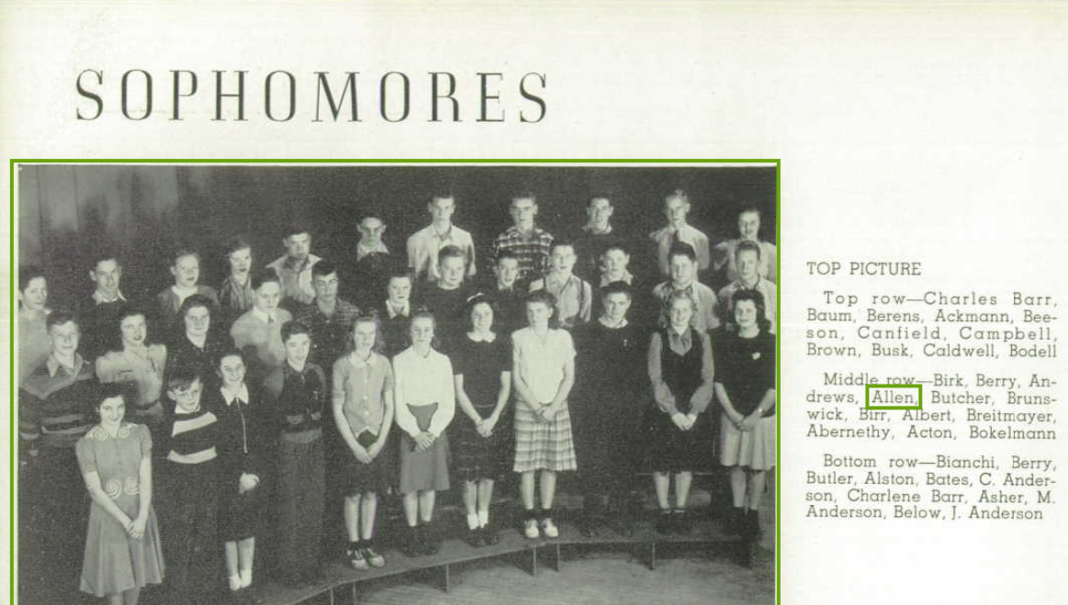
Glenbard Highschool, Shelton Allen is middle row, fourth from left.

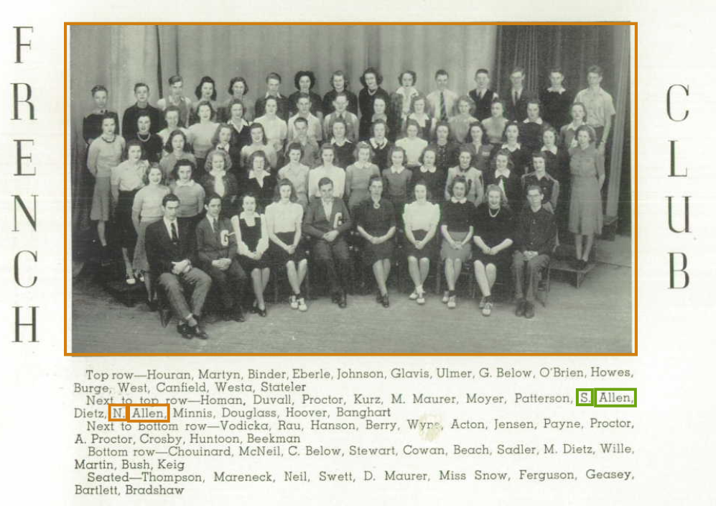
Glenbard High School French Club with both Shelton Allen (Sophomore) and Nancy Allen (Senior). Shelton is in the middle of the second to last row wearing a vest, Nancy is two over in the right of the picture.

OCTOBER 16 - President Roosevelt opened draft registration for all American men 21 to 35 years old. https://www.historynet.com/october-16-1940-uncle-sams-got-your-number-guys/

NOVEMBER 16 – Shelton turned fifteen.
1941

JANUARY 20 - Franklin Roosevelt was sworn in for his third term as President of the United States.

FEBRUARY 12 – PENICILLIN - "The first person to receive penicillin was (Albert Alexander) an Oxford (England) policeman who was exhibiting a serious infection with abscesses throughout his body. The administration of penicillin resulted in a startling improvement in his condition after 24 hours. The meager supply ran out before the policeman could be fully treated, however, and he died a few weeks later." https://www.ncbi.nlm.nih.gov/pmc/articles/PMC5403050/

JULY 1 - "The world’s first television commercial aired ... before the beginning of a baseball game in New York between the Brooklyn Dodgers and Philadelphia Phillies ... (It) was only 10 seconds long, and was an advertisement for Bulova watches. It cost the company a total of $9. Five dollars went to station charges, and four dollars went to airtime charges.
The advertisement was simple. It showed a black and white picture of the United States, minus Hawaii and Alaska since they were not part of the union yet, and had a clock face with the words 'Bulova' and 'Clock Time.' A voiceover was done by NBC staff radio announcer Ray Forrest that said, 'America runs on Bulova time.' It’s believed the commercial was only seen by a few thousand people in the market who happened to have a television at the time." https://medium.com/knowledge-stew/the-worlds-first-television-commercial

FALL - Shelton started his junior year and Evelyn her sophomore year at Glenbard High School. Nancy was taking classes at nearby Wheaton College and still living at home.

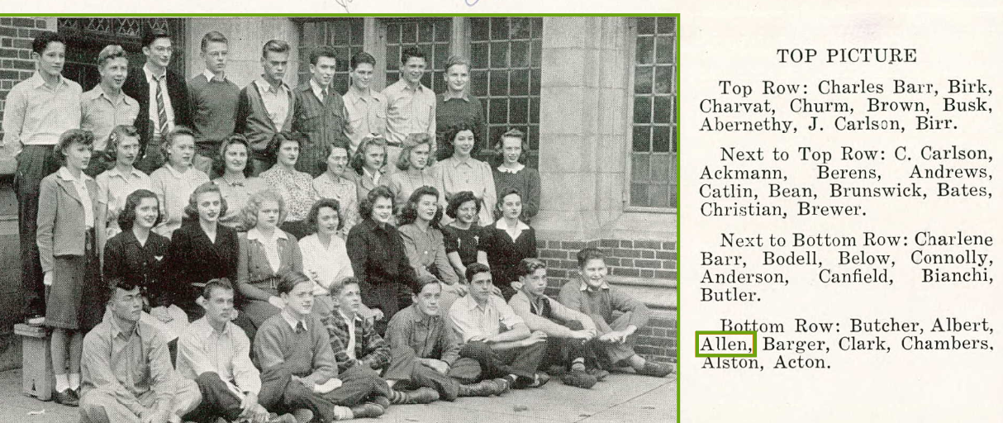
Glenbard High School Juniors, Shelton Allen is seated on the ground in the first row, third from left.

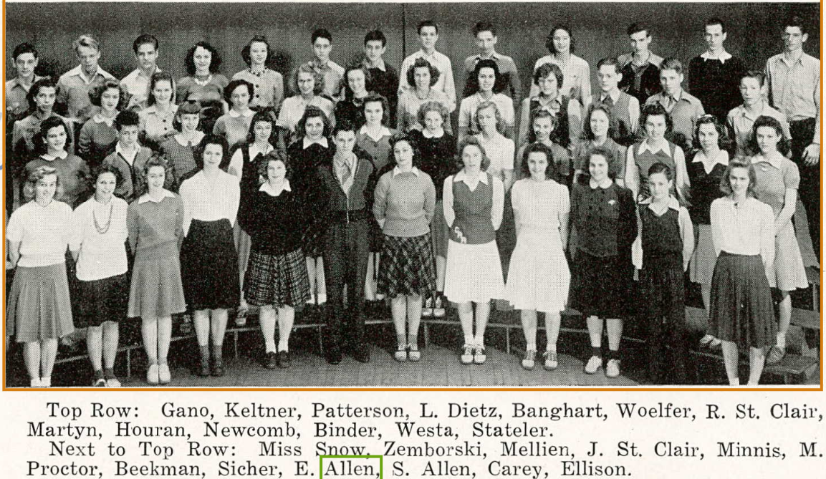
Glenbard High School French Club with both Evelyn Allen (Sophomore) and Shelton Allen (Junior, wearing a vest) fourth and third over from the right in the second to last row

NOVEMBER 16 – Shelton turned 16. Nancy was “delegated” to take Shelton, who was learning to drive, on his practice drives.

DECEMBER 11 - The US joined World War II after the attack on Pearl Harbor four days prior. https://historycooperative.org/when-did-the-us-enter-ww2/
1942

A DAILY RITUAL AT THE ALLEN HOME

At some time before my memory I was told the hot water heater had not turned off properly, overheated and exploded, or something! Anyway, I eventually reached a time when I was aware that every night Daddy would make sure everyone was finished using the hot water and then go down to the basement, look at the water heater, and then come back upstairs and go to bed. As each of us (meaning me, Shelton and Evelyn) reached an age where Daddy thought we could be trusted to perform this ritual we would be taken down to look at the water heater and to be instructed about what we were to do when we came down to check it. I thought we were all told the same thing; Daddy even demonstrated for me by turning on the hot water faucet to show how a little valve lifted up which resulted in the gas flame igniting. When the faucet was turned off the valve closed and the flame went out. My job was to look at the valve and be sure it had closed and that the flame was out. Even so, Daddy would always ask us when we came upstairs, “Did you look at the water heater?” We would answer “Yes” and all would safely go to bed.

Many years later when the family was together we were telling our kids some stories about our childhood and got onto the story about the water heater. Evie then popped up and said, “l never did know what I was supposed to look at.” I said, “You mean for years you went down to check on the water heater and you didn’t know what you were looking for?” “Yes, Shelton was supposed to tell me what to do, but he never did. So I’d go halfway down the basement stairs, look under the railing and see that the water heater was in its usual place (across the room next to the furnace) and turn around and go back upstairs. When Daddy asked if I’d looked at the water heater, I’d answer ‘Yes’ and he seemed to be satisfied so I’d go to bed.” The kids began to laugh, and even now when we tell the story, Evie and I can’t help laughing. As far as I know, that water heater never overheated again!

FALL - Shelton started his Senior year and Evelyn her Junior year at Glenbard High School. Nancy began attending Coe College in Cedar Rapids, Iowa.

NOVEMBER 11 – The U.S. Congress lowered the minimum age for registration for the draft to 18.

NOVEMBER 16 – Shelton turned 17.
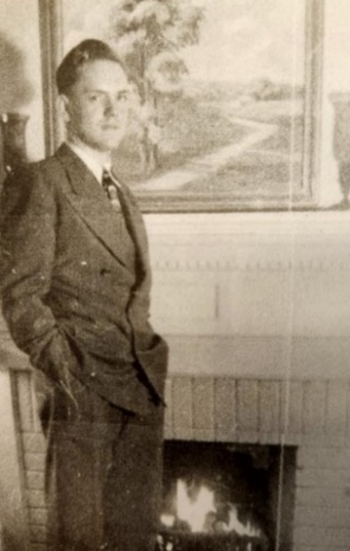
Shelton Allen (17)
1943

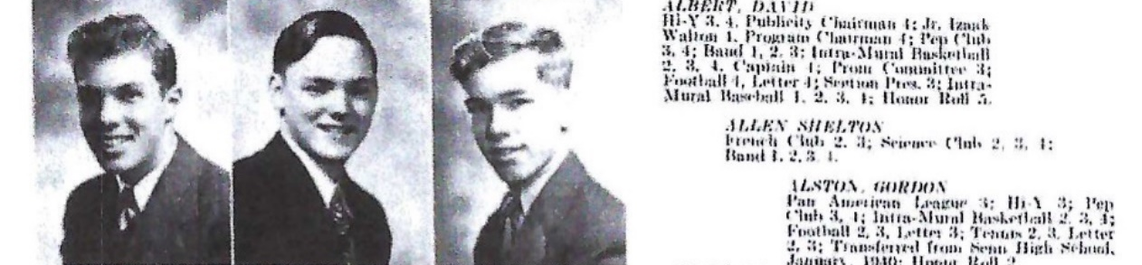
The picture is not very clear, but Shelton is in the middle. His caption reads:

ALLEN, SHELTON
French Club 2,3; Science Club 2, 3, 4;
Band 1, 2, 3, 4

Shelton was “terribly shy around girls” according to Nancy and had a massive inferiority complex according to him.

Evelyn had to guarantee that one of her friends liked him and would accept his invitation to his senior prom if only he would get up enough nerve to ask her! (He did.)

JUNE – Shelton graduated from Glenbard High School.

SUMMER – In his journal entry on the 25th of November 1946, transcribed below in the appropriate year, Shelton referred to the “Ghosts of ‘43”, the “summer of ‘43”, and some friends, including one in particular - Adelaide. It seems apparent he formed an affinity for this mysterious Adelaide and that she was perhaps his first great “love”. He described it as “a major topic, a chapter heading” in his life and that “for me, there seems to be no real life before the summer of ’43.”

FALL - Shelton started his freshman year at the Technological Institute of Northwestern University in Evanston, Illinois, about 31 miles from home.

Based on a science project which he submitted in high school, Shelton was awarded a full college scholarship by General Electric.

During his elementary and high school years Shelton’s friends called him “Shelt”. However, as the years went by, and children being children, he soon realized that his first name, although rich in family history, also brought teasing from schoolmates. Therefore, as his big sister Nancy later recalled, “When he was ready to go to college he confided in me that he didn’t want to be called by either of his names and asked me to give him a nickname he could introduce himself as when he got into his new surroundings. I suggested that he combine his two initials L. S. and call himself ‘Les’ Allen, and that’s what he did.” His parents, while visiting during his first year of college at Northwestern University were, at the very least, perplexed when they saw the name card on his dorm room door proclaiming “Les Allen” lived there. Maybe it is a rite of passage at a certain age for some people to not care for the name they were given when they were born. But later he would come to accept his middle name. For as long as I was aware he was Shelton or L. Shelton Allen, although what the “L” stood for remained a carefully guarded family secret.

NOVEMBER 16 – Shelton turned 18.
1944

JANUARY 10 – Shelton enlisted in the U.S. Navy but continued his studies at Northwestern University.

MARCH 15 – In his journal entry on the 25th of November 1946, transcribed below in the appropriate year, Shelton referred to “The Ides of March, 1944” and the “tremendous influence” Adelaide had on him. Perhaps it was during spring break from college, possibly in Michigan City, Indiana, that he met Adelaide again and was able to express his affection for her. He described these “Ides of March” along with the traumatic experience during the typhoon on Okinawa in 1945 as “points in time from which all thoughts, impressions, ideas, events, seem ordered” and “all of my convictions originated at that moment, or during that hour.”

SUMMER - Shelton, while in Monterey, possibly when he began his training with the Navy as a radio technician, had a “mountain top experience” where he felt “completely revitalized”, as he wrote in his journal on November 24, 1946, transcribed in the appropriate place below.

FALL – Shelton continued training with the Navy. Nancy started her senior year and Evelyn her freshman year at Coe College in Cedar Rapids, Iowa. Lam began to lose “control of his mental faculties”.

One afternoon the summer of 1944, while Evie was getting ready to leave for college, he wasn’t on the train when Mother went to pick him up. She waited for the next commuter train and he wasn’t on that one either. She frantically called his office manager, Archie Kelsey, who told her Dad had left for the station at his usual time. Then, if I correctly remember what I was told, she received a telephone call from the local station master who said he had been informed that Dad had been found on an empty train out in the yards. He was very confused and disoriented and they had to look in his wallet for identification and had him taken to the next train leaving for Glen Ellyn. Mother met the next train and with the help of the station master found him and took him home. Then she called Archie again and asked that from now on someone follow him to be sure he got on the right train.

That worked for a while until after Evie left for school. One day (Mother) got a call from one of her friends who told her she had seen Dad get off the train in Lombard, the stop before Glen Ellyn. It was a cold, snowy night. Mother drove to Lombard. He wasn’t at the station so, thinking he was probably trying to walk home, she drove up and down the nearby streets until she found him. After that she couldn’t allow him to go anywhere alone. They didn’t call it Alzheimer’s disease then - hardening of the arteries, I think. Whatever, it meant our dear Daddy was mentally slipping away from us at an alarming rate, and although Mother had been advised to place him in a nursing home, she couldn’t bring herself to do so. She had indicated she thought that since I was so close to him that I might be able to be a soothing influence since, like a child, he was rebelling when he wasn’t allowed to have his own way.

NOVEMBER 15 – Julia Ottilia Winckler Smith, Shelton’s Grandmother Smith, died in Glen Ellyn, Illinois at 72 years, 11 months, and 7 days old.

NOVEMBER 16 – Shelton turned 19.

Just before Thanksgiving I received a telephone call from Mother that Granny Smith had died. She was staying with Mother at the time. She complained during the day that she didn’t feel well and Mother took her to the doctor’s evening office hours. While waiting to see him, my dear, dear Mommy died in Mother’s arms. Through my tears I said to Mother, "She never got to go to Hawaii! "

Evie and I both went home for Christmas and our brother, Shelton, was home on leave just before he was to sail for the South Pacific as a radar-sonar technician for which he had been training for several months.

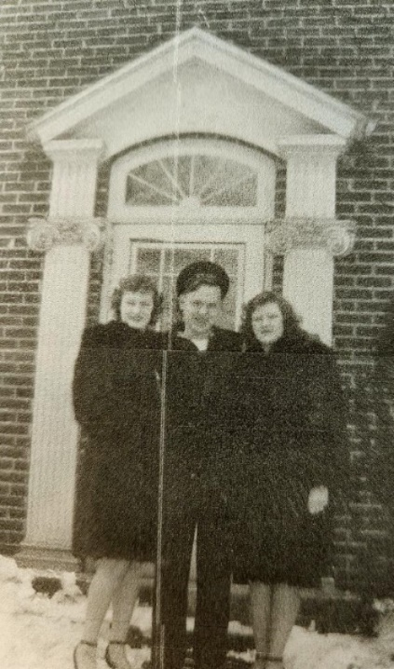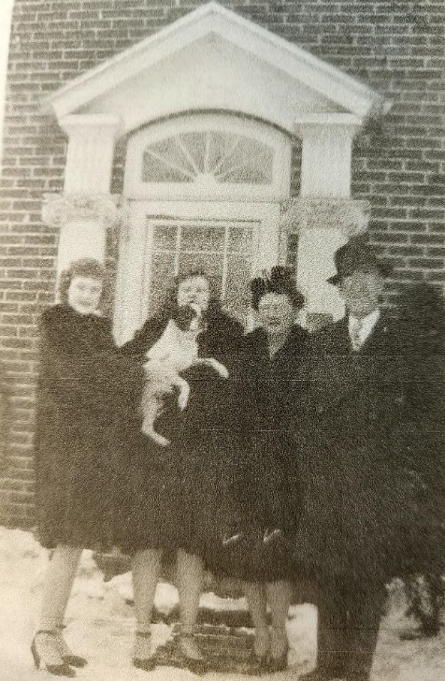
Nancy (21), Shelton (19), and Evelyn (17) Nancy, Evelyn with Teddy (9), Alice (44) and Lam (68)

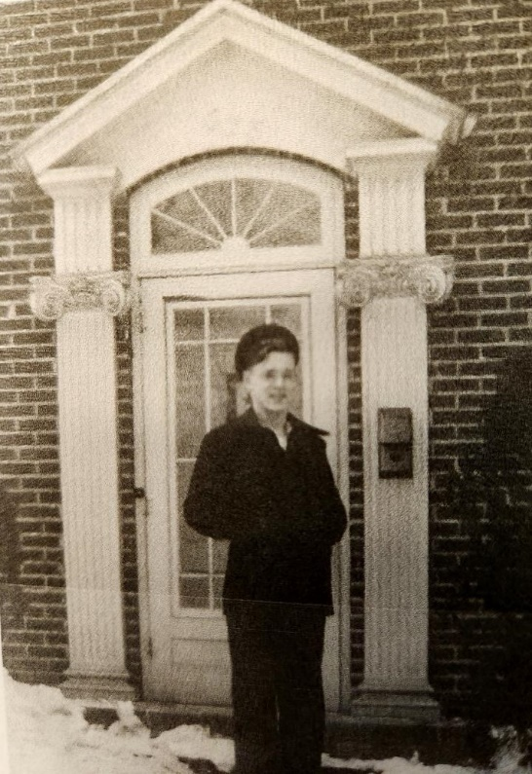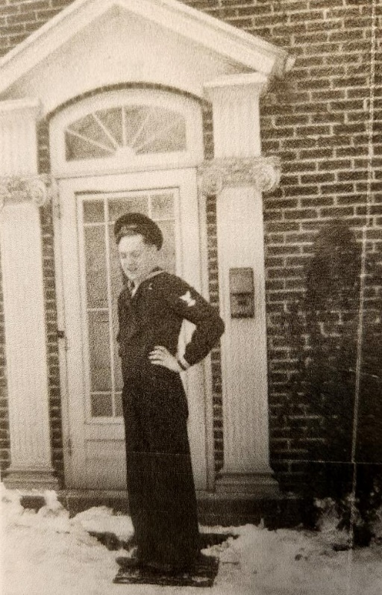
The Navy man, Lambeth Shelton Allen, Junior

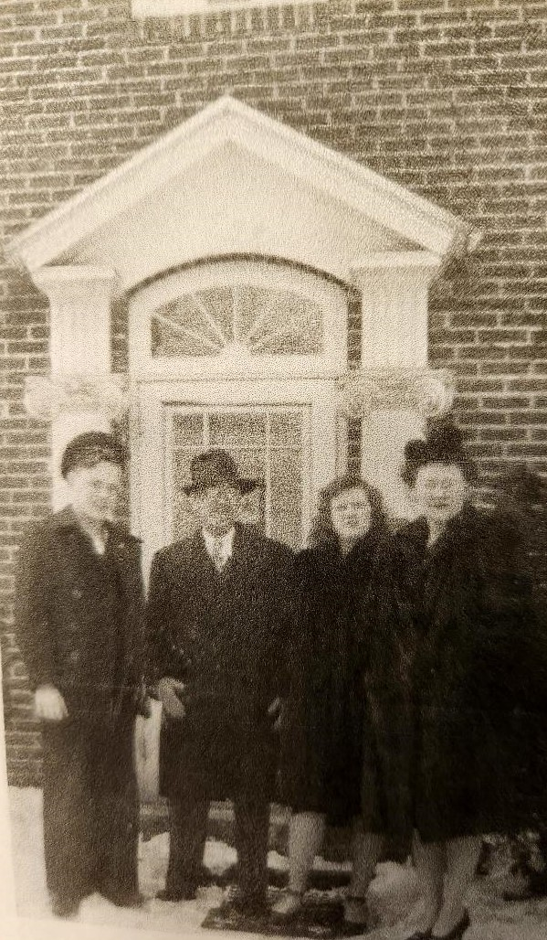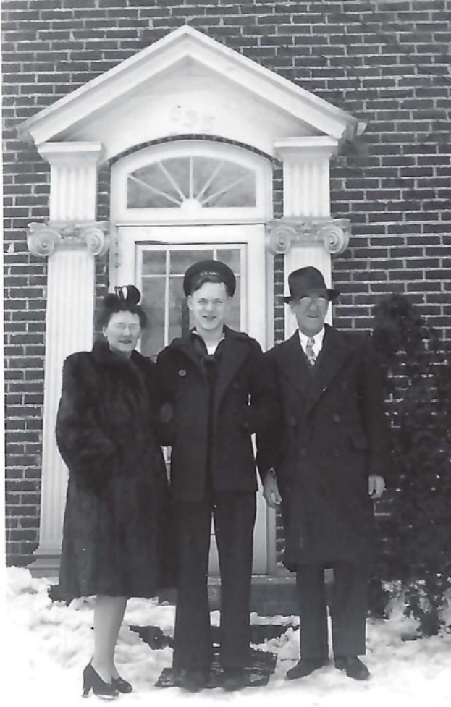
Shelton, Lam, Evelyn and Alice Allen Alice, Shelton and Lam Allen

We spent Christmas in East Troy with Uncle Ed’s family. There was a poignant feeling of sadness. The little house next door was closed and silent, waiting for Mother to come up and decide with Uncle Ed what to do with Mommy’s belongings.

1945

JANUARY – Shortly before leaving for the South Pacific with the Navy Shelton had some papers notarized by Archie Kelsey, the office manager at the L. S. Allen Company, “pertaining to a ‘patent idea’” he had, afraid that while he was deployed overseas “someone would steal” his idea. He wrote about these papers in his journal entry from December 27, 1946, which is transcribed in the appropriate year below.

JANUARY 20 – Franklin Roosevelt was sworn in for his fourth term as President of the United States.

APRIL 1 – On Easter Sunday, the Battle of Okinawa began. It “was the last major battle of World War II, and one of the bloodiest.” Three months and 21 days later it would end. “Though it resulted in an Allied victory, kamikaze fighters, rainy weather and fierce fighting on land, sea and air led to a large death toll on both sides.” https://www.history.com/topics/world-war-ii/battle-of-okinawa

APRIL 12 – President Roosevelt died of a cerebral hemorrhage while in office and his Vice President Harry S. Truman was sworn in as the 33rd President of the United States.

APRIL 30 – Adolf Hitler fatally shot himself in his bunker in Germany.

MAY 8 – V-E Day: Germany surrendered, ending the War in Europe, but not yet with Japan.

MAY 28, MEMORIAL DAY - Evelyn’s near-death experience while attending Coe College:

Early in the afternoon there was a rap on my door and it was the school nurse. My sister, Evelyn, had been taken to the dorm infirmary with a painful stomachache. The nurse had at first felt it was just from overeating, but had become concerned because Evie had a fever. She had called the school doctor who suggested Evie be taken to the hospital, which was across the street from the campus, to check her blood count. The nurse and I immediately went to the hospital where Evie had been taken by a taxi. The blood count showed a high rate of white blood cells and suddenly the pain stopped! The doctor immediately suspected a ruptured appendix and called for a surgeon, who happened to be out playing golf on this holiday.

In the meantime the nurse told me they had to have a parent’s permission to operate and I had to call Mother to tell her what was going on. The permission was given and I promised Mother I would call her as soon as I knew anything else. There was some delay in locating the surgeon before they could start the operation, and as I sat alone waiting for word, the nurse came out of the operating room, crying! The appendix had ruptured, Evie was already gangrenous; they had filled her with Sulfa which was the strongest medication they had and put her on a stomach pump and intravenous injections. Then they confiscated a private nurse from a male patient who had been injured in a small airplane accident, telling him there was a college student who was in a life or death situation.

I called Mother back and she said she would get to Cedar Rapids as quickly as she could. The school nurse was distraught and had to be calmed by hospital personnel. After the special nurse took charge I went back to the campus and found … some of my other friends. We notified Mrs. York and she gave us permission to prepare Evie’s room for Mother.

My … friends stayed up with me until we finally saw Mother walking up to the dorm about midnight. Otto Anderson had driven her in her car; he gave Mother all of his gasoline ration stamps so she would be able to drive to Cedar Rapids and back, saying he would straighten it out with the ration board to replace them. Aunt Olga had come over to the house to stay with Daddy. Otto stayed in a hotel overnight and took the train back to Chicago the next day … We all finally got to bed, but Mother was up early and spent five days sitting in Evelyn’s hospital room, knitting, reading and praying, because the doctors were not sure whether she would make it. They had been able to obtain some penicillin from the Clinton, Iowa, military hospital. This antibiotic had been available only to the military during the war and the dosages which eventually saved Evie’s life had to be released by special request from a group of doctors who were of the combined opinion that she was not responding to treatment and probably would not make it.

Evie was unconscious for five days. Dr. Berger was there to see her every day and was standing at the foot of her bed in prayer when she first opened her eyes. Even in such a physical state, her quick wit, when she saw Dr. Berger, burst forth with, “What is happening? Are you giving me the last rites?” Mother said she laughed and cried all at the same time as she realized she had her baby daughter back!

The Resident Nurse … Evelyn told me recently, was so traumatized by this experience that she gave up nursing and several years later, when attending a meeting in Chicago, came to Glen Ellyn “just to see her in a healthy state”, she said.

JUNE 21 - "After three months and 21 days, the fighting on Okinawa ends. US Army, Navy and Marines dead or missing are 18,900. At least 150,000 Japanese civilians have died – about one-third of the population – many by suicide. About 100,000 Japanese soldiers have died, many by suicide. 7,000 were taken alive." http://www.fsmitha.com/time/1945.htm

AUGUST 6 – The U.S. detonated the first atomic bomb over Hiroshima in Japan. It is estimated that between 70,000 and 135,000, mostly civilians, would die “both from acute exposure to the blasts and from long-term side effects of radiation.” https://www.history.com/topics/world-war-ii/bombing-of-hiroshima-and-nagasaki

AUGUST 9 - The U.S. detonated the second atomic bomb over Nagasaki in Japan. An estimated 60,000 – 80,000, again mostly civilians, would die. https://www.history.com/topics/world-war-ii/bombing-of-hiroshima-and-nagasaki

AUGUST 15 – V-J Day: Emperor Hirohito of Japan surrendered, thus ending World War II nearly six years and an estimated 70 - 85 million deaths after it was started with Hitler’s invasion of Poland. Shelton was serving as a Radio Technician 2nd class aboard the U.S.S. Alcyone (AKA-7) in the Pacific.

OCTOBER 9 – Typhoon “Louise” hit Okinawa where Shelton was stationed. The storm literally altered the direction of his life.

Later Shelton recounted his experience to his sister Nancy who wrote the following in her memoirs:

Shelton was a Sonar technician, and since the ship was not at sea where he would be responsible for detecting enemy submarines or ships which might be in the vicinity, at anchor he was considered a non-combatant. A large tent had been erected to serve as the mess hall on the island, among other things.

While the non-combatants were having dinner in the mess tent, they were suddenly advised that a typhoon was rapidly approaching the island and they were ordered back to their tents. Before all of them could reach their tents the storm hit the island with a vengeance, and without warning a piece of sheet metal, off one of the small buildings located near their campground, flew through the air and decapitated Shelton’s tentmate who was struggling against the high winds right next to him. Shelton scrambled to a large rock and hung onto to it for protection from the howling wind, weeping and horrified by what he had seen happen to his friend. He said he called out to God to save him, and promised Him that if he survived he would come back to Japan as a missionary to its people.

The story of his experience was dramatized in 1996 on the Christian radio program “Unshackled”.

According to the Naval History and Heritage Command, the Typhoon, called by the Japanese Akune, reached “winds of 80 knots (92 miles per hour) and 30-35 foot waves battered the ships and craft in [Buckner] bay [Nakagusku Bay] and tore into the quonset huts and buildings ashore. A total of 12 ships and craft were sunk, 222 grounded, and 32 severely damaged. Personnel casualties were 36 killed, 46 missing, and 100 seriously injured.”

It is highly probably that no one back home was aware of this typhoon, let alone where Shelton was actually stationed during his time in the Navy, other than somewhere in the South Pacific. Even if they had known he was on Okinawa, in those days the only way to quickly communicate important events, such as that he had survived this devastating typhoon, would have been through a telegram. Overseas telephone calls from service men across the Pacific were unheard of in those days, restricted during the war to official military use and even then only through spotty radio waves with lots of static and interference. The first undersea telephone cable to Japan was not placed until 1964 and even after that the cost was prohibitive to the average citizen for many years. Aside from a telegram, letters were written, but these sometimes could take weeks to reach their destination, especially during the war. It is highly probable that no one back in the States knew of this traumatic and ultimately life-altering event in Shelton’s life until over a year later when he returned home. Conversely, he most likely had not heard of his little sister Evelyn’s near-death experience until he had returned to the States. https://en.wikipedia.org/wiki/Submarine_communications_cable

OCTOBER 19 - George Orwell published an article in which he coined the phrase "Cold War" "to refer to what he predicted would be a nuclear stalemate between 'two or three monstrous super-states, each possessed of a weapon by which millions of people can be wiped out in a few seconds.' It was first used in the United States by the American financier and presidential adviser Bernard Baruch in a speech at the State House in Columbia, South Carolina, in 1947." This Cold War period between the United States and the Soviet Union would last for more than forty years until the breakup of the Soviet Union. https://www.britannica.com/event/Cold-War

NOVEMBER 16 – Shelton turned 20.

1946

MAY – In San Francisco while still in the Navy Shelton had an experience that nearly equaled his “mountain top” experience of revitalization that he had had in Monterey during the summer of 1944. He referenced this experience six months later in his journal, transcribed below on November 24, but gave no further detail to what actually happened.

JULY 4 – Lam, who had not been working since 1945, continued to decline.

Daddy liked to take our dog, Teddy, for walks in the park across the street from our house. Knowing that he easily became confused, either Mother or I would follow him from a distance or walk with him. As the 4th of July celebration started drawing a crowd across the street, he wanted to go for his walk. Mother tried to dissuade him, but called upon me to keep him at home. I tried talking to him calmly, but he didn’t understand why I wouldn’t let him go, and for the first time in his life turned on me, slapping my face. Mother was in the kitchen but heard me cry out. When she realized what happened she said, “If he will turn on you I’ll have to put him in a home.” She found a quiet place near a lake about 10 miles from Glen Ellyn with a wide porch where he could see the trees and water. She and I went every weekend to see him. He didn’t know who we were. It was heart-breaking when one day he looked at us with his sweet smile and said, “It’s so nice of you ladies to come and see me.”

JULY 17 – Shelton was discharged from the Navy.

FALL - Shelton returned for one more semester at the Technological Institute (“Tech”) at Northwestern University, “continuing his scholarship from General Electric”.

NOVEMBER 16 – Shelton turned 21.

THE FOLLOWING ARE ENTRIES FROM SHELTON’S OWN JOURNAL

While at “Tech” in Evanston, Illinois, Shelton wrote:

Nov. 20, 1946

I am at the crossroads. On the one hand there is my love of mathematics, and my sincere interest in electronics and radio, and on the other hand there is a desire to continue my search for the Absolute Truth.

Tonight Tony and I went to the Pembridge [a former hotel which served as a dorm for female students at the time] to meet some girls who are interested in the classics. We played Tchaikovsky’s 4th and sixth symphonies. After this, we entered on a discussion of ethics and religion. One girl asked if she was in need of saving, since she didn’t believe in a hereafter or in Christ’s divinity, although she did believe in God. Tony asked me if I wanted to answer the question, and I told him, “I’d rather not.”

Later I admitted to Tony that I would give almost everything I have if I could but put my thoughts into words the way he did tonight. I had let myself out of the conversation because of my self-consciousness and because of my inability to express myself. The thought has just occurred to me that perhaps this inability to put my thoughts into words is purely psychological.
Tech. is too materialistic for me. I want to go off by myself and think and talk and strive to find my answer to the question, “What is truth?”

Would to God that I could write up in this sheet of paper the thoughts and emotions that stir my soul! I feel surging within me what I wish to interpret as a “calling.” Indeed, the things that are preventing me from entering upon a career in the clergy are: my psychological speaking incapabilities; and my insufficient understanding of truth, of the answers to life’s perplexing problems. The former is probably due in part to the latter.

I am not afraid of death. I am not afraid of Hell. I believe that I can say this frankly and honestly. As a theorist, I love mankind, and the thought of mankind falling into sin and death grieves me. As a man on the street, jostled about by drunken men, boisterous men, and selfish men, I am a hater of mankind, believing that the world would be a wonderful place if it weren’t for men. There is, quite obviously, a schism, a dichotomy, here. I am perplexed. I am a believer in passive resistance. I believe I would turn the other cheek. I believe that I would rather die a tormented death than squeeze a trigger. I am in 01. [This may have been a military recruiting organization after the war.] Am I doing right? I am inclined to think not. Do I hold these beliefs, hoping for some future reward? I wish I knew. I am inclined to believe that I would hold to these beliefs even if it could be proved irrevocably that there is no hereafter, but, of course, I can’t be certain. A decision must be made. I have known for some time now that I should be at the crossroads soon. Must I sacrifice one completely? If so, tech. must go, for I cannot go on without God. Where am I to turn for help? Who can advise me?

Nov 21

I do not pretend to be moral, though I do not smoke nor drink and am a virgin. I am constantly falling into evil thoughts, hate, greed, and swearing.

Nov 23

I have decided that, by the Grace of God, I can and will overcome all of my bad, evil, and wicked habits. One I have had since infancy, one I have had only three years. It will not be easy. It is a gigantic task that I have undertaken, but if I ever intend to preach the Word of God, I must be beyond reproach.

Am I a hypocrite? I say I despise war, even fist fighting, and yet I am in 01 and encourage others to join, too. At least, I can’t deny that my motives are purely selfish. The Navy pays me almost enough to pay for my room, and if enough ETM’s join, we can get a radio transmitter and testing and repair equipment to play with. But am I living up to my ideals when I support a military organization?

I was worried before. I am more worried now. I don’t believe in falsehood, I don’t believe it is ever justified. Suppose, then, that I saw a murder committed. Am I to let the murderer go unpunished? If I am called as a witness, I could not lie. But my testimony would send a man to his death. Que faire? I would have to admit that I have some information. Refusal to testify is an offense against society. Would I take the punishment meted out by society rather than bear witness? If so, why? Do I expect a reward in the hereafter? What are my true motives for believing the way I do? I do not know myself.

Tony has often asked me why I am in tech. I have never been able to answer him. I must admit that I do not know myself. Tony says I should be a clergyman, a poet, a philosopher, anything but an engineer. While I don’t exactly consider Tony a criterion on character analysis, I must admit that I am inclined to agree with him when he says I shouldn’t try to become an engineer. What am I to do? Which way am I to turn? I must make up my mind definitely now. Time will not wait for me. If I wait, I will remain in tech. Would this be a mistake? Can I make a mistake? Is it all predestined? God help me to “unravel the master knot of human fate”! [From a story by Ellis Meredith first published in 1901.]

Why is it that I permit Satan to tempt me? Why is it that I obey him without resistance? I apparently have all of the questions, and none of the answers.

And yet, don’t we all have the answers? There are some who refuse to accept them as such, it is true, but the others, including myself. What of us? How are we different from those who do not believe? I believe it is the Spirit, the Divine Spark that gives the facts true meaning, that is lacking in me and all too many believers. If I sincerely believe all that Christ taught, how can I continue in sin? I have not placed my life entirely in his hands. I am too willing to go my own earthly way.

I think that my “psychological speaking incapabilities” are due to the fact that I am a hypocrite. How can I possibly express Divine Truth with the mouth that utters profanity? How can I conceivably censure and admonish others, while my own life is such a moral wreck? Oh God, have mercy on me, a hypocrite and an evildoer!! Grant that I may truly repent, and do thy will wholeheartedly. Chasten me and make me pure. Substitute convictions for my questions.

Amen.

Today I decided definitely to take French as an elective instead of German. I already have a working knowledge of French, and can probably take an intermediate course in the language. Eventually I hope to master French, German, Spanish, and Japanese, the real mastery attained by travel in the country. Why? Again, I don’t know. My lust for travelling was developed while I was in the Navy. I have always liked languages. But what do I intend to do when I get there? Just travel? No. Sometimes I answer this question “study engineering,” sometimes, “go into missionary and mission work.” I must decide, I must!

Why do I refuse to make up my mind? I think it is because I would decide to enter the clergy, which would mean giving up tech. which would upset my family and friends. I am also afraid that God will send me away from everything I know and love. I intend at present to remain in tech. until I get my degree, and then go into the clergy. If I don’t do it now, will I ever do it? I am afraid. Apparently I do not trust God entirely. “All things work together for good to them that love God.” Am I willing to believe this and put my life entirely in His hands? And how am I to know if it is His will that I go into the ministry?

Since the typhoon I have been on a steady rise. I escaped being an alcoholic by the Grace of God, and I gave up smoking by the Grace of God. I hope that some day I will be in a small way worthy of all the blessings He has bestowed upon me. How better than to give up all and follow Him in simple faith?

I didn’t think it possible, but Satan almost tempted me to smoke tonight. If I do, I am breaking an oath to God. God help me never to do this!!

Sun., Nov. 24, 1946

I went to the Methodist Church here in Evanston today and heard Dr. Tittle speak on “What Can I Do?” I expected something more than I got. “Write to your Congressman,” he said. He quoted Byrnes, Molotov, and, surprisingly enough, Christ. It seemed that, if the order of his presentation indicates anything, Christianity is second in importance in his mind to government and world federation.

The typical pattern, “The Lord be with you,” “and with thy spirit,” and “let us pray,” was followed during the service. I wonder how long it will be before they translate it back into Latin, “Dominus vobiscum, et cum spirito tuo,” etc.

“This church is affiliated with the Evanston Council of Churches, Church Federation of Greater Chicago, Federation Council of Churches, and World Council of Churches,” which may or may not be a good thing.

“Dr. Arthur Wagler, professor at Garret Biblical Institute, will speak to members of the High School Fellowship on “Protestantism and Catholicism” at the group’s regular meeting at 6:30 o’clock in rooms 33-4, 35, and 37.” Ought to be interesting. Too bad I can’t go. I guess they’re poisoning them while they’re young.

Up until now I have had phenomenal success with my determination of yesterday. I have found it almost too easy to resist. But Satan has a way of teasing us that way. I can’t allow myself to imagine that it is a cinch, and let my guard down.

I wish that I would look at this whole thing objectively always. At times, it is all very clear to me, but not for long. I am much too comfortable. What can awaken me? Another typhoon, perhaps?

It has been over six months now since my last “mountain-top experience.” I have been moved, it is true, but I have never been completely revitalized as I was one evening in Monterey in the summer of ’44. ‘Frisco in the spring of this year (’46) was the last time I approached it. I feel a need to feel the ever-present nearness of God.

Clearly the decision rests with me. If I could but place my trust completely in Him “as a little child.” Wherein lies my doubt?

Mon. Nov 25, 1946

Today I met Ruby Anderson in Scott Hall. Ghosts of ’43!!! We discussed Bob, Becky, Tex, ----- Adelaide, ---- Bob and A. D., Jim Martin and A. D. It seems all so strange now, like the morning after looking back on the night before. The Ides of March, 1944!!! What a tremendous influence that girl has exerted over my life!!! That letter. Perhaps I should have kept it. But why when I practically have it memorized?

She exists – actually, literally. She is not just a figment of my imagination. Her naïve husband is a fraternity brother of some of my 1943 friends. I will meet her again, of that I am certain. But what will I say? What will it mean? What effect will it have on me? On her? She will know me, I am sure.

I can look upon ’43 objectively. It involves tremendous emotional factors, it is true, but I can classify it and fit it into the outline of my life. It is a major topic, a chapter heading.

“Find some sweet kid whose first love you’ll be ----.” “’It was fun while it lasted’, thanks for the memory’, and ‘goodbye forever’.” Was it forever? Is it? I wondered when I wrote it. I wonder now.

I do not love her. I thought perhaps I always would ---- regardless. I have matured a lot since then. She is a lost soul in whom I have more than just a humanitarian interest. She is a part of my life. Perhaps I will be part of hers. She exerted an influence over me. Perhaps I will exert an influence over her. It will be interesting, ---- fascinating!!!

They say marriage hasn’t affected her. I can hardly believe that. I would like to talk to her. They say she confirms and denies; confirms to the world, denies to her husband. Has she no soul? But then, I know her better than to ask that! Would I, could I ever believe her again? “You can’t say that I haven’t been as frank and honest with you as possible at all times,” she said. She never denied. I never asked. She did say, “Forget me, leave me alone. I’m not good enough for you.” Would she be truthful with me now? It will be interesting!!

At some time, I suppose, I will get the insight. It must come through faith. Looking back, it will seem as though all of my convictions originated at that moment, or during that hour. The Ides of March 1944, October 9 1945. Both are points in time from which all thoughts, impressions, ideas, events, seem ordered. When the next milestone is reached, convictions I now hold will seem to have originated at that point in time still in the future. This is, fundamentally, the purpose of this diary, along with a desire to record progress day by day: to show me that I actually did live and think and hope before my revelation comes.

For me, there seems to be no real life before the summer of ’43. I remember events then as if they were events in the life of some person other than myself. Perhaps my existence now will appear a mere dream after the next milestone has been passed. Perhaps life is merely a succession of dreams after all, each vaguely recalling and loosely dependent on those that precede it.

I remember Michigan City, ---- the letter. Events ensuing from it I ascribe to the Ides. I remember SAH-7, Okinawa. Events ensuing from it I ascribe to the typhoon. Perhaps this diary will tell me at what particular point in time my subsequent insights took place.

“The moving Finger writes; and having writ, moves on: nor all your Piety nor Wit, shall lure it back to cancel half a Line, nor all your Tears wash out a Word of it.” [Quote by Omar Khayyam (from the 1859 translation into English by Edward Fitzgerald of the poem “The Rubáiyát of Omar Khayyam”)]

While home in Glen Ellyn for Thanksgiving break Shelton wrote the following:

Thurs., Nov. 28, 1946

Today was Thanksgiving. Notable in my progress is the fact that today I was asked to say Grace and declined. Why? I try to tell myself, “I’m not ready yet.” If I continue this procrastination I will never be ready. I must begin sometime. I declined to speak the Word of God to the girl at the Pembridge, and I have declined to say Grace at a Thanksgiving Dinner. Perhaps at Christmas I will be ready. If I am ready, I have merely to request to say it, and I shall be allowed to do so. I can if I will. What I must do between now and then is live up to my high ideals day by day, and abstain from all that I know to be wrong.

God strengthen me that I may be able to withstand Satan and refuse to obey his voice. May I put on the gospel armor. Make my will to conform to thy will. Help me not to desire to have my will fulfilled, but let me rather desire that in all things thy will be done. Those things I ask in Jesus’ precious name. Amen.

Fri., Nov 29, 1946

I have little to say. What can I say? I feel strongly my own worthlessness. I am arguing with God. I was about to say that I am arguing with God as did Moses and Ezekiel, but what a wrong impression that would give. I in no way consider myself worthy to be mentioned in the same paragraph with them.

It gladdens my sad heart to think that God is calling me. I don’t know for what purpose, to what place, in what capacity, or through what hardships, but I am certain that He is calling me.
If I would only meet Him halfway. Why do I continue to argue with Him? Why do I tenaciously hold to the ungodly course I am pursuing? Why do not I place my trust in Him and let Him lead me? I am afraid of what people will say. I hope for a sign. I tell myself I’m not good enough. If the Lord wants me, I should be willing to take His word for it that I am of some value to Him.
True, I am unworthy. Granted, I haven’t many talents to recommend me to the Lord. But “He is able to do exceeding abundantly above all that we ask or think.” I should be happy to serve Him in whatever capacity He thinks best.

“But,” I ask myself, “Just what does He expect from me?” I want my plans laid out before I make up my mind. I cannot get myself to prove my faith in God by sacrificing all. If He could sacrifice His Glory above, and His Blood on Calvary, cannot I sacrifice tech? Is it really His desire that I do?

In searching now through the Scriptures for the account of Ezekiel’s argument with God, I came across the following passage: Ezekiel 3:18. “When I say unto the wicked, Thou shalt surely die, and thou givest him not warning, nor speakest to warn the wicked from his wicked way, to save his life; the same wicked man shall die in his iniquity; but his blood will I require at thine hand.” In reading this, tears welled up in my eyes: tears not yet dry. I asked, “Is this, then, thy message to me?” Can I remain in tech while I preach to the wicked?

Sun, Dec 1, 1946

While reading Romans tonight, I became aware of the fact that it is not the works that justify man. If it were works, man would perhaps consider that it is something he did which saved him. But all of us are guilty before God. We are all evil continually. It is the Grace and the Love of God that redeems us. Perhaps, knowing this, I am going about this all in the wrong way.

Back at “Tech” in Evanston Shelton wrote the following:

Wed, Dec 11, 1946

I am nothing more nor less than a damned hypocrite!!!! I am wicked! I cannot rationalize my behavior. I am too much a slave of sensuality. It is futile, vain, and hypocritical for me to attempt to tell others how to run their lives according to moral standards when I myself am immoral in nearly every sense of the word.

I have decided to quit 01. I have decided that, holding my present ethical views about war and military organizations, I am wholly unjustified in being a member of one. I shall attempt to quit it tomorrow. But would to God that I were able to control myself! Would to God that logic and ethical reasoning were able to overcome animal passion! I am an animal. As much as I attempt to become human, and as much as I try to transcend my present state of immorality, I find myself almost totally unable to do so.

I have ceased smoking and drinking. And yet I continue to carry on my present immoral conduct, and I continue to curse and to swear, and to use foul and abusive language. This would be bad enough, but to be hypocritical besides is too much!!! Oh God, have mercy upon me! Am I beyond salvation?

Saturday, Dec. 14

Yesterday I quit 01. I feel so much more at ease with my conscience now because I am no longer a member of a military organization.

I hate myself. I hate myself because of the way I think and because of the way I talk, but above all, because of the way I act. True, it is not the act that damns the soul, but the wicked thoughts behind the act that give it life. But still, the act having been committed; the hateful deed having been done; the abominable thought and the damning influence have taken their toll of my soul.
I am not ready. I often doubt if I shall ever be ready. I wish that I could write here about a permanent decision, but I am unable to record aught but the doubts, fears, and nondecisions that beset me.

Back home in Glen Ellyn for Christmas break Shelton wrote the following:

Mon. Dec 16

Today I told Mother of my desire to travel. I told her that when I did, it wouldn’t be just a short vacation. She said, “It takes money to travel.” I answered, “I have two G’s. Besides, I don’t want to travel first class, or stay in the fanciest hotels in the country.” Mother asked, “What do you want to see, the slums?” “Certainly not just swank and Americanized hotels,” was my reply. “I want to see the people, how they live, how they think.”

Mother informed me that I am free to do as I please and go where I wish after I get my degree. “Is that too much to ask?” she said.

“You would be very mad at me and never speak to me again if I didn’t get my degree, wouldn’t you?” I said jokingly.

“I would be very disappointed,” she answered.

“That’s one of the few things that’s keeping me in school, mom,” was the statement of mine that brought tears to her eyes.

And so on one side there is the wish of my mother that I remain in tech., and on the other side there is the promise that, “every one that hath forsaken houses, or brethren, or sisters, or father, or mother, or wife, or children, or lands, for my name’s sake, shall receive an hundredfold, and shall inherit everlasting life.”

It is indeed a great decision. Will further deliberation avail me anything? Can I determine the right course of action by means of reason?

Sun, Dec 22

Two nights ago, the night of Dec 20, Friday, from 11:40 P.M. until 12:00 P.M., I prayed. Just 20 minutes (it could have been done in five) I confessed my moral bankruptcy, and my inability to stand against the unseen forces of evil, alone.* I was afraid to swear an oath to God, afraid I wouldn’t be able to keep it. But I thought that if I only had faith, I would be able to stand in the strength of the Trinity, and I am certain that Satan and all of his host is unable to stand against the Trinity.

And so I am free from temptation in this matter for always. Perhaps not from temptation, but at least from being tempted strongly enough to yield.

*At this time I also sang, silently and tearfully, “Into my heart, Lord Jesus.” I believe I meant it for the first time. (Sept. 10, 1947)

Wed, Dec. 25

I didn’t say grace today because the Andersons [Olga and Otto] were here to Christmas dinner.

I feel so free now, so released from immorality. Of course, I dream. It is the infirmity of the flesh. But I have not yielded and I shall not yield.

I have been wondering lately if perhaps there are not existing some angels and devils in human form. It is a primitive theory, perhaps, but it is something to think about. I would like to meet an angel. I undoubtedly wouldn’t recognize him, though.

Fri, Dec 27

Tonight I looked over some papers I had notarized almost two years ago. They were pertaining to a “patent idea” I had. I am going to burn them tomorrow. I cannot understand why Mother and Dad allowed me to talk to a patent attorney about it and why mother kept the paper in the vault.

I imagined myself to be quite grown up then, as I imagine myself to be now. The abuse of the English language that I made then was even more than my present abuse of it. I was a child in scope, concept, and understanding. It will be interesting in a few years to re-read these pages and see what a child I am now.

The bad feature about my “patent ideas” was that Kelsey [Ridell “Archie” Kelsey, the office manager at L.S Allen Company] saw them, knew what they pertained to, and notarized them. The good feature about these sheets is that probably no one will ever read them. I shall perhaps burn them in a few years, but I cannot be very objective about it now. I laugh when I remember how afraid I was that someone would steal my idea. They are welcome to it now, whether it’s bad or good. I suppose something could be made of it, but I have neither the time, the money, nor the inclination.

Mother told me a few days ago that Kelsey and Frank [Frank J. Wirkus, the shop manager who had worked for the L.S. Allen Company since 1907] were afraid of Nancy, Evelyn, and I. They thought that if anything happened to mother, we would try to take over the business and run it. I told mother that I don’t want it. They need have no fear of my trying to run it for them. If anything happens to mother, my share in the L. S. Allen Co. and Manton & Smith will go to Nancy and Evelyn, if I think at all then as I think now.

I don’t believe that I have as yet recorded here the intention of Tony and I to go to Alaska this summer. It would be just what I need, I think, to go to Alaska and hunt and fish and take all the time I need to think things out.

I don’t imagine I would hunt, though. Of course, if I don’t hunt, there is no excuse left for fishing, and no excuse left for ordering meat or fish while in a restaurant in town.

All this must sound awfully narrow. Perhaps I am being terribly infantile about it, but I don’t believe I have the right to take the life of one of God’s creatures, or to partake of the flesh of one of God’s creatures.
1947

SOMETIME THIS YEAR – Elmer’s Glue-All was first marketed for consumers. This, along with Scotch Tape (introduced in 1930) and Dove soap (which wasn’t marketed until 1957), was one of the products Shelton was later sure to take a supply of when he was in Japan. https://justuseglue.com/history-of-elmers-glue/

FROM SHELTON’S JOURNAL while still home in Glen Ellyn for Christmas break:

Jan. 1, 1947

Satan is able to cause a man’s mind to entertain all manner of hateful, blasphemous thoughts. A man’s mind can hate and despise these thoughts so much that he is unwilling to put them into words and entertain them in his mind in confession to Almighty God, and yet Satan is able to cause the thought to run through his mind.

I feel certain that, though I were convinced that I were eternally damned, I would seek to warn others and guide them into the right path, or, if that is impossible, at least to steer them away from the path that I followed.

It is not Christ that I hate, or the Holy Spirit that I blaspheme, but Antichrist and the Spirit of Perdition!!! God be my witness!!!

I have made my decision!!!! “As long as I am convinced that this is Thy will, oh God, I must obey. I have committed myself.” I shall cash my bonds, and turn the money, all of my worldly wealth, over to the Lord. I will be baptized by Reverend Stevens [of East Troy Bible Church], and go away, anywhere, to receive further Instructions from God.

Fri, Jan 3, 1947

Perhaps my decision of Jan 1st was a bit rash, or perhaps Satan is too strong for me. I am still convinced that it is God’s will that I sacrifice Tech. Therefore, I am committed so to do, but I am not yet sure what to do with my bonds. I shall retain them until I am sure.

I don’t know how to make my decision known. No one but myself and God are as yet aware of my decision. Tomorrow, Dolores, her roommate, Uncle Ed, and Reverend Stevens are coming. I shall tell them of it sometime tomorrow, I believe.

My decision as of now, is this: I will sacrifice Tech., and home. I will leave everything behind except a suitcase full of clothes and $400 in addition to my Bibles. I will go somewhere, anywhere, and await the revelation of the Lord.

I don’t want to make a mistake. I don’t want to do anything rash. I want to be sure that every step I take is right and well within the will of God.

NANCY’S MEMORIES OF THESE EVENTS – Friday, January 3

[Shelton] was home for the Christmas holiday break. One evening Mother was at a friend’s house when Shelton came to my room, saying he wanted to talk to me. I was somewhat surprised because all during our adolescent years Shelton and Evelyn had always had a close relationship; I, being the oldest, always had other interests. In short, they were just my kid brother and sister, so I had little interest in their activities. I couldn’t imagine what he would want to talk to me about.

He shut the door and then told me that he would like me to help him tell Mother that he wasn’t going to return to Northwestern but wanted to enroll in a school which would prepare him for the ministry as a missionary. So, now I understood his having come to me. I was to assume the role of big sister!

I asked him whenever he had decided he wanted to be a missionary. He then told me an amazing story. At one time when his ship was anchored near a U.S. occupied island in the South Pacific [Okinawa], non-combatant troops were housed in tents on the island. Shelton was a Sonar technician, and since the ship was not at sea where he would be responsible for detecting enemy submarines or ships which might be in their vicinity, at anchor he was considered a non-combatant. A large tent had been erected to serve as the mess hall on the island, among other things.

While the non-combatants were having dinner in the mess tent, they were suddenly advised that a typhoon was rapidly approaching the island and they were ordered back to their tents. Before all of them could reach their tents the storm hit the island with a vengeance, and without warning a piece of sheet metal, off one of the small buildings located near their campground, flew through the air and decapitated Shelton’s tentmate who was struggling against the high winds right next to him. Shelton scrambled to a large rock and hung onto to it for protection from the howling wind, weeping and horrified by what he had seen happen to his friend. He said he called out to God to save him, and promised Him that if he survived he would come back to Japan as a missionary to its people.

When he finally got back to his tent, the only thing which had not blown away was a Bible which Grandma Smith (Mommy) had given him just before he left for overseas. It was drenched from the rain, and he said he spent days turning the pages one by one to dry them, and every day until he was back home read God’s book for the first time.

Shelton then told me, “l thought I could go back to Northwestern and take up where I had left off, but God won’t let me forget that promise! I’ve got to go back to that part of the world as a missionary!”

The next morning I went with him to talk with Mother. She was adamant against it at first, not able to face what she felt was losing her son for a second time, but with God’s help, Shelton and I prevailed. [Here Nancy’s recollections vary slightly from what Shelton wrote in his journal below.] Mother called Uncle Ed and told him what happened. They left immediately for East Troy and when they returned they had made the decision that Shelton would drop out of Northwestern and enroll at Bob Jones University, a fundamental Christian school, where one of Uncle Ed’s daughters, Dolores, was a student. So, after New Year’s day, 1947, Shelton was on his way to the east coast, North Carolina I think. [Greenville, South Carolina]

Mother often expressed disappointment that he did not take advantage of the balance of that scholarship which would have led to challenging employment with G.E.

FROM SHELTON’S JOURNAL

Sat. Jan 4, 1947 [Alice’s 47th birthday]

I told mother just a few minutes ago!! I told her I hadn’t told her before because I wasn’t sure how she’d take it. She told me that I should have known she wanted me to do what will make me happy. She asked, “Can’t we work it out together?” But I told her it must be between myself and the Lord.

I am going up to East Troy with Uncle Ed and Reverend Stevens, become baptized, and then --- I’ll see.

Mother doesn’t want me to go off by myself. She, as always, is afraid for my safety. God bless her!!!

(11:50 P.M.) I am in East Troy. We had a prayer meeting at Steven’s. For the first time in my life I prayed in a group. We prayed for my family, after thanking God for giving me eternal life, and a knowledge of His will.

Uncle Ed and Reverend Stevens both believe that mother is at the point of salvation. I sincerely hope and pray so. I have found peace. I want to show others the way to peace, through Christ, as it can come in no other way.

I have much to learn. Satan’s voice still speaks to me. I suppose it always will, but I am as yet unaccustomed to resisting.

Sun., Jan 5, 1947

Today, I was called upon to give my testimony before the East Troy Bible Church at their evening meeting. Reverend Stevens said I preached my first sermon. Uncle Ed said that mother would have been proud of me.

Reverend Stevens told me I handled it like a veteran, and they say that whatever he says, he means. His “yea is yea and his nay, nay.” I was afraid, I was self-conscious, but I was strengthened and sustained by the Spirit.

Yesterday as we were coming up here, Rev. Stevens asked me, if I am not going back to Northwestern, and I can’t get into a ministerial school right away, what would I do with my time. I told him that I would read God’s word and study it this time. He asked me if I felt a responsibility for the lost souls, and I told him of my experience with Ezekiel 3:18. After telling him this, he told me that he was convinced that I am called of God. As he says, my “down and out is now up and out.”

Arrangements are to be made for my baptism, and Reverend Stevens is going to write to Dr. Bob Jones to see how long it will be before I can get into Bob Jones College.

Tomorrow I am going to break with Northwestern, and then stop off at Moody Bible Institute and get a copy of “Gray’s Synthetic Bible Study”, for home study of the Word between now and the time I can enter Bob Jones College, which may not be until next September.

Wed, Jan 8, 1947

I am at home, have been since Monday night. Reverend Stevens helped me to get my feet planted firmly on the Rock, and then I came home.

Mother is afraid that I have “gone off the deep end”, and become a “fanatic.” She is still convinced that the arm of flesh sustains, and that she will “be giving some others a push up the golden stairs.” She does not understand the workings of the Spirit.

Satan’s voice seems to grow stronger each day. Eventually my faith must be placed to another test. I pray that the Holy Spirit of God will deafen my ear to Satan’s blasphemies. The thought of them is painful to me.

Sunday, January 19, 1947

Up until this time, I have thought that I was saved on Okinawa during the typhoon, but looking back over these notes, I realize that that was merely my conviction before God. I was really saved December 29, just one month ago, when I “confessed my moral bankruptcy.” I can see that that was a turning-point of equal or greater importance than the conviction of the Holy Spirit Oct 9, 1945 [the typhoon].

I pray to God that mother’s acceptance of Christ on January 17, after a talk in our home by Reverend Stevens, is heart-felt. I pray that she realizes now that the arm of flesh fails, and that society cannot satisfy the thirsting and searching of the spirit and soul of man.

Killing animals for meat is not a sin. I am convinced of this from Genesis 9, verse 3. [“Every moving thing that liveth shall be meat for you; even as the green herb have I given you all things.”] I will keep my bonds. They are a gift to me from God.

JANUARY - Shelton started attending Bob Jones University in Greenville, South Carolina as a 2nd semester Freshman.

MARCH 7 - "The first pictures of Earth as seen from altitude greater than 100 miles in space" from cameras mounted in the nose shell of a V-2 rocket "clearly showed the planet set against the blackness of space." https://www.nasa.gov/multimedia/imagegallery/image_feature_1298.html

FALL – Shelton started his Sophomore year at Bob Jones University.

NOVEMBER 16 – Shelton turned 22.

1948

MAY 3 – CBS Television began broadcasting a 15-minute segment with an anchorman as the “First, Live, Nightly Network News”. https://eyesofageneration.com/may-3-1948-cbs-debuts-tvs-first-live-nightly-network-news

MAY 14 – Israel was established as an independent state in a plan approved by the United Nations which partitioned Palestine between the Jews and Arabs. The Arabs, of course, rejected the plan. https://www.history.com/topics/middle-east/history-of-israel

AUGUST 14 – Nancy married Al Haeger.

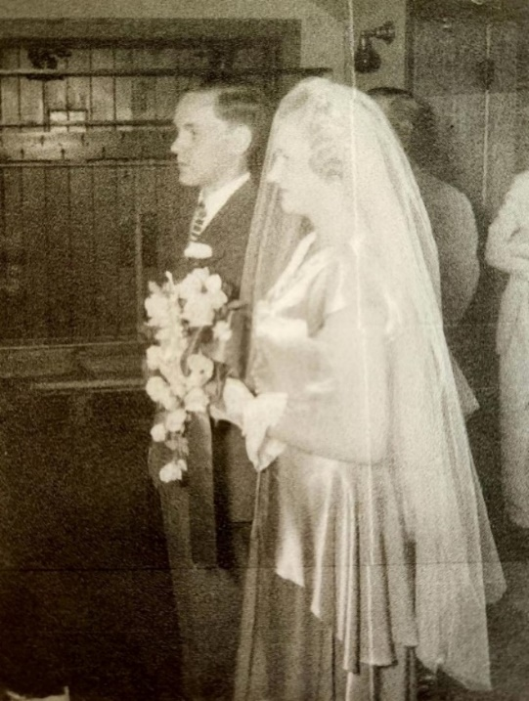

Two days after sister Nancy’s 25th birthday Shelton walked her down the aisle in place of their father Lam whose dementia had advanced to where he would not have understood the circumstances or recognized anyone.

In a letter to Shelton in 2001, Nancy wrote:

There are … two times when we were together that have always meant a great deal to me – the time, one night … when you were home for Christmas break from Northwestern and you asked me to help you tell mother and Dad* that you would not be returning there to school because you had been called to return to the far east as a missionary. At the end of that Christmas holiday you were on your way to Bob Jones. The second time was in August 1948 when you accompanied me down the aisle at my wedding because Dad was in a nursing home and incapable of being present.

*Although their father had already been in a nursing home for about six months.

Fall 1948 - "Regularly scheduled programming on the four networks— ... ABC ... CBS ... NBC and the DuMont Television Network, which folded in 1955—was scarce. On some evenings, a network might not offer any programs at all, and it was rare for any network to broadcast a full complement of shows during the entire period that became known as prime time (8–11 PM, Eastern Standard Time). Sales of television sets were low, so, even if programs had been available, their potential audience was limited. To encourage sales, daytime sports broadcasts were scheduled on weekends in an effort to lure heads of households to purchase sets they saw demonstrated in local appliance stores and taverns—the venues where most TV viewing in America took place before 1948. Although a television set cost about $400—a substantial sum at the time ... by autumn of that year, most of the evening schedules on all four networks had been filled, and sets began appearing in more and more living rooms, a phenomenon many credited to comedian Milton Berle (who) was the star of TV’s first hit show, The Texaco Star Theatre (NBC, 1948–53), a comedy-variety show that quickly became the most popular program at that point in television’s very short history. When the series debuted, fewer than 2 percent of American households had a television set; when Berle left the air in 1956 (after starring in his subsequent NBC series The Buick-Berle Show [1953–55] and The Milton Berle Show [1955–56]), TV was in 70 percent of the country’s homes, and Berle had acquired the nickname 'Mr. Television.'” https://www.britannica.com/art/television-in-the-United-States

FALL - Shelton started his Junior year at Bob Jones University.

NOVEMBER 16 – Shelton turned 23.

1949

JANUARY 20 – Harry Truman was sworn in for his second term as President of the United States.

JUNE – “The world’s first operational stored-program computer [began] running its first program”. The Manchester Mark I “was designed by T. Kilburn and F.C. Williams at the University of Manchester in the United Kingdom. https://www.encyclopedia.com/computing/dictionaries-thesauruses-pictures-and-press-releases/manchester-mark-i “The computer can both calculate and control the sequence of calculations at electronic speed. It's a glorified calculator." http://www.fsmitha.com/time/1949.htm

August 6 – Shelton walked his little sister Evelyn (22) down the aisle for her marriage to William Kudebeh.

Shelton was discharged from the Navy in 1946, returned to Northwestern University for one quarter, then transferred to Bob Jones University. He would be home for holidays, and by the time I married in 1948 and Evie married in 1949, Dad was in a nursing home diagnosed with what is now called Alzheimer’s disease and Shelton escorted both of us down the aisle in Dad’s place. We were married in August, a year apart, so I don’t remember if he came home for the entire summers or just for the weddings.

Later in life Shelton described his sisters in the following way, “One who was always on the Honor Roll [Nancy], and one who always had lots of friends and could make people laugh [Evelyn]. And both of you could sing!"

FALL - Shelton started his Senior year at Bob Jones University.

NOVEMBER 16 – Shelton turned 24.

1950

11 MARCH – Lambeth Shelton Allen, Senior, Shelton’s father, died at the Bellevue Place Sanitorium in Round Lake, Illinois from complications of dementia at 73 years, 3 months, and 26 days old.

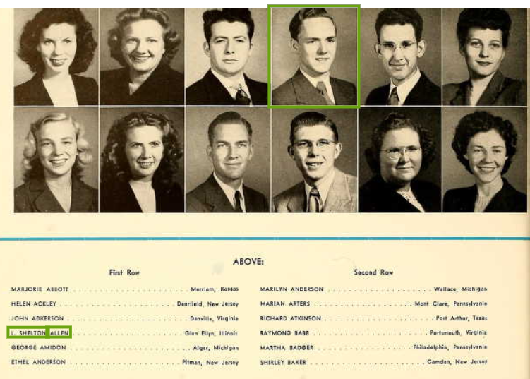

APRIL – The U.S. Census shows L.S. Allen, 24, as a student at Bob Jones University in Greenville, South Carolina.

JUNE - Shelton graduated from Bob Jones University and joined Far Eastern Gospel Crusade (FEGC), the mission board that he would serve under in Japan.

JUNE 27 – THE KOREAN WAR – Less than five years after the end of World War II "President Truman announced to the nation and the world that America would intervene in the Korean conflict in order to prevent the conquest of an independent nation by communism ... Despite the fear that U.S. intervention in Korea might lead to open warfare between the United States and Russia after years of 'cold war,' Truman’s decision was met with overwhelming approval from Congress and the U.S. public. Truman did not ask for a declaration of war, but Congress voted to extend the draft and authorized Truman to call up reservists." https://www.history.com/this-day-in-history/truman-orders-u-s-forces-to-korea-2

FALL – Shelton traveled to Kentucky as a minister.

October 1, 1950

Dear Mom,

I really don’t expect you to believe half of what I’m going to tell you in this letter, but I hereby solemnly affirm that all statements herein made are the truth, the whole truth and nothing but the truth. I wouldn’t believe it either if I hadn’t seen it and experienced it all myself. This is really the hills and I don’t mean maybe. For example, this letter was started on its way by means of a mule pack. I’m not kidding.

I don’t know just exactly how far I am from yawl, but it took me a little longer to get here than I had expected. I didn’t arrive until about 7:00. That was partly due to the hills, which have more hairpin turns than I ever thought I’d live to see. After leaving Winchester, it was one hairpin after another, and it was impossible to travel much faster than fifteen or twenty miles per hour. The grades also were very steep, and sometimes I felt as if I were climbing straight up. Never saw such terrain!

After I got to the roaring town of Jackson, I headed out for Shoulder Blade, and I checked my mileage and added ten miles to it, hoping to be able to spot something that looked like a town after that much mileage had elapsed. I knew by that time that what was called a “town” on the map was only a wide place in the road, but Shoulder Blade beats all I ever expected. I sailed right on by it without even knowing it was there. After I had gone a few miles further, I stopped and asked a man, and he said that “hit” was back over the hill I’d just successfully climbed. So back I went over the hairpins, and found a curve in the road that had a sign saying “school”. I couldn’t see any signs of life except a few boys going up a dirt road, but they assured me that I was at Shoulder Blade, and the dirt “road” was the way to the Highland School about five miles further.

So off I went clocking another five miles until I came to another wide place in the road and another dirt road going off from there, which I rightly understood to be Guerrant. Going up that road “a piece” brought me here at Highland.

Naturally, a school located right by a super highway such as this has electricity, so that part is all right, but there is no telephone service. There is a ’phone here at the school, but it never works, so it might not be here at all. We have two mule express mail deliveries a day, so that may not slow up the mail too much. The man that rides the U. S. Mule out here is an old character with a white handlebar mustache.

The first night, they put me in the guest room, which was located right in the middle of the girl’s dormitory. You can imagine how I felt about that. High school girls running around all over the place, and me a subject of much interest, whispering, and so on. I was the only stranger in these parts, so that caused quite a stir. It seems they had been awaiting my arrival, and that all day long, whenever a car drove up, they all put on their best smile expecting to greet the new teacher, so when I did get here, I was thoroughly stared at, which can cause some discomfort.
The next day, Mrs. Coker explained the situation to me, and I stated my position, and we have reached a tentative agreement pending approval by the IFCA [Independent Fundamental Churches of America] and the FEGC [Far Eastern Gospel Crusade]. I am sure that the Crusade will be very pleased with the set-up, and I am also positive that everything will be OK with Stevens. I will explain all of that later.

Alice [I don’t believe this was his cousin Alice Smith as she had married John Rogers in 1942 and was living in Aimes, Iowa per the 1950 U.S. Census with her husband and two sons, but Shelton refers to her as if she was someone his mother knew as well.] said that maybe I’d like to come to her psychology class the next morning since I didn’t have a class until second period. I wasn’t to teach the first day, but I thought I might go along with the temporary teacher and see how things went. Alice warned me though that if I did attend her class, I’d have to give a lecture, but I misunderstood, and thought she said that I’d get a lecture. Anyway, with nothing else to do, I dropped in and took a seat in the rear, and was promptly introduced and requested to take over. The lesson was on habits, good and bad, and how they’re made and broken. I had great fun. Then I met Mr. Schum, the temporary teacher, who is also the preacher with whom I will be working. He is a graduate of Bob Jones College ten years ago, and is well acquainted with Rev. Stevens and with Bill Stevens Junior, having gone to school together at BJ. Mr. Schum said that I will have ample opportunity to do every possible phase of Christian service and pastoral duties, including funerals. They have quite a few of them here. The death rate from disease is high because of flies, distance from competent doctors, and impassibility of “roads”. When the rains come, it is impossible to reach a large percentage of the population, as I will explain later, which you also won’t believe. Then too, there is remaining hostility of the old feudal days, and that term doesn’t mean what it means in English History. It has nothing to do with lords and serfs and manors. It means the old “feudin’, fussin’, and fightin’”. There was a man who got his head bashed in with a hammer just last week, and the man that did it said as he hit him, “I’ve been meanin’ to get even with you for three years”. They hid the body in a well.

Friday night was prayer meeting night in the “holler”. One of the families at the Shoulder Blade church was having prayer meeting at their house about two miles up the creek from Shoulder Blade. Mr. Schum took me along. No REA up there. (REA is “Rural Electrification Authority”). These hills as I’ve said before are impassable, so we have to travel in the valleys between them. What’s in the valley? A creek. What’s on both sides of the creek? Mountains, rising almost straight up. What’s there to travel over? Creek bed. Yes, believe it or not, the majority of the population is “up the creek”. Mr. Schum has a jeep, which is the only possible means of transportation besides a mule. I didn’t think it was possible, but that jeep in “low-low” with four wheel drive pulled over those boulders in the creek and climbed up water falls just like a caterpillar tractor. It was a rough ride, but we finally arrived farther up the creek than any car had traveled before. The people remarked how funny it looked to see a car up that far. So we had prayer meeting by kerosene lamp. Once Mr. Schum was up a creek and he saw the water turn muddy, so he figured that they’d had a rain further up, and decided to head out. He was lucky, because the creek rose up so high just as he got out that the people were stranded for a week. Seems that when the rains come, with the maintains so close to the creek and rising so sharp, the water has no place to go but up, and the creek may rise from a little trickle to a 35-foot-deep river in a few hours. Just about every year regular the floods come, and the people have to get out of their houses in a rowboat. They don’t mind, though, because as one man put it, the houses get washed out real good at least once a year.

From the guest room, they moved me up to the high school boy’s dormitory. I am the “matron” of this dorm. The boys don’t seem to understand that a man can’t be a matron, but it is a convenient term, and Mrs. Coker said not to say anything about it. It’s just a synonym for Dormitory Supervisor to them. I have fourteen boys, all of them over fourteen, but some of them are in grade school. For that reason, this is the “old boys” dorm and Alice has the “young boys” dorm. I have an apartment here. It is two rooms connected by a hall off from which there is a bath. In the living room, such as it is, I have a cot, two straight chairs and a rocker and a desk and desk lamp. In the bedroom there is a double bed, a chest of drawers, and another rocking chair. I have a little electric burner for boiling coffee, etc., and I have an old Frigidaire which is in good working condition. The only thing I don’t have the facilities to do is baking.
Lights are out here at 9:00 C.S.T and rising bell rings at 5:45. Breakfast is at 6:15.

I started this letter Saturday, and here it is Monday night already. I think that a paragraph or two was written yesterday. Sunday was a busy day, and today I had to prepare for my classes and coach basketball. I have had quite an interesting time of it. Also, I have been appointed the young people’s director. That means that I am put in charge of just about everything that no one else wants to do. It is lots of fun.

My first day of teaching went off all right. I have had more trouble with my English class than with any other. It seems that so many of the work students have to get up earlier than any of the others, and English is right after lunch, so they get pretty sleepy. I was warned of that by Mr. Schum. Then too, some of them have had a lot of drill on Grammar, and some of them practically none. So that means that my class is divided, but I feel that I ought to spend a little time on grammar for the benefit of those who are lacking in it.

I went to a graveyard picnic yesterday. Everyone who has “kin” buried in the graveyard are invited, as well as all preachers in the area. Since they claim kin as far removed as sixth cousins, and they all live just “up the creek” or “up the holler” from each other, the graveyard picnics include practically all of the neighborhood, except of course the Martins don’t invite the Coys to come unless they leave their shootin’ arms at home.

After the picnic, we went to a church up the creek. We had to walk about ½ mile, and cross a swinging bridge. It was the most rickety thing that I ever crossed. It was about ten feet above the creek bottom, but it gets washed out every year when the floods come.

I played my saw for the young people’s meeting last night. They seemed to like it fine. It is always such a novelty. Now they want to hear the rubber glove, and the “OOK.” Incidentally, I forgot to bring the ook and I didn’t return the books to the library.

Next Wednesday, the 11th, starts vacation here until the 17th. I don’t think that Rev. Stevens can arrange to have the ordination on, say, the 13th or 14th could he? It is rather short notice, I admit. Maybe I should write to him and see.

I am drawing a salary of $125 a month. That is almost twice what Uncle Sam was giving me, and so I ought to be able to save a sizable sum. I will be sending money home periodically, unless I decide to put it in a bank here at Jackson.

Well, the boys will be returning from study hall in about twenty minutes, and I haven’t begun my studying for the classes tomorrow yet, so I’d better get this letter in an envelope and on that mule. Don’t be surprised if it has a barnyard scent.

All my love,
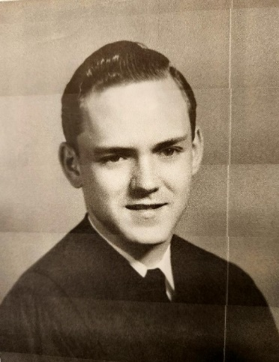

Shelton was ordained as a minister of the Gospel at East Troy Bible Church in Wisconsin, either during the school break he mentioned in his letter above or later that year or the next.

NOVEMBER 16 – Shelton turned 25.
1951

SEPTEMBER - "President Harry S. Truman’s opening speech before a conference in San Francisco is broadcast across the nation, marking the first time a television program was broadcast from coast to coast." https://www.history.com/this-day-in-history/president-truman-makes-first-transcontinental-television-broadcast

NOVEMBER 16 – Shelton turned 26. Years later he would say, “No one should get older than 26!”

DECEMBER – While on the train to California and the ship that would take him to Japan to begin his missionary service with Far Eastern Gospel Crusade, Shelton wrote a poem which would later be set to music by two fellow missionaries. When the hymn was published, he included the following introduction:

Ephesians 1:12 had arrested my attention for many years, particularly after having been called to missionary service.

In December, 1951, while aboard a train on the way to California, this verse in Ephesians again overwhelmed me. “That we should be to the praise of His Glory!” No one could know better than I how hopelessly impossible that was with me. And yet He had willed it! “My life for thy Glory! Lord, can it be that Thou has willed this for me?” These words uttered in prayer took the form of a little poem, the first two stanzas and chorus of which were jotted down aboard that train. The chorus, the answer to the theme questions, was inspired by Galatians 2:20: I am crucified, Christ lives in me.

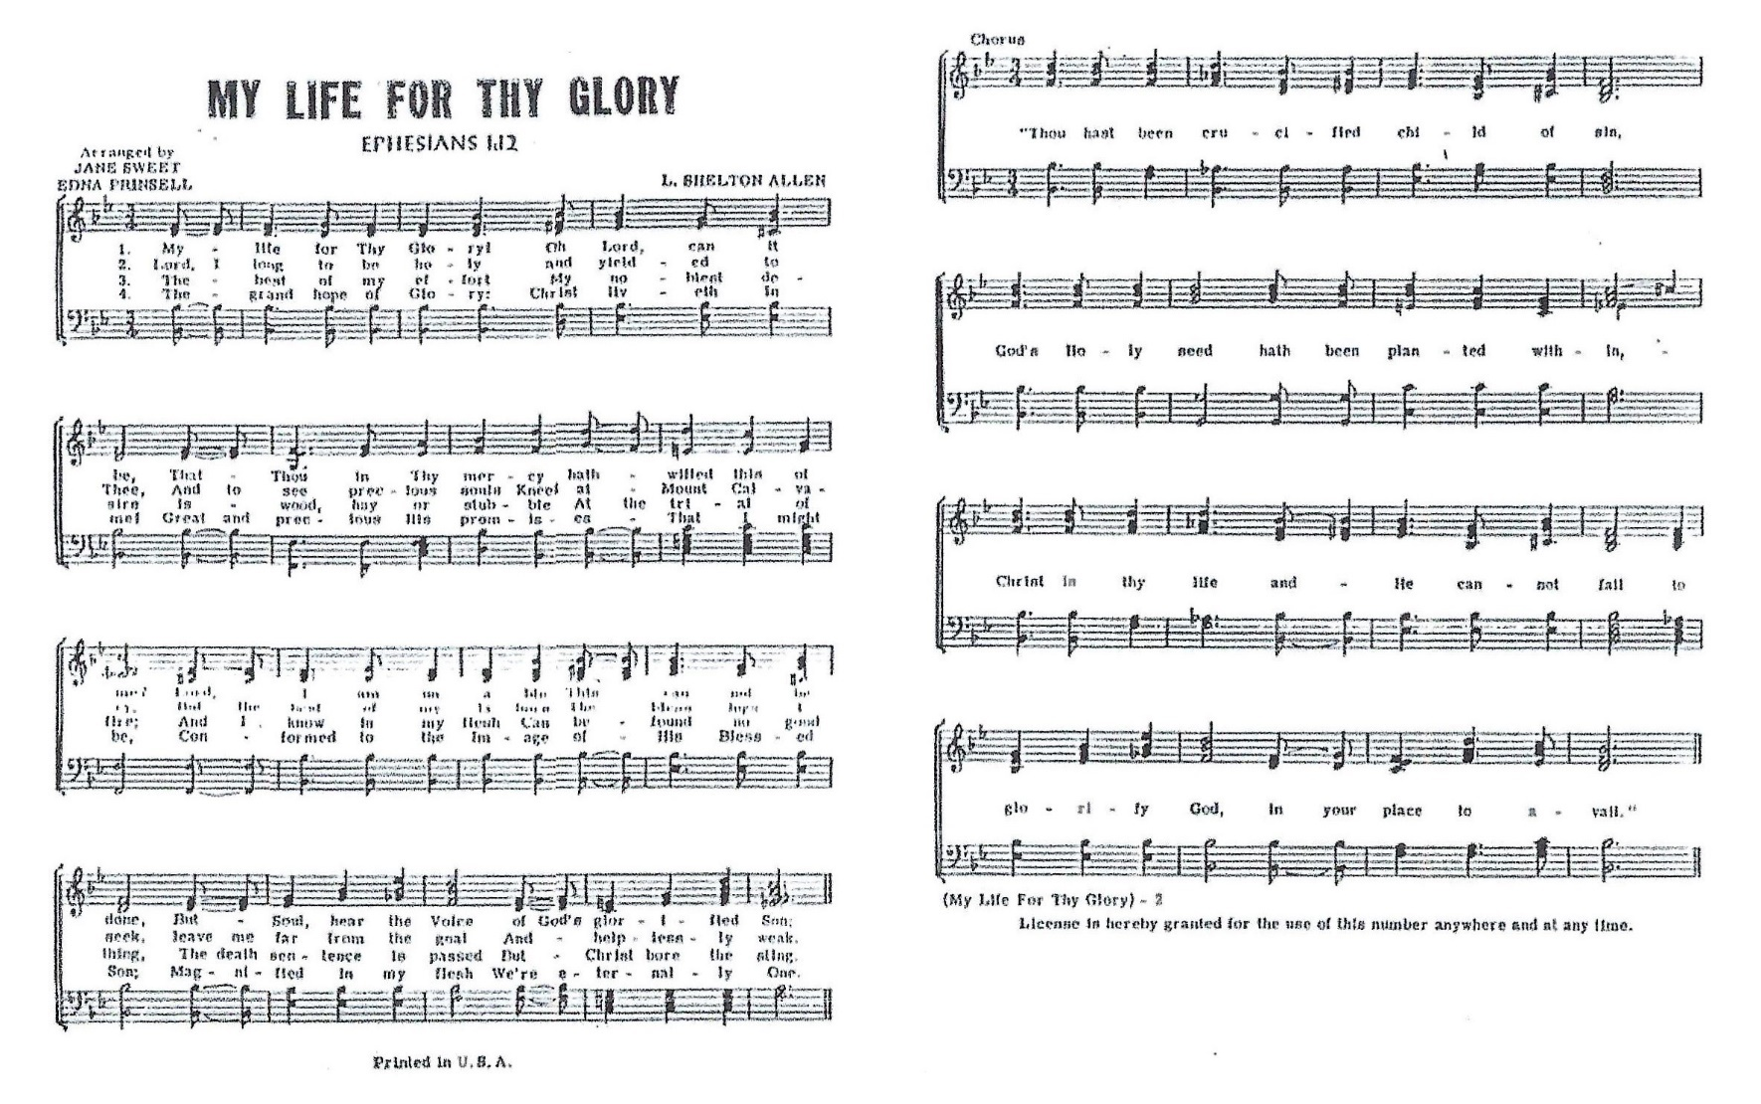
My Life for Thy Glory
by L. Shelton Allen

My Life for Thy Glory! Oh Lord, can it be,
That Thou in Thy mercy hath willed this of me?
I am unable. This cannot be done,
But Soul, hear the Voice of God’s glorified Son:

Lord, I long to be holy and yielded to Thee,
And to see precious souls Kneel at Mount Calvary.
But the best of my labors, the best words I seek
Leave me far from the goal and helplessly weak.

The best of my effort, my noblest desire
Is wood hay or stubble at the trial of fire;
And I know in my flesh can be found no good thing
The death sentence is passed, but Christ bore the sting.

The grand hope of glory: Christ liveth in me!
Great and precious His promise – that I might be
Conformed to the image of His blessed Son;
Magnified in my flesh, we’re eternally one.

CHORUS:
“Thou hast been crucified child of sin,
God’s Holy seed hath been planted within,
Christ is thy life and He cannot fail
To glorify God, in your place to avail.”

The ship to Shelton’s new life in Japan would arrive in Tokyo on the 15th of January 1952.

His sister Nancy reflected later:

for 35 years there would be [four or five years] between his return to the United States on furloughs with only brief visits with family on his way to his mission Headquarters in Michigan.

