THE STORY OF MY PATERNAL GREAT GRANDPARENTS
ELLEN NANCY PITTS AND ROBERT ALEXANDER ALLEN
unfolding over one hundred two years, eight months, and 21 days
from November 4, 1836, to July 25, 1939

I have added some familiar U.S. and world events to paint the historical backdrop for Robert’s and Ellen’s lives. Although both born in Missouri, where all seven of their children were also born, between the late 1880s and 1890s Robert had homesteads in the future state of Oklahoma where it is said he helped in the opening of the Oklahoma and Indian territories. From my youth I had been told that he was a horseback-riding circuit-preaching minister. I have found that, like his grandfather Pines Allen and at least two of his brothers, he belonged to the Methodist Episcopal Church (South). Ellen wrote short stories and published a book of poetry called “Autumn Leaves”, which, unfortunately, I have not been able to locate. She was also a teacher. They both established a Female Seminary in Missouri before she and Robert and possibly their three youngest moved to Great Bend, Kansas to preach and teach. The following years between 1894 and 1905 would take one or both to homesteads in the Oklahoma Territory, The Dalles in Oregon, Fort Pierce in St Lucie County, Florida, Cedaredge in Delta County, Colorado, and finally, along with their youngest daughter Mabel who would care for them for the rest of their lives, to Chicago, Illinois, to live with their only son, my grandfather Lambeth Shelton Allen. Robert died in Chicago in 1917 and Ellen spent the last years of her life in Homestead in Miami County Florida with Mabel and eventually also her daughter Esther Virginia as well.

1836

MARCH – At the Alamo in Texas, Davey Crockett and all the other “Texian” defenders died protecting the fort. Up to 256 men had lost their lives, but this did not stop the declaration of The Republic of Texas as an independent country from Mexico. From this tragedy was born “Remember the Alamo!”, the rallying cry for the Mexican-American War (1846-1848), when the Republic of Texas was annexed into the United States. https://www.britannica.com/event/Battle-of-the-Alamo-San-Antonio-Texas-United-States-1836,

Also in March, the Missouri State Penitentiary opened, the first Penitentiary west of the Mississippi River. https://www.sos.mo.gov/archives/history/timeline

JUNE - Arkansas, the first state to become part of the United States since Missouri fifteen years prior, became the 25th state to be entered into the Union.

OCTOBER 22 - Sam Houston became the first regularly elected President of the independent country of the Republic of Texas. Https://www.tsl.texas.gov/ref/abouttx/prestx.html

NOVEMBER 3 – Voting began in the 13th U.S. Presidential election as Andrew Jackson, the 7th President of the United States, was nearing the end of his second term in office.

NOVEMBER 4 – In St. Charles County (possibly in what was then called Cuivre Township where the family was recorded in the U.S. Census four years later) a son was born to Robert Buxton Allen (28) and his wife Louisa Jane Chambers Allen (17). Robert and Louisa had married in St. Charles just under eleven months earlier, eighteen days after Louisa had turned seventeen. They named their first born ROBERT ALEXANDER ALLEN. His middle name was after Louisa’s father Alexander Chambers (1787-1871).

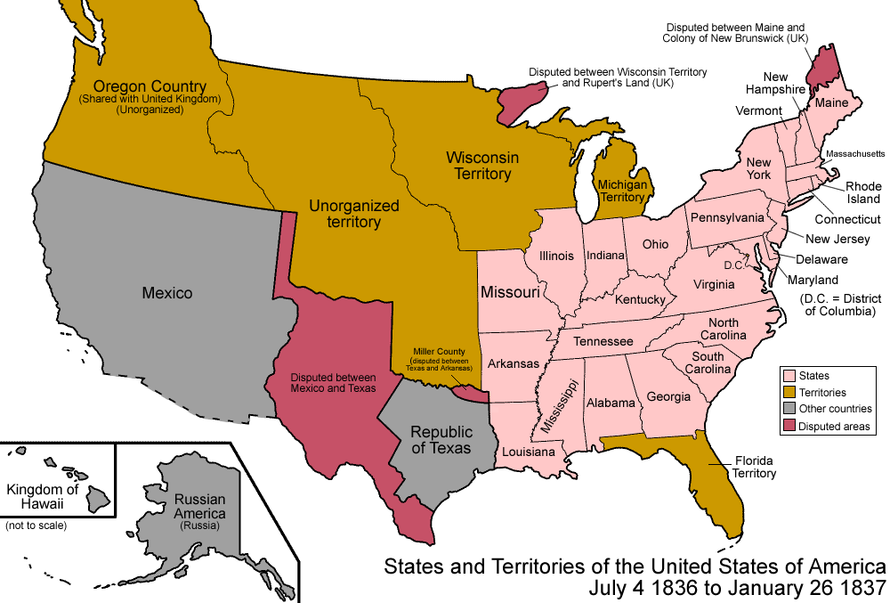
What the United States looked like when Robert Alexander Allen was born.

1837

JANUARY 26 - Michigan became the 26th state to be entered into the Union.

MARCH 4 - Martin van Buren was sworn in as 8th President of the United States.

JUNE 20 - Alexandrina Victoria of the House of Hanover became Queen Victoria of the United Kingdom of Great Britain and Ireland upon the death of her uncle King William IV.

NOVEMBER 4 – Robert Alexander Allen turned one while living in St. Charles County, Missouri.

1838

This year the very first picture of a person was taken by Louis Daguerre from his window on Boulevard du Temple in Paris. "To achieve this image (one of his earliest attempts), he exposed a chemically treated metal plate for ten minutes. Others were walking or riding in carriages down that busy street that day, but because they moved, they didn't show up. Only this guy stood still long enough — maybe to have his boots shined — to leave an image ... There is also the very faint image of the bootblack bent over his work." https://www.npr.org/sections/krulwich/2011/03/31/130754296/first-photo-of-a-human-being-ever

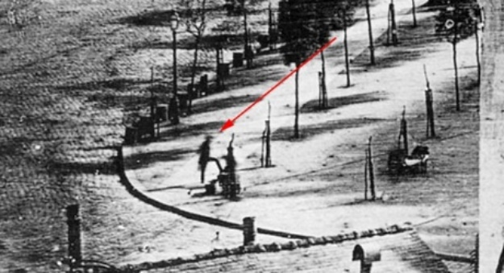

MAY - The Trail of Tears: More than 15,000 Cherokee were forced to march from Georgia to the Indian Territory in present-day Oklahoma. "More than a thousand Cherokee – particularly the old, the young, and the infirm – died during their trip west, hundreds more deserted from the detachments, and an unknown number – perhaps several thousand – perished from the consequences of the forced migration. The tragic relocation was completed by the end of March 1839, and resettlement of tribal members in Oklahoma began soon afterward. The Cherokee, in the years that followed, struggled to reassert themselves in the new, unfamiliar land. Today, they are a proud, independent tribe, and its members recognize that despite the adversity they have endured, they are resilient and invest in their future." https://www.nps.gov/trte/learn/historyculture/index.htm

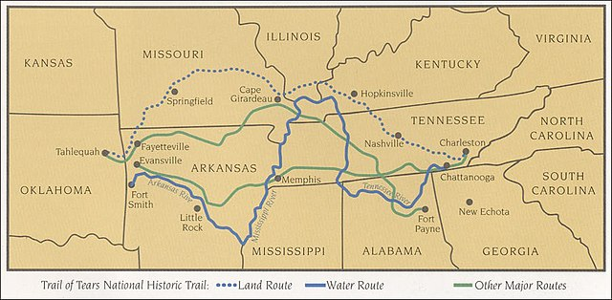

JULY 4 - Iowa formerly became a Territory.

NOVEMBER 4 – Robert Alexander Allen turned two while living in St. Charles County, Missouri.

NOVEMBER – At two years old Robert Alexander Allen became a big brother when his mother Louisa (19) and father Robert Buxton Allen (30) had another son in St. Charles, Missouri. They named him John Traylor Allen after John C. Traylor, the husband of Robert Buxton Allen’s Aunt Tabitha Churchill Bailey Traylor.

1839

JULY 18 – In St. Charles County, Missouri, ELLEN NANCY PITTS was born to George Richardson Pitts (45, a medical doctor) and Catherine “Kitty” Eliza Spence Pitts (38). She joined six brothers and three sisters. Her older siblings were Benjamin (16 days shy of 17 years old), Oliver (16 and 2 months), Walter (14), Thomas (10), Virginia (9), Philip (7), Edward (6), Caroline (3), and Mary (2). A more full account of this family can be found in my chapter “A Convoluted Saga From the Pitts Side” which began as a deep dive into two letters that were written in 1828 and 1848 by Ellen’s mother Catherine “Kitty” Eliza Spence Pitts.

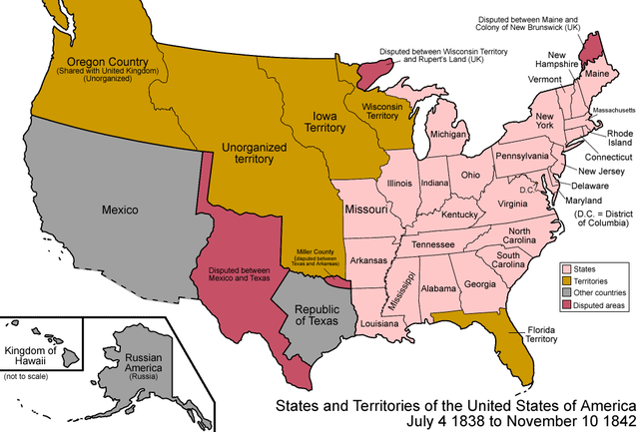
What the United States looked like when Ellen Nancy Pitts was born.

OCTOBER - First “selfie”: In the backyard of his family's lamp and chandelier store in Philadelphia, Robert Cornelius sat "for between three and 15 minutes to allow the necessary exposure time as he posed for the self-portrait ... He wrote on the back of it: “The first light Picture ever taken. 1839.” https://www.guinnessworldrecords.com/world-records/114019-first-selfie



NOVEMBER 4 – Robert Alexander Allen turned three while living in St. Charles County, Missouri.

1840

In the ten years since the 1830 U.S. Census had been taken, the population of the United States had grown from 13 million to nearly 18 million. 3,400 miles of railway track had been added to what had been only around 100 miles of track in 1830. http://www.fsmitha.com/time/ce19-4.htm

JUNE 1 – The 1840 U.S. Census for St. Charles County, Missouri, which only listed the names of the head of household with the rest of the house tallied by age, recorded the following about our families:

- In Cuivre Township, St. Charles County: R.B. Allen as head of house with two males under 5 years old (Robert Alexander, 4, and John Traylor, 2), one male 20-29 which could have possibly been either a farm hand or one of Robert Buxton Allen’s unmarried brothers - John Parks Bailey Allen (24) or Charles Cavnes Allen (21), 1 male 30-39 (Robert Buxton, 31), one female 20-29 (Louisa Jane, 22), and, significantly for that time, no slaves. (See the chapter “My Family’s Contribution to the Ten Million Names Project” for the possible implications of this.)

- In Dardenne Township, St. Charles County: Geo R. Pitts as head of house with 2 males under 5* (Philip, 8, and Edward, 7), 1 male 10-14 (Thomas, 11), 2 males 15-19 (Oliver, 17, and Walter, 15), 1 male 40-49 (George, 46), 3 females under 5 (Caroline, 4, Mary, 3, Ellen Nancy, 11 months), 1 female 5-9 (Virginia, 9), 1 female 30-39 (Catherine “Kitty”, 39), 2 male slaves under 10, 1 male slave 10-23, 2 female slaves 10-23, 1 female slave 24-35.

*The listing of two males less than 5 and 3 females less than 5 would be 5 children under 5 in the house. The following explanation is from my chapter “A Convoluted Saga From the Pitts Side”: “it’s possible the George Pitts’s were caring for someone’s young child or children, but as the 1840 census does not list any males 5-10 … [and I know for from further censuses and evidence that Philip and Edward would have been in the “5-10” age range] I believe the census taker erroneously put the ‘2’ in the ‘males less than 5’ line instead of the ‘males 5-10’ line. This would clear up the aggravating discrepancy between the 1830 and 1840 censuses … Until there is further proof otherwise, I will go with this theory.”

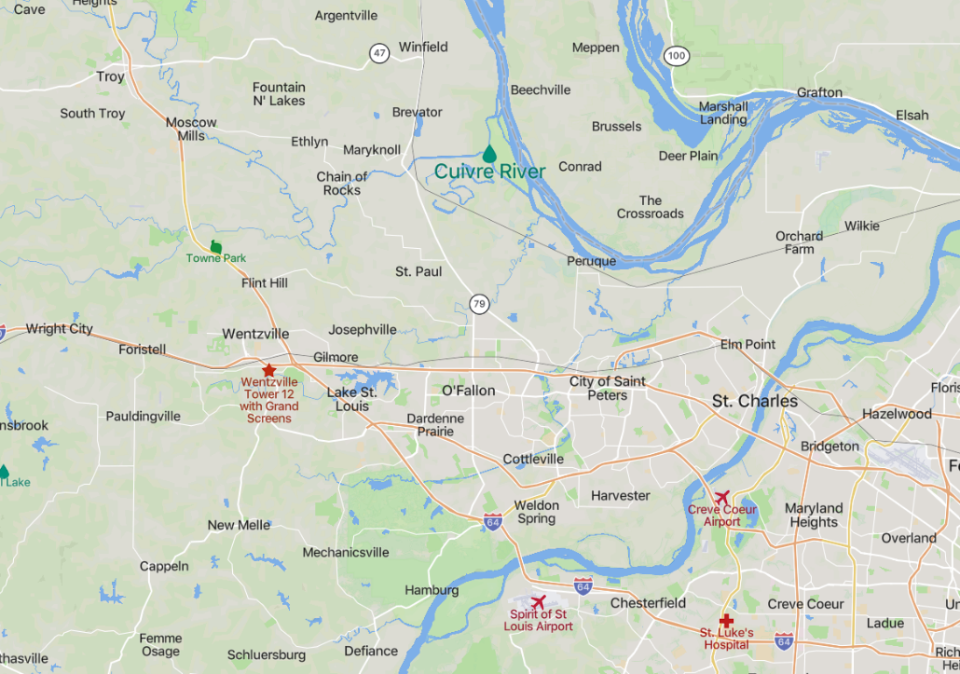

This map shows the portion of St. Charles County, wedged between the Mississippi River to the north and the Missouri River to the south, where Robert and Ellen’s families lived in 1840. Although Cuivre Township is now extinct, the State Historical Society of Missouri (SHSM) says it was “Bounded on the north by Cuivre River, on the southeast by Dardenne Township, and on the west by Warren County.” Cuivre River flows off the Mississippi. [My third great grandfather Pines Allen moved to this area in 1829. According to SHSM, Allen’s Prairie “in the southeastern part of Cuivre Township, six miles west of O'Fallon … was named for the family of Pines Allen, a Methodist Episcopal clergyman, who was born in Virginia in 1784, moved to Missouri in 1829, located on what has since been known as Allen's Prairie, and died in 1846.” An older brother of Pines, Joseph S. Allen, moved to the area in 1828. According to Wentzville Historical Society he was “a distinguished Methodist Minister and father of William M. Allen” the founder of Wentzville.]
Sometime after the 1840 U.S Census Robert Buxton Allen moved his family about forty miles northwest to Lincoln County, Missouri where, according to SHSM, he established the town of Truxton, Missouri. Although the township was not officially established until 1852, he “built the first house in the village in 1843 … He lived there to his death in 1875. The village was named in honor of Captain Thomas Truxton (1755-1822), distinguished as a commander of privateers in the Revolutionary War.”

JULY 18 – Ellen Nancy Pitts turned one while living in Dardenne Township, St. Charles, Missouri.

NOVEMBER 4 – Robert Alexander Allen turned four while living in Cuivre Township, St. Charles County, Missouri.

1841

MARCH 4 - William Henry Harrison was sworn in as ninth President of the United States.

APRIL 4 - President Harrison died, probably from pneumonia, 31 days after coming into office, becoming the first U.S. President to die in office.

APRIL 6 - Vice President John Tyler was sworn in as the 10th President of the United States

It was this year in the eastern counties of Missouri, including St. Charles county, that, according to the Wentzville Missouri Historical Society:

The Slickers were organized to rid the county of thieves and counterfeiters. The name of the organization came about because they would tie the culprit to a tree and ‘slick’ or whip him with hickory sticks. He was then given notice to leave the country within a stated time. The first Slicker organization in Missouri started in Benton County. At times, false reports were made and people were unjustly accused. This led to the organization of the anti-Slicker companies, and in some parts of the State actual war raged between the opposing factions, and many persons were killed, wounded, or maltreated.

These events may have helped to contribute to the tales of the Wild Wild West as Missouri along with Arkansas and Louisiana were the Western most States at this time. In about 1844 two of Ellen’s older brothers joined the anti-slickers, as did a few Allens and Sheltons, cousins of Robert’s father. The Slicker War finally ended around 1847.

There is more detail about the Slicker War in my chapter “A Convoluted Saga From the Pitts Side”.

JULY 18 – Ellen Nancy Pitts turned two while living in Dardenne Township, St. Charles, Missouri.

NOVEMBER 4 – Robert Alexander Allen turned five while living in Lincoln County, Missouri.

DECEMBER 12 – Joseph Bensin Allen, a second brother for Robert, was born in Lincoln County Missouri to Robert Buxton Allen (33) and Louisa Jane Chambers Allen (23). Joseph would become a lawyer and live in the town of Troy in Lincoln County, Missouri for most of his life. There, in his sixties, he found a fascination with researching the family trees of his four sets of great grandparents. This work he published in The Troy Record and from this record much of the information I have about these four sets of my fourth great grandparents and their descendants was either gleaned or confirmed.

1843
Two Years Later

APRIL 23 – With the birth of Georgia Ann Pitts, the youngest and tenth child born to George Richardson Pitts (49) and Catherine Eliza Spence Pitts (42), Ellen became a big sister.

JULY 18 – Ellen Nancy Pitts turned four while living in Dardenne, St. Charles, Missouri.

NOVEMBER 4 – Robert Alexander Allen turned seven while living in Lincoln County, Missouri.

1844

MAY 6 – Robert became a brother for the third time with the birth of Charles Pines Allen (his middle name was after his grandfather Pines Allen) in Lincoln County, Missouri. Their father Robert Buxton Allen was 35 and mother Louisa Jane Chambers Allen was 25.

MAY 24 - "Samuel F. B. Morse transmitted the first message on a United States experimental telegraph line (Washington to Baltimore) using the 'Morse code' that became standard in the United States and Canada." https://www.historyofinformation.com/detail.php?entryid=551

JULY 18 – Ellen Nancy Pitts turned five while living in Dardenne, St. Charles, Missouri.

NOVEMBER 4 – Robert Alexander Allen turned eight while living in Lincoln County, Missouri.

1845

MARCH 3 – Florida became the 27th State to be added to the Union.

MARCH 4 - James Polk was sworn in as the 11th President of the United States.

JULY 18 – Ellen Nancy Pitts turned six while living in Dardenne, St. Charles, Missouri.

Sometime before the 24th of October, when his estate was first probated, Dr. George Richardson Pitts, the father of Ellen Nancy Pitts, died. He was 51 years old. I have not been able to find his grave, obituary, actual Last Will and Testament, or any mention of his death in the local newspapers through Newspapers.com.

NOVEMBER 4 – Robert Alexander Allen turned nine while living in Lincoln County, Missouri.

DECEMBER 29 – Texas became the 28th State to be added to the Union.

1846

MAY 13 – The U.S. declared war on Mexico “in effort to gain California and other territory in Southwest." https://www.infoplease.com/history/us/us-history-a-new-nation-1800-1849

JULY 18 – Ellen Nancy Pitts turned seven while living in Dardenne, St. Charles, Missouri.

AUGUST 8 – In an attempt “to ban slavery in territory gained in the Mexican War.” The Wilmot Provisio was “introduced by Democratic representative David Wilmot of Pennsylvania.” Although the Provisio was “blocked by Southerners,” it succeeded in enflaming “the debate over slavery." https://www.infoplease.com/history/us/us-history-a-new-nation-1800-1849

NOVEMBER 4 – Robert Alexander Allen turned ten while living in Lincoln County, Missouri.

NOVEMBER 20 – Mary V. Allen, Robert’s fourth sibling and first sister, was born in Lincoln County, Missouri to Robert Buxton Allen (38) and Lousia Jane Chambers Allen (27).

DECEMBER 28 – Iowa became the 29th State to be added to the Union.

1848
Two Years Later

JANUARY 25 - Gold was discovered at Sutter's Mill in El Dorado County, California and the California Gold Rush began. Ellen’s older brother Oliver would join the rush for a time and the 1850 U.S. Census finds him as 27 years old living in Placerville “and its Vicinity” of El Dorado County with Landon Preston, 21, and his seventeen-year-old brother Ouachita (recorded as 19 on the census) who four years later married Jane Eliza Pitts, the cousin of Ellen and Oliver. (More about Oliver, Ouachita and Jane can be found in “A Convoluted Saga From the Pitts Side”.)

FEBRUARY 2 - The U.S./Mexico War ended with the Treaty of Guadalupe Hildago. Mexico recognized the Rio Grande as the new boundary with Texas and accepted $15 million “to cede territory comprising present-day California, Nevada, Utah, most of New Mexico and Arizona, and parts of Colorado and Wyoming." https://www.infoplease.com/history/us/us-history-a-new-nation-1800-1849

MAY 29 – Wisconsin became the 30th State to be added to the Union.

JULY 18 – Ellen Nancy Pitts turned nine while living in Dardenne, St. Charles, Missouri.

NOVEMBER 4 – Robert Alexander Allen turned twelve while living in Lincoln County, Missouri.

NOVEMBER or DECEMBER – Ellen’s mother, Catherine “Kitty” Spence Pitts (48) wrote a letter to her oldest daughter Virginia Charlotte “Lottie” Pitts (18) who, I believe, had gone with her Uncle Alexander “Alec” Spence (43) back to Westmoreland, Virginia. I have “dissected” this letter and the family relationships in “A Convoluted Saga From the Pitts Side”.

1849

MARCH 4 – The twin sisters of Robert, Martha “Mattie” Jane and Charlotta Annie S. Allen, his 5th and 6th siblings and 2nd and 3rd sisters, were born in Lincoln County, Missouri to Robert Buxton Allen (40) and Louisa Jane Chambers Allen (30).

MARCH 5 - Zachary Taylor was sworn in as the 12th President of the United States.

JULY 18 – Ellen Nancy Pitts turned ten while living in Dardenne, St. Charles, Missouri.

NOVEMBER 4 – Robert Alexander Allen turned thirteen while living in Lincoln County, Missouri.

DECEMBER 6 – Harriet Tubman escaped from slavery. She would soon become “one of the most effective and celebrated members of the Underground Railroad [the name for the network of safe houses for runaway slaves that led all the way to Canada]." https://www.infoplease.com/history/us/us-history-a-new-nation-1800-1849

1850

JULY 9 - President Taylor became the second sitting President to die in office. "On July 4, 1850, Zachary Taylor attended a ceremony at the unfinished Washington Monument; temperatures were blistering, and he reportedly ate only raw vegetables, cherries and milk. He took ill with violent stomach cramps the following day and died ... of acute gastroenteritis. (Conspiracy theorists later suggested that Taylor may have been poisoned, but his remains were exhumed in 1991 and this speculation was disproved.)" https://www.history.com/topics/us-presidents/zachary-taylor

JULY 10 – Vice President Millard Fillmore was sworn in as the 13th President of the United States.

JULY 18 – Ellen Nancy Pitts turned eleven while living in Dardenne, St. Charles, Missouri.

SEPTEMBER 9 – California, as a free state, became the 31st State to be added to the Union. The Compromise of 1850 had settled the debate over “whether territory gained in the Mexican War should be open to slavery.” California was free and the Utah and New Mexico territories were left to decide by popular sovereignty (the whites voted proslavery). Per the Compromise, the slave trade in Washington, DC, was prohibited. https://www.infoplease.com/history/us/us-history-civil-war-and-reconstruction-1850-1899

SEPTEMBER 18 - The Fugitive Slave Act "was part of the Compromise of 1850. The act required that slaves be returned to their owners, even if they were in a free state. The act also made the federal government responsible for finding, returning, and trying escaped slaves." https://www.battlefields.org/learn/primary-sources/fugitive-slave-act

NOVEMBER 4 – Robert Alexander Allen turned fourteen while living in Lincoln County, Missouri.

SEPTEMBER 6 – The 1850 U.S. Census for District 49 of Lincoln County, Missouri, the first to list all members of a household, recorded Robert A. Allen (13, a farmer) living with his father Robert B. Allen (42, a farmer), his mother Louisa J. Allen (32), and his siblings John T. (11), Joseph B. (8), Charles P. (6), Mary V. (4), Martha J. (1) and Charlott A. (1). Only Robert A. and John T. were reported to have attended school within the year.

SEPTEMBER 27 – The 1850 U.S. Census for District 78 of St. Charles County, Missouri recorded “Nancy E” (Ellen Nancy, 10) living with her mother Catherine E. Pitts (48), and her siblings Virginia C. (18), Edward J. (16), Caroline C. (14), Mary E. (13), and Georgeana (6). Edward, Caroline, Mary, and “Nancy” had attended school within the year.

1851

Beginning this year, Harriet Beecher Stowe started publishing Uncle Tom's Cabin in installments in the abolitionist newspaper "The National Era." It was a "Moral Battle Cry For Freedom." https://www.harrietbeecherstowecenter.org/harriet-beecher-stowe/uncle-toms-cabin/

JULY 18 – Ellen Nancy Pitts turned twelve while living in Dardenne, St. Charles, Missouri.

NOVEMBER 4 – Robert Alexander Allen turned fifteen while living in Lincoln County, Missouri.

DECEMBER 1 – Robert’s oldest sister Mary V. Allen died in Lincoln County, Missouri 11 days after her 5th birthday. Their mother Louisa (33) was around seven months pregnant with her eighth child at the time.

1852

This year Truxton, founded by Robert’s father Robert Buxton Allen and where the family had been living in Lincoln County, Missouri, was officially established as a township. Robert Buxton Allen also established a school and seminary there. According to the write up on Find A Grave for Robert Buxton’s grandson and namesake Robert Buxton Allen, “His parents were educated people and their necessary goods include books. His namesake grandfather had (also) founded a school and seminary in Truxton.”

FEBRUARY – William Newland Allen, Robert’s fourth brother and seventh sibling, was born in Truxton, Lincoln County, Missouri to Robert Buxton Allen (43) and Louisa Jane Chambers Allen (33).

JULY 18 – Ellen Nancy Pitts turned thirteen while living in Dardenne, St. Charles, Missouri.

NOVEMBER 4 – Robert Alexander Allen turned sixteen while living in Truxton, Lincoln County, Missouri.

DECEMBER 9 – THE FIRST TRAIN IN MISSOURI - “[A] passenger train, with the company's officers and leading citizens of St. Louis aboard, inaugurated the new Pacific Railroad with a trip to the end of the line. The people of Missouri then had their first look at a steam railroad. That train was the first to be operated west of the Mississippi River, and ran the five miles from the depot on Fourteenth Street to Cheltenham in some ten minutes.” http://www.mopac.org/history_mp.asp

1853

MARCH 4 - Franklin Pierce was sworn in as the 14th President of the United States.

JULY 18 – Ellen Nancy Pitts turned fourteen while living in Dardenne, St. Charles, Missouri.

NOVEMBER 4 – Robert Alexander Allen turned seventeen while living in Truxton, Lincoln County, Missouri.

1854

MAY 30 - "The Kansas-Nebraska Act drew new borders for [the territories of] Kansas and Nebraska and allowed its citizens to decide the inclusion or exclusion of slavery ... within their boundaries. Northern abolitionists viewed the Act as a ... betrayal of the North and against the policy of incremental abolitionism. Abolitionist leaders such as Frederick Douglass took a more revolutionary role. The nullification of the 1820 Missouri Compromise led to violent instability and became the most significant turning point on the road to the American Civil War." http://www.compromise-of-1850.org/kansas-nebraska-act-1854/

The website mocivilwar.org states that “between 1854 and 1859 pro and antislavery forces ambushed and raided each other in an attempt to control the future of Kansas. This fighting prepared Missourians for the type of Civil War they would witness in the country’s great struggle.”

JULY 18 – Ellen Nancy Pitts turned fifteen while living in Dardenne, St. Charles, Missouri.

OCTOBER – Ada Finley Allen, Robert’s fourth sister and eighth sibling, was born in Truxton, Lincoln County, Missouri to Robert Buxton Allen (46) and Lousia Jane Chambers Allen (35).

OCTOBER 14 – Benjamin R. Pitts, Ellen’s oldest brother, died, leaving his twenty-nine-year-old wife Susan Roberta Simms Pitts and two young sons – George, 8, and Peyton, 6. He was an attorney who that year was a candidate for the Missouri State Senate. He was thirty-two years, two months, and eleven days old. There is more about Ben, Roberta and their sons in the portion of “A Convoluted Saga From the Pitts Side” that covers the letter written by his mother Kitty Spence Pitts in 1848.

NOVEMBER 4 – Robert Alexander Allen turned eighteen while living in Truxton, Lincoln County, Missouri.

1855

JULY 18 – Ellen Nancy Pitts turned sixteen while living in Dardenne, St. Charles, Missouri.

NOVEMBER 4 – Robert Alexander Allen turned nineteen while living in Truxton, Lincoln County, Missouri.

Late this year the Pacific Railroad was completed through Jefferson City, Missouri, a city that would play a prominent part a few years later in Robert and Ellen’s lives and where their only son, my grandfather, Lambeth Shelton Allen was born.

West from that point the railroad was purposely located away from the Missouri River for fear that it would be unable to compete with the steamboats. However, the Pacific Railroad itself established a fleet of twelve steamboats to connect with the trains at Jefferson City and transport passengers and freight on up the river to Kansas City and beyond. An advertisement of that period stated that at Jefferson City passengers could step from the train to the waiting steamboat and that by this route, the time from St. Louis to Kansas City had been cut to only 50 hours! http://www.mopac.org/history_mp.asp

1856

APRIL 22 - "The first railway bridge across the Mississippi River [was] completed." http://www.fsmitha.com/time/ce19-6.htm

[T]he citizens of Rock Island, Illinois, and Davenport, Iowa, cheered as they watched three steam locomotives pull eight passenger cars safely across the newly completed Chicago and Rock Island railroad bridge over the Mississippi River. The first railroad bridge across the Mississippi was open for business. Now the people of eastern Iowa could reach New York City by rail in no more than forty-two hours.

The construction and completion of this bridge came to symbolize the larger issues affecting transcontinental commerce and sectional interests. Backers of a railroad across the country were divided between those who favored a northern route and those who advocated a southern one. The bridge also pitted steamboats against the railroads, and these disagreements were decided in the federal courts.

Two notable players in the controversy surrounding the bridge were men who would later face each other on a grander stage: Abraham Lincoln and Jefferson Davis. Lincoln was the attorney for the bridge company in litigation brought by the steamship interests. Davis, as secretary of war, took an active role in the contest between northern and southern routes for a transcontinental railroad. https://www.archives.gov/publications/prologue/2004/summer/bridge.html

JULY 18 – Ellen Nancy Pitts turned seventeen while living in Dardenne, St. Charles, Missouri.

OCTOBER 10 – Lou Bird Allen, Robert’s fifth sister and ninth sibling, was born in Truxton, Lincoln County, Missouri to Robert Buxton Allen (48) and Louisa Jane Chambers Allen (37).

NOVEMBER 4 – Robert Alexander Allen turned twenty while living in Truxton, Lincoln County, Missouri.

1857

MARCH 4 - James Buchanan was sworn in as the 15th President of the United States

MARCH 6 – The Supreme Court decided in the Dred Scott v. Sanford case that slaves were not citizens and that Congress did “not have the right to ban slavery in states.” https://www.infoplease.com/history/us/us-history-civil-war-and-reconstruction-1850-1899

"The Dred Scott case ... was a decade-long fight for freedom by a Black enslaved man named Dred Scott. The case persisted through several courts and ultimately reached the U.S. Supreme Court, whose decision incensed abolitionists, gave momentum to the anti-slavery movement and served as a stepping stone to the Civil War." https://www.history.com/topics/black-history/dred-scott-case

JULY 18 – Ellen Nancy Pitts turned eighteen while living in Dardenne, St. Charles, Missouri.

NOVEMBER 4 – Robert Alexander Allen turned twenty-one while living in Truxton, Lincoln County, Missouri.

1858

MAY 11 – Minnesota became the 32nd State to be added to the Union.

JULY 18 – Ellen Nancy Pitts turned nineteen while living in Dardenne, St. Charles, Missouri.

SEPTEMBER 16 – “By July, 1858 the Pacific Railroad … completed the 160 miles to Tipton, Mo., then the end of the line from St. Louis. Tipton was also the eastern terminus for a new overland mail service to San Francisco. This service, called "The Overland Mail', made its initial eastward stagecoach run from San Francisco on September 16, 1858, arriving at Tipton on October 10. At Tipton, the mail and passengers were transferred to a waiting Pacific Railroad special train for the run to St. Louis. The time from San Francisco to St. Louis was 24 days, 18 hours and 26 minutes, about 10 days faster than the old Isthmus of Panama route.” http://www.mopac.org/history_mp.asp

NOVEMBER 4 – Robert Alexander Allen turned twenty-two while living in Truxton, Lincoln County, Missouri.

1859

FEBRUARY 14 – Oregon became the 33rd State to be added to the Union.

JULY 18 – Ellen Nancy Pitts turned twenty while living in Dardenne, St. Charles, Missouri.

OCTOBER 8 – Francis Lowe Allen, Robert’s fifth brother and tenth and youngest sibling, was born in Truxton, Lincoln County, Missouri to Robert Buxton Allen (51) and Lousia Jane Chambers Allen (40).

NOVEMBER 4 – Robert Alexander Allen turned twenty-three while living in Lincoln County, Missouri.

1860

Sometime between the 1850 and 1860 U.S. Censuses Catherine “Kitty” Eliza Spence Pitts, the mother of Ellen Nancy Pitts, died. I have not been able to find any death records (grave, obituary, Will or probate) for Kitty. She was born in 1801 or 1802 so would have been between 49 and 59 when she died.

APRIL - The Pony Express was established. "From St. Joseph, Missouri, to Sacramento, California (more than 1,800 miles) the Pony Express could deliver a letter faster than ever before." Operation ceased 18 months later in October 1861 when the telegraph lines were connected between New York and San Francisco. https://www.nps.gov/poex/learn/historyculture/index.htm

JUNE 15 – The 1860 U.S. Census for Bear Creek Township, Montgomery, Missouri recorded Ellen Pitts (20) living with her brother Oliver (37, a farmer), and her sisters Virginia (30), Caroline (25), Emily (23), and Georgianna (16).

JULY 18 – Ellen Nancy Pitts turned twenty-one while living in Bear Creek, Montgomery County, Missouri.

AUGUST 29 – The 1860 U.S. Census for Truxton, Lincoln County, Missouri recorded R.A. Allen (Robert Alexander, 23, a merchant) living in the Truxton Hotel with his father R. B. Allen (Robert Buxton, 51, a farmer and Inn Keeper), his mother Lousia Allen (41), his brother John T. Allen (21, a merchant) and John’s wife Lucy A. Allen (18), and his other siblings Jos B. Allen (Joseph Bensin, 18, a law student), Charles P. Allen (15, a farmer), Charlotte A. Allen (11), Martha J. Allen (11), William Allen (9), Ada F. Allen (5), Lou B. Allen (4), and Frank Allen (1).

NOVEMBER 4 – Robert Alexander Allen turned twenty-four while living in Truxton, Lincoln County, Missouri.

NOVEMBER 6 - Abraham Lincoln was elected President of the United States to take office in March the following year. This election was highly contentious with an 81.2% voter turnout and four candidates on the ballot for President. Abraham Lincoln for the rather newly formed anti-slavery Republican Party, Stephen Douglas for the Democratic Party, John Breckinridge for the Southern Democratic Party, and John Bell for the Constitutional Union Party. With two candidates splitting the votes of the Democratic Party, Lincoln was able to win the nomination “by carrying states above the Mason–Dixon line and north of the Ohio River, plus the states of California and Oregon in the Far West”. He did not win any slave states and had less than 40% of the popular vote. https://en.wikipedia.org/wiki/1860_United_States_presidential_election

Scott David, M.A., on the website enotes.com stated:

In many respects, the election of Abraham Lincoln was the culmination of a much longer preceding history of growing tension and division within the United States, centered on the issue of slavery. At the same time that abolitionism was growing within the North, the South was becoming increasingly entrenched in slavery's defense. With the impact of westward territorial expansion, there was an open question to be answered regarding the status of slavery within the territories, and this became a major source of tension and turmoil within the country across the 1850s.

For Southern defenders of slavery, the election of the Republican Lincoln was an unacceptable outcome, as well as a sign that their defense of slavery was swiftly becoming untenable. Keep in mind that the Republican Party was founded as an opposition party to slavery. For the anti-slavery Lincoln to win a national election for an anti-slavery party thus had the appearance of being, for Southerners, a worst-case scenario in the making.

Their answer was secession. https://www.enotes.com/topics/secession-civil-war/questions/how-did-the-south-react-to-the-election-of-301350

DECEMBER 20 – South Carolina seceded from the Union.

THE MARRIAGE OF ROBERT AND ELLEN - Sometime after the 1860 U.S. Census was taken, probably in November or December, Robert Alexander Allen (24) and Ellen Nancy Pitts (20) were married. [In the 1910 U.S. Census for Chicago, taken in April of that year, Robert and Ellen were recorded as having been married 49 years. The write-up in 1939 about Ellen’s 100th birthday “anniversary” in The Miami News stated they were married in 1860 and in Ellen’s Obituary in The Miami Herald it was written that they celebrated their golden wedding anniversary in 1910.]

I do not know the story of how Robert and Ellen met. However, the distance between where Robert was living in Truxton, Lincoln County and where Ellen was living in Bear Creek, Montgomery County, was perhaps only ten miles. Truxton sits near the western border of Lincoln County. Also, the Allens and Pitts families had been acquainted for many years. Their brothers and cousins had been involved together during the Slicker Wars of the 1840s and in a letter written by Ellen’s mother in 1848 (which I have dissected in great detail in “A Convoluted Saga From the Pitts Side”) she makes mention of the Allens.

Three years later Robert is listed as living in Bear Creek on his U.S. draft registration. I do not know if he moved there with Ellen to help on the farm of her brother, Oliver, or if they moved there to run the farm after Oliver joined the Confederate cause in December of 1861.

1861

JANUARY 9 – Mississippi became the second State to secede from the Union.

JANUARY 10 – Florida became the third State to secede from the Union.

JANUARY 11 – Alabama became the fourth State to secede from the Union.

JANUARY 19 – Georgia became the fifth State to secede from the Union.

JANUARY 21 – As a United States Senator from Mississippi, Jefferson Davis, who would become the first and only President of what he hoped to be the country of The Confederate States of America, "made a moving farewell speech in the Senate and pleaded eloquently for peace." https://www.britannica.com/biography/Jefferson-Davis

JANUARY 26 – Louisiana became the sixth State to secede from the Union.

FEBRUARY 1 – Texas became the seventh State to secede from the Union.

JANUARY 29 – Kansas, on Missouri’s western border, became the 34th State (still counting the seven which had recently seceded) to be added to the United States. After years of bloody fighting over whether to be admitted as a slave or free state, it was admitted as a free state.

FEBRUARY 8 – From the seven States that had seceded from the United States the new country of The Confederate States of America was established.

FEBRUARY 18 - Jefferson Davis sworn in as the President of The Confederate States of America and Alexander Stevens as the Vice President. .

MARCH 4 - Abraham Lincoln was sworn in as the 16th President of the United States.

MARCH 21 – Missouri was very much divided between pro-Union and pro-Confederacy. The years of the 1850s had seen “a large contingent of German immigrants [who] were staunchly antislavery.” _{mocivilwar.org/year-1861/} This division was also complicated by the fact that:

Through slavery and commerce down the Mississippi River, the state had ties to states that would become a part of the Confederacy. Through industrialization, railroad trade, and immigration, the state also had ties to the North. https://www.legendsofamerica.com/camp-jackson-affair-missouri/

Therefore, when the Missouri state constitutional convention convened in response to the call from the newly elected proslavery Governor Claiborne Fox Jackson the votes were cast 98 against and 1 for secession. However, they

also voted not to supply weapons or men to either side if war broke out. The Convention then adjourned. Afterward, Governor Jackson and his allies still maneuvered for Missouri’s secession using questionable methods.

For example:

Jackson refused President Abraham Lincoln’s call for troops after the firing of Fort Sumter. With approval from the state legislature, he began raising and equipping the Missouri State Guard, a state militia whose members were primarily secessionist. https://www.legendsofamerica.com/camp-jackson-affair-missouri/

APRIL 12 –THE AMERICAN CIVIL WAR - “The attack on Fort Sumter [in Charleston, South Carolina] marked the official beginning of the American Civil War—a war that lasted four years, cost the lives of more than 620,000 Americans, and freed 3.9 million enslaved people from bondage." https://www.battlefields.org/learn/civil-war/battles/fort-sumter

[Any events regarding the Civil War included here will primarily focus on what took place in Missouri where the lives of Robert and Ellen would have been most affected.]

Robert and Ellen had been married less than half a year and were expecting their first child when the Civil War began. The draft for the Union did not happen in Missouri until 1863, when Robert (listed as 27, married and a farmer) registered in the 8th Subdistrict of Montgomery County as living in Bear Creek, Missouri. His brothers John Traylor (24, a farmer) and Joseph Bensin (22, a lawyer), their residence listed as Prairie, registered in the 5th Subdivision of Lincoln County. Ellen’s brother Oliver (who she and her sisters were living with at the time of the 1850 U.S. Census) as well as Ouachita Preston (who Oliver had gone to California with during the gold rush and who had married their cousin Jane Eliza Pitts in 1854) both fought on the side of the Confederacy. Ouachita Preston survived the war, but Oliver died in 1864 in the Battle of Franklin in Tennessee and is buried near the battlefield.

Many others of the extended family also fought, most, it seems, on the side of the Confederacy. One family in particular proudly displayed the plaque below. They were the second cousins of Robert and his siblings (the sons of the cousin of Robert’s father).

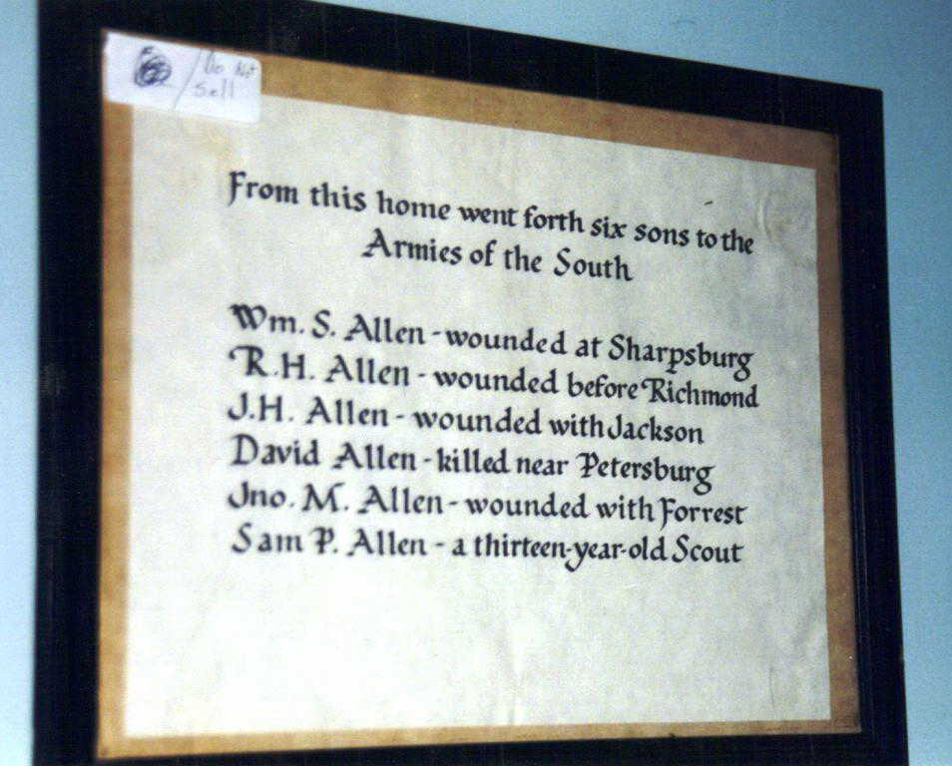

Recalling that the Democrats were proslavery. Over forty years after the Civil War, Robert’s younger brother, Joseph Bensin Allen, wrote in The Troy Record of February 1902 that the Sheltons, who were cousins of their father (James Shelton had been captain of the anti-slickers back in the 1840s), “are all natural-born Democrats, are bold, determined men and make their power felt in any locality in which they cast their lot; the Allens are natural-born not Democrats and when they undertake to get on Democratic lines they soon get lost in the shuffle.”

Joseph Bensin also wrote in the June 1901 edition (the bold emphasis is mine) that Allens are “all fighters in time of war. You’ll find them in the war of the revolution and that of 1812, the Indian wars, the one with Mexico, while in our now old unpleasantness [the Civil War] they took sides, I believe most of them the wrong side, but espousing the cause of their respective localities, many of them offered up their lives upon the gory battlefield.” Joseph Bensin was clearly a Republican (on the side of the Union). On the front of each edition of The Troy Record is written “Its politics, if any, will be Republican.” Of one second cousin who wrote to give information regarding the extended family he said, “after rapping me over the knuckles for being a black republican gives me much information of the Allen family which I appreciate greatly.”

Originally, I had been under the impression that my great grandfather had been pro-Confederacy. Only because my aunt, Robert’s granddaughter, Nancy Ellen Allen Haeger (named after her grandmother Ellen Nancy), had written in her memoirs about Robert, “Although said to be a Southern sympathizer he did not serve in the Confederate Army. We have understood that it was possible, if you were conscripted, to pay someone to go in your place, the fee being around $300 [a heavy price to pay back then - over $10,000 in 2024 value]. We do not know whether he chose this path or whether he was exempt from conscription because he was a minister.”

However, Robert did not become a minister until 1871, as I have uncovered from Newspapers.com, when he was assigned the Versailles Circuit by the Methodist Episcopal Church, South, in Missouri. (In 1850 he was a “farmer”, in 1860 a “merchant”, in his Union draft of 1863 a “farmer”, in 1870 a “brick mason”.) And with further digging, particularly on Newspapers.com, I found that Robert’s daughters Mabel and Virginia “Genna” attended a meeting with their mother Ellen for “Daughters of Union Veterans” in Miami, Florida in 1927. So, perhaps not only did he register for the Union draft in 1863, he must also have fought on the side of the Union, although I have yet to find any records to show where and in what capacity.

[Of course, my Aunt Nancy, when she was researching and writing her memoirs, would not have had access to all the digitalized information on sites like Ancestry.com, Newspapers.com, and Find-A-Grave now available to me. I know that in the future much more information will be “out there” for anyone interested in digging for it to add to and either verify or refute the information I have uncovered in my own research.]

APRIL 17 – Virginia became the eighth State to secede from the United States and join the Confederate States.

APRIL 20 – The following is an account of what led up to the first bloodshed of the Civil War in Missouri which took place in St. Louis, just around seventy miles from Bear Creek Township where Robert and Ellen were living. This account is written by Kathy Alexander on the website Legends of America and shows the tone of contention between those who were pro-Union (or Federalists) and those who were pro-secession (or Confederates).

Several days after the Battle of Fort Sumter, a pro-Confederate mob seized the Liberty Arsenal in Liberty, [in western] Missouri, and confiscated about a 1,000 rifles and muskets. This sparked fears that Confederates would also seize the much larger St. Louis Arsenal [in eastern Missouri], which had nearly 40,000 rifles and muskets — the largest stockpile in any slave state.

Confederate forces had overtaken other federal arsenals in the South, so the threat to the St. Louis federal arsenal was credible. Moreover, [Missouri Governor] Jackson supported a bill that placed the St. Louis City Police under state control, weakening the protection of the arsenal. Soon the Missouri State Guard established an encampment just west of downtown St. Louis which they named after their governor, Camp Jackson.

General William Harney was a conservative commander in charge of federal troops in St. Louis. Underneath him was Captain Nathaniel Lyon, who was tasked with defending the arsenal alongside Frank Blair, an influential U.S. Congressman from St. Louis. They began raising their own pro-Union militia, comprised of many German immigrants, and through Blair’s influence, became sanctioned by the Lincoln administration. In St. Louis, to help with mustering troops in nearby Belleville, Illinois, Captain Ulysses S. Grant wrote to his wife Julia about this development:

“There are two armies now occupying the city, hostile to each other, and I fear there is great danger of a conflict which, if commenced, must terminate in great bloodshed and destruction of property without advancing the cause of either party.”

To safeguard surplus weapons at the arsenal, Lyon shipped them across to Illinois for safekeeping. https://www.legendsofamerica.com/camp-jackson-affair-missouri/

APRIL 27 – Although not officially declared a state for over two years, West Virginia was formed when forty-eight counties in western Virginia seceded from the Confederate States to rejoin the United States. "When the state of Virginia voted to secede from the United States ... the people of the rugged and mountainous western region of the state opposed the decision and organized to form their own state, West Virginia, in support of the Union." https://www.history.com/topics/us-states/west-virginia

MAY 6 - Arkansas became the ninth State to secede from the United States and join the Confederate States.

MAY 10 – Twenty days after opposing sides were set up around the arsenal in St. Louis the clash that Captain Ulysses S. Grant feared occurred, as told by Kathy Alexander in Legends of America.

To prevent the pro-secessionist militia from storming the arsenal, and after hearing that Camp Jackson had received four cannons captured by Confederates at the Federal Arsenal at Baton Rouge, Louisiana, Lyon and Blair led a preemptive march on May 10, with 6,500 troops to force Camp Jackson’s 700-man garrison to surrender. Before the march started, Grant had gone to the arsenal and personally chatted with Lyon and Blair, expressing sympathy for their purpose. The march was successful, and the garrison at Camp Jackson surrendered. But as Grant predicted, violence occurred when Lyon marched his prisoners through the streets of St. Louis. Many … St. Louis residents came out to witness this procession. Among the spectators was a mob of secessionists who were incensed that a great number of the Unionist militia was German. They first began heckling the Unionists and shouting ethnic slurs. It then turned violent when the secessionists brandished knives and guns and threw objects at the Unionist troops. After an accidental gunshot, Lyon’s men fired into the mob, killing at least 28 civilians, including women and children, and injuring dozens of others.

Several days of rioting throughout St. Louis followed. The violence ended only after martial law was imposed and Union regulars were dispatched to the city.

Afterward, sporadic violence continued for another day, with six more deaths. During this time, Grant, intending to return to the arsenal to congratulate Lyon and Blair, witnessed the commotion. He later reflected in his memoirs that he encountered and had a conversation with a St. Louis secessionist. When the secessionist bluntly told him, “Where I come from, if a man dares to say a word in favor of the Union, we hang him to a limb of the first tree we come to.” Grant retorted, “After all, we are not so intolerant in St. Louis as we might be; I had not seen a single rebel hung yet, nor heard of one; there were plenty of them who ought to be, however.” https://www.legendsofamerica.com/camp-jackson-affair-missouri/
MAY 20 – North Carolina became the tenth State to secede from the United States and join the Confederate States.

MAY 21 – Kathy Alexander in Legends of America continued the story of the escalation of the Civil War in Missouri:

Following the Camp Jackson Affair, [Union] General Harney struggled to keep the peace between secessionist and unionist elements in Missouri. On May 21, Harney met with Confederate General Sterling Price, a former governor of Missouri. They worked out an agreement in which Price’s state forces kept order in Missouri, and the federal government would not interfere in state affairs, but the federal army would regulate affairs in St. Louis. By this agreement, General Harney conceded to the heavily pro-secessionist state authorities the right to run state affairs. Naturally, Frank Blair, Nathaniel Lyon, and their allies were incensed by this, and they successfully maneuvered for Harney’s removal and for Lyon to replace him.

Soon after, Lyon was promoted to Brigadier General. He bluntly stated his uncompromising unionist stance in a meeting with [Governor] Claiborne Fox Jackson, Sterling Price, and Frank Blair at the Planters House in St. Louis. When Price sought to continue the agreement that he worked out with Harney, Lyon would hear none of it. Irritated and uncompromising, Lyon allegedly stood up during the middle of the meeting and stated angrily, “Rather than concede to the State of Missouri for one single instant the right to dictate to my Government in any matter however unimportant… I would see you and every man, woman, and child in the State, dead and buried.” As he finished, he turned to Governor Jackson with the grand finale of his speech, “This means war.” From that moment, the Civil War was officially underway in Missouri. https://www.legendsofamerica.com/camp-jackson-affair-missouri/

JUNE 8 – Tennessee became the eleventh and final State to secede from the United States and join the Confederate States.

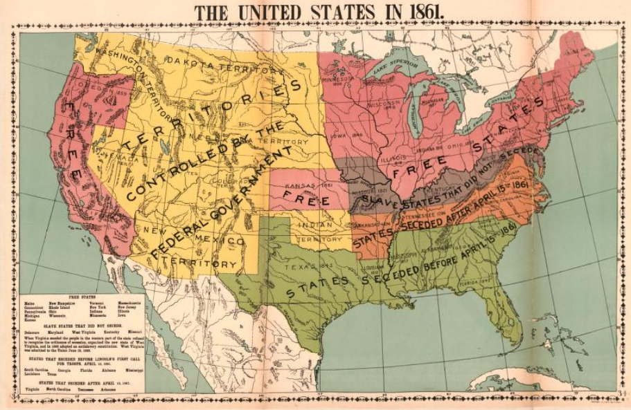

JUNE 12-17 – Kathy Alexander in Legends of America continued with the Missouri Civil War Saga following the disastrous meeting of opposing leaders in St. Louis on May 21st:

Governor Jackson returned to the state capital at Jefferson City. Lyon delivered federal troops by steamboat to Jefferson City on June 12, and Jackson fled west to join newly assembled State Guard troops near Boonville. Lyon’s men occupied the capital without resistance and pursued Jackson with approximately 1,400 volunteers and U.S. Army regulars. Against the advice of his senior officers, Jackson exercised his authority as Commander-in-Chief and ordered the State Guard to make a stand at Boonville. In the resulting Battle of Boonville on June 17, Lyon’s troops routed the State Guard. Jackson, the State Guard, and a few secessionist state legislators escaped to southwest Missouri, near the Arkansas border, leaving most of the state under federal control. https://www.legendsofamerica.com/camp-jackson-affair-missouri/

JULY 18 – Ellen Nancy Pitts Allen, six months pregnant, turned twenty-two, possibly while still living in Bear Creek Township, Montgomery County, Missouri.

JULY 22 – From Legends of America:

A Missouri Constitutional Convention convened … and declared the office of Governor vacant due to Jackson’s absence. The Convention then voted to appoint former Chief Justice of the Missouri Supreme Court and conservative Unionist Hamilton Rowan Gamble as Governor of the Provisional Government of Missouri.

Brigadier General Nathaniel Lyon would not see the fruition of his uncompromising Unionist stance, dying at the Battle of Wilson’s Creek near Springfield, Missouri, on August 10, 1861. Ulysses S. Grant remembered the Camp Jackson Affair and praised Lyon and Blair in his Personal Memoirs.

“I have little doubt that St. Louis would have gone into rebel hands, and with it the arsenal with all its arms and ammunition” had Lyon and Blair allowed Camp Jackson to stand. “As soon as the news of the capture of Camp Jackson reached the city, the condition of affairs was changed. Union men became rampant, aggressive, and, if you will, intolerant. They proclaimed their sentiments boldly and were impatient at anything like disrespect for the Union.”

OCTOBER 28 – Robert (24) and Ellen (22) Allen had their first child, a girl they named Kitty Pitts Allen (after Ellen’s mother Catherine “Kitty” Spence Pitts).

NOVEMBER 4 – Robert Alexander Allen turned twenty-five possibly while still living in Bear Creek Township, Montgomery County, Missouri.

DECEMBER 4 – Ellen’s brother, Oliver G. Pitts, who was 38 at the time, enlisted on the side of the Confederacy in Company C of the 2nd Missouri Infantry in St. Claire County, Missouri, per the “Compiled Service Records of Confederate Soldiers who Served in Organizations from the State of Missouri” in the National Archives. [More can be found about Oliver in “A Convoluted Saga From the Pitts Side”, especially in the section from his mother’s letter of 1848.]

1862

JANUARY - MARCH - From the website Missouri’s Civil War:

[Union] General Samuel Curtis formed the Army of the Southwest in Rolla, and launched a winter campaign to push General Price’s command from southwest Missouri. By mid-February the Federals forced the Southerners into the Boston Mountains of Arkansas. The Confederates struck back and surprised the Federals at the battle of Pea Ridge, Arkansas on March 7 and March 8. The Federals rallied and drove the Southerners into a disastrous retreat. Although fought in Arkansas, this victory kept Missouri in the Union the remainder of the war. [However,] General Curtis’ victory at Pea Ridge did not end hostilities with the state. https://www.mocivilwar.org/year-1862/

MAY 20 – Abraham Lincoln signed the Homestead Act which was intended to speed up the settlement of the western frontier. For a filing fee of $18 ($560 in 2024 value) any head of house 21 years or older could have up to 160 acres of federal lands as long as they lived on it for five straight years and made improvements on it, such as a house and farm. https://www.archives.gov/education/lessons/homestead-act

JULY 18 – Ellen Nancy Pitts Allen turned twenty-three probably while still living in Bear Creek Township, Montgomery County, Missouri.

NOVEMBER 4 – Robert Alexander Allen turned twenty-six probably while still living in Bear Creek Township, Montgomery County, Missouri.

1863

JANUARY 1 – The emancipation proclamation was issued which freed the slaves in the here-to-for “slave states” of the South.

JUNE 20 – West Virginia was formally admitted into the Union as the 35th State, still counting the 11 States which had previously succeeded and joined the Confederate States of America.

JULY 1 – Robert’s brothers - John Traylor (24, a farmer) and Joseph Bensin (22, a lawyer) - registered for the U.S. Civil War Draft in Lincoln County, Missouri. Robert (27, a farmer) registered in Bear Creek, Montgomery County, Missouri.

JULY 3 - Union forces won the Battle of Gettysburg. "Considered the largest during the American Civil war, and the biggest skirmish ever fought in North America ... At the end of the battle, the Union suffered approximately 23,055 casualties with 3,155 dying in the battle. The Confederacy casualties (were) approximately 23,231 with 4,708 killed in the battle." https://totallyhistory.com/battle-of-gettysburg

JULY 18 – Ellen Nancy Pitts Allen, two months pregnant with her second child, turned twenty-four possibly while still living in Bear Creek Township, Montgomery County, Missouri.

NOVEMBER 4 – Robert Alexander Allen turned twenty-seven, possibly while still living in Bear Creek Township, Montgomery County, Missouri.

NOVEMBER 19 - President Abraham Lincoln delivered the Gettysburg address at the dedication of the Gettysburg Civil War Cemetery. "It has come to be recognized as one of the most powerful statements in the English language and, in fact, one of the most important expressions of freedom and liberty in any language." https://www.nationalgeographic.org/encyclopedia/gettysburg-address/

From the website Missouri’s Civil War:

Throughout the years of Civil War in Missouri there were constant incidents of guerilla and bushwhacking activity. These events occupied the Federal troops in the state and brought death and suffering to the civilian population. The Union leadership responded by issuing Order No. 11, which cleared the civilian population from the western counties near the Kansas border. [Montgomery County, where Robert and Ellen made their home, is in eastern Missouri.] The purpose was to check guerilla activity in the region, but this harsh measure served only to increase the bloodshed. Wiliam Quantrill, Bloody Bill Anderson and numerous others raised terror in the hearts of anyone connected with the Union war effort … Despite the guerrilla uprisings the year concluded with the Federals solidly in control of Missouri. https://www.mocivilwar.org/year-1863/

1864

FEBRUARY 16 – A second daughter was born to Robert and Ellen Allen, probably in Bear Creek Township, Montgomery County, Missouri. They named her Roberta “Birdie” Richardson Allen. Ellen’s father’s name was George Richardson Pitts after his mother Ann Richardson. [There is more about the Pitts and Richardson families in “A Convoluted Saga From the Pitts Side”.] Roberta (possibly named after both her father Robert and Ellen’s sister-in-law, Susan Roberta Simms Pitts, the wife of her oldest brother Benjamin Pitts) joined her sister Kittie who was two years and four months old.

JULY 18 – Ellen Nancy Pitts Allen turned twenty-five probably while still living in Bear Creek Township, Montgomery County, Missouri.

OCTOBER 31 – Nevada became the 36th State to be admitted into the Union.

NOVEMBER 4 – Robert Alexander Allen turned twenty-eight probably while still living in Bear Creek Township, Montgomery County, Missouri.

NOVEMBER 30 – Ellen’s brother, Sgt. Oliver G. Pitts (41), was killed in the Civil War Battle of Franklin in Williamson, Tennessee. Per the remarks on his Confederate Historic Roll Record written at the time, Oliver, who had enlisted on December 4, 1861, had been engaged in the battles of Lexington in Kentucky and Elk Horn in Arkansas where he “left sick and captured but escaped, recaptured in 1863 and exchanged.” He was then involved in the Georgia campaign of 1864, Allatoona and finally “Franklin Tenn where he was killed dead in the field in 20 steps of the 2nd line of enemy works on the 30th of November 1864, buried on field.” [There is more about Oliver in the portion of “A Convoluted Saga From the Pitts Side” that covers the letter written by his mother Kitty Spence Pitts in 1848.]

1865

JANUARY 31 - The 13th Amendment to the Constitution was passed by Congress. “Neither slavery nor involuntary servitude, except as a punishment for crime whereof the party shall have been duly convicted, shall exist within the United States, or any place subject to their jurisdiction.” “The final announcement of the vote was the sequel for a whirlwind of applause wholly unprecedented in Congressional annals,” reported the Chicago Tribune. “The galleries led off, giving cheer after cheer. The members on the floor then joined in the shouting, throwing up their hats and clapping their hands.” https://history.house.gov/HistoricalHighlight/Detail/36815

MARCH 3 – The Freedmen's Bureau was established which “was responsible for the supervision and management of all matters relating to the refugees and freedmen and lands abandoned or seized during the Civil War.” https://www.archives.gov/research/african-americans/freedmens-bureau

[A filing to the Freedmen’s Bureau is included in section J. of “A Convoluted Saga From the Pitts Side”, titled “Regarding Thomas H. Pitts and the Probable Source of Some of My African American DNA Cousins”.]

MARCH 4 – President Abraham Lincoln was sworn in for his second term as President of the United States.

APRIL 9 – THE END OF THE CIVIL WAR AND THE BEGINNING OF RECONSTRUCTION - Terms of surrender were signed to end the U.S. Civil War for General Robert E. Lee and the Confederate Army of Northern Virginia. The terms stated that Confederate soldiers would be granted parole after surrendering their weapons and would not be prosecuted as long as they did not take up arms again and that the men could keep their own horses as they belonged to them personally. https://www.nps.gov/apco/learn/historyculture/the-surrender-meeting.htm

APRIL 14 – President Lincoln was assassinated by John Wilkes Booth while attending a special performance of the comedy "Our American Cousin" at Ford's Theatre in Washington D.C. He was the third sitting President to die in office and the first to be assassinated.

APRIL 15 – Vice President Andrew Johnson was sworn in as the 17th President of the United States.

JULY 18 – Ellen Nancy Pitts Allen turned twenty-six possibly while still living in Bear Creek Township, Montgomery County, Missouri.

SEPTEMBER 19 - “During the Civil War, raids were made against all of the Missouri railroads and great damage was done. The most serious one on the Pacific was that led by Sterling Price in the fall of 1864. Bridges, buildings, tracks and rolling stock were destroyed all the way from Franklin to Kansas City. Early in 1864, rails, locomotives and cars had been taken by Missouri River steamboats to Kansas City and construction eastward from that point started. The line from Kansas City to Independence (Kansas City's first railroad) had been opened to the public on August 1, 1864, but even this disconnected section did not escape Price's fury.

Repairs to the damaged property were ultimately completed and the railroad resumed construction. On September 19, 1865, the last spike was driven connecting the two parts of the railroad, and the next day a train was run through from Kansas City to St. Louis, leaving at 3:00 a.m. and arriving in St. Louis at 5:00 p.m.” http://www.mopac.org/history_mp.asp

NOVEMBER 4 – Robert Alexander Allen turned twenty-nine possibly while still living in Bear Creek Township, Montgomery County, Missouri.

1866

JULY 18 – Ellen Nancy Pitts Allen turned twenty-seven probably while still living in Bear Creek Township, Montgomery County, Missouri. In The Miami News of 1939 it was said that “In her early married life Mrs. Allen wrote short stories for a weekly newspaper.” I do not know which paper that might have been, or if any copies may have survived.

JULY 24 - Tennessee, the last state to have withdrawn from the Union, was the first state to be readmitted to the Union after ratifying the 13th amendment to the U.S. Constitution abolishing slavery. https://www.politico.com/story/2018/07/24/this-day-in-politics-july-24-1866-731071

NOVEMBER 4 – Robert Alexander Allen turned thirty possibly while still living in Bear Creek Township, Montgomery County, Missouri.

1867

Sometime probably between July of 1866 and January of 1867 Robert and Ellen’s third daughter Lola B. Allen was born. I have found no record showing the exact date. The family had possibly moved from Bear Creek Township west about 75 miles to Jefferson City, the capital of Missouri, as some family trees indicate. However, I have found no documentation to back that up, although they were definitely living in Jefferson City by 1876. Instead, they may have moved about sixty miles southeast to Bridgeton in St. Louis County, as an event the following year would indicate. Lola joined her sisters Kittie (5) and Birdie (2).

MARCH 1 – Nebraska became the 37th State to be added to the Union.

MARCH 2 – “The Reconstruction Act outlined the terms for readmission of the onetime rebel states. The measure divided the former Confederate states … into five military districts … It required each former Confederate state to write a new constitution that needed to be approved by a majority of state voters, including newly emancipated African-Americans, before being considered for representation in Congress. In addition, each state was required to ratify the 13th Amendment and 14th Amendment to the Constitution.” https://www.politico.com/story/2015/06/arkansas-is-readmitted-to-the-union-june-22-1868-119258

JULY 18 – Ellen Nancy Pitts Allen turned twenty-eight while living in Missouri, possibly in St. Louis County.

NOVEMBER 4 – Robert Alexander Allen turned thirty-one while living in Missouri, possibly in St. Louis County.

1868

JANUARY 27 – Kitty Pitts Allen the oldest daughter of Robert (31) and Ellen (28) died and was buried in the Fee Fee Cemetery in Bridgeton, St. Louis County, Missouri. She was six years, two months and 30 days old. Her surviving sisters were Roberta, almost three, and Lola B., about one.

The reason I do not believe Lola was born in Jefferson City is because of where Kitty is buried. The family, unless they had moved back west again after trying out and not liking Jefferson City (which doesn’t seem likely since they would eventually move there), would have had to travel almost 120 miles to bury their little daughter. (Her Uncle Edward J. Pitts, Ellen’s brother, and one of Edward’s daughters, her cousin Susan B. Pitts Russell would years later be buried in the same cemetery.)

JUNE 22 - Arkansas became the 2nd State to be readmitted into the Union.

JUNE 25 - 5 more States were readmitted into the Union: Florida, Alabama, Louisiana, North Carolina, and South Carolina.

JULY 9 - The Fourteenth Amendment, which also overturned the Supreme Court’s ruling of 1857 on the Dred Scott Case, was added to the Constitution as one of the Reconstruction Amendments. "All persons born or naturalized in the United States, and subject to the jurisdiction thereof, are citizens of the United States and of the State wherein they reside ... nor shall any state deprive any person of life, liberty, or property, without due process of law; nor deny to any person within its jurisdiction the equal protection of the laws.”

JULY 18 – Ellen Nancy Pitts Allen turned twenty-nine while living in Missouri.

NOVEMBER 4 – Robert Alexander Allen turned thirty-two while living in Missouri.

DECEMBER 25 - President Johnson "issued a blanket pardon for all Confederate veterans of the US Civil War." https://www.historyandheadlines.com/history-december-25-1868-president-johnson-pardons-all-confederate-veterans/

1869

MARCH 4 - Ulysses S. Grant was sworn in as the 18th President of the United States.

MAY 10 - "Central Pacific and Union Pacific railroads are joined at Promontory, Utah, creating first transcontinental railroad." https://www.infoplease.com/history/us/us-history-civil-war-and-reconstruction-1850-1899

The railroad connected Sacramento, California with Council Bluffs, Iowa and Omaha, Nebraska and “resulted in passengers and freight being able to cross the country in a matter of days instead of months and at one tenth the cost of stagecoach or wagon transport. With economical transportation in the West … now farming, ranching and mining could be done at a profit. As a result, railroads transformed the country, particularly the West (which had few navigable rivers).” https://en.wikipedia.org/wiki/History_of_rail_transportation_in_the_United_States

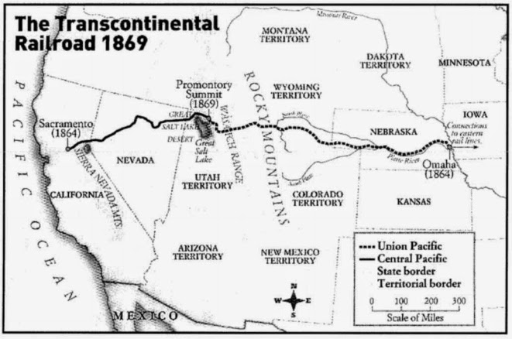

In 1895 Ellen would travel on the Union Pacific and wrote the following:

I left Woodward, Ok., on the morning of the 31st of July and arrived at The Dalles, Oregon, Aug 7, seven days, making a trip of 1800 miles or more, besides being detained on the route 55 hours. When we remember that the time was when months of toil and hardships were required to accomplish such a journey, and how easily and pleasantly it is done now, we bless the day of railroads and telegraphy. My route was on the Sante Fe from Garden City to Denver, and the remainder over the Union Pacific.

JULY 18 – Ellen Nancy Pitts Allen, two months pregnant with her fourth child, turned thirty while living in Missouri, possibly Lexington.

NOVEMBER 4 – Robert Alexander Allen turned thirty-three while living in Missouri, possibly Lexington.

DECEMBER 28 – Lou Bird Allen, Robert’s youngest sister, died at thirteen years, two months and eighteen days old. She was buried in the Truxton Cemetery in Truxton, Missouri. According to the autobiography of her nephew Robert Buxton Allen (1882-1967, the son of her brother Charles Pines Allen and named after his grandfather [my second great grandfather] Robert Buxton Allen [1808-1875]): "She was in a jumping rope contest at school and fell dead from exhaustion."

1870

JANUARY 27 - Virginia became the 8th State to be readmitted to the Union.

FEBRUARY 3 - The 15th amendment became part of the US Constitution. "The right of citizens of the United States to vote shall not be denied or abridged by the United States or by any State on account of race, color, or previous condition of servitude."

FEBRUARY – Mary Allen, the fourth daughter of Robert and Ellen (both had a sister named Mary), was born in Missouri. Later that year they were recorded living in Lexington, Missouri. Some family trees say she was born in Jefferson City, as these same trees say her sister Lola was. Although the family was living in Jefferson City six years later and may have moved around 130 miles with an infant, it was more likely they were in Lexington all along. Until I find documentation to support one way or the other, I will hold with my theory of Mary being born in Lexington. She joined her sisters Birdie (6) and Lola (3).

FEBRUARY 23 - Mississippi became the 9th State to be readmitted to the Union.

MARCH 30 - Texas became the 10th State to be readmitted to the Union.

JUNE 6 – Construction of the Missouri, Kansas and Texas Railroad (MK&T, or Katy) was completed to the Kansas border and into what would later become the state of Oklahoma in the then Cherokee Lands in the Indian Territory. https://www.american-rails.com/mkt.html

JUNE 27 – In the 1870 U.S. Census for Lexington, Lafayette, Missouri, Robert Allen (32, a brick mason) and his wife “Anna” (Ellen, 29) were recorded with their daughters “Burden” (Roberta or “Birdie”, 6), Lola (3), Mary (6 months), and sister-in-law Caroline “Bedy” (35). (Caroline’s last name would still have been Pitts at this time, she did not marry until 1878 when her last name became Thompson. But the census taker obviously wasn’t too accurate with their names. For more about Caroline see “A Convoluted Saga From the Pitts Side”.)

JULY 15 - Georgia became the 11th and final former Confederate State to be readmitted to the Union.

JULY 18 – Ellen Nancy Pitts Allen turned thirty-one while living in Lexington, Missouri.

NOVEMBER 4 – Robert Alexander Allen turned thirty-four while living in Lexington, Missouri.

1871

JULY 18 – Ellen Nancy Pitts Allen turned thirty-two while living in Lexington, Missouri.

SEPTEMBER 27 – Robert, as reported in the Kansas City Times the following day, attended the Annual Conference of the West St. Louis District of the Methodist Episcopal Church, South, in St Louis, Missouri, where he attended as a “Lay Member” and, along with two Reverends, was appointed “On the Interest of the Colored Churches”.

OCTOBER 13 – Robert, probably at this point a full-fledged Reverend, was appointed to the Versailles Circuit at the Conference of the Methodist Episcopal Church, South, in Kansas City, Missouri, as reported in the Kansas City Weekly Journal. Versailles is a city in Morgan County, Missouri which is over one hundred miles southeast of where the family was living in Lexington, Missouri at the time.

NOVEMBER 4 – Robert Alexander Allen turned thirty-five while living in Lexington, Missouri.

1872

JANUARY 13 – An announcement appeared in the Warrensburg Journal-Democrat that “Rev R. A. Allen has been holding a protracted meeting, at the Walker school house, in this vicinity, this week, resulting in good.” That is how the announcement ended. Warrensburg is about thirty-four miles south of Lexington where the family was living. On the website historicmissouri.org it is said that the first congregation of the Methodist Episcopal Church was formed in 1866, right after the end of the Civil War and that it “played an important role in the life of Warrensburg and specifically in the lives of its African American congregants.”

MARCH 1 - Yellowstone National Park in Wyoming, Montana and Idaho was established as the first US National Park "For the Benefit and Enjoyment of the People." http://yellowstoneteton.org/places/yellowstone-national-park/

MARCH 29 – An advertisement appeared in the Tipton Weekly Advance out of Tipton, Missouri that

Prof. O. Goodrich and Rev. R. A. Allen and lady, have entered into a compact with a view to establishing a permanent Select School in this city. The first term will begin in the Harker House on Monday, April 22d and continue three months. Terms from $1.50 to $3 per month. Primary, common and higher branches, will each receive due attention.

I do not know if this first term was ever started and, if it did, if it continued beyond this. Tipton is a town about ninety-five miles southeast of Lexington, Missouri. It is only about thirty-six miles northeast of Jefferson City, Missouri, so the family may have moved to or were contemplating a move to Jefferson City at this point.

JULY 18 – Ellen Nancy Pitts Allen turned thirty-three possibly while living in Jefferson City, Missouri.

OCTOBER 13 – At the west St. Louis conference of the Methodist Episcopal Church, South, held in Nevada City, Missouri, Robert was appointed to the Jefferson City Circuit, as reported in the Kansas City Times. Jefferson City, the capital of Missouri, is about 130 miles southeast of Lexington, Missouri.

NOVEMBER 4 – Robert Alexander Allen turned thirty-six probably while living in Jefferson City, Missouri.

1873

MARCH 4 - Ulysses Grant was sworn in for his second term as President of the United States

JULY 18 – Ellen Nancy Pitts Allen, eight months pregnant with her fifth child, turned thirty-four probably while living in Jefferson City, Missouri.

AUGUST 29 – Esther Virginia (Jennie or Genna) Allen, the fifth daughter of Robert and Ellen, was born in Missouri, probably in Jefferson City. (Virginia was the name of Ellen’s oldest sisters.) She joined her sisters Birdie (9), Lola (6), and Mary (3).

NOVEMBER 4 – Robert Alexander Allen turned thirty-seven probably while living in Jefferson City, Missouri.

1875
Two Years Later

JULY 18 – Ellen Nancy Pitts Allen turned thirty-six while living in Jefferson City, Missouri.

OCTOBER 5 – In Truxton, Lincoln County, Missouri, Robert’s father Robert Buxton Allen died in his sleep at the age of 67 years, one month and five days. According to his obituary “He had lately recovered from an attack of remittent fever and had been feeling much better than usual. The day before he died he worked busily in the field cutting up corn. He retired early, but was awakened in the middle of the night by a thunderclap and got up to put down a window. As he did so he spoke of how sweetly he had slept. As he returned to bed, in reply to a question from Mrs. Allen, he said he felt better than usual. He soon fell asleep. When Mrs. Allen awoke next morning she found him cold in death.” His son Joseph Bensin Allen, my great granduncle, later wrote in The Troy Record of July 2, 1900: he “went to sleep in apparent good health and waked up in Heaven. I saw him a few hours afterwards, and the calm, sweet smile upon his face told that the God, Whom he had so faithfully served, was with him as his soul ran up the shining way.”

NOVEMBER 4 – Robert Alexander Allen turned thirty-nine while living in Jefferson City, Missouri.

1876

MARCH 7 - Alexander Graham Bell received a patent for his telephone. "Three days after filing the patent, the telephone carried its first intelligible message—the famous 'Mr. Watson, come here, I need you'—from Bell to his assistant.” https://www.history.com/this-day-in-history/alexander-graham-bell-patents-the-telephone

JULY 18 – Ellen Nancy Pitts Allen, five months pregnant with her sixth child, turned thirty-seven while living in Jefferson City, Missouri.

AUGUST 1 - Colorado became the 38th State to be admitted into the Union.

NOVEMBER 4 – Robert Alexander Allen turned forty while living in Jefferson City, Missouri.

NOVEMBER 13 – Lambeth (Lam) Shelton Allen, the sixth child and only son of Robert and Ellen and my grandfather, was born in Jefferson City, Missouri. Lambeth is a surname from the Pitts family tree and Shelton is one from the Allen family tree. [The sources of these names are more deeply discussed in “A Convoluted Saga From the Pitts Side”.] Lam joined his sisters Birdie (12), Lola (9), Mary (6), and Jennie (3).

1877

JANUARY 4 – The Bates County Democrat advertised that “Rev. R. A. Allen, of the M. E. Church, (South), will preach at the Ohio street M. E. Church, next Sabbath morning at the usual hour. All are cordially invited to attend.”

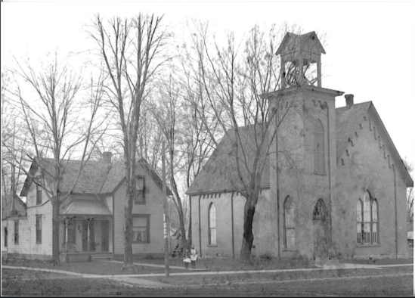
The Ohio Street M. E. Church in Butler, Missouri, circa 1870

“Prior to the Civil War, a tragic split occurred in the Methodist Church over the issues of slavery, dividing the church into two separate organizations: the Methodist Episcopal and Methodist Episcopal South. The Southern Methodists also had a congregation in Butler and a building on North Delaware. In 1919, twenty years before the two factions reunited nationally, the Ohio Street M.E.C. (this church) and the M.E. South Church of Butler decided to unite their congregation. An acceptable and legal agreement took time and effort to accomplish … [but] More than 90% of the South Church came over…cheerfully and ‘lived happily ever after.’” https://www.ohiostreetumc.org/history-of-our-church/

Robert, a minister with the M. E. Church, South, was preaching at “the other” Methodist Episcopal Church in 1877.

MARCH 5 - Rutherford B. Hayes was sworn in as the 19th President of the United States.

APRIL 15 - The first telephone line was completed between Boston and Somerville, Massachusetts. https://www.infoplease.com/history/us/us-history-civil-war-and-reconstruction-1850-1899

MAY 10 - President Hayes had "the White House’s first telephone installed in the mansion's telegraph room. President Hayes embraced the new technology, though he rarely received phone calls. In fact, the Treasury Department possessed the only other direct phone line to the White House at that time. The White House phone number was '1.'" https://www.history.com/this-day-in-history/hayes-has-first-phone-installed-in-white-house

JULY 18 – Ellen Nancy Pitts Allen turned thirty-eight possibly while living in Jefferson City, Missouri, although the family would move back to Lexington, Missouri, before June of the following year.

AUGUST 9 – In the Bates County Democrat the following was submitted by Robert and printed:

There will be a camp meeting held by the M. E. Church South, three miles north of Johnstown, beginning on the 13th of August, and continuing ten days. The meeting is expected to be strictly on the self-sustaining plan. All are invited to come and bring their provisions with them. Come and bring tent, covered wagon, or any way that suits you: Only come and be with us, and we’ll do the good, R. A. Allen.

Johnstown in Bates County, Missouri is about 120 miles southwest of Jefferson City and 97 miles southwest of Lexington.

AUGUST 16 – The Bates County Democrat reported the following:

Rev. R. A. Allen preached here yesterday to a good congregation. He proposes at his next appointment to take up the subject of baptism and said if he could not prove by the Bible that sprinkling adults and infants is baptism he would quit the practice. Here is an opening for some doughty warrior either Baptist or Campbellite, to distinguish himself.

OCTOBER 5 – Robert was at the Seventh Annual Session of the Southwest Missouri Conference of the M. E. Church (South) in Independence, Missouri. Independence, near the border of Kansas, is about 34 miles west of Lexington, Missouri.

OCTOBER 12 – It was reported in the Kansas City Weekly Journal that at the conference Robert was appointed to the Sedalia circuit. Sedalia is about sixty or so miles southeast of Lexington, Missouri.

NOVEMBER 4 – Robert Alexander Allen turned forty-one probably while living in Lexington, Missouri.

NOVEMBER 7 – Robert’s sister, Charlotta Annie S. Allen Pennington, died at the age of 28 years, eight months, and three days. She is buried in Truxton, Missouri, alongside her father Robert Buxton Allen (1808-1875) and sisters Mary (1846-1851) and Lou Bird (1856-1869). Her brother Joseph Bensin Allen, my great granduncle, wrote in The Troy Record of July 2, 1900, that they “await the resurrection of the just.” Annie left her husband William Solomon Pennington, who was one of the schoolteachers in Truxton, and three young children. Her sons Antonio “Tony” and Arthur, just ten months apart, were 8 years and nine months and 7 years and 11 months. Her daughter Nellie was 4 years and one month. An infant son, Joseph, had predeceased her in 1874.

1878

FEBRUARY 19 - Thomas Edison of New Jersey received the patent for his phonograph, the first device that could record and play sound back. https://www.history.com/this-day-in-history/thomas-alva-edison-patents-the-phonograph

JUNE 3 – According to The Lexington Intelligencer, at their home in Lexington, Missouri, Robert officiated the wedding of Ellen’s sister Caroline “Carrie” Pitts (42) to Thomas P. Thompson, a fifty-eight-year old widow from England who was raising his ten-year-old grandson, Arthur Stern.

JULY 18 – Ellen Nancy Pitts Allen turned thirty-nine while living in Lexington, Missouri.

NOVEMBER 4 – Robert Alexander Allen turned forty-two while living in Lexington, Missouri.

1879

MAY 5 – The following letter, signed by Rev. R. A. Allen and others, appeared in the Kansas City Journal of May 7, 1879:

STRASBURG, MO., May 5, 1879, - We the undersigned take pleasure in announcing to the public that the reports that have been going the rounds in the papers about Rev. Martin Ryder, of Lafayette county, drowning his daughter and himself are false. We saw him on Saturday last on his way home from this and Vernon counties where he has been for about three or four weeks with Rev. J. B. H. Wooldridge holding a series of protracted meetings. It is supposed the report was gotten out and started by some unprincipled person, probably a personal enemy of his to injure his usefulness in the ministry, he says he has but one enemy in the world that he knows of. It is a shame and a scandal to allow such a person to start and circulate such falsehoods against a minister without being prosecuted to the fullest extent of the law.

JULY 18 – Ellen Nancy Pitts Allen, one month pregnant with her seventh child, turned forty while living in Lexington, Missouri.

OCTOBER 1 – In the Jefferson City Tribune it was announced that a letter addressed to Miss V. C. Pitts (Ellen’s oldest sister Virginia Charlotte Pitts) in care of Rev. R. A. Allen was waiting to be picked up at the Jefferson City Post Office. Homes weren’t required to have a mailbox for over twenty more years.

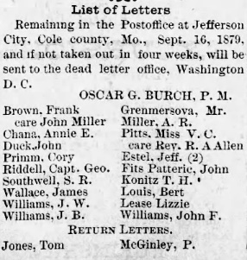

OCTOBER 3 – The Kansas City Times reported that Robert was “elected to elders’ orders” at the Southwestern Methodist Conference in Kansas City, Missouri.

OCTOBER 7 – It was reported in the Kansas City Journal that Robert was appointed to the Chapel Hill circuit in the closing session of the Methodist conference. Chapel Hill is only about 30 miles from Lexington where the family was living.

OCTOBER 21 - Thomas Edison refined the light bulb to make "the first practical incandescent light bulb ... in [his] laboratory in Menlo Park, N.J." https://findanyanswer.com/what-year-did-thomas-edison-invent-the-lightbulb

NOVEMBER 4 – Robert Alexander Allen turned forty-three while living in Lexington, Missouri.

1880

MARCH 22 – Mabel Carrie Allen, the sixth daughter and seventh and youngest child of Robert (43) and Ellen (41) was born in Lexington, Lafayette, Missouri. Ellen had a sister named Caroline who was also called Carrie and perhaps Mabel Carrie was named after her. Mabel joined her siblings Birdie (16), Lola (13), Mary (10), Jennie (6), and Lam (3).

JUNE 7/8 – In the U.S. Census for Lexington, Lafayette County, Missouri Robert (43) and Ellen (41) were recorded living with their six children on Washington Street. Robert’s occupation was listed as “preacher”, and he reported having “lung disease”. The children were Roberta (16), Lola (13), Mary (10), Virginia (6), Lambeth (3), and Carrie (2 months).

JUNE 27 – Helen Keller was born in Tuscumbia, Alabama.

JULY 18 – Ellen Nancy Pitts Allen turned forty-one while living in Lexington, Lafayette, Missouri.

NOVEMBER 4 – Robert Alexander Allen turned forty-four while living in Lexington, Lafayette, Missouri.

1881

MARCH 4 - James Garfield was sworn in as the 19th President of the United States.

JULY 2 - President Garfield was shot by Charles Guiteau while waiting to board a train in Washington, D.C. President Garfield did not die that day, but in Guiteau's pocket was a note which read, “The president’s tragic death was a sad necessity, but it will unite the Republican Party and save the Republic. Life is a fleeting dream, and it matters little when one goes.” https://www.history.com/news/the-assassination-of-president-james-a-garfield

JULY 18 – Ellen Nancy Pitts Allen turned forty-two while living in Lexington, Lafayette, Missouri.

SEPTEMBER 19 - President Garfield succumbed to his wounds in Elberon, New Jersey, becoming the 4th sitting President to die in office and the second to be assassinated. He had been "taken to a cottage on the Jersey shore in the hope that the cool sea air would revive him ... A massive infection—most likely caused by his medical treatment—had left Garfield with a persistent fever and abscesses over his entire body ... He had been president for just 200 days ... many historians now believe that Garfield would have lived if not for the limitations of 1880s medicine" https://www.history.com/news/the-assassination-of-president-james-a-garfield

SEPTEMBER 20 – Vice President Chester Arthur was sworn in as the 21st President of the United States.

OCTOBER 2 – Pablo Picasso was born in Malaga, Spain.

OCTOBER 5 – It was reported in The Kansas City Times that Robert was appointed to the Burette circuit in Bates County, Missouri. Burdette is about 95 miles southwest of Lexington.

NOVEMBER 4 – Robert Alexander Allen turned forty-five while living in Lexington, Lafayette, Missouri.

1882

APRIL 25 – The Butler Weekly Times reported a wedding at which Robert officiated in Butler, Bates County, Missouri.

JUNE 6 – In New York City "Henry W. Seely … patented the electric iron, at the time called an electric flatiron." https://www.thoughtco.com/who-invented-the-iron-1991675

JULY 18 – Ellen Nancy Pitts Allen turned forty-three while living in Lexington, Lafayette, Missouri.

NOVEMBER 4 – Robert Alexander Allen turned forty-six while living in Lexington, Lafayette, Missouri.

NOVEMBER 25 – The Lexington Intelligencer reported a wedding at which Robert officiated near Lexington, Missouri.

1883

JULY 18 – Ellen Nancy Pitts Allen turned forty-four while living in Lexington, Lafayette, Missouri.

JULY 29 – Benito Mussolini, who would become the infamous leader of Italy during World War II, was born in Italy.

AUGUST 11 – Ellen’s sister Virginia Charlotte “Lottie” Pitts (53) and her brother Philip Pitts (51) visited the Allen home in Lexington, Missouri. More can be found about the Pitts family in “A Convoluted Saga From the Pitts Side”.

OCTOBER 2 – The Sedalia Weekly Bazoo reported that at the Southwest Missouri Conference on September 22 in Boonville, Missouri the “Committee on conference relations” declined “to grant supernumerary relation to R. A. Allen.” Which, if I’m not mistaken, meant that he had requested to not have to travel anymore, but his request was declined.

OCTOBER 16 – The Sedalia Weekly Bazoo reported the following from Rich Hill, in Bates County, Missouri:

Mrs. R. A. Allen, of Lexington, Mo., assisted by her husband, Rev. Dr. Allen, and daughter, Roberta, have been in the city the past week and completed arrangements to erect a suitable building for a female seminary on the corner of Hickory and First streets, in Walton’s addition, south of the Gulf railroad, and the first term will open the first Monday in February next.

Roberta was nineteen years old at the time. Rich Hill is about 108 miles southwest of Lexington.

NOVEMBER 4 – Robert Alexander Allen turned forty-seven while living in Lexington, Lafayette, Missouri.

NOVEMBER 29 – The following from the Rich Hill, Missouri area was published in the Kansas City Journal:

A meeting was held last night at the mayor’s office, in the interest of the female seminary projected by Mrs. R. A. Allen, of Lexington, Mo.

1884

JANUARY 25 – The following was published in the Bates County Republican:

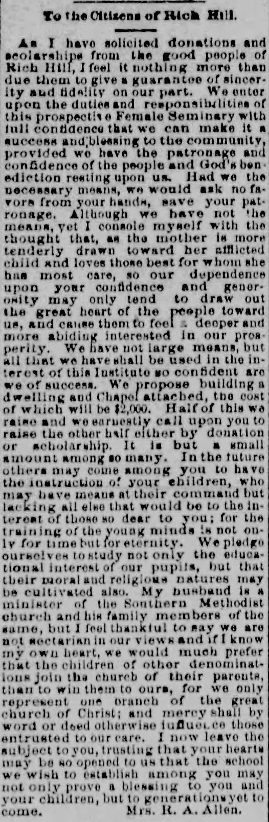

JANUARY 30 – The following was published in The Butler Weekly Times:

Prospects for the Rich Hill Female Seminary are very good. Such a school is needed here, and will be well patronized.

MARCH 5 – The Kansas City Journal reported the following from Rich Hill, Missouri:

The family of Rev. R. A. Allen, of Lexington, Mo., arrived here Saturday evening [March 1st] and will make this their home in the future. Mr. Allen is principal of the female seminary.

MAY 25 – The following was published in the Kansas City Journal:

The programme [sic] of the commencement exercises of the Rich Hill female seminary is out. The exercises will be held at the opera house, Tuesday evening next, and promise to be very interesting.

JUNE 1 – Robert filled in for Rev. Deering at the M. E. Church South in Rich Hill.

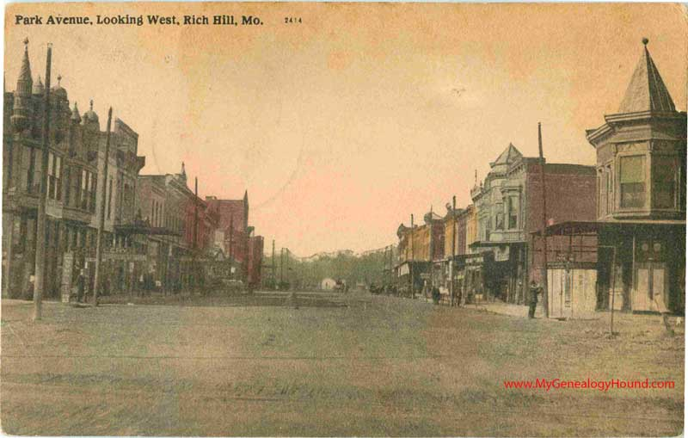
Park Avenue was the street on which the Allens made their home.

JUNE 22 – It was reported from Rich Hill in the Kansas City Journal that “Miss Mollie Blevens, one time a teacher in the public schools here, is visiting the family of R. A. Allen.”

JULY 18 – Ellen Nancy Pitts Allen turned forty-five while living in Rich Hill, Bates, Missouri.

JULY 26 – The following was reported in the Lexington Intelligencer:

We have received the first annual announcement of the Rich Hill Female Seminary, of which Rev. R. A. Allen is president, and Misses Roberta and Lola Allen, Miss V. C. Pitts and Mrs. R. A. Allen are teachers. The parties are all thoroughly known in our community, and they carry with them an unusually large share of public esteem. They are all energetic, conscientious Christian workers, thoroughly qualified, and we hope they may be successful in their worthy undertaking.

NOVEMBER 4 – Robert Alexander Allen turned forty-eight while living in Rich Hill, Bates, Missouri.

1885

This year the world's first skyscraper was completed in Chicago, Illinois. The Home Insurance Building which "towered all of 10 stories with its peak at 138 feet, miniature by today’s standards but gargantuan at that time." https://www.guinnessworldrecords.com/world-records/first-skyscraper/

MARCH 4 - Grover Cleveland was sworn in as the 22nd President of the United States.

MARCH 6 – The following was reported in the Bates County Republican:

Rev. R. A. Allen, principal of the Rich Hill Female Seminary, after making a thorough comparison with other cyclopedias, subscribed for it and says: “I think Johnson’s superior and worthy of a place in every library.”

JULY 18 – Ellen Nancy Pitts Allen turned forty-six while living in Rich Hill, Bates, Missouri.

NOVEMBER 4 – Robert Alexander Allen turned forty-nine while living in Rich Hill, Bates, Missouri.

1886

MARCH 1 – Ellen’s sister, Mary Emily Pitts Quisenberry (49), and her two sons Oliver Pitts Quisenberry (19, named after Ellen and Mary Emily’s brother Oliver Pitts who had died November 30, 1864, fighting on the side of the Confederacy during the Civil War) and John Francis Quisenberry (17, named after his father), were killed in the early-morning hours when their house in Fulton, Missouri, about 170 miles east of Rich Hill, caught fire, as reported in the following way in Fulton Gazette on Friday, March 5th. (I include the report in its entirety as it shows the deep impact the loss of the sister and nephews of Ellen had on the community, shows the graphic detail which was considered appropriate to report in a newspaper of the time, and because both of Ellen’s and Mary Emily’s parents George Richardson and Catherine Spence Pitts were also deceased at this point, so the story won’t be included in their narrative chapter.) The news of the Quisenberrys’s deaths hardly reached the family in time as the two representatives of the family arrived by train from St. Louis during the funeral to take the remains back to St. Louis. Ellen was in Rich Hill, Missouri, twice as far away by train as St. Louis.

HORRIBLE!
A Whole Family Burned to Death.
A MOTHER’S SACRIFICE.
A Profound Impression Made on the Community.

On Tuesday, between 2 and 3 o’clock a.m. fire destroyed the residence of Mrs. Emily Quisenberry; her sons Ollie P. and John F. were burned to a crisp and Mrs. Quisenberry was so fearfully burned that she fell dead in her yard, within a few feet of the burning dwelling. The house was a double cottage, a story and a half in height, containing four rooms and a hall on the first story, a kitchen formed an ell, and there were two small rooms and hall in the half story; it was situated on the west side of Nichols street just south of the bridge that crosses the railroad at the head of that street.
The Alarm.
Between the hours named the cry of fire was heard ringing out on the night air, and the citizens who hurried to the streets in answer to the cry were guided to the point of danger by the bright glare that threw the Syodical [sic, Synodical] Female College and the adjacent buildings into bold relief and contrasted ominously with the surrounding blackness. Soon the clang of the bell at the Pilgrims Rest Church (colored) was heard, and a horseman galloped through the streets shouting fire. A crowd quickly gathered to assist the neighbors in keeping the fire from spreading, for Mrs. Quisenberry’s house was such a mass of flame that nothing could be done to stay its fury. Except a few articles of furniture nothing was saved from the house, not even the lives of the inmates. As soon as the news spread through the crowd that Mrs. Quisenberry had been found dead in the yard, inquires began to be made for the
TWO BOYS.
No one had seen them nor heard of them, and the dreadful conviction that they were in the burning house was forced upon the crowd. The roof had begun to fall in and flames were bursting out on every side before most of the persons present had arrived. As soon as the fire had completed its work and the once happy home was a bed of glowing coals, anxious eyes discovered the bodies of the two young men, blackened and burned and burning still, in the midst of the glowing pile. As soon as it was possible, the kindly hands of Ike Morts, ---- Craghead and others removed the bodies, all that was left of them, from the smoking ashes.
WHAT IS KNOWN.
Mr. Seymour Maughas, of the GAZETTE, who resides with his widowed mother not more than forty feet south of the Quisenberry house, was the first person, so far as is known, to discover the fire. He was sleeping in the northwest room of his house. Between 2 and 3 a.m. he was awakened. Whether he was roused by cries or the roar of the fire or by the light, he does not know; but he had a feeling, he says, that something was wrong. As soon as he was awake he discovered the fire, and hastily throwing on this clothes he ran out his back door and through his yard toward the fire. As he approached he saw something lying on the ground and burning, about ten or twelve feet from the back door, which was open. It proved to be Mrs. Quisenberry. Her hair and her clothing were on fire and he heard
HER MOANS.
Maughas ran to the well and caught up a bucket of water and threw it on her, extinguishing the fire on her hair and clothes. Then he drew her further away from the burning house, the heat from which was already fierce; but even as he drew her away from the fire her form quivered in the death agony. Maughas shouted fire and hurled a stone against the house of Mr. Hunter, who resides just south of him. The first answering shout was heard from Mr. John Will Tucker’s house. Tom Hunter, followed by his father, was the first upon the scene after Maughas, and then the two Jenkins, who are college students. They
BROKE THE DOOR
in front and doors leading from the hallway to the north and south rooms. Mr. Hunter jerked the shutters off the windows on the north side of the house. When Maughas found Mrs. Quisenberry dying in the yard, the flames were bursting from the kitchen and from the roof, but her room did not seem to be on fire. By the time Hunters and Jenkins got there the house was all on fire. As they ran around the house they could see or hear nothing of the boys and the flames barred all entrance. The Maughas house began to smoke under the fierce heat, and they turned their attention to saving that. A colored man, named Sam Tate, pointed out the body of Mrs. Quisenberry to Mr. Hunter, and he and Mr. Dan Tucker wrapped the body in a sheet and carried it to Mr. Hunter’s house.
THE BODIES
of the two boys, Ollie and Johnny, were placed in a box and sent down to Bauer’s undertaking establishment to await the inquest and be prepared for burial. The boys were burned to a crisp, and the fore-arms and legs had separated. It was difficult to move the bodies without some part becoming detached. Johnny’s face could be recognized by those who knew him well, though it was black as coal and much disfigured. To describe their condition further would be unpleasant to the reader.
Mrs. Quisenberry’s body was frightfully burned from head to foot, but she was not disfigured. Her body was placed in a casket ready for burial as soon as the coroner should permit. When found she had on shoes and stockings and had a blanket wrapped around her. The flannel jacket and such under clothing as she wore had been burned from her body.
AN ACCIDENT OR CRIME
was the question that troubled the minds of our citizens. After a full investigation the majority have reached the conclusion that it was an accident. As the kitchen was burning most fiercely when discovered, it is supposed that the fire originated there, though no one can tell how. We have heard that there was a defective flue in the house. There is no doubt that Mrs. Quisenberry could easily have escaped, as she slept on the ground floor from which two doors and several windows would have afforded egress. From the fact that she had a blanket around her it is supposed that she discovered the fire and attempted to ascend the burning stairway to rouse and save her sons. Her burns show that she must have made a desperate and heroic effort. She was blinded, suffocated, and burned, and failing to reach her sons by the burning stairway and hall, rushed to the open air to call them to the upper windows or to obtain aid from her neighbors. She had probably inhaled flame and fell dying in the yard as soon as she reached the open air. All the evidence tends to show that the boys were asphyxiated and never suffered the torture of the fire. They were found just underneath where they had slept and were only six or eight feet apart. The charred remains of bed clothes were found under one of them.
THE MOVEMENTS
of the family the day previous had been as follows: Johnny worked at the GAZETTE office till nearly six o’clock. After supper the mother and the sons attended service at the Presbyterian Church, of which they were all members. The boys usually studied till after 11 p.m. Both were students of Westminster, and so stood high in their classes that their mother was justly proud of them. The family moved to Fulton about five years ago from St. Louis county, when Mrs. Quisenberry lost her husband. Though accounted wealthy, the family netted very little from the estate. Shortly after coming to Fulton, Mrs. Quisenbery’s [sic] step-son¹, a student, died of pneumonia, and soon afterwards her only daughter died.²
THE SCHOOL.
At chapel service at Westminster several of the Faculty addressed the students briefly in a manner suitable to the occasion, and recitations were suspended. At the S. F. C. where Mrs. Quisenberry was once a teacher, recitations were suspended for the morning.
SOLEMN FUNERAL
services were held at the Presbyterian Church on Wednesday morning at 9 a.m.
The faculty and students of Westminster College assembled in front of Bauer’s warehouse and thence followed the caskets containing the bodies of the two boys to the church; the bodies were borne by classmates of the dead students. At the church they were met by the hearse and pall-bearers with the body of Mrs. Quisenberry, and in the solemn procession the church was entered and the three coffins placed in front of the pulpit. The pupils and faculty of S. F. College also marched to the church in a body. The church was filled by a sympathetic and tearful congregation. Though not a relative was present tears and sympathy were not lacking in a warm-hearted community. The several Gospel hymns that were loved by the deceased were interspersed in the services and were rendered by a choir of students. All the boys wore badges of mourning. Rev. Dr. Reaser and Dr. Charles led in earnest prayers. Rev. W. H. Marquess said a few touching words and then President Hersman spoke, taking as his text the words of Stephen, “Lord Jesus, receive my spirit.” After paying a high tribute to the faithfulness in study and work of the two boys and their beautiful devotion to their mother, he read the flowing resolutions adopted by the students:
WHEREAS, It has pleased Almighty God in his providence to visit us by coming in the still hour of night and removing from our midst two of our most beloved and promising students, Ollie P. and John F. Quisenberry, be it
Resolved, by the students of Westminster College, in mass meeting assembled, that while we do deeply deplore our loss, yet we bow in humble submission to Him who doeth all things well, and rejoice in the knowledge that our classmates were ready to answer the dread summons, so that it mattered little whether it came slowly with the wasting hand of disease or at midnight amid fierce flame and smoke.
Resolved, That by their death we have lost two of our most faithful and efficient co-workers, and their memories will be long cherished by us.
Resolved, That this should be a solemn warning to us all and that we recognize the voice of our Maker saying to us, “Be ye also ready, for ye know neither the day or the hour.”
Resolved, That we extend our heartfelt sympathy to their sorrowing relatives and friends in this hour of their affliction.
Resolved, That these resolutions be read before the students of our college, and that copies be sent to the city papers for publication.
J. E. Crawford,
Committee S. G. Miller,
Howard Sutherland.
Dr. Reaser then read the following that will be spread upon the minutes of the Faculty of Westminster:
On the night of Monday, March 1st, 1886, two of the students of this college, O. P. and J. F Quisenbury [sic], and their mother, were burned to death in the fire that after midnight consumed their dwelling.
In view of this sad dispensation of an inscrutable Providence, the Faculty deem it proper to make the following record:
1st. We bow with adoring reverence and trembling awe under the mighty hand of God, and desire to say, “even so Father, for so it seemed good in thy sight.”
2nd. With grateful hearts we bear testimony to the excellent qualities of these young men; to their uniform courtesy as gentlemen, their untiring diligence as students, their constant walk as Christians, and not least their beautiful devotion to their loving and self-sacrificing mother.
3rd. While we deeply deplore the sudden removal from earth of this loved and loving household, we cannot but rejoice that mother and sons “were lovely and pleasant in their lives” and regard it as of God’s mercy that “in death they were not divided.”
4th. We earnestly pray that this sore trial may deeply impress upon our own hearts, as well as upon the hearts of all their fellow-students and friends, the admonition of our blessed Lord “be ye therefore ready also; for the Son of man cometh at an hour when ye think not.”
During the services Miss Fanny Quisenberry³ and Mr. Dan Eaches⁴ (a brother-in-law of Mrs. Quisenberry) reached the church, having just come from the train.
At the conclusion of the services the relatives and the students and the Faculty followed the remains to the depot when Miss Quisenberry and Mr. Eaches accompanied them to St. Louis county, where the burial will take place.
Ollie T. Quisenberry was nineteen years old, John F. was seventeen, and the mother could not have been more than forty-five.⁵
The two days succeeding the fire were sad ones in Fulton. In answer to a call from the pastor of the Presbyterian and M. E. Churches, where meetings are being held nightly, the business men closed their houses and the churches were crowded to listen to the impressive discourses prompted by the calamity.
In Memoriam.
WHEREAS, In the mysterious providence of God, Oliver B. [sic, “P”] and John Quisenberry, two of our most faithful members, have been called from our midst by a terrible catastrophe, and,
WHEREAS, We remember them to have been urbane in deportment, courteous in manner, and gentlemanly toward all with whom they were thrown in contact, and,
WHEREAS, We as a society, feel our deep loss, remembering them as earnest workers and faithful members, therefore be it
Resolved, That we, the members of the Philologic society of Westminster, in view of this sad affliction, now bow with mournful submission to the will of a kind, heavenly Father as manifested in this dispensation of Providence.
Resolved, That we hereby desire to testify to the conscientious faithfulness and earnest diligence of these, our fellow students, in the discharge of all the duties devolved upon them as students and as members of our society.
Resolved, That we extend to their bereaved relatives and friends our heartfelt sympathy.
Resolved, That a copy of these resolutions be recorded in the minutes of our society, and a copy be sent to each of the county papers.
W. H. FERGUSON, Committee
C. F. NESBIT, of
W. M. DUFFY. Philologic Society

¹William Quisenberry was the only surviving son of Mary Emily’s husband John Francis Quisenberry and his first wife Susannah who had died in 1865 after giving birth to her 9th child, six of whom, including her infant girl, had died before their mother. Mary Emily was 29 and John Francis was 43 when they were married in 1866 when William was about four years old. William was nineteen when he died.

²Amanda (1871-1881), the only daughter of Mary Emily and John Francis Quisenberry.

³Fanny Quisenberry (27), who, along with her sister Lucy Quisenberry Pitts (33, who in 1871 at 19 had married Edward Pitts [38 at the time], thus becoming Mary Emily’s sister-in-law as well as her stepdaughter) were the only surviving of the nine children of Mary Emily’s husband and his first wife. Fanny was about seven and Lucy 14 when Mary Emily became their stepmother.

⁴Dan Eaches (63, 1822-1893) was the husband of Mary Emily’s sister-in-law, Amanda Quisenberry Eaches, the sister of her late husband.

⁵Mary Emily Pitts was 49.

MAY 29 – The following was published in the Kansas City Journal regarding the commencement exercises for the Rich Hill Female Seminary: Note that Miss Mary Allen (16) gave an instrumental solo of “Martha”.

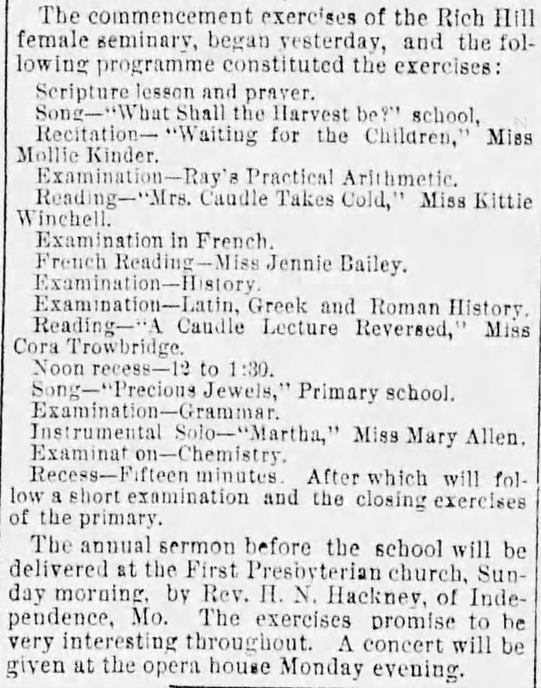

JUNE 30 – A double wedding took place in the home of Robert (49) and Ellen (46) for their two daughters Roberta (22) and Lola (19). Below is the newspaper article in the Butler Weekly Times for July 7, 1886. The humor of the printer is evident at the end.

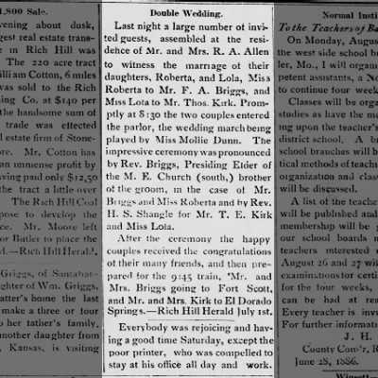

JULY 18 – Ellen Nancy Pitts Allen turned forty-seven while living in Rich Hill, Bates, Missouri.

Around this time Robert had purchased a claim in Beaver County in “No Man’s Land”, the Pan Handle of what in 1890 would become the Oklahoma Territory. Robert’s brother Charles Pines Allen and their brother-in-law Dr. Joseph Errett had also purchased homesteads and would move to Beaver County.

[Charles Pines (42) and his wife Katie (29) had two children with them, Robert Buxton (4, named after his Grandfather Allen) and Maggie Arvilla (about one). Joseph Henry Errett (41), a medical doctor, was married to Ada Finley Allen Errett (32), the sister of Robert and Charles, they had one daughter with them, Mary (3). Louisa Chambers Allen, about 67, the widowed mother of Robert, Charles, and Ada also moved with them.]

In a contribution to the Find A Grave site for Robert made by Robin, who is a long-time family researcher and aunt to a great granddaughter of a Charles Pines Allen, the following is said:

Between 1880 and 1900 [Robert] moved around parts of what was to become Oklahoma, often in concert with his younger brother, Charles Pines Allen.
During the 1880s, while he was living in Beaver City in what is now the Oklahoma panhandle while it was unattached to any U. S. state or territory, he was part of the organizing group attempting to form it into its own territory known as the Cimarron Territory. He was later elected as a territorial senator under the territorial constitution that he helped to write.

Initially I had written for these years that Robert, Ellen, and the four youngest children (Mary, 16, Esther Virginia, 13, Lam, 9, and Mabel, 6) had all moved to Beaver County. This idea was based on the knowledge that the Homestead Act of 1862 required the homesteaders to live on the land for five straight years and make improvements, such as a house and farm. Also, in the 1890 Census of the newly established Oklahoma Territory, the six of them, as well as Robert’s mother, are shown having lived in Beaver County, Oklahoma Territory for four years. However, further discoveries in newspapers of the time clearly show that Ellen remained in Rich Hill until 1892, and I can only assume that the younger children remained there with her. Therefore, it seems that Robert (who appears to have gone back and forth between his homestead in No Man’s Land, his preaching circuits in Missouri and Kansas, and his family in Rich Hill, Missouri) possibly had Charles Pines keep an eye on his homestead when he was not there. Because Beaver County was in
“No Man Land” and therefore not under the jurisdiction of any government, U.S. or others, it seems the rules of the Homestead Act may not have applied and so Robert was free to come and go and still keep his land.

For a clearer picture of the areas Robert traveled in during that time, the railroad map below is from the early 1890s before the Oklahoma “land rush” of 1893. (The 1893 land rush was in the area on the map highlighted in darker red.) Rich Hill is on the western border of Missouri in about the middle between the northern and southern borders of Missouri. Robert and the families could have taken the train from Rich Hill through Kansas to the Oklahoma border. From there they would have had to travel by horse or wagon, most likely on the Jones and Plummer Trail which joined Dodge City, Kansas with the panhandle of Texas via Beaver County and No Man’s Land.

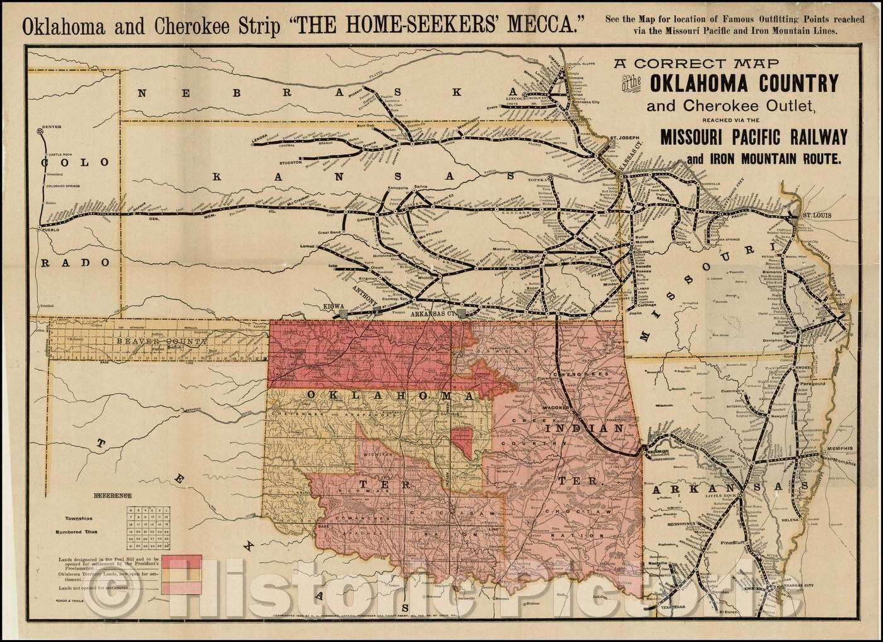

[A brief history, as I understand it, of how there came to be a “No-Man’s Land” - and later the panhandle in Oklahoma:

- The Missouri Compromise of 1820 essentially prohibited slavery, other than in Missouri, in areas obtained in the Louisiana Purchase which were north of the 36°30′ parallel [the border between Missouri and Arkansas]. https://en.wikipedia.org/wiki/Missouri_Compromise

- In May of 1838 “when the Cherokees were moved from Georgia to the Indian Territory (The Trail of Tears) in present day Oklahoma they were given a treaty, ‘a perpetual outlet west, and a free and unmolested use of all the country lying west of the western boundary” of the United States, which at that time was the 100th meridian and is now the eastern border of the Oklahoma panhandle. https://genealogytrails.com/oka/beaver/nomansland.html

- In 1845 Texas joined the Union as a slave state and therefore had to set its northern boundary as the 36°30′ parallel, which is today the southern border between the Oklahoma panhandle and Texas.

- In 1850 the eastern border of New Mexico (and thus the western border of the No Man’s Land) was set at the 103rd meridian.

- In 1854 when Kansas was being organized by the Kansas and Nebraska Bill, Congress originally had the southern boundary set at the 36°30′ parallel until it was realized “that this would deprive the Cherokees” of their westward outlet “as given them by treaty” so “the bill was therefore amened so that the thirty-seventh parallel was made the southern boundary of Kansas” and part of the northern boundary of No Man’s Land. https://genealogytrails.com/oka/beaver/nomansland

- In 1861 the southern border of Colorado was also organized along the 37th parallel leaving a strip of land 34 miles wide and 169 miles long “between the 100th and the 103rd meridians of longitude and the parallels of the latitude of 36 30 and 37 wholly unorganized.” https://genealogytrails.com/oka/beaver/nomansland

- Because this strip of land, although owned by the U.S government, was not under control of any specific jurisdiction (State or Territorial) there were no courts or judicial system to govern it so it was left up to the people themselves to regulate the (lack of) law.]

OCTOBER 26 – Because there literally were no laws or law makers, in order to keep the peace and manage the most serious of infractions as well as those who would “jump the claims” of others by moving in and taking over their homesteads, for the more conscientious

people who desired to live in Beaver City and do business there it became necessary to afford some sort of protection to the weak physically against the strong for with the growth of population not a few had come without firearms.

At first there were conferences between two’s and three’s of the business men. These were followed by conferences of a half dozen or more in various private houses, the men in all cases being personal friends who could trust each other. Finally they called a public meeting for the evening of October 26, 1886, and at this meeting a set of rules were adopted by oral vote for the governing of the Squatters and the settling of disputes over claims.*

[*For the full text of this period in No Man’s Land go to https://genealogytrails.com/oka/beaver/nomansland.html to read “The Saga of No Man's Land as seen in 1888 and 1889: Early historical facts and stories of Beaver City, Oklahoma, Cimarron Territory, the Oklahoma Panhandle.” (Source: Beaver Okla.: Published and distributed by The Herald-Democrat, 1969)]

What inspired Robert and particularly the families of his two siblings to move so far from the familiar with their 67-year-old mother, I do not know. Perhaps Robert, as a circuit riding preacher, had been to the area already. Or perhaps they had heard of it through a flier in the mail or an advertisement in the papers of Wichita, Kansas, which was described as the “Boomingist of Boom Towns” in “The Saga of No Man’s Land as seen in 1888 and 1889”. https://genealogytrails.com/oka/beaver/nomansland

The immense profits made in real estate speculations while the “boom” was on at Wichita stimulated many of her citizens to start booms elsewhere. Out of this stimulation grew the Beaver City Town company … The company was formed to lay out and boom a city on the Beaver Paver, No Man’s Land … Having completed their survey, the Beaver City Town Company went to Washington to get the townsite lawfully entered, and at the same time began to let the world know all about the advantages of the new city and of the surrounding country … they filled the Wichita papers with glowing descriptive articles about the town, and scattered handsomely printed circulars broadcast throughout the mails. https://genealogytrails.com/oka/beaver/nomansland

The reason there was so much interest in forming a town in Beaver to begin with was because it was the halfway point on the Jones and Plummer trail between Dodge City in Kansas and the Panhandle of Texas. The Beaver County, Oklahoma Genealogy Trails website describes the beginnings of the town of Beaver, as follows:

All sorts of goods and merchandise and government stores were carried over this trail in trains of covered wagons-the prairie Schooners of which everyone has heard. The wagons were hitched together in trains of three or four, and then from ten to twenty mules were hitched to the front end of the train, while drivers with long whips and much profanity kept the mules in motion.
The half way stopping place on this trail was on the Beaver River, in No Man's Land. It was a hundred miles from Dodge City and from Tascosa [Texas]. The valley of the Beaver was a very attractive location. The water of the Beaver is pure and sweet. The grass on the bottom land was long and nutritious. There were hundreds of trees along the stream. Buffalo, deer, antelope, and smaller game were to be had in any quantity. On this account the country had always been a favorite hunting ground of the Indians. The drivers of the mules invariably rested their teams here two days and not infrequently a week. https://genealogytrails.com/oka/beaver/nomansland.html

In the very year that the Allens and Erretts arrived the town was just beginning to grow. As described in “The Saga of No Man’s Land as seen in 1888 and 1889”, the local agent of the Beaver City Town Company William Waddle had

built in Beaver a sod house of two rooms one as a grocery, and the other as a home for himself and family … Four new sod houses were completed by the end of four weeks from the date of the completing of the platting of the town, and within four weeks more there were twenty under way or wholly completed. One of the first men to come in … built the first livery stable in the “Strip,” and a livery stable is erected about as soon as any building when a town is to be boomed in the West.

The stable was what is termed a dug-out. It was built with a log front, but had an almost perpendicular bank of earth for the sides and back. It was roofed, as is commonly done there with sod.

The next building erected in Beaver was a saloon with sod walls and a wooden roof … This was followed by a number of sod house dwellings, and then, in May [1886] Adbison Mundel, who subsequently became the city’s first marshall, bult the first wooden house for business purposes while L. E. Harlan, who now serves as sheriff in the provisional county government that has been established, built the first wooden dwelling. Mundel’s building was about 10X14 feet large. It was occupied by Frank Palmer and Rube Chilcott, who had a large stock of dry goods and cowboy furnishings which they had brought there in a prairie schooner … Another building erected about this time, which should be mentioned, was about 24x50 feet large, with an extension 12x24 feet large at the rear. It was one story high with sod walls and wooden roof, and was … the first dance house in the Strip. https://genealogytrails.com/oka/beaver/nomansland

So, this was the “boom” town to which the families moved.

The grandson of Robert’s sister Ada, William Errett Cederberg White, would later write, “In 1886 [his grandparents] left Truxton, Lincoln County, Missouri, by horse and wagon for Oklahoma Territory … When they first arrive in Oklahoma Territory they lived in a sod hut ½ mile from Beaver. After several years they moved into Beaver and built a sod house on the lot later occupied by the Beaver Public School.”

Perhaps the families moved into some of the recently built sod houses like the one pictured below - what a difference it must have seemed from the “civilized” wood houses in the towns and cities in Missouri!

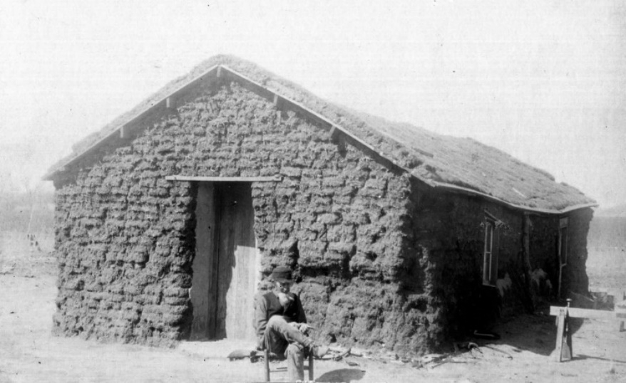
A sod house, circa 1890, from the Encyclopedia of Oklahoma History and Culture (8864, W. K. Hartford Collection, OHS)

While I can only speculate what enticed Robert, Charlie and Katie, and Joseph and Ada to uproot from their homes in Missouri, I know they were busy once they arrived in Beaver City. Whether or not Joseph continued to practice as a physician I do not know, but he and Ada were college educated and teachers and Joseph became the schoolteacher as well as the Beaver County Superintendent. Charles Pines was a farmer his whole life. Robert continued as a Methodist Episcopal minister, as well as being active in the developing government and teaching in the schools.

OCTOBER 28 - "The Statue of Liberty, a gift of friendship from the people of France to the people of the United States, [was] dedicated in New York Harbor by President Grover Cleveland." https://www.history.com/this-day-in-history/statue-of-liberty-dedicated

NOVEMBER 4 – Robert Alexander Allen turned fifty while living in Beaver County in No Man’s Land.

NOVEMBER 9 – A meeting was held in the Township of Beaver to establish

“a code of bylaws for our future adoption” … It was at this time that first steps were taken which resulted in one of the most unique governments ever organized by civilized men.

It is interesting to note that this meeting was “called … at 7 o’clock in the school house” … Although there had as yet been no form of government established, the citizens had got together early in September and built a sod walled house in which their children could attend school, the teacher being paid by volunteer subscription. https://genealogytrails.com/oka/beaver/nomansland.html

Joseph and Ada Errett were later teachers at this school.

1887

FEBRUARY 22 – Elections were held in “the entire population of Cimarron Territory … as near in conformity to law as possible … It will be observed … that they [had] decided on a name for their Territory. It was called Cimarron, from the River of that name that flows across the northeast corner of the Stirp, the Territory was divided into districts. To make a government at all good, it was necessary to have the whole territory represented, for settlement had been formed and claims located throughout the whole 167 miles of its length, Beaver being only a much envied metropolis.” https://genealogytrails.com/oka/beaver/nomansland.html

Robert was elected to represent his district in the legislature.

MARCH 4 – The first meeting of the Cimarron Territorial legislature was held as shown below, from the website Genealogy Trails History Group on the page about Beaver County, Oklahoma (I have added the bold to Robert’s name):

The election came on in due course of time and there was a spirited contest in Beaver City, but it is doubtful whether settlers in the west end of the Strip ever heard there was to be an election. If they did they paid no attention to it. Nevertheless, three delegates to represent three districts were declared elected, although they all lived within a few miles of Beaver City. The election returns were made to Dr. J. A. Overstreet, the secretary of the respective Claim Board and in his report the nine delegates who had been elected gathered in the school house on March 4th as the first legislative body in No Man's land. Their names are attached to the following oath to which they subscribed.
We, the undersigned members of the Territorial Council of Cim-arron [sic] Territory and officers of the same do hereby solemly [sic] swear that we will support the Constitution of the United States, and faithfully execute and enforce the laws of said United States and also laws adopted by Territorial Council for the government of said Cimarron Territory, to the best of our ability. O. G. Chase, President; Merritt Magann, Clerk; R. M. Overstreet; J. G. Snode; James Lane; Robert A. Allen; Elmer Tompkins; Thomas Waters; W. J. Kline.
R. M. Overstreet was a Presbyterian preacher, and Robt. A. Allen a Methodist preacher. https://genealogytrails.com/oka/beaver/nomansland

At this meeting the representatives declared themselves “the Territorial Council of said Cimarron Territory” and adopted “the constitution of the United States and the laws thereof, as the ground work and foundation for all our laws or rules to be adopted for our government.” The first law passed was for ministers, such as Robert, to be “empowered to solemnize the rights of matrimony for parties having first procured from the secretary of any auxiliary Council or from the secretary of the Territorial Council a certificate authorizing such ceremony between the parties there in named.” https://genealogytrails.com/oka/beaver/nomansland

APRIL – A railroad was built into what would later be the territory and then state of Oklahoma to where the town of Woodward was started. The “Southern Kansas Railway (a subsidiary of the Atchison, Topeka and Santa Fe) built tracks to this point from Kiowa, Kansas … Situated in the western quadrant of the Cherokee Outlet”. https://www.okhistory.org/publications

[Woodward would be the closest town to where Robert and Charles Pines would move after the Land Run of 1892. According to a write-up on the Find A Grave site for one of the children of Charles Pines Allen, Woodward was the closest railroad town to where they lived and “the family went (there) twice a year to sell cattle and buy supplies.”

APRIL 15 – The “Territorial Council of Cimarron Territory” met, and Robert was appointed the chaplain. https://genealogytrails.com/oka/beaver/nomansland.html

MAY 22 – Meanwhile, back in Missouri, Ellen continued to run the Female Seminary. The following was published in The Kansas City Times:

The Rich Hill female seminary gave their annual entertainment at the opera house Monday and Tuesday nights. The singing and recitations of the young ladies was very good. Miss Kittie Winchell was awarded the silver medal for the highest grade during the year.

JUNE 12 – The Santa Fe Railroad was completed from Arkansas City, Kansas through eastern Oklahoma to Gainesville, Texas. http://www.cchsm.com/resources/transportation/trains/sf_ark_city.html

JUNE 20 – Queen Victoria of the British Empire celebrated her Golden Jubilee – 50 years on the throne.

JULY 18 – Ellen Nancy Pitts Allen turned forty-eight while living in Rich Hill, Bates, Missouri.

NOVEMBER 4 – Robert Alexander Allen turned fifty-one while living in Beaver County in No Man’s Land.

NOVEMBER 6 – The following was published in The Kansas City Times:

The Rich Hill seminary gave an interesting musicale [sic] in the chapel Friday evening. Quite a large number of patrons and friends of the school were present.

DECEMBER - By the end of the year the Cimarron Territorial Council was in disarray. Council President Dr. Owen. G. Chase went to Washington D. C. to ask “for a territorial government, a land office, a proper land survey, and a federal court.” However, another group led by Reverend R. M. Overstreet had appointed their own representative, John Dale.

These two factions refused to acknowledge each other's legitimacy, and both Chase and Dale went to Washington as the "real" spokesperson. In December Rep. William M. Springer of Illinois delivered Chase's petition to the Fiftieth Congress. The petition proclaimed that Cimarron Territory had ten thousand residents who needed protection and who therefore had formed a provisional government. Congress tabled Chase's plea, and there, it died.
By Sara Richter and Tom Lewis https://www.okhistory.org/publications/enc/entry

The dream of Cimarron Territory began to fade.

DECEMBER – “Sir Arthur Conan Doyle's first Sherlock Holmes story A Study in Scarlet was first published in Beeton's Christmas Annual." https://bakerstreet.fandom.com/wiki/A_Study_in_Scarlet

1888

George Eastman invented the Kodak box camera. "With the KODAK Camera ... Eastman put down the foundation for making photography available to everyone. Pre-loaded with enough film for 100 exposures, the camera could be easily carried and handheld during operation. It was priced at $25 [about $834 in 2024 dollars, still out of the price range of the average American]. After exposure, the whole camera was returned to Rochester. There the film was developed, prints were made and new film was inserted -- all for $10 [about $333 in 2024 dollars]." https://www.kodak.com/en/company/page/george-eastman-history

JANUARY 1 – The Kansas City Journal reported the following from Rich Hill:

Rev. R. A. Allen returned from Kansas last week to spend Christmas with his family in this city.

Perhaps Robert was beginning to get disillusioned by the fight it was becoming to officially establish Cimarron Territory. The following is by Sara Richter and Tom Lewis from the website okhistory.org:

In 1888 the Strip faced even harder times. People became increasingly concerned with survival; political interest waned. Drought and crop failure plagued homesteaders, who could not secure funds to help themselves. Plans asking New Mexico Territory to annex it, or attaching it to a future Oklahoma Territory, collapsed. Regardless, a new territorial council convened. Believing that President Cleveland would help the cause, they created "An Act to Organize the Territory of Cimarron." It provided for an elected senate, house, and supreme court, provided for a presidentially appointed governor, secretary, justices, attorney, and marshal, placed the territorial seat at Beaver, and called for citizens' approval or disapproval.

This measure became Cimarron Territory's last gasp. Only thirteen of twenty-three elected legislators attended. Chase lost his enthusiasm and left the territory, so distillery owner L. M. Hubbard became council leader. The council proclaimed Territory of Cimarron a reality; it would try to attain congressional approval for the decision later. Groundswell efforts to create Cimarron Territory continued to evaporate. Still, the council reconvened for three days in March 1889, but few attended. They considered the Organization Act, discussed funding the election to adopt it, and argued about how to affix their signatures to the measure.

The article below, titled The Saga of No Man’s Land as seen in 1888 and 1889, was printed in the Sun.

Up to the meeting of Congress in December, 1887, the whole territory boomed along in a way that delights a western heart. Even the completion of the Ft. Worth & Denver railroad through the Panhandle of Texas which then stopped the freighters train over the Jones & Plummer trail did not check the prosperity of Beaver City let alone the influx of settlers who were looking for homesteads. Claims changed hands at prices that farms with good titles wound not have brought across the line in Kansas. But when the fiftieth Session of Congress had grown old and nothing had been done for the relief of No Man’s Land its people began to get discouraged. Their capital had keen sunk in improvements and surrant [sic] expenses. They had nothing left to live on. Not only were the influx of the settlers stopped but many of the residents began to “haul their freight” which in the vernacular here means to leave the country. The majority of these people, however, left such improvements on their claims as will enable them to return and hold them whenever the Strip comes in. There was probably at one time a population of 12,000 people in No Man’s Land. Now there may be 8,000.

Nevertheless, many of those who remained are full of hope and no less than forty new houses were added during the past six weeks. To the three hundred to which Beaver contains. They are as a rule sod houses of cheap box frames, but they will serve to hold the town lot as the boom arrives.

To trace the history of other parts of No Man’s Land than this, the metropolis, is out of the question. There are dozens of small settlements and a half dozen villages of twenty or more houses in every one of which there have been fights, murders, lynchings, and the usual lawlessness to be found on the frontier. To give in detail half the tales of the sort which the Sun reporter took note would fill many pages of this paper not to mention the common place killing of which no note was taken. But the record of events at Beaver is tolerably complete, and that will give an idea of what occurred elsewhere.

To the man who comes from a land where trees grow the scenery about Beaver seems at first sight utterly desolate. The barren sand hills, which are found all along the north bank of every stream in the country fairly seems to dance in the glare of the sun even on a winter day. The lowlands were once covered with trees but these all have long since been cut away. The table lands between the streams are only a little less dreary than the sand hills. But in a day or two, or at most a week, this feeling wears off. There is something about the sweep of the uplands that excites the imagination and fascinates the eye. The hills may be a picture of desolation but one is found confessing that in the sense of grandeur exceed the depression which their desolation at first creates. The whitish buffalo grass which by reflecting the sun light, had at first made the eye ache is seen at last to be of a delicate shade of green that is delightful to look upon.

The one difficulty in the way of farming is the south winds. The trade winds from over the sea sweeping across the Gulf of Mexico and over the land until deflected to the north by the Rocky Mountains. They drive along the broken prairies for hundreds of miles. Heated above by the direct rays of the sun and heated below by those rays reflected back from the white buffalo grass sod. They come like the breath from the furnace in which Shadrach, Meshack and Abednego, fell down and they destroyed the face of the land.

Two crops of ordinary garden vegetables are raised every season and each crop is in itself a wonder. As the country is settled up and the buffalo grass turned under the climate will change and this land will be as good as it is in Kansas – no better and nor worse. Central Kansas used to get burned up as this country now.

But in spite of this obvious drawback, there will be a tremendous influx of population here as soon as the laws of the land reach the country. Two railroads, one near each end of the Strip are built to the line and have stopped there only temporarily. The country has been so much talked about everywhere throughout the west that thousands will hasten hither as much from curiosity as from any other reason as soon as property is secure. There will be a mushroom growth of partial wilting down again and then No Man’s Land will become a humdrum country of farms with only a curious early history to make it talked about. https://genealogytrails.com/oka/beaver/nomansland.html

MARCH 23 – The Bates County Republican reported that “R. A. Allen will leave for his claim in the neutral strip this week.”

The picture below, taken in Rich Hill, Bates, Missouri, is circa 1886 to 1888, which would place Mabel between 6 and 8 (she looks too baby-faced to be much older than that), Ellen between 47 and 49, and Lam between 9 and 11. Lam could possibly be a year or two older, but I have a hard time seeing Mabel as older than eight there. If taken in 1888, Robert’s and Ellen’s daughters Roberta and Lola were married. Perhaps Mary, who would have been 18, was finished with school and teaching somewhere. Esther Virginia, who would have been 15, may have been enrolled in a school in Great Bend, Kansas, where there were better opportunities for education. In 1892, the year she was married, The Great Bend Weekly Tribune said, “Miss Genna Allen … has been a student of the college for some time.” (This was probably the Central Normal College in Great Bend which was opened in 1888 with the aim of educating students to be elementary teachers.) This would explain why the older girls are not in the picture. As noted above in the Bates County Republican in March 1888, Robert had “left for his claim in the neutral strip” which could explain his absence from the photo as well.

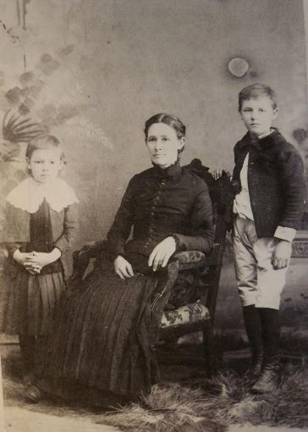

APRIL 2 – Robert and Ellen became grandparents when their daughter Roberta (24) and son-in-law Frank (29) Briggs gave birth in Missouri to their first child, a daughter Lottie Lee Briggs.

JUNE 8 – Ellen went to visit family in St. Louis. Her brothers Philip (56) and Edward (55) and their families lived in the area. It was reported in the Bates County Republican that “Mrs. R. A. Allen, of the female seminary, took the Gulf train Wednesday for St. Louis, where she expects to visit for some time.” While this says nothing of Lam (11) and Mabel (8) going with her, I would expect she took them along.

JULY 18 – Ellen Nancy Pitts Allen turned forty-nine while visiting relatives in St. Louis, Missouri.

JULY 20 – Ellen returned from her summer vacation in St. Louis, as reported the Bates County Republican: “Mrs. R. A. Allen returned home Saturday after a months visit in St. Louis.”

AUGUST 3 – Ellen’s oldest sister Lottie (about 58) came to Rich Hill for a visit as reported in the Bates County Republican: “Miss Virginia C. Pitts, of Orlanda [sic], Florida, came in Sunday and is visiting her sister, Mrs. R. A. Allen, of the Seminary.”

AUGUST 10 – The following appeared in the Bates County Republican: “Mrs. T. E. [Lola, 21] Kirk, wife of our former townsman, now of St. Joseph, came in Saturday night and is visiting her mother, Mrs. R. A. Allen.”

AUGUST 24 – Along with the announcement that “T. E. Kirk came down from St. Joe last Friday to see his wife who is visiting her mother here”, the following appeared in the Bates County Republican:

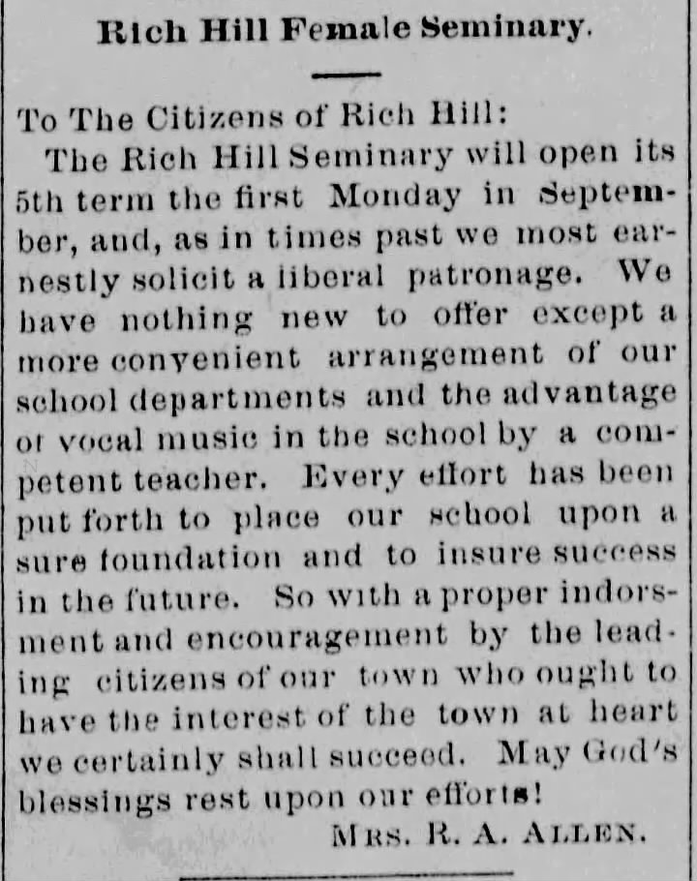

AUGUST 31 – The following appeared in the Bates County Republican:

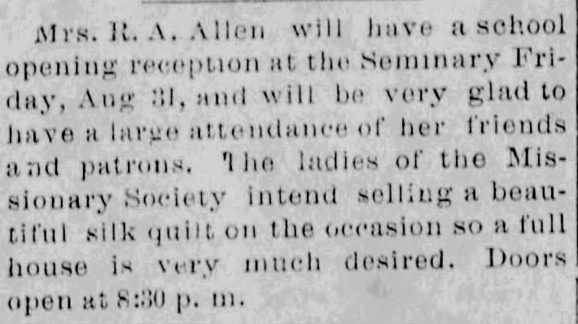

AUGUST – The serial killer who would be known as “Jack the Ripper” began his murderous spree in the Whitechapel area of London, England.

SEPTEMBER 28 – The Bates County Republican reported that “Miss Pitts, who has been visiting her sister, Mrs. R. A. Allen for some time, is very low with fever.”

SEPTEMBER 29 – Virginia Charlotte “Lottie” Pitts, 58, died at the home of her sister, Ellen. [There is more about Virginia in the portion of “A Convoluted Saga From the Pitts Side” that covers the letter written by her mother Kitty Spence Pitts in 1848.]

OCTOBER 5 – Lottie’s death was reported in The Bates County Republican.

Miss Virginia Pitts, sister of Mrs. R. A. Allen died at the residence of the latter on East Park Avenue last Saturday, of fever. The remains were taken to St. Louis for interment.

NOVEMBER 4 – Robert Alexander Allen turned fifty-two possibly in Beaver County in the soon to be U.S Territory of Oklahoma.

1889

JANUARY 11 – Robert seems to have been home in Rich Hill, possibly for the holidays. The Bates County Republican reported that “Rev. R. A. Allen is quite sick.”

MARCH 4 - Benjamin Harrison was sworn in as the 23rd President of the United States.

MARCH 23 – President Harrison authorized the settlement of 1,887,796 acres of land in central Oklahoma, which was organized into the land run one month later.

MARCH 31 - The Eiffel Tower in Paris, designed by Gustave Eiffel for the Exposition Universelle (World's Fair) of 1889, was inaugurated. https://www.toureiffel.paris/en/the-monument/history

APRIL 20 – Adolph Hitler was born in Austria.

APRIL 26 – Robert apparently recovered from his illness earlier in the year, but remained in Rich Hill for a while, as the Bates County Republican reported that “Rev. R. A. Allen is erecting a residence on the South side into which he will move his family as soon as the seminary closes.” From this it also seems that the life of the Rich Hill Female Seminary had reached its end.

MAY 10 – It was reported in the Bates County Republican that “Mrs. R. A. Allen went to Sprague last Saturday and visited friends over Sunday.”

MAY 31 – The following was published in the Bates County Republican:

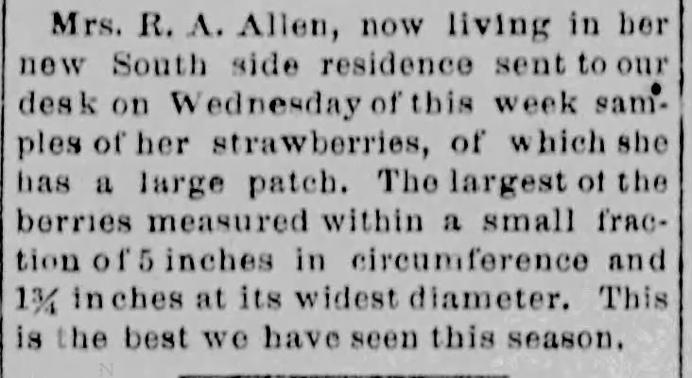

JULY 18 – Ellen Nancy Pitts Allen turned fifty while living in Rich Hill, Bates, Missouri.

AUGUST 16 – In the Bates County Republican it was reported that

Rev. Joseph Allen of Troy, Missouri, came in last Wednesday night and is visiting the family of his brother, R. A. Allen of this city. He is pastor in charge of the M. E. church south, at that place.

Joseph Bensin Allen would begin publication of The Troy Record in July 1900. It was “devoted to temperance and the history of my four great-grand parents”. It’s not a stretch to thing that this visit by Joseph to his brother was the reason just two months later Robert was “traveling in the interest of the Temperance Benevolent Association of Troy, Mo.”

SEPTEMBER 13 – After they closed the Rich Hill Female Seminary, for reasons I do not know, Ellen’s passion for teaching, and possibly as a means to make money, did not subside as the following was published in the Bates County Republican:
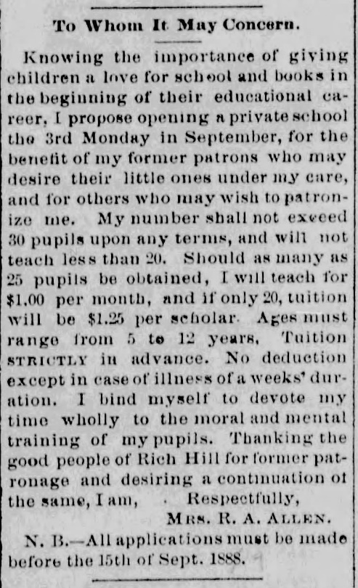

OCTOBER 18 – The following appeared in The Pleasant Hill Register:

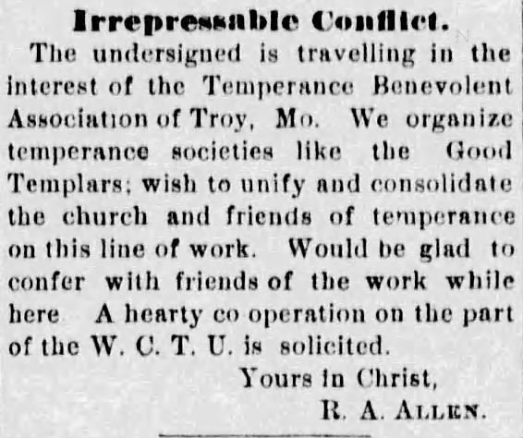

NOVEMBER 2 - North Dakota and South Dakota become the 39th and 40th States, respectively, to be admitted to the Union.

NOVEMBER 4 – Robert Alexander Allen turned fifty-three perhaps while living at the family home in Rich Hill, Bates, Missouri.

NOVEMBER 8 - Montana became the 41st State to be admitted to the Union.

NOVEMBER 11 - Washington became the 42nd State to be admitted to the Union.

1890

JANUARY 17 – Robert and Ellen’s 2nd grandchild was born in Kansas. She was the second daughter for Roberta (25) and Frank (31) Briggs who they named Ethel Mary Briggs.

MAY 2 – No Man’s Land “was officially opened to settlement by the Oklahoma Organic Act”. https://nationalcowboymuseum.org/explore/rushes-statehood-oklahoma-land-runs

The opening of Oklahoma's Unassigned Lands in April 1889 signaled Cimarron Territory's death knell. With failed crops, bad weather, no secure property rights, no law, and most importantly, no broad-based, national support, the plan was doomed. In less than a year more than ten thousand of the region's fourteen thousand occupants had left. The remaining settlers finally found relief when the area became officially attached to Oklahoma Territory in May 1890, ending all hopes for Cimarron Territory.
By Sara Richter and Tom Lewis on okhistory.org: https://www.okhistory.org/publications/enc/entry

One year later “the director of the U.S. Census Bureau announced that [the West had been settled] the frontier was closed. The 1890 census had shown that a frontier line, a point beyond which the population density was less than two persons per square mile, no longer existed." https://www.cliffsnotes.com/study-guides/history/us-history-ii/settling-the-west/the-closing-of-the-frontier

MAY 30 – The following was published in the Bates County Republican: “Mrs. R. A. Allen has a fine lot of strawberries, she is marketing them and would be glad to receive your order.”

[I have no proof of this, but given that her son Lam, who would turn fourteen this year, would later be in the printing business, I do wonder if there were more tidbits about Ellen published in the local paper because he was working there at the time.]

JUNE 12 – In the U.S. Territorial Census for Beaver County, Oklahoma, Robert (53) and Ellen (48, she was actually 50) were recorded living with their four youngest children Mary (18, actually 20), Jennie (15, actually 16), Lambeth (13), Mabel (10), and Robert’s mother Louisa (74, actually 71) who had been widowed for fifteen years. The census reported the family had lived in Oklahoma for four years, although reports from the Missouri newspapers clearly show that they had not. Perhaps their visit there during the summer break from school just happened to coincide with the census.

Robert’s brother Charles Pines Allen and family lived nearby and had actually lived there for four years. Next door to Robert lived Joseph and Ada (the sister of Robert and Charles Pines) Errett and their seven-year-old daughter Mary.

Although Charles Pines was listed as a “farmer”, the following by Kenneth R. Turner seems to be true for him:

Little serious farming took place. Few squatters could afford seed and equipment, and grain markets were too far away for meaningful profits.* Most of the Strip's squatters practiced subsistence farming. Men often took jobs in towns far back east, and their families stayed to hold onto the claim. Some derived extra income by collecting buffalo bones for fertilizer. These were very hard years, marked by blizzards and drought, and most squatters would abandon their claims forever to join the 1889 Land Run. https://www.okhistory.org/publications/enc/entry

*The first railroad through the Oklahoma panhandle didn’t arrive until 1901.

The following about Charles Pines Allen was posted by Find A Grave contributor and family researcher, Shirley:

The family lived in a dugout and made money by hauling buffalo bones to the railhead at Liberal, Kansas … hard times started, half the team died and he had to trade all of the remaining horses for a yoke of oxen. Times were very hard, near starvation, and he took work with a rancher in Kansas homesteading 160 acres of land that the rancher wanted. He had to live on the land and improve for 18 months but was then able to sell to the rancher for a decent amount of money and move back to his homestead in what was by then the panhandle of the Oklahoma Territory. The land there was not very good, though, and rain unreliable.

JULY 3 - Idaho became the 43rd State to enter the Union.

JULY 10 - Wyoming became the 44th state to enter the Union.

JULY 18 – Ellen Nancy Pitts Allen turned fifty-one, possibly while visiting Beaver, Oklahoma, but while still calling Rich Hill, Bates, Missouri, her home.

SEPTEMBER 25 - Sequoia National Park in California was established as the second U.S. National Park. https://www.nps.gov/seki/learn/historyculture/index.htm

OCTOBER 1 - Yosemite National Park in California was established as the third U.S. National Park. https://www.history.com/this-day-in-history/yosemite-national-park-established

NOVEMBER 4 – Robert Alexander Allen turned fifty-four while living in Beaver County, Oklahoma Territory.

1891

FEBRUARY 11 – Robert was a teacher in Benton, Beaver County, Oklahoma Territory as reported in The Herald-Democrat of Beaver.
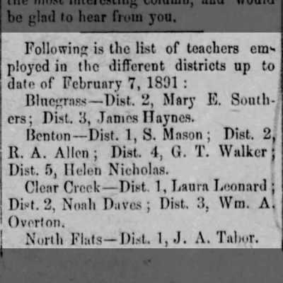

MARCH 4 – Robert officiated the funeral of Hiram S. Smith in Beaver, Oklahoma Territory, as reported in The Herald-Democrat.

MARCH 11 – Robert attended the Teacher’s Association meeting for Beaver County, Oklahoma as reported below in The Herald-Democrat of Beaver.

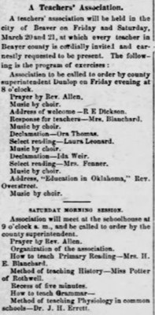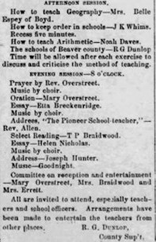

JULY 18 – Ellen Nancy Pitts Allen turned fifty-two while making her home in Rich Hill, Bates, Missouri, although she may have been on an “extended trip, East” as reported below.

SEPTEMBER 4 – The Bates County Republican reported that “Mrs. R. A. Allen having returned from her extended trip, East, will occupy her residence on the South side.”

SEPTEMBER 22 – The second Land Run in “the recently purchased lands (1,120,000 acres) of the Iowa, Sac, Fox, Pottawatomie, and Shawnee tribes [in central Oklahoma were] opened for settlement” at noon. https://nationalcowboymuseum.org/explore/rushes-statehood-oklahoma-land-runs

NOVEMBER 4 – Robert Alexander Allen turned fifty-five while living in Beaver County, Oklahoma Territory.

1892

JANUARY 1 - "Ellis Island ... opened ... as an immigration station ... Located at the mouth of Hudson River between New York and New Jersey, Ellis Island saw millions of newly arrived immigrants pass through its doors. In fact, it has been estimated that close to 40 percent of all current U.S. citizens can trace at least one of their ancestors to Ellis Island." https://www.history.com/topics/immigration/ellis-island

FEBRUARY 12 – It was reported in the Bates County Republican that “Mrs. R. A. Allen arrived from Hardin, Ray county to-day, where she had been visiting a sister.” Her youngest sister Georgia Ann Pitts Mallory (48) lived in Hardin, Missouri. Although Georgia had a ten-year-old son and a four-year-old daughter at home, two months prior she had become a grandmother by her oldest daughter Ellen “Nellie” (20, who had obviously been named after her Aunt Ellen).

APRIL 19 – Oklahoma’s third land run began at high noon into 4,300,000 acres purchased from the Cheyenne and Arapaho Nations in the central western part of Oklahoma as the following map from The National Cowboy Museum shows:
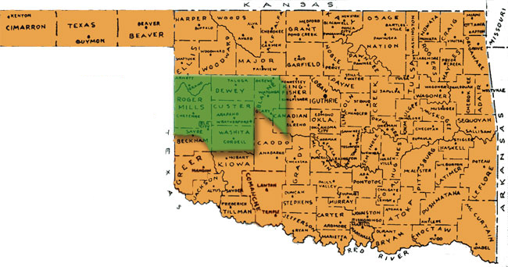
https://nationalcowboymuseum.org/explore/rushes-statehood-oklahoma-land-runs

Perhaps because of the hard times in Beaver, Robert and his brother Charles Pines participated in this land run. Their sister Ada and her family, along with their mother Lousia, remained in Beaver.

The following is found on the Find A Grave site for Charles Pines Allen:

When he (Charles Pines) heard that some land in the area previously reserved for the Cheyenne and Arapaho would be opened up for settlement he decided to participate in the "run."
He moved his household goods and livestock to the edge of the area to camp out for the winter in a dugout for the April [19] start of the run. It was a hard winter and he lost about half of his livestock. He and his brother [Robert] cut trees for fence posts and hauled them across the line into Texas with the ox team to trade them to farmers for corn to feed the cows.
Finally April the [19th] came and he successfully got 160 acres of land on the Canadian River. For the first two years the family lived in a one room sod house. Then a two room log cabin was built next to it that was used for four years. Finally a good house made out of lumber with two basement rooms and four above ground rooms. The family lived in that house for five years. During that time the last three children were born to Charles and Kate.

Robert at fifty-five and Charles Pines at forty-eight were obviously still looking for new opportunities and adventures. Although Robert must have also purchased a homestead during this land run and begun building a home (Ellen would join him in March of 1894), later in the year he was working as a minister in Great Bend, Kansas.

JULY 18 – Ellen Nancy Pitts Allen turned fifty-three while living in Rich Hill, Bates, Missouri. It was her last birthday in Rich Hill.

[For the next few years Ellen also moved around quite a bit. Her youngest two children, Lam, 15, and Mabel, 12, were still school-aged, and whether they moved around with her I do not know. It was common in that day for older children to attend school in another city where opportunities for a better education could take place. By 1896, when he was nineteen, Lam was well established in Chicago where two of his sisters, Lola and Mary, seem to have lived and died as young women. In 1900 there is a commencement ceremony announcement for Maryville, Missouri public school which lists Mabel C. Allen as a graduate. If this is our Mabel she would have been 20 at the time. But by 1903 Mabel was established in Delta County, Colorado where her sister Roberta was living. Robert and Ellen would also live in Delta County for a time before the three of them moved to Chicago around 1905.]

AUGUST – According to a letter written to the Rich Hill Daily Review in August of 1895, Ellen left Rich Hill “to take a position as matron in the normal school at Great Bend, Kansas.” Probably Central Normal College, the same school her daughter Genna was attending. [“Normal” schools were for the education of elementary teachers. From www.newworldencyclopedia.org referencing The American Heritage Dictionaries, “The term ‘normal school’ originated in the early nineteenth century from the French école normale, which translates as ‘standard’ or ‘model school.’"]

OCTOBER 28 – The third grandchild for Robert and Ellen was born in Kansas, another daughter for Roberta (28) and Frank (34) Briggs who they named Lola Lee Briggs.

NOVEMBER 4 – Robert Alexander Allen turned fifty-six while living either in Great Bend, Kansas or the township of Stone in “Cheyenne country” in Oklahoma Territory.

DECEMBER 24 – The following announcement appeared in The Gray County Sentinel in Garden City, Kansas:

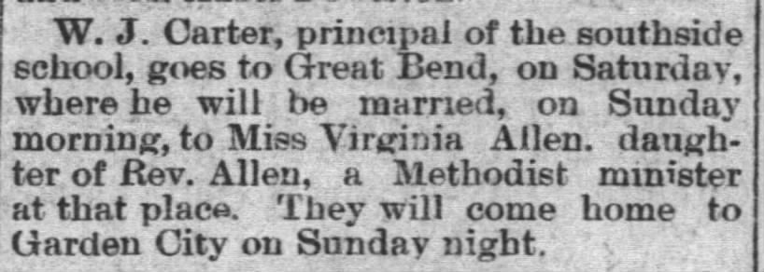

DECEMBER 25 – Robert and Ellen’s daughter, Esther Virginia Allen (19), was married to William J. Carter (24) in Great Bend, Kansas, as printed in The Great Bend Weekly Tribune from Great Bend, Kansas. [Note above it the mention of the “promiscuous” Santa, which would mean something entirely different in my day and age!!]

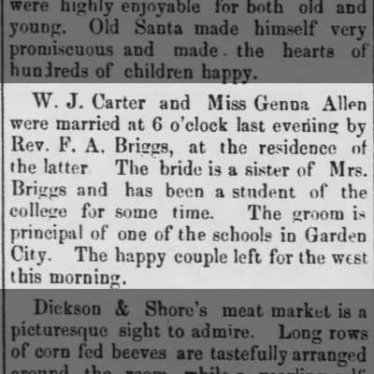

1893

JANUARY 17 - Queen Lili’uokalani of Hawaii "was overthrown in a coup by American businessmen in collusion with the American government backed by United States Marines ... Although President Grover Cleveland [later] determined that the coup was illegal, and tried to reinstate the Queen, the fait accompli prevailed, and the island kingdom became a protectorate of the United States." https://landmarkevents.org/the-overthrow-of-hawaiis-queen-liliuokalani-1893/

MARCH 4 - Grover Cleveland was sworn in as the 24th President of the United States (up until 2024 he was the only President to be elected for two nonconsecutive terms).

JULY 18 – Ellen Nancy Pitts Allen turned fifty-four. Per her letter of 1895 and the write-up for her 100th birthday in The Miami News she may have gone to live in Colorado after her year at the normal school in Great Bend, Kansas. [In 1895 she said that after Great Bend she’d been “in the cities of … Denver, Colorado” and in 1939 it was said that they “returned to Colorado” after being in Fort Pierce, Florida from 1896 – 1898.]

August 1893 - At the Chicago World's Fair "Thomas Edison introduced ... the Kinetograph, the first practical moving picture camera." https://www.filmbug.com/dictionary/moviehistory.php

AUGUST 29 - "American machine salesman, mechanical engineer and inventor Whitcomb L. Judson receives the patent for a 'Clasp Locker', today better known as the zipper, the mechanical little wonder that has kept so much in our lives ‘together.’ But first, the new invention showed only little commercial success. It took almost 80 years [before] the magazine and fashion industry made the novel zipper the popular item it is today." http://scihi.org/whitcomb-judson

SEPTEMBER 16 – Oklahoma’s fourth land run: As shown in the red area on the map below, at high noon “the 6,361,000 acres of the Cherokee Outlet was opened to settlement … Congress had purchased the Cherokee land for $8,505,736 or about $1.40 per acre. The Cherokee Outlet was a 60-mile wide strip of land from the 96th meridian west to the 100th meridian. This land is not to be confused with the Cherokee Strip which was a belt of land 2 ½ miles wide that ran along the northern boundary of the Outlet along the 37th parallel”. https://nationalcowboymuseum.org/explore/rushes-statehood-oklahoma-land-runs

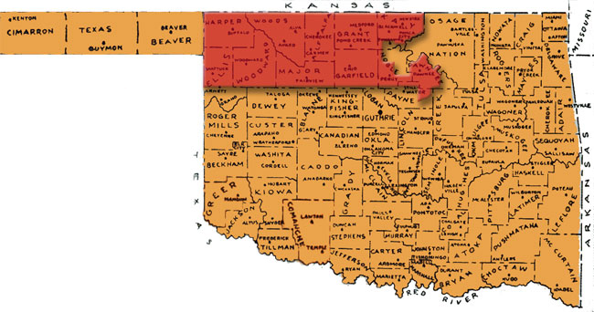

For a while I thought it possible that Robert and Charles had taken part in this land run as well. Seven years later their brother Joseph Besin Allen wrote that his brother “Robert … (was) residing at Stone, Okalahoma (sic)”. The township of Stone, Oklahoma that exists today is in Major County, which is in the area of this 1893 land run. However, further digging has revealed that there was another township called Stone in Oklahoma Territory in the area of the 1892 land run where the families already had homesteads. This is confirmed by two things: 1) the article below from March 15, 1894 which says Ellen was joining Robert “at their new home in the Cheyenne country” - the 1892 run was in the Cheyenne country while the 1893 run was in the Cherokee outlet; and 2) the following bits written on Find A Grave sites by Robin, the aunt of a great granddaughter of Charles Pines Allen, where it seems clear the family remained in the original area from 1892 – 1903 when they left, first briefly for California and finally Texas.

For the first two years (1892-1894) the family lived in a one room sod house. Then a two room log cabin was built next to it that was used for four years (1894-1898). Finally a good house made out of lumber with two basement rooms and four above ground rooms. The family lived in that house for five years (1898-1903).

And

The next to the youngest child of a large family, Ellen [born in 1896 and named after her Aunt Ellen Nancy Pitts Allen], who was always known as Nell, was born in a two room log house in now defunct Day County, Oklahoma and lived with her family on a farm in the Stone community (now extinct) near the Canadian River. The nearest town at the time was the railroad town of Woodward, Woodward, Oklahoma. Older brother Robert B. Allen stated that the family went to Woodward twice a year to sell cattle and buy supplies.

NOVEMBER 4 – Robert Alexander Allen turned fifty-seven (he could have been in Delta County, Colorado, or on his homestead in Stone in “Cheyenne country” in the Oklahoma Territory.)

NOVEMBER 7 - Colorado became the first state to allow women to vote in state elections. http://www.fsmitha.com/time/ce19-91.htm

1894

JANUARY 13 – Robert and Ellen welcomed a fourth grandchild, their first grandson and the first child of Esther Virginia (20) and William J. (25) Carter who they named Allen Lee Carter, born in Garden City, Kansas.

MARCH 15 – Ellen, with her son Lam now seventeen and possibly already in Chicago, may have returned to Missouri for a while before she continued her travels, as the following clip from The Herald-Democrat of Beaver, Oklahoma shows. [Her youngest daughter Mabel was fourteen, high school age, and could have been at a school in Missouri.]

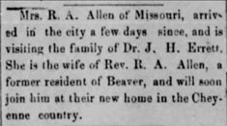

JULY 18 – Ellen Nancy Pitts Allen turned fifty-five while living in Stone in “Cheyenne country” in the Oklahoma Territory.

NOVEMBER 4 – Robert Alexander Allen turned fifty-eight while living in Stone in “Cheyenne country” in the Oklahoma Territory.

1895

JANUARY 7 – Robert and Ellen welcomed their 5th grandchild and second grandson, a second son for Esther Virginia (21) and William J. (26) Carter who they named Ernest Walter Carter, born in Garden City, Kansas.

MAY 3 – “The fifth, smallest and final run took place, resulting in the addition of 183,400 acres” in central Oklahoma. https://nationalcowboymuseum.org/explore/rushes-statehood-oklahoma-land-runs

JULY 18 – Ellen Nancy Pitts Allen turned fifty-six while living in Stone in “Cheyenne country” in the Oklahoma Territory.

JULY 19 – Robert and Ellen welcomed their 6th grandchild and third grandson, the fourth child and first son for Roberta (31) and Frank (36) Briggs who they named Robert Ernest Briggs, born in Lansing, Kansas.

JULY 31 – Ellen left the home in Stone in “Cheyenne country” via Woodward, Oklahoma (the nearest railroad town), per her letter published on August 26, 1895, and transcribed below. By this time her son-in-law Will Carter was the Superintendent of the Simnasho School where Ellen had accepted the position as seamstress.

AUGUST 17 – The following was published in The Dales Times-Mountaineer of Dalles, Oregon:

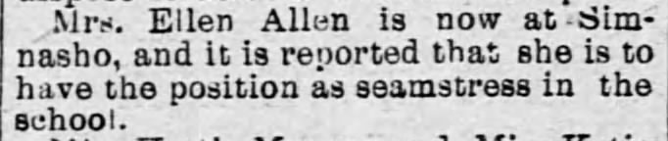

AUGUST 26 – A letter Ellen had written on August 12th from Simnasho, Oregon was published in the Rich Hill Daily Review.

A Former Well Known Rich Hill Lady
Writes an Interesting Letter From
The Far West.

After an absence of some years from the city of Rich Hill, I flatter myself that I have friends who have known me and been interested in my welfare who would be pleased to hear of my present surroundings. I left Rich Hill three years ago this month, to take a position as matron in the normal school at Great Bend, Kan. Since then I have been in the cities of Chicago, Garden City, Kan., Houston, Tex., Woodward, Ok., Denver, Colo., and today finds me among the foothills of the Cascade Mts. employed in an Indian Mission School at Simnasho, Oregon.

To attempt to tell why I have been such a “will ‘o the wisp” might prove of interest to some, but for fear my article might find the way to the waste basket from too much “padding,” I will merely say that circumstances have led me on and on, and the God whom I trust has directed my footsteps, while I acknowledge His goodness through it all.

I left Woodward, Ok., on the morning of the 31st of July and arrived at The Dalles, Oregon, Aug 7, seven days, making a trip of 1800 miles or more, besides being detained on the route 55 hours. When we remember that the time was when months of toil and hardships were required to accomplish such a journey, and how easily and pleasantly it is done now, we bless the day of railroads and telegraphy. My route was on the Sante Fe from Garden City to Denver, and the remainder over the Union Pacific.

The crops through the states of Kansas and Colorado looked flourishing, but as we traveled farther west the face of the county changed, and I imagine that we passed through the most uninviting portions of Wyoming and Idaho, for I was impressed with nothing but barren hills, sage brush and clouds of dust. I have no doubt were I to pass through these states again by a different route and under more favorable circumstances my present opinion would be changed. It was my privilege to behold the famous Pike’s Peak in all its grandeur. We came in sight of it soon after sunrise, and as the cars wound round and round, I viewed it from every point in its great magnitude. Where we were it was hot, dry and dusty, but as we gazed upon its snow-capped summit our enthusiasm was unbounded. I became entrance by the beauty of my surroundings, scarcely realizing that I was rapidly leaving them behind, for one lovely scene after another arose to view till the conductor called “Colorado Springs.” Many of the passengers were going there for an outing, so we stopped some little time. I will not attempt a description of this lovely resort, for many of your readers have been here and others have read descriptions from far abler pens than mine.

When I reached The Dales, situated at the foot of the Cascade mountains, on the Columbia river, I met my son-in-law, W. J. Carter, awaiting me. How I rejoiced at the sight of that one familiar face, so far from loved ones “a stranger in a strange land.” Mr. Carter is my daughter Jennia’s husband, and Superintendent of the Simnasho School. No doubt “Jenna’s” friends will think of her as a mere child, for such she was a few years since while attending the “Old Rich Hill Female Seminary” but we now find her a mother of two boys. Such is the flight of time!

The school will begin the first of September. 60 pupils are expected. As many as the boarding department will accommodate are required to attend. We also have a Mission Church under the supervision of the Presbyterians. I hope and believe good work is being done both in the church and school. There are nine employees who are paid by the Government. The Agency is 20 miles distant, where this school is expected to be moved in the near future. These are of the Digger tribe of Indians, and I believe to be considered the lowest except the “Flat Head.” These are peaceable, good natured and by kindness become fast friends. Wishing the REVIEW great prosperity, Sincerely you friend, MRS. R. A. ALLEN

NOVEMBER 4 – Robert Alexander Allen turned fifty-nine possibly while still on his homestead in Stone in “Cheyenne country” in the Oklahoma Territory.

1896

JANUARY 4 - Utah became the 45th State to enter the Union.

APRIL 6 - "The Olympic Games, a long-lost tradition of ancient Greece, are reborn in Athens 1,500 years after being banned by Roman Emperor Theodosius I. At the opening of the Athens Games, King Georgios I of Greece and a crowd of 60,000 spectators welcomed athletes from 13 nations to the international competition." https://www.history.com/this-day-in-history/first-modern-olympic-games

MAY 18 - "Plessy v. Ferguson: Landmark Supreme Court decision holds that racial segregation is constitutional, paving the way for the repressive Jim Crow laws in the South." https://www.infoplease.com/history/us/us-history-civil-war-and-reconstruction-1850-1899

After her term at the Simnasho school was completed and sometime this year, per the write-up in The Miami News for Ellen’s 100th birthday forty-three years later, Robert and Ellen moved to Fort Pierce in St. Lucie County, Florida where Robert had a church. This is also mentioned in 1911 in the St. Lucie News Tribune when Ellen went to visit her sister Caroline “Carrie” C. Pitts Thompson, just days before she died. “Mrs. Allen is an ex-resident of our city, her husband having been the Methodist minister here many years ago.” Ellen’s brother Walter also lived in Fort Pierce at the time, but their sister Carrie didn’t move there until after 1900.

JULY 18 – Ellen Nancy Pitts Allen turned fifty-seven, while living in Fort Pierce, St Lucie County, Florida.

NOVEMBER 4 – Robert Alexander Allen turned sixty, while living in Fort Pierce, St Lucie County, Florida.

By this year, their only son Lam (19) had moved to the Chicago area where he would live for the rest of his life.

1897

MARCH 4 - William McKinley was sworn in as the 25th President of the United States.

JULY 18 – Ellen Nancy Pitts Allen turned fifty-eight while living in Fort Pierce, Saint Lucie County, Florida.

OCTOBER 20 – Robert and Ellen welcomed their seventh grandchild and fourth granddaughter, a fourth daughter for Roberta (33) and Frank (39) Briggs who they named Eunice Ellen Briggs, born in Delta County, Colorado.

According to The Troy Record of July 2, 1900, which was published by Robert’s brother, Joseph Bensin Allen, their mother Louisa Jane Chambers died “while at the home of my sister, Ada Errett, at Traver, California.” The North America, Family Histories 1500-2000 shows the year as 1897, although Joseph stated that she died “Twenty-three years after the death of my father” which would have been 1898. I can find no other records to more accurately pinpoint the date. Louisa would have been 79 or 80.

NOVEMBER 4 – Robert Alexander Allen turned sixty-one while living in Fort Pierce, St. Lucie County, Florida.

1898

APRIL 21 – 25 – THE SPANISH AMERICAN WAR - Spain and then, retroactive to the 21st of April, the United States declared war on each other over Cuba. The war ended seven and a half months later with the Treaty of Paris.

The war originated in the Cuban struggle for independence from Spain, which began in February 1895. Spain’s brutally repressive measures to halt the rebellion were graphically portrayed for the U.S. public by several sensational newspapers engaging in yellow journalism[*], and American sympathy for the Cuban rebels rose. The growing popular demand for U.S. intervention became an insistent chorus after the still-unexplained sinking in Havan harbor of the American battleship USS Maine, which had been sent to protect U.S. citizens and property after anti-Spanish rioting in Havana … Spain declared war on the United States on April 24, followed by a U.S declaration of war on the 25th, which was made retroactive to April 21. https://www.history.com/topics/early-20th-century-us/spanish-american-war

*”Journalism that relies on eye-catching headlines, exaggeration and sensationalism to increase sales.” https://www.history.com/topics/early-20th-century-us/spanish-american-war

JULY 18 – Ellen Nancy Pitts Allen turned fifty-nine while living in Fort Pierce, Saint Lucie County, Florida.

NOVEMBER 4 – Robert Alexander Allen turned sixty-two while living in Fort Pierce, St. Lucie County, Florida.

DECEMBER 10 – THE END OF THE SPANISH AMERICAN WAR – “The Treaty of Paris ending the Spanish American War was signed … In it, Spain renounced all claim to Cuba, ceded Guam and Puerto Rico to the United States and transferred sovereignty over the Philippines to the United States for $20 million.” https://www.history.com/topics/early-20th-century-us/spanish-american-war

1899

MARCH 11 – The Alva Courier in Alva, Oklahoma (which had been established as a town for the land run of 1893) published the following which had originally been published the year before:

March 11, 1899, viz: Alice Harmon,
Formerly Alice Houser,
who made homestead entry no 1748, for the northeast 1-4 of section 27, township 29 north, range 9 west. She names the following witnesses to prove her continuous residence upon and cultivation of said land, viz: Robert A. Allen, Moses H. Yoder, Lousie C Brenington of Springs, OT; and Alvey D Harmon, of Manchester, OT R A Cameron, register,
First pub in Courier, Feb 3, 1898

JULY 18 – Ellen Nancy Pitts Allen turned sixty possibly while living in Delta, Colorado, near where her daughter Roberta and family lived.

NOVEMBER 4 – Robert Alexander Allen turned sixty-three possibly while living in either Colorado or Stone, Oklahoma Territory.

1900

The world's population was estimated to be 1.65 billion, up 660 million in 100 years. https://ourworldindata.org/world-population-growth

The U.S. population was 76.1 million. http://www.demographia.com/db-uspop1900.htm

Life expectancy in the United States was 47 years old. https://www.cdc.gov/nchs/fastats/life-expectancy.htm, https://www.census.gov/popclock/world

In the United States 140 out of 1000 children born would die before they turned five years old. https://www.cdc.gov/reproductivehealth/maternalinfanthealth/infantmortality.htm

Only 4,000 cars were sold worldwide. https://policyadvice.net/insurance/insights/us-auto-sales-statistics "Just 1 in every 9,500 Americans owned an automobile. 40% were steam powered; 38% were electric; and just 22% were powered by gasoline." https://www.outrightolds.com/index.php/olds-showroom/1900-1914

The average weekly earnings in the United States was $9.70. https://www.indeed.com/career-advice/pay-salary/average-salary-in-us

A pound of sugar cost around 6 cents, a dozen eggs around 21 cents, a pound of butter around 26 cents, a pound of flour around 2 ½ cents, a half-gallon of milk around 13 ½ cents, ten pounds of potatoes around 14 cents, and a pound of bacon also around 14 cents. https://www.infoplease.com/business/economy/retail-prices-selected-foods-us-cities-1890-2015

In the United States it is estimated that only one percent of homes had indoor plumbing. https://www.pmmag.com/articles/93671-the-plumbing-census

There were only 356,000 telephones in the United States. With a population of 7.1 million people in the United States, that would be one phone for about every 20 people. https://www.census.gov/history/pdf/agbellarticle

FEBRUARY - “Eastman Kodak Company introduced its new Brownie cameras (and) photography became available to everyone ... The Brownie camera was ... a simple box with an opening in the front for light to reach the film, a small viewing screen on top, and a switch to expose the film. The film came on easy-to-load rolls ... They cost only one dollar, plus fifteen cents for film. ... now everyone could take pictures (and) make photo albums of family pictures that captured parents, friends, relatives, and images of daily life. These photos helped preserve cherished memories for generations of people." https://www.encyclopedia.com/history/culture-magazines/brownie-cameras

JUNE 7 - Carry Nation (54), began her temperance campaign of destroying the alcohol stock in saloons across Kansas, first with rocks and later with hatchets. "Alone or accompanied by hymn-singing women, Nation would march into a bar and sing and pray while smashing bar fixtures and stock with a hatchet. Between 1900 and 1910, she was arrested some 30 times for 'hatchetations', as she came to call them. Nation paid her jail fines from lecture-tour fees and sales of stick pins in the shape of hatchets ... Engraved on the handle of the hatchet, the pin reads, 'Death to Rum'." https://en.wikipedia.org/wiki/Carrie_Nation

JULY 2 – According to Robert’s brother, Joseph Bensin Allen, Robert, as well as Charles Pines and their sister Mattie Williams, were living in Stone, Oklahoma. I have not found them on the U.S. Census. According to the write-up for Ellen’s 100th birthday in The Miami News they went back to Colorado after two years in Fort Pierce, Florida, but maybe only Ellen did, with Robert going back to Stone.

JULY 18 – Ellen Nancy Pitts Allen turned sixty-one possibly while living in Delta, Colorado.

SEPTEMBER 2 – Robert and Ellen welcomed their eighth grandchild and fourth grandson, the second son and sixth and youngest child for Roberta (36) and Frank (41) Briggs who they named Frank Allen Briggs, born in Cedaredge, Delta, Colorado.

NOVEMBER 4 – Robert Alexander Allen turned sixty-four possibly while living in either Colorado or Stone, Oklahoma Territory.

NOVEMBER 16 – The following appeared in The Delta Independent which show that Ellen was either relocating to Delta, Colorado, or already lived there.

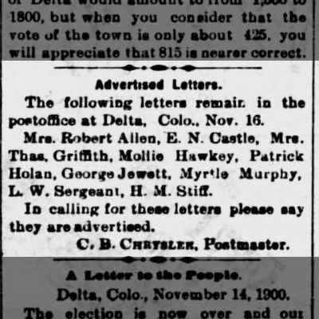

1901

Definitely by this year the family had permanently moved near Cedaredge in Delta County Colorado where their daughters Roberta and Mabel were living. [According to his granddaughter Nancy Ellen Allen Haeger, Robert was a “Methodist Minister – horseback circuit rider in Missouri, Oklahoma and Colorado.”

JANUARY 22 – Edward VII (59) became King of the United Kingdom of Great Britain and Ireland after the death of his mother Queen Victoria at the age of 81. She had reigned longer than any previous British monarch, 63 years and 7 months total.

FEBRUARY 16 – Although mixing up Robert and Ellen’s daughters Esther Virginia (Genna) and Mary, Joseph Bensin Allen wrote the following in The Troy Record;

Robert Alexander Allen, first son of Robert B. Allen and Louisa J. Allen (nee Chambers) was born Nov. 4, 1836. Married miss Ellen Pitts, daughter of Dr. Pitts, of St. Charles county, Missouri. He has been a minister, both local and traveling in the M. E. church south, for thirty years. Kittie Pitts, their first child died in childhood, Lola and Jennie [Mary] died in Chicago. Lamb, their only son is a good business man in Chicago. Mary [Genna] married Rev. Carter, of the M. E. church south, he is nutral [sic] strip in Oklahoma. Birdie married Rev. Briggs, a brother of our Grand Master of the A. F. & A. M., in Missouri, and they reside at Cedaredge, Colo. Mabel, their only single daughter, is teaching school at the house of her sister, Mrs. Carter [although I think it was at Frank and Roberta’s house as I find Mabel in the Delta, Colorado newspapers].

MARCH 4 – William McKinley was sworn in for a second term as President of the United States. Theodore Roosevelt was his Vice President.

JUNE 7 – It was reported in The Delta Independent that “Rev. Allen, who has been ill for some time is feeling quite well again.”

JULY 18 – Ellen Nancy Pitts Allen turned sixty-two while living near Cedaredge, Delta County, Colorado.

SEPTEMBER 6 – President McKinley was shot by Leon Czolgosz, an American Steel worker and anarchist from Michigan, at "a public meet-and-greet at a theater called the Temple of Music" at the Pan-American Exposition in Buffalo, New York. He survived surgery, although the bullet remained lodged in his abdomen. https://www.history.com/news/the-assassination-of-president-william-mckinley

SEPTEMBER 14 – The condition of President McKinley became “increasingly desperate. Gangrene had formed on the walls of (his) stomach and brought on a severe case of blood poisoning. In a matter of hours, he grew weak and began losing consciousness. At 2:15 a.m. ... he died with his wife Ida by his side." He became the 5th sitting President to die in office and the 3rd to be assassinated. Vice President Theodore Roosevelt was sworn in as the 26th President of the United States. https://www.history.com/news/the-assassination-of-president-william-mckinley

OCTOBER 29 – Robert and Ellen welcomed their ninth grandchild and fifth grandson, a third son for Esther Virginia (28) and William J. (32) Carter who they named Frederick William Carter, born in Garden City, Kansas.

NOVEMBER 4 – Robert Alexander Allen turned sixty-five while living near Cedaredge, Delta County, Colorado.

DECEMBER 10 - The first Nobel Prize ceremony was held in Stockholm, Sweden. Awards were given from the estate of Alfred Nobel for "the greatest benefit to mankind" for achievements "in physics, chemistry, physiology or medicine, literature and peace." https://www.nobelprize.org/prizes/themes/the-very-first-nobel-prizes/

1902

MAY 5 – Robert and Ellen’s oldest grandchild, the daughter of Roberta (38) and Frank (43) Briggs, died of “inflammation of the heart” in Delta County, Colorado, as reported by The Delta Independent. She was 14 years, 1 month and 3 days old. The siblings who were now without their oldest sister were Ethel (12), Lola (9), Robert (6), Eunice (4), and Frank (20 months).

MAY 22 - Crater Lake National Park in Oregon was established as the 6th U.S. National Park. https://www.terragalleria.com/parks/info/parks-by-date.html

JUNE 13 – Rev. Robert Allen officiated a wedding in Cedaredge, Colorado, as reported in The Delta Independent.

JULY 4 – President Roosevelt declared victory in the Philippine-American War which had been going on since the United States had gained control of the Philippines through the Treaty of Paris at the end of the Spanish American War. The Filipinos had been fighting for independence. Roosevelt granted “general amnesty to all Filipino insurgency leaders, combatants, and civilian participants.” https://www.thoughtco.com/philippine-american-war-4846100

JULY 18 – Ellen Nancy Pitts Allen turned sixty-three while living near Cedaredge, Delta County, Colorado.

AUGUST 22 - "Theodore Roosevelt becomes the first American President to ride in an automobile when he [rode] in a Columbia Electric Victoria through Hartford, Connecticut." http://www.fsmitha.com/time/1902.htm

NOVEMBER – The Teddy Bear – “One of the world’s most beloved toys was named in honor of President Theodore Roosevelt … Brooklyn, New York, shopkeeper Morris Michtom and his wife Rose made a stuffed fabric bear in honor of America’s 26th commander-in-chief and displayed it with a sign, “Teddy’s bear,” in their store window, where it attracted interest from customers. After reportedly writing to the president and getting permission to use his name for their creation, the Michtoms went on to start a successful company that manufactured teddy bears and other toys.” https://www.history.com/news/who-invented-the-teddy-bear

NOVEMBER 4 – Robert Alexander Allen turned sixty-six while living near Cedaredge, Delta, Colorado.

1903

JUNE 16 – Henry Ford established the Ford Motor Company in Dearborn, Michigan. https://en.wikipedia.org/wiki/History_of_Ford_Motor_Company

JULY 18 – Ellen Nancy Pitts Allen turned sixty-four while living near Cedaredge, Delta, Colorado.

AUGUST 4 - "Pope Pius X becomes the 257th pope, succeeding Leo XIII." http://www.fsmitha.com/time/1903.htm

OCTOBER 1 – In the first baseball World Series the Boston Red Sox defeated the Pittsburg Pirates five to three. https://en.wikipedia.org/wiki/List_of_World_Series_champions

NOVEMBER 4 – Robert Alexander Allen turned sixty-seven while living near Cedaredge, Delta, Colorado.

DECEMBER 17 - The "Wright brothers make the first controlled, sustained flight in heavier-than-air aircraft at Kitty Hawk" North Carolina. _{https://www.kittyhawknc.gov/}

1904

JANUARY 9 - Wind Cave National Park in South Dakota was established as the 7th US National Park. https://www.terragalleria.com/parks/info/parks-by-date.html

JANUARY 27 – Per the Florida Death index, Ellen’s brother, Walter S. Pitts, died in Brevard County, Florida. He had lived in St. Lucie County, Florida. He was 78 years, 11 months, and five days old. According to a post on the “Fort Pierce Connection” Facebook page by Billy Johnson: “He lived in a tent in Edgartown. He lived on the corner of Cedar Place and Riverside Dr. (Second Street). With all his dogs.” [There is more about Walter in the portion of “A Convoluted Saga From the Pitts Side” that covers the letter written by his mother Kitty Spence Pitts in 1848.]
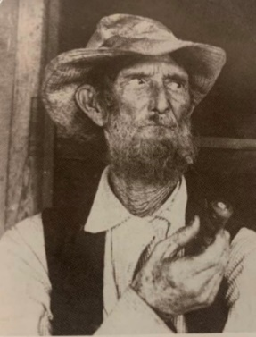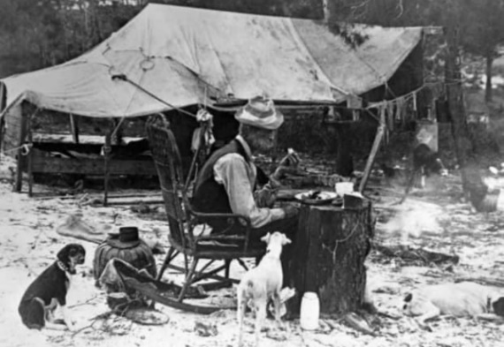
Walter S. Pitts Walter with some of his dogs outside his “house”.

FEBRUARY 19 – The following was published in the Colorado newspaper The Delta Independent:

Frank B Doughty to Robert A Allen, 20 acres, $500.

JULY 1 – St. Louis, Missouri hosted the third modern-day Olympic Games “the first Olympic Games held outside Europe." http://www.fsmitha.com/time/1904.htm

JULY 18 – Ellen turned sixty-five while living near Cedaredge, Delta, Colorado. In The Miami News of July 16, 1939, it was said that “at 65 she published a book of poems, all of which had been written after she was 60.” I have not been able to find this book of poems which she had titled “Autumn Leaves” according to a write-up for her 89th birthday in The Miami Herald.

AUGUST 5 – It seems that Robert and Ellen may have been planning an extended trip to visit family in Chicago and St. Louis and hoped to rent their house out while they were gone as the following was published in The Delta Independent:
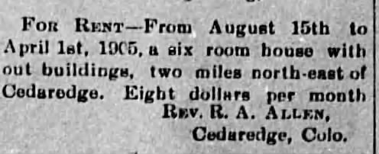

SEPTEMBER 16 – Whether the extended trip was cut short or perhaps Robert had all along intended to live with Mabel for a while, the following was reported in The Delta Independent of Delta, Colorado:

Rev. Allen and daughter Mabel [24], returned from St. Louis last Tuesday. Mrs. Allen will spend the winter with her son in Chicago.

On the same page of the newspaper it was reported that Robert and Ellen’s granddaughter, Ethel Briggs (14), “went to Delta last Saturday to attend the high school.”

Ellen would stay in Chicago for the winter with their son, Lam (27), my grandfather, who was unmarried. His future wife Alice was only four years old in 1904. Shortly thereafter Robert and Mabel would also move to Chicago.

SEPTEMBER 23 – In The Delta Independent it was reported from Cedaredge, Colorado that “Rev. Allen will occupy the M. E. pulpit Sunday morning.”

OCTOBER 27 - The New York subway system opened. https://www.history.com/this-day-in-history/new-york-city-subway-opens

NOVEMBER 4 – Robert Alexander Allen turned sixty-eight while living near Cedaredge, Colorado.

NOVEMBER 19 – Robert and Ellen welcomed their tenth grandchild and sixth grandson, a fourth son and the youngest for Esther Virginia (31) and William J. (35) Carter who they named Robert Jacob Carter, born in Kansas.

1905

This year, according to the family tree on Geneanet and Ancestry, Robert’s brother, John Traylor Allen, died in Madison, Illinois, although I can find no other sources for this event. Traylor, like his brothers Robert and Joseph and their grandfather Pines Allen before them, had also been a minister for the Methodist Episcopal Church, South, as well as being a store keeper at a steel factory, according to the 1900 U.S. Census. Also, according to the 1900 U.S. Census, he and his wife Lucy Ann Grimes had twelve children born to them, seven of whom had died prior to 1900. Only two of the five remaining married and neither of those two had any children to pass on his legacy. He would have been 67 years old when he passed. He and Lucy, who outlived him, had been married 45 years.

This year, also, according to the write-up in The Miami News in 1939 for Ellen’s 100th birthday, Robert and Ellen moved to Chicago. The 1910 U.S. Census shows them, as well as their youngest daughter Mabel, living with their son, my grandfather, Lambeth Shelton Allen (“Lam”).

Lam’s daughter Nancy Ellen Allen Haeger wrote in her memoirs:

The reason my Father hadn’t married before he was in his 40s was that he was the sole support of his Father, Mother and younger sister, Mabel. His Father had been a Methodist minister, riding the circuit through Missouri, Oklahoma and parts of Eastern Colorado. He had no “home” church contributing to his support, relied on goodwill offerings wherever he wandered, and there were no pension plans for retiring ministers. Sons and daughters were expected to care for the elderly. Dad was the next to the last of seven children, the only son. One of the older girls had died at a young age, the four other older sisters had married which left Mabel, the youngest, to physically care for her aging parents.

[The 1910 U.S. Census shows that Ellen Nancy Pitts Allen had had seven children born with only four still living at the time. In The Troy Record of February 16, 1901, written by their Uncle Joseph Bensin Allen, gave the name of the oldest daughter who “died at a young age”, Kitty Pitts Allen, born October 28, 1861, died January 27, 1868, and buried in Truxton, Missouri. The other two older sisters were Lola, who was born in 1867 and married Thomas E. Kirk in 1886, and Mary, who was born in February of 1870. I can find no records to indicate that Mary was ever married. Their Uncle Joseph also mentioned in The Troy Record of 1901 (although he had Virginia “Jennie” and Mary mixed up) that both Lola and Mary had died in Chicago by then. There is a record for a Lola A. Kirke who died in Chicago in 1896, but no obituary to confirm this was the same Lola. Of Mary I find no record at all after the Oklahoma Territorial Census of 1890. Besides his youngest sister Mabel, Lam’s other sisters were Roberta (“Birdie”) and Virginia (“Jennie” or “Genna”).]

Nancy Ellen Allen Haeger continued:

Dad was born November 13, 1876 in Jefferson City, Missouri. In his 20s he moved to Chicago and started his own business in direct-mail advertising, The L.S. Allen Company. The business must have been fairly successful, and although I don’t know the exact date, at some time around 1910 he bought the house in Austin and moved his family from Missouri to live in it with him. His Father would have been 74 in 1910, his Mother 71 [70].

[Per the 1910 U.S. Census Lambeth Allen lived in a rented house at 5713 West Ohio Street in Chicago, Illinois with his parents and sister Mabel. In 1920, after his father had died and his mother and sister had moved to Florida, Lambeth Allen was living at 637 North Long Avenue in Chicago. While the census lists him as a “roomer”, per Aunt Nancy this may have been the house that he had ultimately purchased. And just a couple quick corrections I have uncovered to what my Aunt Nancy wrote: Lam was definitely in Chicago by the time he was 19 and his parents and sister moved from Colorado, not Missouri.]

MARCH 4 – Theodore Roosevelt was sworn in for his 2nd term as President of the United States.

JUNE 30 - Albert Einstein published his theory of Special Relativity "which explains the relationship between space and time – and between energy and mass – in the famous equation E=mc2." https://timeline.web.cern.ch/albert-einstein-publishes-his-theory-special-relativity

JULY 18 – Ellen Nancy Pitts Allen turned sixty-six while living in Chicago.

NOVEMBER 4 – Robert Alexander Allen turned sixty-nine while living in Chicago.

1906

JUNE 16 – President Roosevelt signed the Enabling Act which joined the “Twin Territories” of Oklahoma and Indian.

JUNE 29 - Mesa Verde Nation Park in Colorado was established as the 8th U.S. National Park. https://www.terragalleria.com/parks/info/parks-by-date.html

JULY 18 – Ellen Nancy Pitts Allen turned sixty-seven while living in Chicago.

AUGUST 22 - "The first phonograph (record player) [was] manufactured." http://www.fsmitha.com/time/1906.htm

NOVEMBER 4 – Robert Alexander Allen turned seventy while living in Chicago.

1907

APRIL 24 – Ellen’s youngest brother Edward J. Pitts died in St. Louis, Missouri. He and his wife Lucy M. Quisenberry had been married thirty-six years. They had had ten children, seven of whom outlived him. At the time of his death he also had two grandchildren. He had been an educator all his adult life. He had also been a very fast runner. In the St. Louis Globe-Democrat in 1893 it was reported he had won “the old men’s race” at the St. Louis County Fair at the age of sixty. A year later at the County Fair he repeated his victory, as reported in the St. Louis Globe-Democrat, “The 100-yard dash for men over 50 years of age was won hands down by Prof. E. J. Pitts of Bridgeton. Time – :13”. He was seventy-three years old when he died. [There is more about Edward in the portion of “A Convoluted Saga From the Pitts Side” that covers the letter written by his mother Kitty Spence Pitts in 1848.]

JULY 18 – Ellen Nancy Pitts Allen turned sixty-eight while living in Chicago.

NOVEMBER 4 – Robert Alexander Allen turned seventy-one while living in Chicago.

NOVEMBER 16 – Oklahoma became the forty-sixth state to be added to the Union.

DECEMBER 31 - "By now, eight percent of US households are wired for electricity." http://www.fsmitha.com/time/1907.htm

1908

JULY 18 – Ellen Nancy Pitts Allen turned sixty-nine while living in Chicago.

OCTOBER 1 - Henry Ford began production of his Model T. "It is generally regarded as the first affordable automobile, which made car travel available to middle-class Americans. The relatively low price was partly the result of Ford's efficient fabrication, including assembly line production instead of individual handcrafting." https://en.wikipedia.org/wiki/Ford_Model_T

NOVEMBER 4 – Robert Alexander Allen turned seventy-two while living in Chicago.

1909

MARCH 4 – William Taft was sworn in as the 27th President of the United States.

JULY 12 – The 16th Amendment to the U.S. Constitution was passed by Congress which Permitted the establishment of a national income tax.

JULY 18 – Ellen Nancy Pitts Allen turned seventy while living in Chicago.

SEPTEMBER 14 – Ellen’s brother, Philip, died at the age of seventy-seven years and six months in Chicago. He and his wife Jane Thompson had been married fifty-four years. They had no children. His death certificate listed his occupation as machinist, although in the U.S. Census of 1900 he had reported being a Merchant Gentleman. [There is more about Philip in the portion of “A Convoluted Saga From the Pitts Side” that covers the letter written by his mother Kitty Spence Pitts in 1848.]

NOVEMBER 4 – Robert Alexander Allen turned seventy-three while living in Chicago.

1910

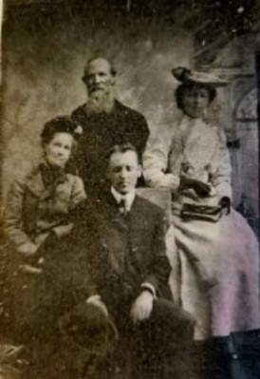
Ellen Allen (about 71), Robert Allen (about 74), Mabel
Allen (about 30), Lambeth Shelton Allen (about 34), Circa 1910

APRIL 18 – The U.S Census for Chicago showed Lambeth S. Allen (33, printer), Robert A. Allen (73), Ellen N. Allen (70), and Mabel C. Allen (30, spelled “Mable” on the Census, as my Aunt Nancy also spelled her name, although in most other cases – newspaper articles, social security application, her gravestone - have it spelled “Mabel”) living together at 5713 W Ohio Street.

MAY 6 - "In England, King Edward VII die[d] at age 69 six days after catching a cold. The raging cold germs produced bronchitis and then pneumonia." http://www.fsmitha.com/time/1910.htm He was succeeded by his son George V (44). https://www.britannica.com/biography/George-V-king-of-United-Kingdom

MAY 11 - Glacier National Park in Montana was established as the 9th U.S. National Park. https://www.terragalleria.com/parks/info/parks-by-date.html

JULY 18 – Ellen Nancy Pitts Allen turned seventy-one while living in Chicago.

NOVEMBER 4 – Robert Alexander Allen turned seventy-four while living in Chicago.

NOVEMBER 7 - "In Ohio, the first air flight for the purpose of delivering commercial freight takes place, between Dayton and Columbus." http://www.fsmitha.com/time/1910.htm

1911

JANUARY 27 – The following was reported in the Florida newspaper the St. Lucie News Tribune:

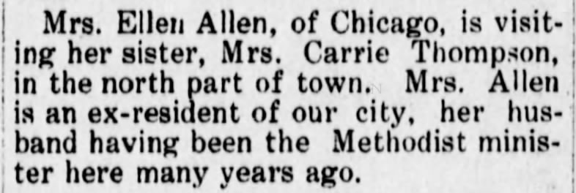

JANUARY 30 – Ellen’s sister, Caroline C. Pitts Thompson, died in Fort Pierce, St. Lucie, Florida at the age of seventy-four and about seven months old. She had married a widow, Thomas P. Thompson, when he was fifty-eight and she was forty-three. They had no children together and he predeceased her by a number of years. [There is more about Caroline in the portion of “A Convoluted Saga From the Pitts Side” that covers the letter written by her mother Kitty Spence Pitts in 1848.] The following obituary, which mistakenly lists her at 78, was published in the St. Lucie News Tribune.

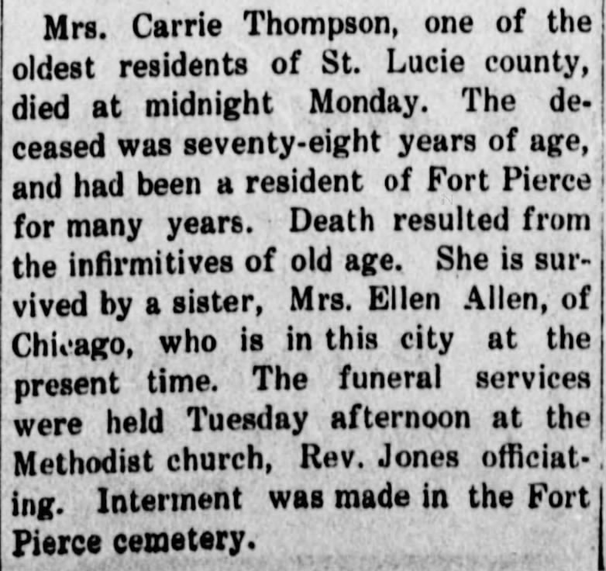

JULY 18 – Ellen Nancy Pitts Allen turned seventy-two while living in Chicago.

NOVEMBER 4 – Robert Alexander Allen turned seventy-five while living in Chicago.

1912

JANUARY 6 – New Mexico became the 47th State to be added to the Union.

FEBRUARY 14 – Arizona became the 48th State to be added to the Union.

APRIL 15 – The Titanic, after striking an iceberg, sank on its maiden voyage. Over 1,500 people died.

JULY 18 – Ellen Nancy Pitts Allen turned seventy-three while living in Chicago.

NOVEMBER 4 – Robert Alexander Allen turned seventy-six while living in Chicago.

1913

"The first successful, mass marketed ... automatic electric refrigeration unit" was invented by Fred W. Wolf Jr. Called the DOMELRE, "a contraction of DOMestic ELectric REfrigerator ... (It) was factory manufactured to be a ready-to-use refrigeration unit that could be delivered, mounted on top of an ice box and simply plugged in. Several thousand were sold between 1914 and 1922." However, most homes of the day still used the ice box which "looked like plain wooden cabinets ... Without electric refrigeration, they were fitted inside with a space for ice, which had to be topped up regularly to keep food cool and fresh." An advertisement for an icebox from 1913: "Keeping the butter hard, the milk and cream sweet, and the meat from spoiling, is a part of the housewife’s trouble in the summer time. White Frost ad from Carter’s Hardware, Sonora CA" https://www.ashrae.org/about/mission-and-vision/ashrae-industry-history/domelre-first-electric-refrigerator https://homethingspast.com/2011/11/06/vintage-white-frost-refrigerator/

MARCH 4 – Woodrow Wilson was sworn in as the 28th President of the United States.

JUNE 18 – Ethel Mary Briggs (23), the oldest living grandchild of Robert and Ellen, and daughter of Frank (54) and Roberta (49) Briggs, was married in Cedaredge, Colorado to Oliver Bidwell Cook (26). She was the first of their grandchildren to marry. Oliver and Ethel never had children. Ethel was the cousin of my Aunt Nancy who transcribed and shared the letters of my second great grandmother Catherine “Kitty” Spence Pitts, which I have dissected in the chapter “A Convoluted Saga From the Pitts Side”.

JULY 18 – Ellen Nancy Pitts Allen turned seventy-four while living in Chicago.

NOVEMBER 4 – Robert Alexander Allen turned seventy-seven while living in Chicago.

1914

JANUARY 1 – Robert’s brother, Charles Pines Allen, died of “malignant cancer” in Tom Green County, Texas, at the age of sixty-nine years, seven months, twenty-five days, per his death certificate. He and his wife Katie had been married fifty-seven years. They had had ten children together, seven of whom were still living, the first three having died in infancy. Seven grandchildren were living at the time of his death.

JUNE 28 – WORLD WAR I - Tensions had been rising between several European countries for a long time and the assassination of Archduke Franz Ferdinand (50), the presumptive heir to the Austro-Hungarian throne, and his wife, Sophie (46), in Sarajevo, the capital city of Bosnia and Herzegovina, on this day was marked as the spark that lit the powder keg for what at the time would be known as THE GREAT WAR and even by H. G. Wells “the war that will end war”. Franz and Sophie were shot at close range by a nineteen year old Bosnian Serb student named Gavrilo Princip in protest of the annexation of his country by Austria-Hungary in 1908.

“The causes of World War I included the rise of Germany and decline of the Ottoman Empire, which disturbed the balance of power in place in Europe for most of the 19th century, as well as increased economic competition between nations triggered by new waves of industrialisation and imperialism. Growing tensions between the great powers and in the Balkans reached a breaking point [due to the assassination.]” https://en.wikipedia.org/wiki/World_War_I

JULY 18 – Ellen Nancy Pitts Allen turned seventy-five while living in Chicago.

JULY 28 – WORLD WAR I – Austria-Hungary held Serbia responsible for the assassination of Archduke Franz Ferdinand and declared war on Serbia. https://www.historyplace.com/worldhistory/firstworldwar

JULY 29 – WORLD WAR I - “Britain call[ed] for international mediation to resolve the worsening crisis. Russia urge[d] German restraint, but the Russians beg[an] partial troop mobilization as a precaution. The Germans then warn[ed] Russia on its mobilization and beg[an] to mobilize themselves." https://www.historyplace.com/worldhistory/firstworldwar

AUGUST 1 – WORLD WAR I - "Germany declare[d] war on Russia. France and Belgium beg[an] full mobilization." https://www.historyplace.com/worldhistory/firstworldwar

AUGUST 3 – WORLD WAR I - "Germany declare[d] war on France, and invade[d] neutral Belgium. Britain then sen[t] an ultimatum, rejected by the Germans, to withdraw from Belgium." https://www.historyplace.com/worldhistory/firstworldwar

AUGUST 4 – WORLD WAR I - "Great Britain declare[d] war on Germany. The declaration [was] binding on all Dominions within the British Empire including Canada, Australia, New Zealand, India and South Africa." https://www.historyplace.com/worldhistory/firstworldwar

The United States would not become involved in the fighting until April of 1917.

AUGUST 6 – WORLD WAR I - "The Austro-Hungarian Empire declare[d] war on Russia." https://www.historyplace.com/worldhistory/firstworldwar

AUGUST 12 – WORLD WAR I - "Great Britain and France declare[d] war on Austria-Hungary. Serbia [was] invaded by Austria-Hungary." https://www.historyplace.com/worldhistory/firstworldwar

AUGUST 15 - The Panama Canal opened for ship traffic, connecting the Pacific Ocean with the Atlantic Ocean and greatly reducing "the time for ships to travel between the Atlantic and Pacific oceans, enabling them to avoid the lengthy, hazardous Cape Horn route around the southernmost tip of South America via the Drake Passage or Strait of Magellan and the even less popular route through the Arctic Archipelago and the Bering Strait." https://en.wikipedia.org/wiki/Panama_Canal

AUGUST 23 – WORLD WAR I - "Japan declare[d] war on Germany. The Japanese then prepare[d] to assist the British in expelling the Germans from the Far East. German possessions in the South Pacific include[d] a naval base on the coast of China, part of New Guinea, Samoa, and the Caroline, Marshall and Mariana Islands." https://www.historyplace.com/worldhistory/firstworldwar

NOVEMBER 4 – Robert Alexander Allen turned seventy-eight while living in Chicago.

DECEMBER 25 – WORLD WAR I - "A Christmas truce occur[d] between German and British soldiers in the trenches of northern France. All shooting stop[ed] as the soldiers exit[ed] their trenches, exchange[d] gifts, s[ang] carols and engage[d] in a soccer game. This [was] the only Christmas truce of the war, as Allied commanders subsequently forb[ade]fraternization with orders to shoot any violators." https://www.historyplace.com/worldhistory/firstworldwar

1915

JANUARY 25 - The first transcontinental telephone call "was a conference call involving Alexander Graham Bell in New York, his assistant Thomas Watson in San Francisco, President Woodrow Wilson in Washington, and the president of the American Telephone and Telegraph Company in Georgia. Using the new commercial service was a major financial commitment. The charge for a three-minute call from New York to San Francisco started at $20.70.” That would be about $644 in 2024. https://www.census.gov/library/audio/profile-america/profileodd/profile-odd-25.html

JANUARY 26 - Rocky Mountain National Park in Colorado was established as the 10th U.S. National Park. https://www.terragalleria.com/parks/info/parks-by-date.html

FEBRUARY 18 – WORLD WAR I - "The first German U-Boat campaign of the war beg[an] with unrestricted attacks against merchant and passenger ships in the waters around the British Isles. Within six months, Allied shipping losses at sea surpass[ed] the number of new ships being built. However, the unrestricted attacks also arouse[d] the anger of the neutral United States as Americans [were] killed." https://www.historyplace.com/worldhistory/firstworldwar/index-1915.html

MAY 6 - "In major league baseball in the United States, Babe Ruth hit his first career home run." http://www.fsmitha.com/time/1915.htm

MAY 31 – WORLD WAR I - "The first aerial bombing of London occur[ed] as German Zeppelins kill 28 persons." https://www.historyplace.com/worldhistory/firstworldwar/index-1915.html

JULY 18 – Ellen Nancy Pitts Allen turned seventy-six while living in Chicago.

NOVEMBER 4 – Robert Alexander Allen turned seventy-nine while living in Chicago.

1916

APRIL 18 - "President Woodrow Wilson threaten[ed] to sever diplomatic ties between the United States and Germany following the sinking of the passenger ferry Sussex by a U-Boat in the English Channel. The attack marked the beginning of a new U-Boat campaign around the British Isles. But in response to Wilson, the Germans call[ed] off the U-Boats." https://www.historyplace.com/worldhistory/firstworldwar/index-1916.html

JUNE 30 – Esther visited her mother in Chicago per the following from the Reno Gazette-Journal:

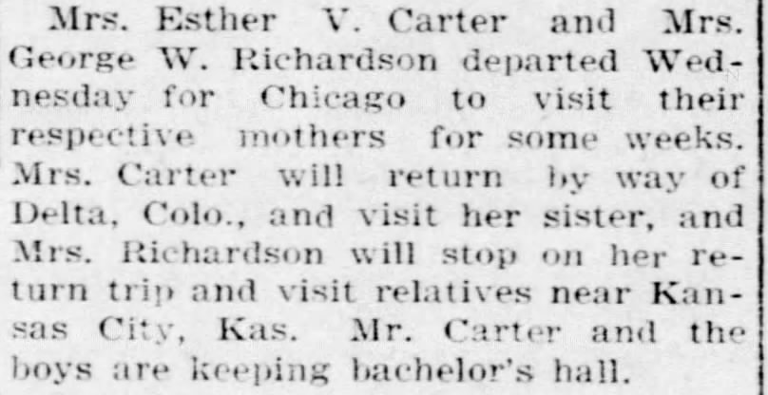

JULY 18 – Ellen Nancy Pitts Allen turned seventy-seven while living in Chicago.

OCTOBER 8 – WORLD WAR I - "The German Air Force (Luftstreikrafte) is founded as various aerial fighting groups are merged." https://www.historyplace.com/worldhistory/firstworldwar/index-1916.html

NOVEMBER 4 – Robert Alexander Allen turned eighty while living in Chicago.

DECEMBER 18 – WORLD WAR I – “President Woodrow Wilson cap[ed] off a year-long effort to organize a peace conference in Europe by asking the combatants to outline their peace terms." https://www.historyplace.com/worldhistory/firstworldwar/index-1916.html

1917

FEBRUARY 3 – WORLD WAR I - "The United States sever[ed] diplomatic ties with Germany after a U-Boat s[ank] the American grain ship Housatonic. Seven more American ships [were] sunk in February and March as the Germans [sank] 500 ships in just sixty days." https://www.historyplace.com/worldhistory/firstworldwar/index-1917.html

MARCH 5 – Woodrow Wilson was sworn in for his second term as President of the United States.

APRIL 6 – WORLD WAR I – The United States declared war on Germany, thus entering into the “Great” War.

According to the CDC, when the US entered World War I, life expectancy in the US was 54 years old for women and 48 years old for men. https://www.cdc.gov/flu/pandemic-resources/1918-commemoration/milestone-infographic.htm

MAY 18 – WORLD WAR I - "The Selective Service Act is passed by the U.S. Congress, authorizing a draft. The small U.S. Army, presently consisting of 145,000 men, will be enlarged to 4,000,000 via the draft." https://www.historyplace.com/worldhistory/firstworldwar/index-1917.html

JUNE 25 – WORLD WAR I – The first American troops landed in France. https://www.historyplace.com/worldhistory/firstworldwar/index-1917.html

JULY 18 – Ellen Nancy Pitts Allen turned seventy-eight while living in Chicago.

NOVEMBER 4 – Robert Alexander Allen turned eighty-one while living in Chicago.

DECEMBER 14 – Robert died in Chicago at the age of 81 years, 1 month, and 12 days.

That year Robert and Ellen’s daughter, Esther Virginia (“Genna”), had moved with her family to Homestead, Florida. Genna’s husband William Carter, like her father and her uncles John Traylor Allen and Joseph Bensin Allen, was a minister with the Methodist Episcopal Church, South. According to his obituary in the Emporia Kansas Gazette from 10 February 1940, in Florida he “continued his church work and was postmaster at Homestead during the Coolidge administration [1923-1929].”

From the memoirs of Nancy Ellen Allen Haeger:

After her Father died, Mable wrote Genna that the cold northern winters were becoming hard on “Mama”; Genna said they had plenty of room in their big house and they invited Mable and [Ellen] to move in with them.

Will’s and Genna’s four sons were Allen (23, his draft card from that year stated that his mind was “not strong”, he never married and, after the death of his parents, would live with his brother Ernest), Ernest (22, he was a private in the infantry), Frederick (16), and Robert (13).

1918

By this year in the United States, one in thirteen families owned a car. https://worldhistory.us/american-history/cars-in-the-1920s-the-early-automobile-industry.php

MARCH 31 - Daylight Savings Time was started in the United States with the Standard Time Act. https://en.wikipedia.org/wiki/Daylight_saving_time_in_the_United_States

APRIL 9 – Per The Miami News Ellen, Esther and Mabel attended a meeting of the White Temple missionary society in Miami, Florida. (This was the Methodist Episcopal Church that Ellen and Mabel joined in Florida.)

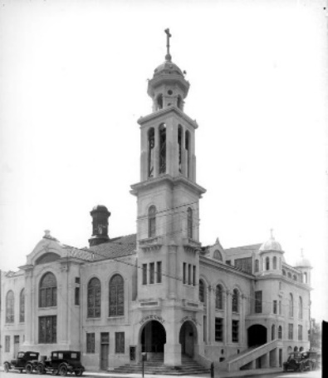

MAY 15 - "The Post Office Department began airmail service between New York and Washington, D.C., via Philadelphia — the nation’s first regularly scheduled airmail route. Initially, Army pilots flew the mail." https://about.usps.com/who-we-are/postal-history/airmail-history-in-pictures.pdf

JULY 18 – Ellen Nancy Pitts Allen turned seventy-nine while living in Homestead, Dade County, Florida.

SEPTEMBER 12 – Robert and Ellen’s son Lambeth Shelton Allen (41) registered for the draft giving his address as 637 North Long Avenue in Chicago, Cook County, Illinois. He listed his occupation as “printing”, his employer as himself with his place of work as 11 South Deplaines in Chicago, Cook County, Illinois. His mother Ellen N. Allen in Miami, Florida was his emergency contact. He was described as medium height, medium build, with blue eyes and light hair.

NOVEMBER 11 – THE END OF WORLD WAR I - "At 5:10 am, in a railway car at Compiègne, France, the Germans sign[ed] the Armistice which [was] effective at 11 am--the eleventh hour of the eleventh day of the eleventh month. Fighting continue[d] all along the Western Front until precisely 11 o'clock, with 2,000 casualties experienced that day by all sides. Artillery barrages also erupt[ed] as 11 am [drew] near as soldiers yearn[ed] to claim they fired the very last shot in the war." https://www.historyplace.com/worldhistory/firstworldwar/index-1918.html

More than one hundred years later, in 2023, History.com reported that “the carnage of the war was so extreme that historians have had difficulty agreeing on exactly how many people lost their lives.” Some tallies include the deaths from the 1918 flu pandemic which overlapped the war and was significantly spread by the number of soldiers who traveled and were stationed in other countries for the war. “A 2011 report by the Robert Schuman European Centre pulled from government records and research by the Carnegie Endowment for International Peace estimated that slightly more than 9.7 million military personnel from more than two dozen nations lost their lives, plus more than 6.8 million civilians who died from causes such as starvation and genocide. In all, about 16.5 million people died.” https://www.history.com/news/how-many-people-died-in-world-war-i

DECEMBER 4 – President Wilson became the first United States President “to travel to any foreign country while holding office” when he departed by ship for the Peace Conference in Paris.

1919

JANUARY 16 – PROHIBITION - The 18th Amendment to the US Constitution ("prohibiting the manufacture, sale, and transportation of liquor") is ratified and made part of the US Constitution. https://www.infoplease.com/history/us/us-history-progressive-era-and-world-wars-1900-1949

FEBRUARY 26 - Grand Canyon National Park in Arizona was established. https://www.terragalleria.com/parks/info/parks-by-date.html

JULY 18 – Ellen Nancy Pitts Allen turned eighty while living in Homestead, Dade County, Florida

1920

This year the first mystery novel of Dame Agatha Mary Clarissa Christie, Lady Mallowan, DBE, The Mysterious Affair At Styles was published. https://en.wikipedia.org/wiki/Agatha_Christie

JANUARY 13 – Per the 1920 U.S. Census for Homestead, Dade County, Florida (there were either no street names or house numbers or they were not written on the census): Ellen Allen (80, widowed) was living with her daughter Mabel Allen (39). Living next door were Ellen's daughter Esther V Allen Carter (46), her husband William Carter (61, a minister) and their four sons Allen L (26), Ernest W (24), Fred W (18) and Robert J (15).

JANUARY 16 – Prohibition became law in the United States. http://www.fsmitha.com/time/1920.htm

Robert and his brother Joseph Bensin Allen had been strong supporters of the temperance movement. Joseph’s periodical, The Troy Record, which he published from July 1900 to at least September 1902, was “devoted to temperance and the history of my four great-grand parents”. In 1889 Robert had traveled “in the interest of the Temperance Benevolent Association of Troy” Missouri, “to unify and consolidate the church and friends of temperance on this line of work.” Joseph was seventy-nine when he saw the results of his efforts in regard to the consumption of alcohol.

JULY 18 – Ellen Nancy Pitts Allen turned eighty-one while living in Homestead, Dade County, Florida.

AUGUST 18 – Women in the United States were finally given the right to vote when Congress ratified the 19th Amendment to the U.S. Constitution. https://www.archives.gov/milestone-documents/19th-amendment

NOVEMBER 2 - KDKA went on the air in Pittsburgh as the world’s first commercially licensed radio station. Leo Rosenberg broadcast the Harding-Cox presidential election returns. Reportedly only about 100 people were listening. "This is KDKA of the Westinghouse Electric and Manufacturing Company in East Pittsburgh, Pennsylvania. We shall now broadcast the election returns. We are receiving these returns through the cooperation and by special arrangement with the Pittsburgh Post and Sun. We'd appreciate it if anyone hearing this broadcast would communicate with us as we are very anxious to know how far the broadcast is reaching and how it is being received..." Leo Rosenberg, KDKA's first broadcast. https://ethw.org/Milestones:Westinghouse_Radio_Station_KDKA,_1920

1921

MARCH 4 – Warren Harding was sworn in as the 29th President of the United States.

JUNE 22 – In Delta, Colorado, Ellen’s granddaughter Lola Lee Briggs (28), daughter of Frank (62) and Roberta (57) Briggs, married Henry William Hart (26).

JULY 18 – Ellen Nancy Pitts Allen turned eighty-two while living in Homestead, Dade County, Florida.

JULY 27 – As published in The Miami News, Ellen and Mabel, as members, attended a meeting “of the Women’s Home Missionary Society of the White Temple”.

AUGUST 24 – As published in The Miami News, Ellen and Mabel attended another meeting of the “Women’s Home Missionary society of the White Temple”.

1922

APRIL 2 – In Colorado Springs, Colorado, Ellen’s granddaughter Eunice Ellen Briggs (24), daughter of Frank (63) and Roberta (58), married Robert Charles Steuerwald (24). Robert would become a dentist, and they would both serve in the military during World War II. Robert and Eunice never had children.

MAY 27 – In Cleveland, Ohio, Ellen’s first great grandchild, named Herbert Grayson Hart, was born to Henry (27) and Lola Briggs (29) Hart a little over eleven months after they were married. He would be their only child and the only grandchild of Frank (63) and Roberta Allen (58) Briggs.

JUNE 7 – Robert and Ellen’s only son Lambeth Shelton Allen (45) married Alice Julie Smith (22) at the Joynce Methodist Episcopal Church in Chicago, Cook County, Illinois.

JULY 18 – Ellen Nancy Pitts Allen turned eighty-three while living in Homestead, Dade County, Florida

OCTOBER 24 – Robert’s brother William Newland Allen died in Ferguson, Missouri, at the age of 70 years, three months, and twenty-five days old. He had been a merchant and a laborer in the steel and railroad industries. He and his wife Mary A Bostic had been married forty-eight years. She died four months after he did. They had had six children together, although only two daughters outlived him, as well as five grandchildren.

NOVEMBER 4 – The U.S. Postmaster General ordered all homes to have a mailbox. “Those preferring not to take orders from the government are free not to have a mailbox, but they will have to relinquish delivery of mail." http://www.fsmitha.com/time/1922.htm

1923

JULY 18 – Ellen Nancy Pitts Allen turned eighty-four while living in Homestead, Dade County, Florida.

AUGUST 2 - "President Warren G. Harding died of apparent heart failure while in the midst of a cross-country tour." He became the 6th sitting President to die in office. https://www.history.com/news/the-unexpected-death-of-president-harding

AUGUST 3 – Calvin Coolidge was sworn in as the 30th President of the United States.

AUGUST – With Mabel, Ellen visited her daughter, Roberta, in Cedaredge, Colorado, and granddaughter, Ethel Briggs Cook, in Delta County, Colorado.

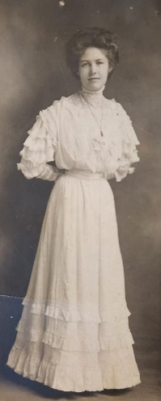
Ethel Mary Briggs Cook (about 23, circa 1913)
Daughter of Frank and Roberta Allen Briggs
Second Grandchild of Robert and Ellen Allen

AUGUST 12 – Ellen welcomed her eleventh grandchild and fifth granddaughter, named Nancy Ellen Allen, who was born in River Forest, Cook County, Illinois, to their only son Lambeth Shelton (46) and his wife Alice Julia Smith (23) Allen (my grandparents).

SEPTEMBER 9 – Ellens’ grandson Ernest Walter Carter (28), son of William (54) and Esther Virginia Allen (49) Carter, married Mary Elizabeth Dasher (21), probably in Homestead, Florida, where their only daughter was born the next year. The Dashers were from Lowndes County, Georgia. Ernest and Mary moved back to the county and the 1930 U.S. Census records them in Dasher District of Lowndes County, Georgia. By 1935 they were in Valdosta, Lowndes, Georgia where they lived the rest of their lives there.

SEPTEMBER 14 – The Delta Independent reported the following:

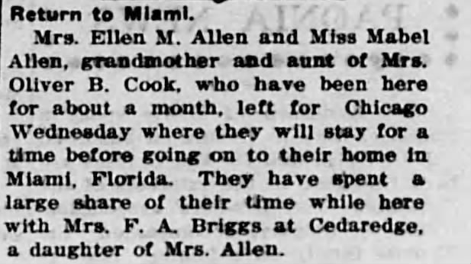

While in Chicago they attended the Christening of Nancy Ellen Allen, the first child of their son and brother Lam, as recorded in Nancy’s baby book.

1924

MARCH 11 – In Broward, Florida, Ellen’s grandson, Frederick William Carter (22), third son of William (55) and Esther Virginia Allen (50), was married to Gladys E. Payne (27).

MARCH 15 – The sister of Robert, Martha “Mattie” J. Allen Williams, died in Woodward, Oklahoma, at the age of seventy five years and eleven days. She had been married to Frank Williams for about 20 years when he died in 1886. She never remarried. She was living next to her brother Charles Pines Allen in Rawdon, Day County, Oklahoma, in the 1900 U.S. Census. Mattie helped to raise Frank’s two children by his first wife, who were about eight and six when she married him. They would have three children of their own. Two of her children outlived her, as well as two grandsons.1922

JULY 18 – Ellen Nancy Pitts Allen turned eighty-five while living in Homestead, Dade County, Florida.

Ellen’s son Lam and family from Chicago came to visit her in Florida, possibly for her 85th birthday.

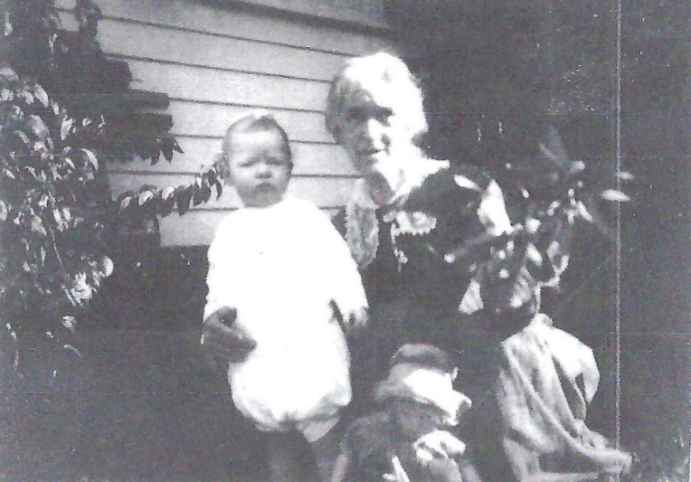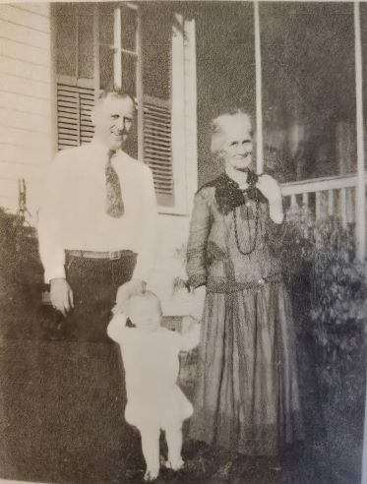
Nancy Ellen Allen, 16 months old, and Ellen Nancy Allen, 85 Three generations, Lambeth Shelton Allen, 48,
(and a doll??) Nancy Ellen Allen, 16 months, Ellen Nancy Allen, 85

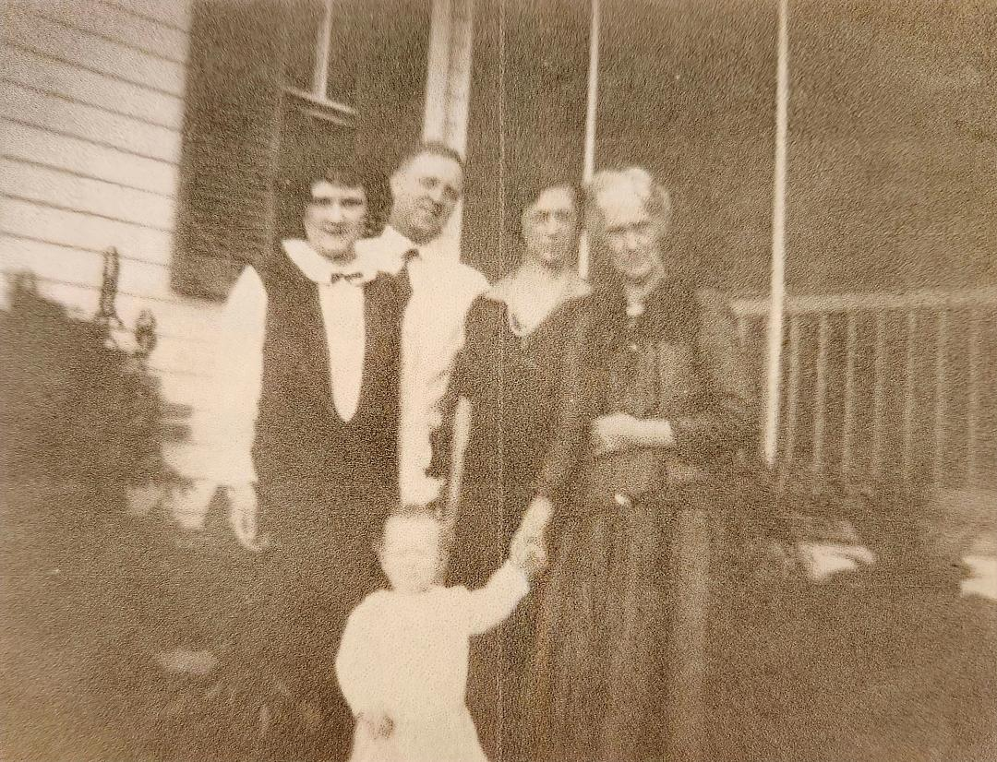
Alice Julia Smith Allen (24), Lambeth Shelton Allen (48), Mabel Carrie Allen (44),
Ellen Nancy Pitts Allen (85), Nancy Ellen Allen (16 months)

In her memoirs Nancy Ellen Allen Haeger wrote the following:

I was named after Grandma Allen [Ellen Nancy Pitts Allen] and the first child of her only son. She would have been around 85 in these pictures. After my birth she wrote me several letters because she felt certain she would not live to see me as a young adult. Mother kept the letters for me and gave them to me when I was in my teens … Since she had been a married woman in her 20s during the Civil War, I was disappointed that she didn’t tell me anything about what it was like to live in a slave state (Missouri) during such a tumultuous time, but I’m sure she wouldn’t have been aware of how interesting that would be to future generations. Just as I lived through World War II, for the most part my every day life at college went on as usual (with the possible lack of some social activities which had been curtailed because of the lack of men on campus.) She had almost lost her sight when the letters were written, and was completely blind many years before she died in 1939 one week after her 100th birthday. She was a small woman - never more than 90 pounds, Mother said, and still ramrod straight in posture in her 80s; a very proper lady - notice the long dress which she was wearing at the time when her new daughter-in-law’s jumper hem was probably at least up to the middle of her legs.

I never got to know that grandmother; except for a trip made about 18 months after Evelyn was born in 1927, and from a lack of pictures otherwise, we never went back to Florida again. Daddy might have, but not as a family. I was 16 when she died. I have no idea if I took after her in any way except that she did write poetry, which I also did in my high school and college years. She had one volume printed and bound - not for general distribution, just for her family. It was not among the box of things which Mother left, but Evie says there are some books from Dad’s library in one of the back bedroom closets which I haven’t explored. So, I’ll look, and, if I find it, will put it with the other things relative to this family history. [I don’t think this book was ever found.]

OCTOBER 29 – In Homestead, Florida, Ellen’s second great grandchild and first great granddaughter, named Mary Esther Carter, was born to Ernest (29) and Mary Dasher (23) Carter. She was their only child and the first grandchild of William (55) and Esther Virginia Allen (51) Carter.

1925

MARCH 4 – Calvin Coolidge was sworn in for his second term as President of the United States. "The inauguration of Calvin Coolidge's for his first full four-year term as president is broadcast live on twenty-one radio stations coast-to-coast. Many homes now have radio receivers.” http://www.fsmitha.com/time/1925.htm

MARCH 8 – The Miami Herald reported that “A buffet luncheon was followed by an enjoyable program and an afternoon spent in sewing” for the Every-Ready Club of Woman’s Relief Corps and G. A. R. Veterans which Ellen attended and Mabel gave a reading. The G. A. R. (Grand Army of the Republic) were veterans of the Union Army, Navy and Marines who served during the Civil War. https://en.wikipedia.org/wiki/Grand_Army_of_the_Republic

JULY 18 – Ellen Nancy Pitts Allen turned eighty-six while living in Homestead, Dade County, Florida.

NOVEMBER 16 – Ellen welcomed her twelfth grandchild and seventh and youngest grandson, named Lambeth Shelton Allen, Jr. (my father), born in River Forest, Illinois to Lambeth Shelton (49) and Alice Julia Smith (25) Allen.

1926

This year the first electric automatic pop-up toaster was marketed for home use. Prior to this, users had to continually monitor the toasting bread to pop it up manually before it burned. https://rarehistoricalphotos.com/vintage-toasters/

MARCH 16 - "Dr. Robert H. Goddard successfully launched the first liquid fueled rocket. The launch took place at Auburn, Massachusetts and is regarded by flight historians to be as significant as the Wright Brothers at Kitty Hawk." https://solarsystem.nasa.gov/news/179/march-16th-marks-75th-anniversary-of-first-liquid-fueled-rocket-launch

JULY 18 – Ellen Nancy Pitts Allen turned eighty-seven while living in Homestead, Dade County, Florida.

Sometime around here Esther’s husband William Carter decided he wanted to turn his big house in Homestead, Florida into a boarding house so he wrote to Lam and asked if he could find another place for Ellen and Mabel to live. Lam bought a house for them at 2318 23rd Court in Miami, Florida.

JULY 21 – In Palmyra, Marion, Missouri, Robert’s brother, Joseph Bensin Allen, died at the age of 84. He lived in Troy, Missouri where he had been an attorney; a minister for the Methodist Episcopal Church, South; and an insurance agent. He also published a periodical called The Troy Record from 1900 to 1902 which was “devoted to temperance and the history of my four great-grandparents.” Although he was the third child of eleven for his parents, he outlived all but the youngest two of his siblings. He and his wife Mary, who he also outlived, were married fifty-two years. They had four children together, two of whom died before their parents, one daughter dying in infancy and one at the age of forty-one. He had six grandchildren living at the time of his death.

OCTOBER 14 – Winnie-the-Pooh by A. A. Milne was first published in the United States.

NOVEMBER 15 – “The oldest broadcasting network in the United States, the National Broadcasting Company (NBC) came into being … with a gala four-hour radio program originating from the ballroom of the Waldorf-Astoria Hotel in New York City. https://www.britannica.com/money/National-Broadcasting-Co-Inc

1927

JANUARY 7 - "The first transatlantic telephone call is made, from New York City to London, via radio waves." http://www.fsmitha.com/time/1927.htm

FEBRUARY 5 – Ellen’s youngest and last-surviving sibling Georgia Ann Pitts Mallory died in Hardin, Missouri. She had been married to John Newton Mallory for fifty-three years when he died in 1923. They had seven children together, although only three were still living, along with fourteen surviving grandchildren (her oldest daughter had lost at least eight), and five great grandchildren. [There is more about Georgia Ann in the portion of “A Convoluted Saga From the Pitts Side” that covers the letter written by her mother Kitty Spence Pitts in 1848.] The following death notice was published in The Hardin News on February 7, 1927.

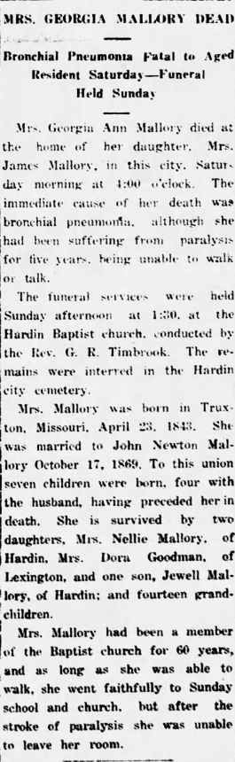

MAY 20 – Ellen welcomed her thirteenth and youngest grandchild and sixth and youngest granddaughter, named Evelyn Mae Allen, born in Glen Ellyn, Illinois, to Lambeth Shelton (50) and Alice Julia (27) Allen (my grandparents). She was their second daughter and youngest child.

MAY 21 - "Charles A. Lindbergh completed the first solo, nonstop transatlantic flight in history, flying his Spirit of St. Louis from Long Island, New York, to Paris, France." https://pioneersofflight.si.edu/content/first-solo-nonstop-transatlantic-flight

MAY 23 – The Miami Herald reported that Ellen, Esther, and Mabel attended “An all-day meeting of Daughters of Union Veterans”.

JULY 18 – Ellen Nancy Pitts Allen turned eighty-eight while living in Miami, Dade County, Florida.

OCROBER 6 - The Jazz Singer, an "American musical drama film directed by Alan Crosland ... [was] the first feature-length motion picture with both synchronized recorded music score as well as lip-synchronous singing and speech (in several isolated sequences). Its release heralded the commercial ascendance of sound films and effectively marked the end of the silent film era." https://en.wikipedia.org/wiki/The_Jazz_Singer

1928

It is estimated that the world’s population in 1928 was two billion, up 35 million in eight years. https://ourworldindata.org/world-population-growth

JANUARY 13 - "Dr. Ernst Frederik Werner Alexanderson performs the first successful public television broadcast. The pictures, with 48 lines at 16 frames per second, were received on sets with 1.5 sq. inch screens in the homes of four General Electric executives in Schenectady, New York. The sound was transmitted by the WGY radio station." https://en.wikipedia.org/wiki/1928_in_television

FEBRUARY 8 - John Logie Baird made the first transatlantic television broadcast. The New York Times the next day described it. "A man and a woman sat before an electric eye in a London laboratory tonight and a group of persons in a darkened cellar in this village outside New York watched them turn their heads and move from side to side. The images were crude, imperfect, broken, but they were images none the less. Man’s vision had panned the ocean; transatlantic television was a demonstrated reality, and one more great dream of science was on the way to realization." https://www.scotsusa.com/scotland/john-logie-baird-first-transatlantic-television-broadcast/

MAY 1828 – Robert’s youngest brother, Francis “Frank” Lowe Allen, died in Dinuba, Tulare, California, at the age of sixty-eight. He had been a fruit farmer in the area. He and his wife Lucy Emily Anderson, who survived him, had been married forty-six years. They had one son who married three times by had no children.

JULY 18 – Ellen Nancy Pitts Allen turned eighty-nine while living in Homestead, Dade County, Florida The following was published in The Miami Herald:

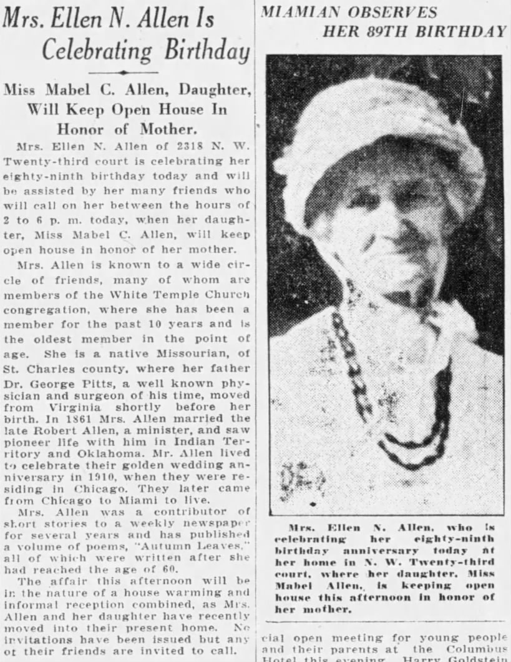

That summer, and probably for her birthday, her son Lam and his young family came for a visit.

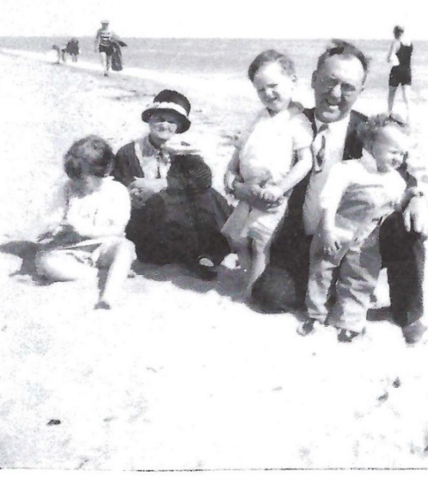
Lam (51) with his mother Ellen (89) and his three children; Nancy (4 years 11 months), Shelton (2 years 8 months), Evelyn (1 year 2 months)

About this trip and the picture below Nancy would write the following in her memoirs:

When Evelyn was over a year old the entire family went by car to Florida, probably sometime in 1928 … I believe this was taken in front of Will Carter’s house … and the two young men in the front are Aunt Genna’s two youngest sons, Ernest and Robert.

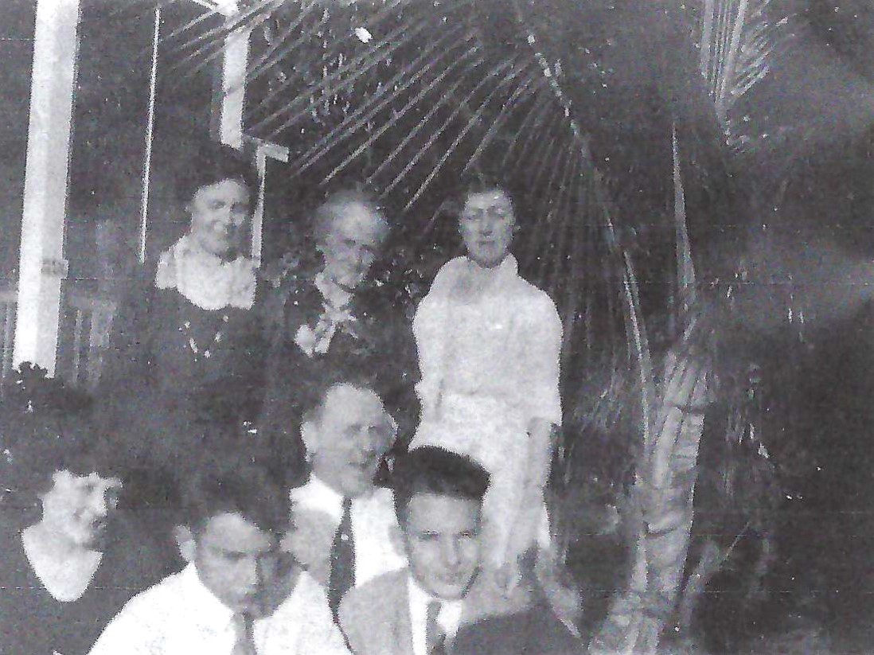
Back: Esther Virginia (Aunt Genna) Allen Carter (55), Ellen Nancy Pitts Allen (89), Mabel Carrie Allen (48),
Middle: Alice Julia Smith Allen (28), Lambeth Shelton Allen (52), Front: Although Nancy wrote that these are Genna’s “youngest” sons Ernest and Robert, I’m not so sure. (Her two youngest were actually Frederick and Robert.) Genna had four sons. In 1928 Allen was 34, Ernest was 33 and had a four-year-old daughter, Frederick was 27 and married, Robert was 24 and in the Navy. I think that these are Allen and Robert, although they look too young to be 34 and 24. Allen, the oldest, never married and lived with his father until his father died and then eventually ended up living by his brother Ernest and wife Mary Dasher until he died and was buried in the Dasher family plot. His 1917 draft registration indicated he possibly had some sort of cognitive disability (“mind not strong”, “mind somewhat affected”), although he could read and write and worked as a farm laborer for a while, at least.
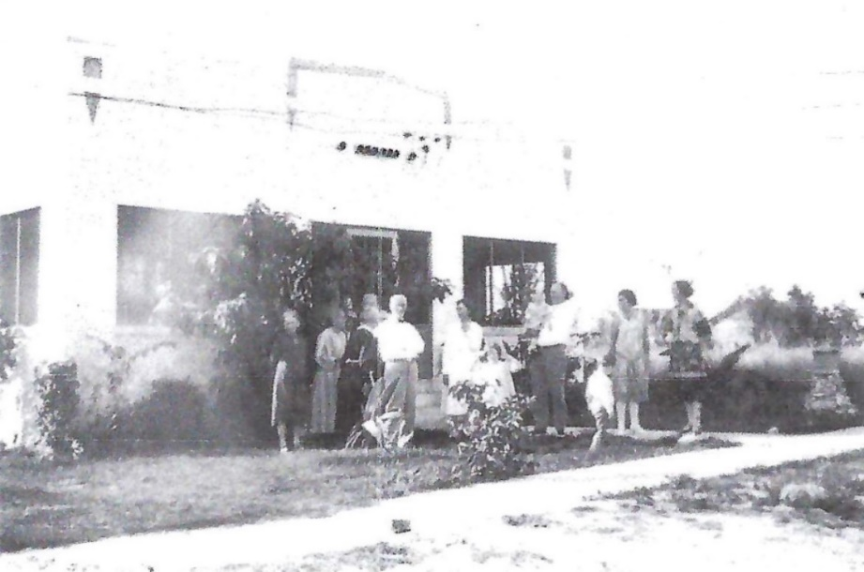
This is the house that Lambeth Shelton Allen bought for his mother at 2318 23rd Court in Miami, Florida.

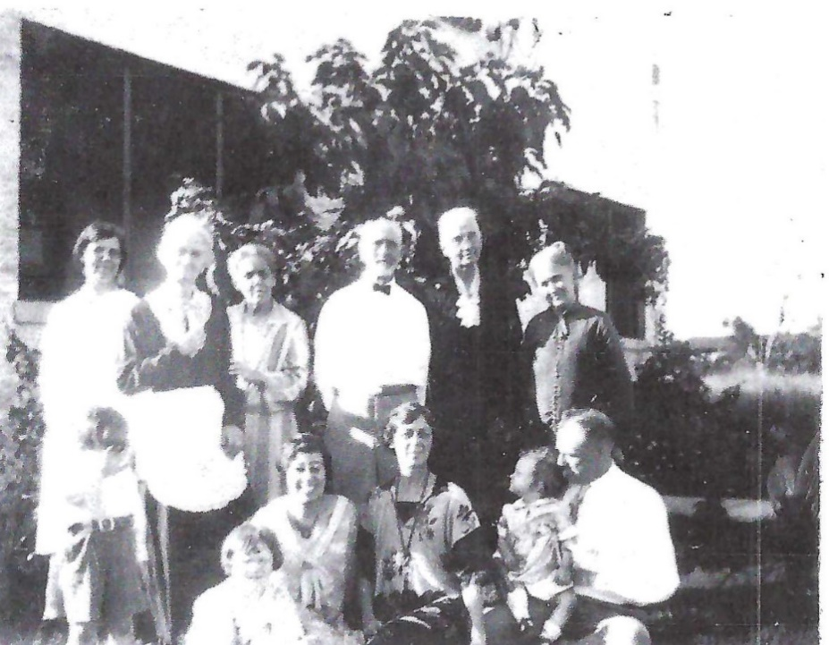
Ellen’s granddaughter Nancy said the following about the picture above: “Shelton (lower left) is standing in front of Aunt Genna and next to Grandma Allen. I don’t know the others in the back row or the lady behind me. Aunt Mable is in the center and Daddy is holding Evelyn.” I have pictures of Ellen’s oldest daughter Roberta and her family in Cedaredge, Colorado and while it’s difficult to tell for certain, I think the lady in the back on the far right is Roberta Richardson Allen Briggs (64) and her husband Frank Briggs (70) is two to the left in the white shirt and bow tie. The gentleman standing between them may be Genna’s husband Will Carter (60), they were still living together until shortly after this. I also believe the younger lady behind little Nancy and next to Mabel might be the daughter of Frank and Roberta Briggs, Ethel Briggs Cook (38). She is the one who transcribed the 1828 and 1848 letters of my Great Great Grandmother Kitty Spence Pitts. The only one I have a question about is the lady next to Ellen holding her arm. As this is definitely a family photo and all of Ellen’s siblings were deceased at this point, perhaps this is a cousin of hers.

OCTOBER 15 - "Following its first commercial flight across the Atlantic, the German dirigible Graf Zeppelin lands in Lakehurst, New Jersey." http://www.fsmitha.com/time/1928.htm

NOVEMBER 1 – In Long Beach, California, Robert’s sister Ada Finley Allen Errett died at the age of seventy-four. She and her husband Joseph Henry Errett, MD, who survived her, had been married fifty-four years. They had lived in Oklahoma before and after it was a Territory of the United States and had taught in the schools there. Although they had had three children together, only one daughter survived childhood. She had two grandsons at the time of her death. She was the last of her nine siblings to die, outliving her youngest brother Frank by nearly six months.

NOVEMBER 18 - Mickey Mouse, created by Walt Disney and animator Ub Iwerks, made his screen debut in "Steamboat Willie." https://www.discovercartooning.com/how-was-mickey-mouse-created "It is the first successful sound-synchronized animated cartoon." http://www.fsmitha.com/time/1928.htm

1929

This year it was estimated that four out of five families in the United States owned a car. https://worldhistory.us/american-history/cars-in-the-1920s-the-early-automobile-industry.php

FEBRUARY 14 - "The St. Valentine’s Day Massacre shocked the world ... when Chicago’s North Side erupted in gang violence. Gang warfare ruled the streets of Chicago during the late 1920s, as chief gangster Al Capone sought to consolidate control by eliminating his rivals in the illegal trades of bootlegging, gambling and prostitution. This rash of gang violence reached its bloody climax in a garage on the city’s North Side ... when seven men associated with the Irish gangster George 'Bugs' Moran, one of Capone’s longtime enemies, were shot to death by several men dressed as policemen. The St. Valentine’s Day Massacre, as it was known, remains an unsolved crime and was never officially linked to Capone, but he was generally considered to have been responsible for the murders." https://www.history.com/topics/crime/saint-valentines-day-massacre

MARCH 4 – Herbert Hoover was sworn in as the 31st President of the United States.

MAY 2 – The Miami Herald listed Ellen and Mabel as attendees of an event held for “Young women students of the University of Miami” hosted by “members of the Town and Gown club of the university”.

MAY 16 - The inaugural Academy Awards ceremony was held. "It is the only Academy Awards ceremony not to be broadcast either on radio or television.” https://en.wikipedia.org/wiki/1st_Academy_Awards

JULY 18 – An announcement for Ellen’s 90th birthday party was published in The Miami Herald.

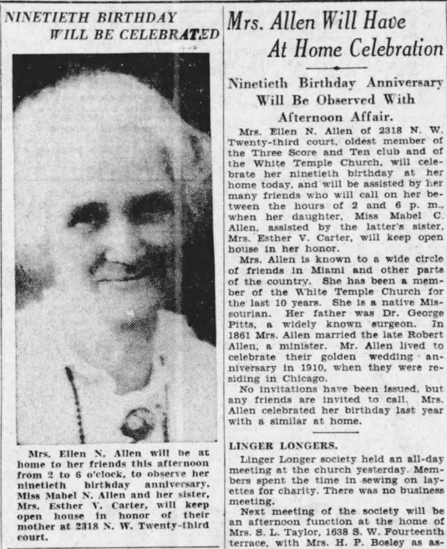

JULY 21 – The following was published in The Miami News regarding the celebration for Ellen’s “90th birthday anniversary”.
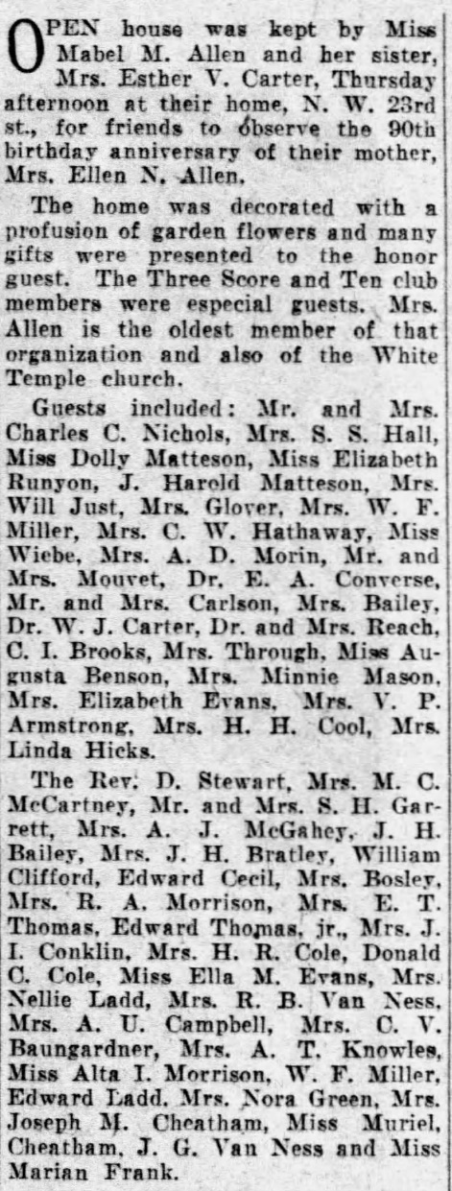

OCTOBER 29, TUESDAY – THE GREAT DEPRESSION - U.S. Stock Market prices collapsed with U.S securities losing $26 billion. Black Tuesday was the first phase of the Great Depression and world economic crisis which lasted to 1940. _{Nancy Ellen Allen Haeger}

1930

This year "Wonder Bread began to commercially produce pre-sliced loaves of bread, popularizing sliced bread and making it a household staple familiar to generations." https://www.thoughtco.com/sliced-bread-invented-1779266

FEBRUARY 18 – Pluto was discovered by astronomer Clyde W. Tombaugh at the Lowell Observatory in Flagstaff, Arizona.
https://www.history.com/this-day-in-history/pluto-discovered

MARCH 30 - "Carrier recorded the first sale of its window-sill-height Weathermaster units to the Superheater Company of East Chicago, Indiana, to air condition the second floor of a two-story building.” https://www.carrier.com/commercial/en/us/about/history/

APRIL 13 - The U.S Census reported Mabel C Allen (48) and Ellen N Allen (90, widowed) living in a home they owned valued at $5,000 at 2318 23rd Court, Miami, Dade, Florida.

MAY 3 – The Miami Herald reported that Ellen and Mabel, as members of the White Temple Church, attended a surprise party “in recognition of outstanding service to the organization” for one of their members.

MAY 27 - The Chrysler Building in New York City opened for the first time. It was "the first man-made structure to be taller than 1,000 feet; and as one newspaper noted, the tower was also taller than the highest points of five states." https://en.wikipedia.org/wiki/Chrysler_Building

JULY 18 – The Miami Herald published the announcement for Ellen’s 91st birthday celebration.

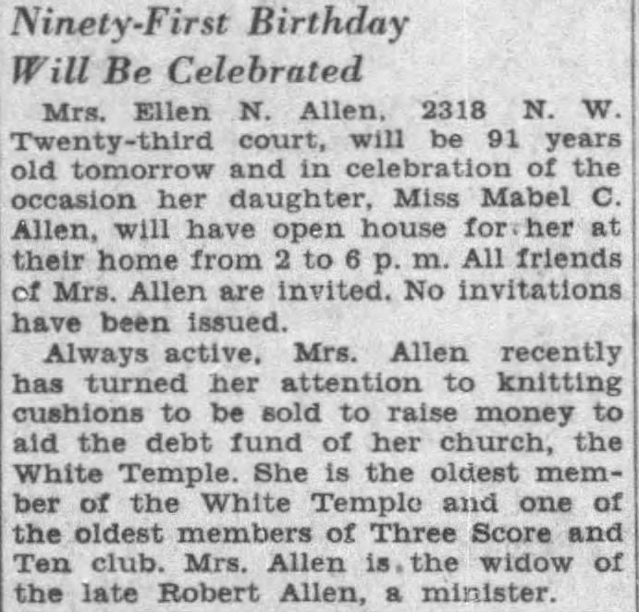

SEPTEMBER 8 – Scotch Tape was first introduced: "3M sent its first roll of cellophane tape to a prospective client, who enthusiastically endorsed it." https://www.acs.org/content/acs/en/education/whatischemistry/landmarks/scotchtape

DECEMBER 10 - Cake Mixes - John D. Duff of Pittsburgh's " P. Duff and Sons ... applied for a patent for an 'invention [that] relates to a dehydrated flour for use in making pastry products and to a process of making the same.' In the application, Duff’s mix for gingerbread involved creating a powder of wheat flour, molasses, sugar, shortening, salt, baking soda, powdered whole egg, ginger, and cinnamon that the home cook could rehydrate with water, then bake." "Though the standard line is that the cake mix was born after World War II and was developed by corporate mills that had too much flour on their hands, it’s really older—it was brought into being at least as early as the 1930s, thanks to a surplus not of flour but of molasses." https://www.bonappetit.com/entertaining-style/pop-culture/article/cake-mix-history

1931

This year the first electric guitar was made. "The Rickenbacker Electro A-22 was an electric lap-steel guitar, (by) Adolf Rickenbacker (and) George Beauchamp." https://www.electricherald.com/history-first-electric-guitar/

Also this year "Sears sold its first affordable and popular electric refrigerator, for $137.50." "With the introduction of small electric motor and nontoxic Freon … refrigerators migrated from industry to home, replacing iceboxes and gas-powered refrigerators." _{Nancy Ellen Allen Haeger}

MARCH 3 - "The Star-Spangled Banner [was] adopted as the national anthem." https://www.infoplease.com/history/us/us-history-progressive-era-and-world-wars-1900-1949

MAY 1 – The Empire State Building was completed and dedicated in New York City. http://www.fsmitha.com/time/1931.htm

JULY 18 – Ellen Nancy Pitts Allen turned ninety-two while living in Miami, Dade County, Florida.

1932

This year Shirley Temple began acting. "She was just 3 years old when she was discovered at her dance school by producers from Educational Films Corporation and contracted by them to appear in the low-budget movies that satirized adult roles and featured all-kid casts. Temple spoofed such stars as Mae West and Marlene Dietrich for the one-reelers." https://www.biography.com/news/shirley-temple-biography-facts

In the Miami, Florida, City Directory Ellen is listed as “Allen, Ellen N (wid Robt A) r2318 NW 23d ct”. Mabel is listed on the next page as “h2318 NW 23d ct”. I think possibly the “r” stands for resident and the “h” stand for head.

MAY 21 – Amelia Earhart completed the “first solo nonstop transatlantic flight by a woman." https://www.infoplease.com/history/us/us-history-progressive-era-and-world-wars-1900-1949

JULY 18 - Ellen Nancy Pitts Allen turned ninety-three while living in Miami, Dade County, Florida.

SEPTEMBER 25 – In Jacksonville, Florida, Ellen’s third great grandchild, named Virginia Ann Carter, was born to Frederick (30) and Gladys Payne (35) Carter. Virginia was the second grandchild of William (63) and Esther Virginia Allen (59) Carter.

OCTOBER 6 – In Grand Junction, Colorado, Ellen’s grandson Frank Allen Briggs (32), the youngest child of Frank (74) and Roberta (68) Briggs, was married to Katherine Mountjoy (28). Frank and Katherine never had children.

NOVEMBER 7 – Buck Rogers, a space comic strip since 1929, became a radio broadcast show. http://www.fsmitha.com/time/1932.htm

DECEMBER 21 – Fred Astaire and Ginger Rogers appeared in their first movie together, dancing in Flying Down to Rio. http://www.fsmitha.com/time/1932.htm

1933

JANUARY 5 – In San Francisco, the construction of the Gold Gate Bride began. http://www.fsmitha.com/time/1933.htm

JANUARY 22 – The twentieth Amendment to the U.S. Constitution moved the inauguration date of the president from March 4 to January 22.

JANUARY 30 – The Lone Ranger began as a radio program. http://www.fsmitha.com/time/1933.htm

MARCH 4 – Franklin Roosevelt was sworn in as the 32nd President of the United States.

"During the bleakest days of the Great Depression, newly elected President Franklin D. Roosevelt delivered his first inaugural address before 100,000 people on Washington’s Capitol Plaza. 'First of all,' he said, 'let me assert my firm belief that the only thing we have to fear is fear itself.' He promised that he would act swiftly to face the 'dark realities of the moment' and assured Americans that he would 'wage a war against the emergency' just as though 'we were in fact invaded by a foreign foe.' His speech gave many people confidence that they’d elected a man who was not afraid to take bold steps to solve the nation’s problems." https://www.history.com/topics/great-depression/new-deal

MARCH 5 - "Roosevelt declared a four-day bank holiday to stop people from withdrawing their money from shaky banks." https://www.history.com/topics/great-depression/new-deal

MARCH 9 - “Congress passed Roosevelt’s Emergency Banking Act, which reorganized the banks and closed the ones that were insolvent … Roosevelt’s quest to end the Great Depression was just beginning ...he acted swiftly to stabilize the economy and provide jobs and relief to those who were suffering. Over the next eight years, the government instituted a series of experimental New Deal projects and programs ... Roosevelt’s New Deal fundamentally and permanently changed the U.S. federal government by expanding its size and scope—especially its role in the economy."" https://www.history.com/topics/great-depression/new-deal

MARCH 12 – LEAD-UP TO WORLD WAR II - The first concentration camp was opened in Germany at Oranienburg outside Berlin for "political prisoners, primarily Communists and Social Democrats." https://encyclopedia.ushmm.org/content/en/article/oranienburg-1

MARCH 24 – LEAD-UP TO WORLD WAR II - Much had been happening in Germany where Adolph Hitler had been slowly and steadily rising to power. On this day the Enabling Act was passed which gave him “the power to rule by decree rather than passing laws through the Reichstag and the president." Thus, Hitler became the dictator of Germany. https://www.theholocaustexplained.org/the-nazi-rise-to-power/how-did-the-nazi-gain-power/1933-elections/

APRIL 1 - LEAD-UP TO WORLD WAR II - “A week after Hitler became dictator of Germany, he ordered a boycott of Jewish shops, banks, offices and department stores. But the boycott was mostly ignored by German shoppers and was called off after three days. However, the unsuccessful boycott was followed by a rapid series of laws which robbed the Jews of many rights." https://www.historyplace.com/worldwar2/timeline/boycott.ht

MAY 6 - Ellen and Mabel attended a “surprise event” for a member, as announced in The Miami Herald, which “was given by women of the White Temple Church … in recognition of outstanding service to the organization.”

JUNE 20 – In California, Ellen’s grandson, Robert Jacob Allen (28), the youngest son of William (64) and Esther Virginia Allen (59) Carter, married Maria Sabina Cution (21). Maria was six months pregnant at the time. This was the first of his three marriages and the second of her three.

JULY 18 - Ellen Nancy Pitts Allen turned ninety-four while living in Miami, Dade County, Florida.

SEPTEMBER 21 – In California, Ellen’s fifth great grandchild and third great granddaughter, named Dulce Ann Carter, was born to Robert (28) and Maria Cution (22) Carter. She was the fourth grandchild and third granddaughter for William (64) and Esther Virginia Allen (60) Carter.

NOVEMBER 11-13 - THE DUST BOWL - “The prairie grasses that had previously held the soil ha[d] been replaced by plowing. Winds bl[ew] dry topsoil across the Dakotas, Oklahoma, Kansas and nearby states in what for the year is a series of dust storms." http://www.fsmitha.com/time/1933.htm

DECEMBER 4 – THE BEGINNING OF RADIO SOAP OPERAS - "At 3:00 PM on NBC’s Red Network, the first episode of OXYDOL’S OWN MA PERKINS was presented. This was more than the debut of a program. It was the first daytime serial on network radio sponsored by a Procter & Gamble product--- and more importantly, a Procter & Gamble SOAP product." It put the soap in soap opera. https://www.old-time.com/commercials/1930%27s/OOMP.htm

DECEMBER 5 - The 21st amendment to the US Constitution (repealing the 18th amendment, Prohibition) is ratified with the support of President Roosevelt who had "campaigned for it, stating that legalizing beer alone could raise 'the federal revenue by several hundred million dollars a year.'" https://prohibition.themobmuseum.org/the-history/the-end-of-prohibition/repeal-of-prohibition/

1934

MAY 9 - THE DUST BOWL - "A strong, two-day dust storm removed massive amounts of Great Plains topsoil in one of the worst such storms of the Dust Bowl. The dust clouds blew all the way to Chicago, where they deposited 12 million pounds of dust ... Two days later, the same storm reached cities to the east, such as Cleveland, Buffalo, Boston, New York City, and Washington, D.C. That winter (1934–1935), red snow fell on New England." https://en.wikipedia.org/wiki/Dust_Bowl

JUNE 30 - LEAD-UP TO WORLD WAR II - The Nazi "Night of the Long Knives." "The purge of the SA was kept secret until it was announced by Adolf Hitler on July 13. It was during this speech that Hitler gave the purge its name: Night of the Long Knives (a phrase from a popular Nazi song). Hitler claimed that 61 had been executed while 13 had been shot resisting arrest and three had committed suicide. Others have argued that as many as 400 people were killed during the purge. In his speech, Hitler explained why he had not relied on the courts to deal with the conspirators: 'In this hour I was responsible for the fate of the German people, and thereby I become the supreme judge of the German people. I gave the order to shoot the ringleaders in this treason.' The Night of the Long Knives was a turning point in the history of Hitler's Germany. Hitler had made it clear that he was the supreme ruler of Germany who had the right to be judge and jury, and had the power to decide whether people lived or died." https://www.jewishvirtuallibrary.org/the-night-of-the-long-knives

JULY 18 - Ellen Nancy Pitts Allen turned ninety-five while living in Miami, Dade County, Florida.

1935

In the Florida State Census for Precinct 17 of Dade County, Florida at 2318 N W 23rd Court lived “Mable” (53 years old, housekeeper, with a high school education) with her mother Ellen N Allen (95 years old, retired, with a grammar school education). Ellen and Mabel were listed as owning the house and renting the apartment over the garage to Orval James Lesh (34, a salesman with a grammar school education), his wife Hazel Marie Lesh (33, a housewife with a grammar school education), their daughter Doris Lavon Lesh (10) and son Orval James Lesh, Junior (8).

This year Parker Brothers bought the rights to the board game Monopoly. Two hundred seventy eight thousand copies were sold in the first year alone. https://www.monopolyland.com/when-was-monopoly-invented/

JANUARY 11 – Amelia Earhart made her solo flight from Honolulu, Hawaii to Oakland, California. http://www.fsmitha.com/time/1935.htm

MARCH 5 – In Florida, Ellen’s fourth great grandchild and second great grandson, named Charles W. Carter, was born to Frederick (33) and Gladys Payne (38) Carter. He was their second child and first son, and the third grandchild and first grandson of William (66) and Esther Virginia Allen (61) Carter.

MARCH 11 – Ellen’s son-in-law, Frank Alton Briggs, the husband of her daughter Roberta (71) died suddenly at his home in Cedaredge, Colorado, possibly of a heart attack or stroke. He was one day shy of 76 ½ years old. Frank and Roberta had been married nearly 49 years.

MARCH 22 - The Division of Investigation officially became the Federal Bureau of Investigation under J. Edgar Hoover. https://archives.fbi.gov/archives/news/stories/2006/march/fbiname_022406

APRIL 14 – THE DUST BOWL - "Known as 'Black Sunday', 20 of the worst 'black blizzards' occurred across the entire sweep of the Great Plains, from Canada south to Texas. The dust storms caused extensive damage and appeared to turn the day to night; witnesses reported that they could not see five feet in front of them at certain points." https://en.wikipedia.org/wiki/Dust_Bowl

JULY 18 - Ellen Nancy Pitts Allen turned ninety-six while living in Miami, Dade County, Florida.

SEPTEMBER 15 – LEAD-UP TO WORLD WAR II - Under the Nuremberg Race Laws, German Jews were stripped of their rights. http://www.fsmitha.com/time/1935.htm

NOVEMBER 9 – In California, Ellen’s seventh great grandchild and fourth great grandson, named Roderick Robert Carter, was born to Robert (ten days shy of 31) and Maria Cution (24) Carter. He was the sixth grandchild and third grandson of William (66) and Esther Virginia Allen (62) Carter.

1936

JANUARY 20 – Britain’s King George V (70) died from “a chronic lung issue”. Prince Edward of York and Cornwall (41), his eldest son, succeeded him as Edward VIII, King of the United Kingdom and the British Dominions, Emperor of India. https://www.britannica.com/story/how-did-king-george-v-really-die

JULY 18 - Ellen Nancy Pitts Allen turned ninety-seven while living in Miami, Dade County, Florida.

DECEMBER 11 – Britain’s Edward VIII (42) abdicated the throne and his younger brother George became George VI King of the United Kingdom and the British Dominions and the Emperor of India.

1937

JANUARY 20 – Franklin Roosevelt was sworn in for his second term as President of the United States.

MAY 6 – The Hindenburg, “a German commercial passenger-carrying rigid airship” or zeppelin, caught fire after crossing the Atlantic as it attempted to land in Manchester Township, New Jersey. Thirteen of the 36 passengers died along with 22 of the 61 crew members. https://en.wikipedia.org/wiki/Hindenburg_disaster

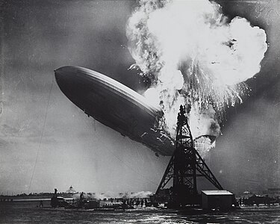

MAY 27 – The Golden Gate Bridge in San Francisco, which had been under construction for five years, opened for “Pedestrian Day” as around 200,000 people walked along “the 4,200-foot-long suspension bridge”. The next day it would open for vehicular traffic. https://www.history.com/this-day-in-history/golden-gate-bridge-opens

JULY 2 – Amelia Earhart (39) and her navigator Fred Noonan (44) disappeared near Howland Island in the Pacific Ocean while attempting to fly around the world. https://en.wikipedia.org/wiki/Amelia_Earhart

JULY 18 - Ellen Nancy Pitts Allen turned ninety-eight while living in Miami, Dade County, Florida.

JULY 19 – In Florida, Ellen’s sixth great grandchild and third great grandson, named John H. Carter, was born to Frederick (35) and Gladys E. Payne (40) Carter. He was the fifth grandchild and second grandson of William (68) and Esther Virginia Allen (64) Carter.

DECEMBER 21 – Walt Disney’s and the world’s first feature-length animated film Snow White and the Seven Dwarfs premiered at the Carthay Circle Theatre in Los Angeles, California.

1938

Some time this year, Genna, who had been living in Chicago with her brother Lam as the nanny for his three young children, moved back to Miami to help Mabel care for Ellen who by this point was blind.

JULY 18 - Ellen Nancy Pitts Allen turned ninety-nine while living in Miami, Dade County, Florida.

SEPTEMBER 30 - LEAD-UP TO WORLD WAR II - British Prime Minister Neville Chamberlain and French Premier Édouard Daladier went to Munich to try and appease Adolf Hitler by persuading Czechoslovakia to agree to the terms of the Munich Agreement (between Germany, Great Britain, France and Italy; Czechoslovakia was not involved in the negotiations of the Munich Agreement) which would allow Germany to annex the Sudetenland in western Czechoslovakia. "Before leaving Munich, Chamberlain and Hitler signed a paper declaring their mutual desire to resolve differences through consultation to assure peace. Both Daladier and Chamberlain returned home to jubilant welcoming crowds relieved that the threat of war had passed, and Chamberlain told the British public that he had achieved 'peace with honour. I believe it is peace for our time.' His words were immediately challenged by his greatest critic, Winston Churchill, who declared, 'You were given the choice between war and dishonour. You chose dishonour and you will have war.'” https://www.britannica.com/event/Munich-Agreement

OCTOBER 30 – Orson Welles broadcast War of the Worlds over the radio. "For much of its duration, the program was presented as a faux newscast. Consequently, Welles, who was then all of twenty-three, had somehow persuaded a portion of the public that Martians were annihilating Earthlings. The New York Times headline painted the picture: 'Radio Listeners in Panic, Taking War Drama as Fact.’ The next day, apologetic, Wells state[d], ‘I know that almost everybody in radio would do almost anything to avert the kind of thing that has happened, myself included ... Radio is new, and we are learning about the effect it has on people. We learned a terrible lesson.” https://www.neh.gov/article/fake-news-orson-welles-war-worlds-80

NOVEMBER 9 - LEAD-UP TO WORLD WAR II - "Kristallnacht - The Night of Broken Glass … A massive, coordinated attack on Jews throughout the German Reich." Adolf Hitler and Propaganda Minister Joseph Goebbles incited Germans to "rise in bloody vengeance against the Jews" in retribution for the death of a German Embassy staff member [Ernst] Vom Rath who was shot and killed by "Herschel Grynszpan, a 17 year old Jew living in Paris ... in retaliation for the poor treatment his father and his family suffered at the hands of the Nazis in Germany [when they] ... and over 15,000 other Jews, originally from Poland, had been expelled from Germany without any warning. They were forcibly transported by train in boxcars then dumped at the Polish border." https://www.historyplace.com/worldwar2/timeline/knacht.htm

1939

FEBRUARY 7 – William J. Carter, the estranged husband of Ellen’s daughter, Esther Virginia “Genna” (65), died in Miami, Florida at the age of seventy.

APRIL 14 - John Steinbeck published The Grapes of Wrath. "It evokes the harshness of the Great Depression and arouses sympathy for the struggles of migrant farmworkers. The book came to be regarded as an American classic." https://www.britannica.com/topic/The-Grapes-of-Wrath

APRIL 30 - The World's Fair opened in New York. "When President Franklin Roosevelt opened the fair, RCA broadcast his speech on the new invention called television and NBC (owned by RCA) used the occasion to launch the first regularly scheduled TV broadcasts in the United States." https://antiqueradio.org/RCA_40X-56_1939_Worlds_Fair_Radio

JULY 18 - Ellen Nancy Pitts Allen turned one hundred while living in Miami, Dade County, Florida. The following was published in the Miami News:

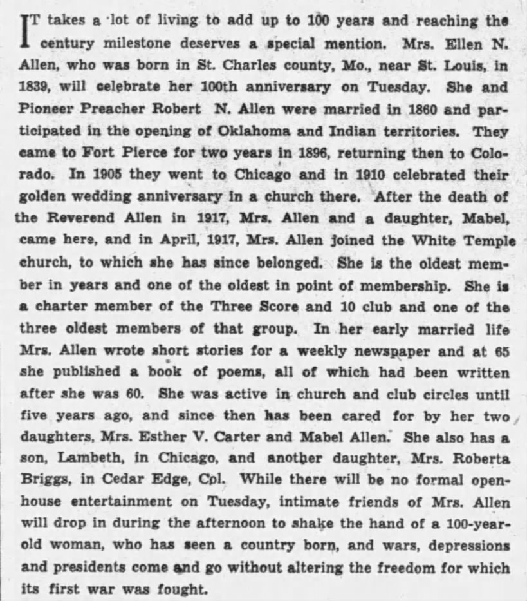

The following appeared in The Miami Herald although these corrections should be noted:

- Her name was Ellen Nancy, not Nancy Ellen.
- They resided in Lexington, Missouri, not Lexington, Kentucky.
- “Rev. Mr. Allen” was there for the opening of the Indian, not Indiana, Territory.

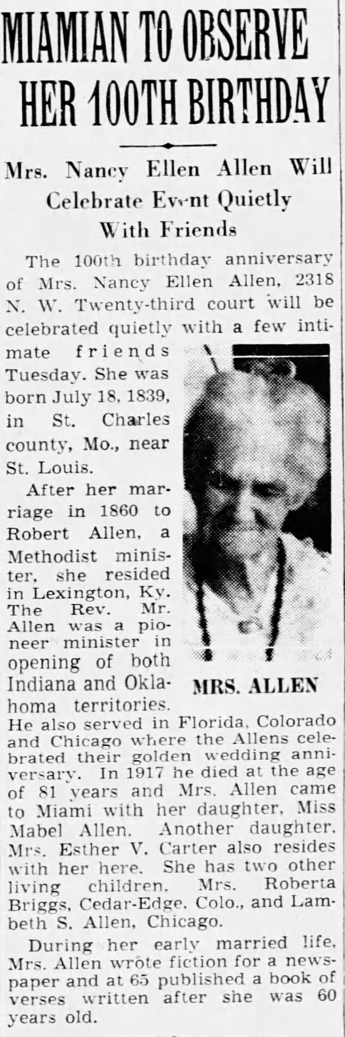

Ellen’s granddaughter Nancy, who was on a cross-country trip with her parents Lam and Alice on Route 66, recalled the following about this birthday in her memoirs:

While traveling through Arizona we stopped in one town so that Daddy could wire flowers to Grandmother Allen in Florida for her 100th birthday. The girl who took the order said that was the first time she would wire flowers to anyone 100 years old!

JULY 25 – Ellen died in Miami, Florida seven days after her 100th birthday.

The following is her obituary in The Miami Herald:

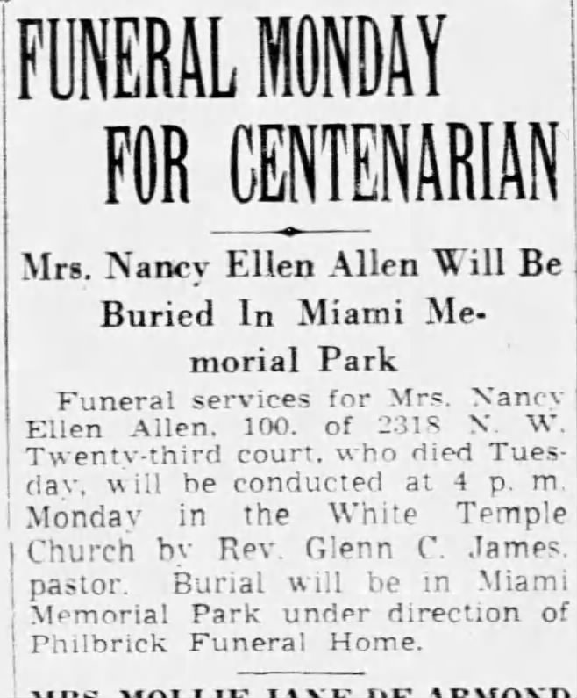

The following death announcement appeared in the St. Charles Weekly Banner on August 3rd:

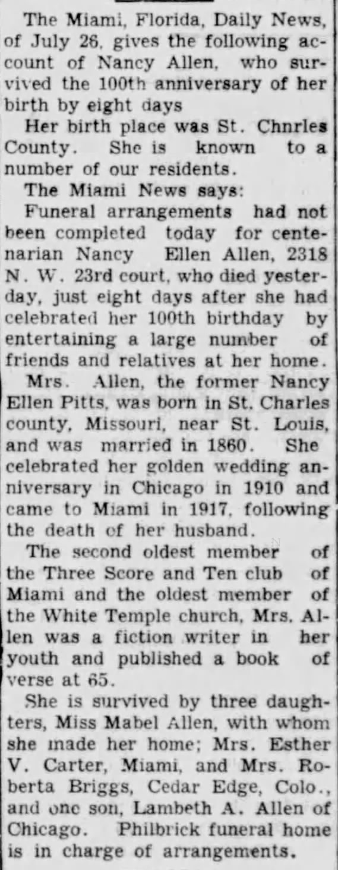

Ellen had survived both of her parents, all ten of her siblings, all ten of Robert’s siblings, three of her daughters, two of her sons-in-law, and her oldest granddaughter. She outlived her husband Robert by twenty-one years, seven months, and eleven days. She had twelve grandchildren living at the time, seven of whom were married. The oldest grandchild was 49 and the youngest was 12. She had seven great grandchildren living at the time, the oldest was 17 and the two youngest were three.

